**REACT**

**React JS HOL (Handson 13)**

**Blogger App**

**FOLDER STRUCTURE:**

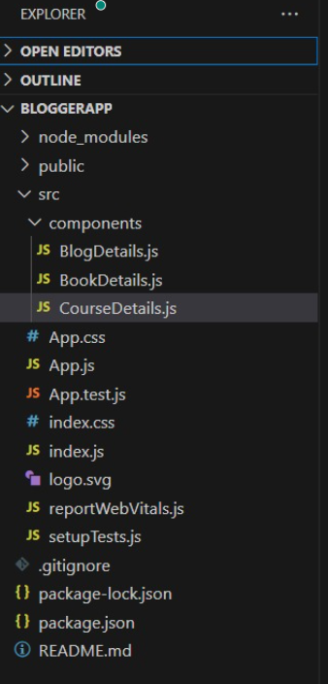

**PROGRAM:**

**App.js**

import React, { useState } from 'react';

import BookDetails from './components/BookDetails';

import BlogDetails from './components/BlogDetails';

import CourseDetails from './components/CourseDetails';

function App() {

const [showComponent, setShowComponent] = useState('books');

let componentToRender;

if (showComponent === 'books') {

componentToRender = <BookDetails />;

} else if (showComponent === 'blogs') {

componentToRender = <BlogDetails />;

} else {

componentToRender = <CourseDetails />;

}

return (

<div style={{ padding: '20px', textAlign: 'center' }}>

<h1>📚 Blogger App Dashboard</h1>

<button onClick={() => setShowComponent('books')}>Show Books</button>

<button onClick={() => setShowComponent('blogs')}>Show Blogs</button>

<button onClick={() => setShowComponent('courses')}>Show Courses</button>

<hr />

{/* Method 1: if-else with variable */}

{componentToRender}

{/* Method 2: Ternary */}

{/* {showComponent === 'books' ? <BookDetails /> : showComponent === 'blogs' ? <BlogDetails /> : <CourseDetails />} */}

{/* Method 3: Logical && */}

{/* {showComponent === 'books' && <BookDetails />}

{showComponent === 'blogs' && <BlogDetails />}

{showComponent === 'courses' && <CourseDetails />} */}

</div>

);

}

export default App;

**BookDetails.js**

import React from 'react';

const books = [

{ id: 1, title: 'React Basics', author: 'John Doe' },

{ id: 2, title: 'Advanced React', author: 'Jane Smith' },

];

const BookDetails = () => {

return (

<div>

<h2>Book List 📖</h2>

<ul>

{books.map(book => (

<li key={book.id}>

<strong>{book.title}</strong> - {book.author}

</li>

))}

</ul>

</div>

);

};

export default BookDetails;

**BlogDetails.js**

import React from 'react';

const blogs = [

{ id: 1, title: 'React vs Angular', writer: 'Alex' },

{ id: 2, title: 'Hooks in React', writer: 'Maria' },

];

const BlogDetails = () => {

return (

<div>

<h2>Blog Posts ✍️</h2>

<ul>

{blogs.map(blog => (

<li key={blog.id}>

<strong>{blog.title}</strong> by {blog.writer}

</li>

))}

</ul>

</div>

);

};

export default BlogDetails;

**CourseDetails.js**

import React from 'react';

const courses = [

{ id: 1, name: 'ReactJS Complete Guide', duration: '30 hours' },

{ id: 2, name: 'Frontend Mastery', duration: '40 hours' },

];

const CourseDetails = () => {

return (

<div>

<h2>Course Details 🎓</h2>

<ul>

{courses.map(course => (

<li key={course.id}>

{course.name} - <em>{course.duration}</em>

</li>

))}

</ul>

</div>

);

};

export default CourseDetails;

**OUTPUT:**

