**REACT**

**React JS HOL (Handson 9)**

**Cricket App**

**FOLDER STRUCTURE:**

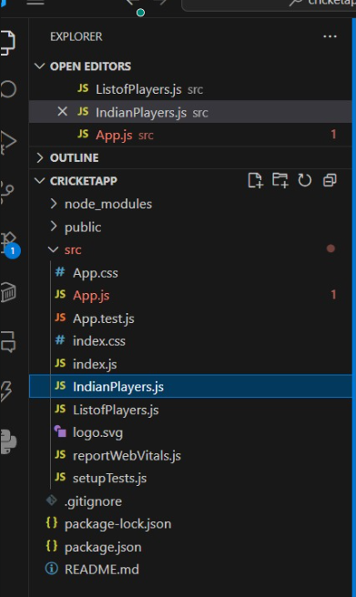

**PROGRAM:**

**ListofPlayers.js**

import React from "react";

const ListofPlayers = () => {

const players = [

{ name: "Virat", score: 85 },

{ name: "Rohit", score: 45 },

{ name: "Gill", score: 75 },

{ name: "Ishan", score: 50 },

{ name: "Pant", score: 90 },

{ name: "Hardik", score: 55 },

{ name: "Jadeja", score: 65 },

{ name: "Ashwin", score: 70 },

{ name: "Shami", score: 35 },

{ name: "Bumrah", score: 25 },

{ name: "Kuldeep", score: 60 }

];

const filteredPlayers = players.filter(player => player.score < 70);

return (

<div>

<h2>All Players</h2>

<ul>

{players.map((player, index) => (

<li key={index}>{player.name} - {player.score}</li>

))}

</ul>

<h2>Players with score below 70</h2>

<ul>

{filteredPlayers.map((player, index) => (

<li key={index}>{player.name} - {player.score}</li>

))}

</ul>

</div>

);

};

export default ListofPlayers;

**IndianPlayers.js**

import React from "react";

const IndianPlayers = () => {

const players = ["Player1", "Player2", "Player3", "Player4", "Player5", "Player6"];

// Destructuring into even and odd team

const oddPlayers = players.filter((_, index) => index % 2 === 0);

const evenPlayers = players.filter((_, index) => index % 2 !== 0);

const T20players = ["Kohli", "Rohit", "Gill"];

const RanjiTrophy = ["Pujara", "Rahane", "Jadeja"];

// Merging two arrays

const allPlayers = [...T20players, ...RanjiTrophy];

return (

<div>

<h2>Odd Team Players</h2>

<ul>

{oddPlayers.map((name, index) => (

<li key={index}>{name}</li>

))}

</ul>

<h2>Even Team Players</h2>

<ul>

{evenPlayers.map((name, index) => (

<li key={index}>{name}</li>

))}

</ul>

<h2>All Players (T20 + RanjiTrophy)</h2>

<ul>

{allPlayers.map((name, index) => (

<li key={index}>{name}</li>

))}

</ul>

</div>

);

};

export default IndianPlayers;

**App.js**

import React from "react";

import ListofPlayers from "./ListofPlayers";

import IndianPlayers from "./IndianPlayers";

function App() {

const flag = true; // Toggle this to false to switch component

return (

<div className="App">

<h1> Cricket App</h1>

{flag ? <ListofPlayers /> : <IndianPlayers />}

</div>

);

}

export default App;

**OUTPUT:**

