**Netflix Content Strategy: Case Study**

**Primary Goal:**

* Analyse Netflix’s content strategy to understand how content type, language, release season, and timing affect viewership patterns.
* Identifying the best-performing content and the timing of its release, the aim is to uncover insights into how Netflix maximizes audience engagement throughout the year.

**About the dataset:**

* The dataset consists of Netflix content released globally, containing information on: -
  + title
  + release date
  + language
  + content type (show or movie),
  + availability status
  + viewership hours
* The dataset allows the exploration of patterns in viewership based on various attributes like content type, release season, language, and release day. The viewership data, represented in hours viewed, serves as a proxy for each title's popularity and audience engagement.

**Data Analysis Steps: -**

* **Data Cleaning: -**
  + Converted the hours viewed into the numeric format by removing the comma (,)
  + In excel, Ctrl + H to replace comma.
* **Data Analysis & Data Visualizations: -**
  + Analysing the trends in content type to determine whether the viewers most watch shows or movies.
    - The visualization **shows** that shows dominate **viewership hours** on Netflix.
    - So, we can say that Netflix’s content strategy leans higher towards shows, as they tend to attract more viewers.
  + Now we will analyze the distribution of viewership across different languages to which language is contributing the most to Netflix’s content.
    - The visualization reveals that **English language content** significantly dominates Netflix’s viewership, followed by other languages like Korean and so on.
    - It is significant that Netflix’s primary audience is mostly interested in seeing English content.
    - Also, Korean and non-English shows and movies have a considerable viewership share, showing a diverse content strategy.
  + Next, analyze how viewership varies based on the release date to identify any trend, such as seasonality and patterns around specific months.
    - For this we are analysing the hours viewed based on months
    - To get the month name in Excel: -
      * **=TEXT(C2,"MMMM")**
    - The graph shows the total viewership hours by month, which reveals a notable increase in viewership during June and a sharp rise toward the end of the year in December.
    - This suggests that Netflix experiences spikes in audience engagement during these periods, possibly due to strategic content releases, seasonal trends, or holidays, while the middle months have a steady but lower viewership pattern.
  + Here we analyze the top 5 content titles based on the hours viewed**.**
    - Since I have used **Excel**, I will be **sorting the hours viewed** from **largest to smallest** and returning the result set.

* + - **The Night Agent: Season 1** (English, Show) with 812.1 million hours viewed.
    - **Ginny & Georgia: Season 2** (English, Show) with 665.1 million hours viewed.
    - **King the Land: Limited Series** (Korean, Movie) with 630.2 million hours viewed.
    - **The Glory: Season 1** (Korean, Show) with 622.8 million hours viewed.
    - **ONE PIECE: Season 1** (English, Show) with 541.9 million hours viewed.
    - English-language shows dominate the top viewership spots. However, Korean content also has a notable presence in the top titles, which indicates its global popularity.
  + Now we are comparing the viewership trends by content type:
    - Here we are taking the release date and comparing the total viewer hours based on the content type.
    - Here we are creating the pivot table and taking the months in rows content type in columns and the hours viewed as value.

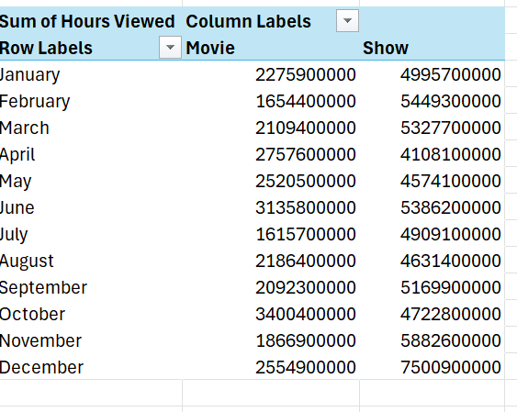

* + - Creating the line graph, graph compares viewership trends between movies and shows: -
    - Shows consistently have higher viewership than movies.
    - It shows that shows consistently have higher viewership than movies, peaking in December.
    - Movies have more fluctuating viewership, with notable increases in June and October.
    - This indicates that Netflix’s audience engages more with shows across the year, while movie viewership experiences occasional spikes, possibly linked to specific releases or events.
  + Let’s check the viewership hours distributed across different release seasons: -
    - For this we need to divide the months into a different season
    - To do that in Excel we used: -
      * **=IF(OR(H2=12,H2=1,H2=2),"Winter",IF(OR(H2=3,H2=4,H2=5),"Spring",IF(OR(H2=6,H2=7,H2=8),"Summer",IF(OR(H2=9,H2=10,H2=11),"Fall"))))**
    - Using the pivot table we calculated the sum of hours viewed in 4 different seasons.
    - The graph indicates that viewership hours peak significantly in the Winter season, with over 25 billion hours viewed.
    - Second fall season with 23 billion views.
    - While Spring and Summer each have relatively stable and similar viewership around the 20 billion mark.
    - This suggests that Netflix experiences the highest audience engagement during the Winter.
  + Now we will be analyzing the number of content releases and their viewership hours across months:
    - For this we created the pivot table by counting the release month based on the different months and the sum of the viewership hours.
    - Created a combo chart where the bar represents counts of release dates and the orange line represents the sum of hours viewed.
    - The number of releases is relatively steady throughout the year, viewership hours experience a sharp increase in June and a significant rise in December, despite a stable release count.
    - This indicates that viewership is not solely dependent on the number of releases but influenced by the timing and appeal of specific content during these months.
  + Next, we will analyze releasing content on specific weekdays and how this influences viewership patterns:
    - For this analysis we will be checking the weekly pattern and hours viewed and the count of release date
    - To get the days from the release date in Excel:
      * **=TEXT(C2,"DDDD")**
    - Using the pivot table we have taken the count of days based on the 7 different days and also the total hours viewed.
    - A chart has been plotted where the blue color bar represents the count of Days and the orange line represents the total hours viewed.
    - The graph highlights that most content releases occur on Fridays, with viewership hours also peaking significantly on that day.
    - This suggests that Netflix strategically releases content toward the weekend to maximize audience engagement.
    - The viewership drops sharply on Saturdays and Sundays, despite some releases, indicating that the audience tends to consume newly released content right at the start of the weekend, which makes Friday the most impactful day for both releases and viewership.

***CONCLUSION***

* The content strategy of Netflix revolves around maximizing viewership through targeted release timing and content variety.
* Shows consistently outperform movies in viewership, with significant spikes in December and June, indicating strategic releases around these periods.
* The Winter season stands out as the peak time for audience engagement.
* Most content is released on Fridays, which aims to capture viewers right before the weekend, and viewership aligns strongly with this release pattern.