RoboWar
In the beginning, I watched the video for basic of RoboWar components
https://www.youtube.com/watch?v=WiJyD3viOOs

1. Chassis & Frame
- Best Overall: Aluminium 6061-T6
Why: It is light, strong, and easy to drill/cut. It is the standard for 70% of robots.
Warning: Do not buy "hardware store" aluminium (which is usually 6063). It is too soft and will bend like butter. You must order 6061-T6 specifically.

Weapon Type: - Vertical Spinner
Why vertical spinner: - Vertical spinners transfer energy upward, which lifts the opponent.
- Vertical spinning weapon: The key feature is a weapon that rotates on a vertical axis, unlike a horizontal spinner that spins side-to-side.
- Weapon types: Weapons can include circular disks, bars, or drum-shaped spinners.
- Centering: The weapon is often mounted over the center of the bot's body.

1.Robotics Motor & Weapon Design Notes
1. Speed and Motor Calculations
Speed Goal Calculation
To determine the necessary motor specifications, you first need to establish the target tip speed and the diameter of the weapon.
Formula for RPM:
Spinner RPM = [Tip speed in mph] * 336.14/Diameter in inches
Example Scenarios:
- Scenario A:
  - Target Tip Speed: 250 mph
  - Diameter: 4 inches
  - Required RPM: approx. 21,000 RPM/11.1V =1891Kv
- Scenario B:
  - Target Tip Speed: 250 mph
  - Diameter: 8 inches
  - Result: approx. 10,500 RPM /11.1V =946 Kv
It’s a pre-calculated chart showing how fast your spinner weapon will rotate and how fast the tip will travel depending on the motor KV, voltage, and weapon diameter.
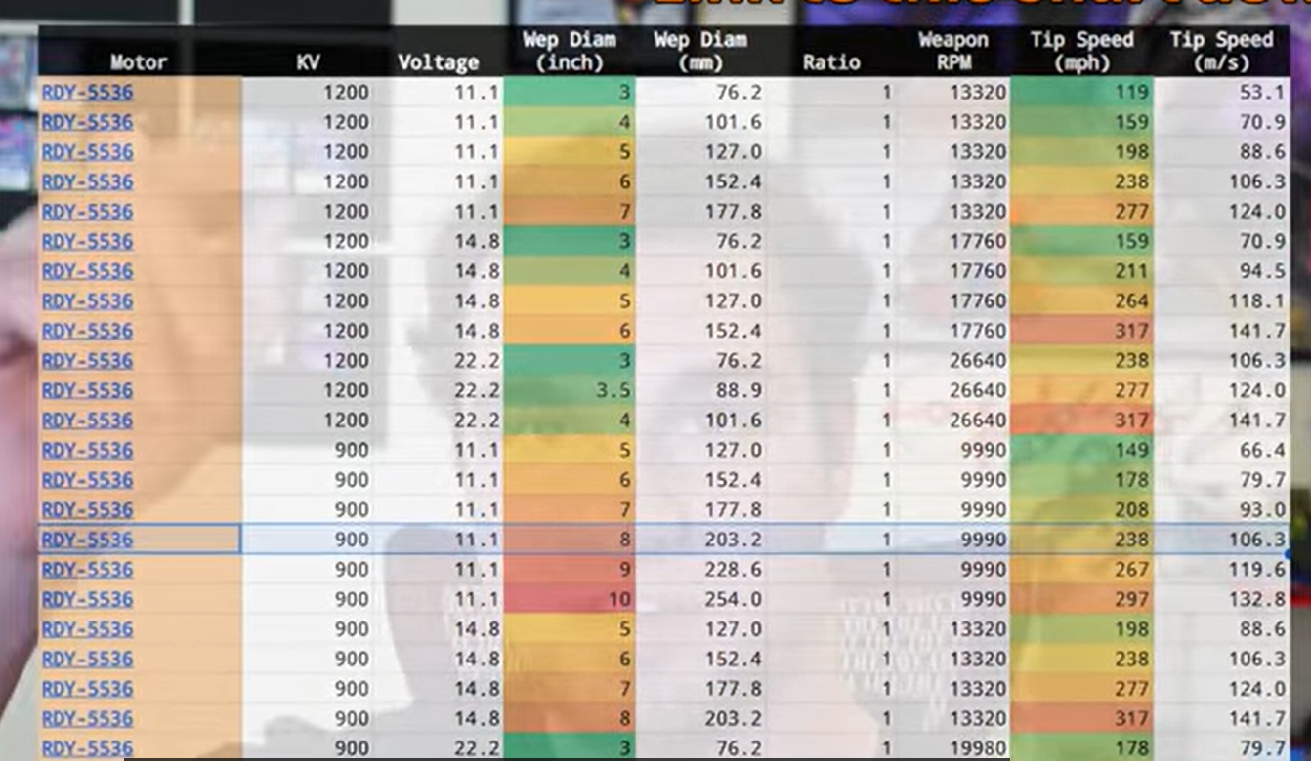

Short Explanation
This table compares weapon tip speed for a combat robot spinner based on different parameters:
- Motor model (RDY-5536)
- KV rating (how many RPM per volt)
- Battery voltage (11.1V, 14.8V, 22.2V etc.)
- Weapon diameter (in inches and mm)
- Gear ratio (here all are 1:1)
- Resulting weapon RPM
- Tip speed (mph and m/s)
Purpose:
To show how changing the KV, voltage, or weapon diameter affects the final tip speed of the spinning weapon.
Higher voltage or larger diameter = higher tip speed.
Green means safe/acceptable, yellow/orange/red = approaching dangerous speeds.

Ideal KV Calculation
Once the target RPM is known, you can calculate the required Motor Velocity Constant (KV) based on your battery voltage.
Formula:
KV = Target RPM\Voltage
Example Calculation (3S Battery):
- Voltage: 11.1V (Standard 3S LiPo)
- Target RPM: 21,000
- Ideal KV: 21,000 / 11.1 =1891 Kv
- Note: For an 8-inch diameter weapon requiring lower RPM, the calculated KV would be roughly 946 KV.
2. Battery Technology
LiPo vs. LiHV
- LiPo: Lithium Polymer. The standard battery chemistry used in robotics.
- LiHV: Lithium High Voltage.
  - Characteristics: Uses the same chemistry as LiPo but consists of higher quality cells capable of charging to a higher voltage.
  - Advantage: Stores more energy per cell compared to standard LiPo batteries.
Blade Design
- Thickness: ~5mm (0.2 inch).
- Diameter Relationship: As the diameter of the weapon increases, the voltage or KV requirements generally decrease to maintain the same tip speed.
3. Vendor and Part Specifics: "Just 'Cuz Robotics"
Hub Motors
- Model 5022:
  - Available KV options: 1200 KV, 1700 KV, and 1100 KV.
  - Note: The text mentions a "Mini version" having specific KV options.
  - Link: -https://justcuzrobotics.com/products/rdy-mini-5022-1700kv-antweight-hubmotor
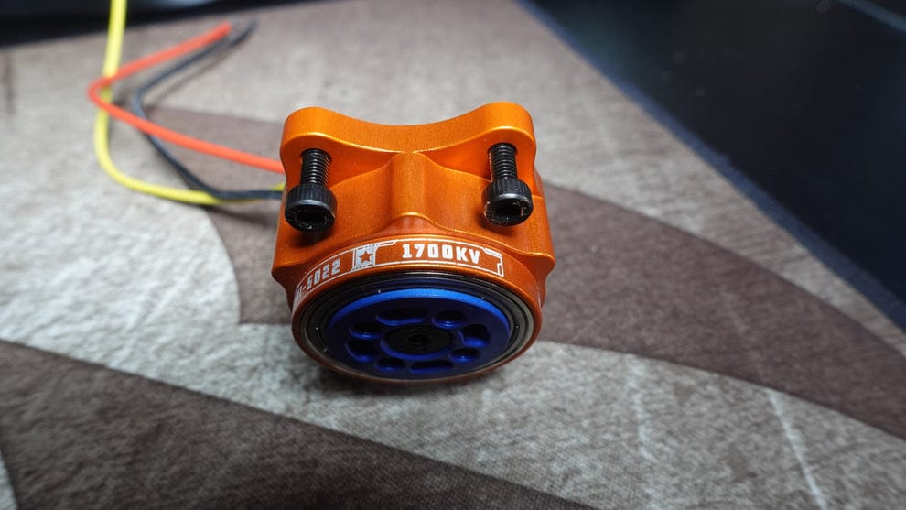
- Model 5536:
Available KV options: 1200 KV.
Link: -https://justcuzrobotics.com/products/rdy-5536-1200kv-hubmotor-battle-ready-weapon-motor
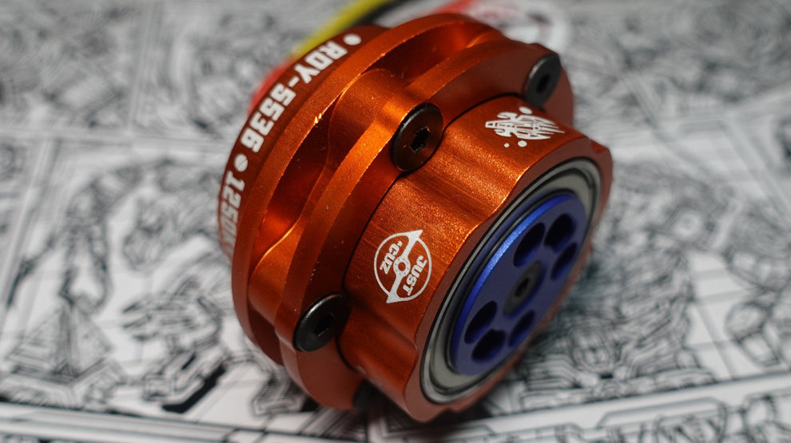

Electronics (ESCs)
- Current Ratings:
  - 35 Amp ESC
  - 70 Amp ESC
- Compatibility: Hub motors like the 5022 will almost always operate fine with a 35 Amp ESC.
4. Reference Conversions & Formulas
- 1 {mile} = 1.609 {kilometres}
- Speed Conversion: {Speed (km/h)} = {Speed (mph) * 1.609
- Tip Speed Logic: Tip speed is a function of Rotational Speed =2*pi*R\60
Where R =radius of blade
If more will be the Voltage then diameter of weapon should get smaller
Reason: - Tip speed Increases with Diameter of weapon.

References: - https://www.youtube.com/watch?v=3rpgrYtIvGk
https://www.youtube.com/watch?v=SJK1kiItuAc

2.Drive System (Using Planetary Gear Motor): -
a. Planetary gear motors
Recommended sizes (based on robot weight):

Bot Weight Planetary Motor Torque

3kg 25D / 37D 15–30 kg.cm
8kg 37D / 42D 35–60 kg.cm
Why you should use a Planetary Gear Motor??
Because they solve the biggest problem in driving a robot:
Motor spin very fast but have very low torque.
Wheels need slow RPM and high torque and a gearbox does exactly that.
Extremely High Torque output where Planetary gearboxes gives very high torque, which is perfect for:
- Pushing other bots
- Lifting
- Driving heavy robots
A normal DC motor gives low torque -planetary gearbox increases torque 10 to 30 times more
b. High Efficiency
- More efficient
- Less heat
- Less power loss

c. Compact & Powerful
They produce huge torque in a small size.
Perfect when space inside the bot is limited

2. Motor drivers
Planetary gear motors are brushed motors, so you need a brushed ESC.
Options:
BTS7960 (up to 43A) - Most common, cheap
Cytron 30A / 60A ESC - Very reliable
Robokits 40A / 100A - Good for heavier bots
Each motor needs 1 driver → 2 ESCs required.

Why Cytron motor drivers are better?
a. More reliable than BTS7960
Cytron drivers do NOT burn easily. They work under heavy load, vibration, heat, and impacts.
BTS7960 has many fake boards → burns often.
Cytron = professional quality.
b. High current capacity
Examples:
Cytron MD10C → 10A
• Cytron MD13S → 13A continuous
• Cytron MD30C → 30A continuous
These current ratings are REAL, not fake numbers like BTS.

3.Wheels
Recommended Wheel Diameter for DC Gear Motors
1) 1 - 3 kg bot (small arena)
Wheel diameter: 6-8 cm (2.5-3 inch) Reason:
Too big wheels → low torque
Too small wheels → low ground clearance
Best: 3 inch wheels
2) 4 - 8 kg bot
Wheel diameter: 8-10 cm (3-4 inch)
Reason: medium weight → needs more torque + stability
Best: 4 inch wheels
3.Robot Control System
4. Transmitter
Flysky-i6
5.Receiver
Minimum 6-channel receiver(iA6B or R6B)
3. BATTERY + POWER SYSTEM
6. Battery (LiPo)
Depends on your bot weight:
Bot Weight Battery
3kg 3S 1500-2200mAh
8kg 4S 2200-3000mAh

