Assignment 4

keerthi Tiyyagura

2023-11-12

#Installing the required packages

library(flexclust)#Calling installed libraries

## Warning: package 'flexclust' was built under R version 4.3.2

## Loading required package: grid

## Loading required package: lattice

## Loading required package: modeltools

## Loading required package: stats4

library(cluster)

library(tidyverse)

## Warning: package 'tidyverse' was built under R version 4.3.2

## ── Attaching core tidyverse packages ──────────────────────── tidyverse 2.0.0 ──  
## ✔ dplyr 1.1.3 ✔ readr 2.1.4  
## ✔ forcats 1.0.0 ✔ stringr 1.5.0  
## ✔ ggplot2 3.4.3 ✔ tibble 3.2.1  
## ✔ lubridate 1.9.2 ✔ tidyr 1.3.0  
## ✔ purrr 1.0.2   
## ── Conflicts ────────────────────────────────────────── tidyverse_conflicts() ──  
## ✖ dplyr::filter() masks stats::filter()  
## ✖ dplyr::lag() masks stats::lag()  
## ℹ Use the conflicted package (<http://conflicted.r-lib.org/>) to force all conflicts to become errors

library(factoextra)

## Warning: package 'factoextra' was built under R version 4.3.2

## Welcome! Want to learn more? See two factoextra-related books at https://goo.gl/ve3WBa

library(FactoMineR)

## Warning: package 'FactoMineR' was built under R version 4.3.2

library(ggcorrplot)

## Warning: package 'ggcorrplot' was built under R version 4.3.2

#Import the "Pharmaceuticals" dataset  
Pharmaceu <- read.csv("C:/Users/keert/Downloads/Pharmaceuticals.csv")  
summary(Pharmaceu)

## Symbol Name Market_Cap Beta   
## Length:21 Length:21 Min. : 0.41 Min. :0.1800   
## Class :character Class :character 1st Qu.: 6.30 1st Qu.:0.3500   
## Mode :character Mode :character Median : 48.19 Median :0.4600   
## Mean : 57.65 Mean :0.5257   
## 3rd Qu.: 73.84 3rd Qu.:0.6500   
## Max. :199.47 Max. :1.1100   
## PE_Ratio ROE ROA Asset_Turnover Leverage   
## Min. : 3.60 Min. : 3.9 Min. : 1.40 Min. :0.3 Min. :0.0000   
## 1st Qu.:18.90 1st Qu.:14.9 1st Qu.: 5.70 1st Qu.:0.6 1st Qu.:0.1600   
## Median :21.50 Median :22.6 Median :11.20 Median :0.6 Median :0.3400   
## Mean :25.46 Mean :25.8 Mean :10.51 Mean :0.7 Mean :0.5857   
## 3rd Qu.:27.90 3rd Qu.:31.0 3rd Qu.:15.00 3rd Qu.:0.9 3rd Qu.:0.6000   
## Max. :82.50 Max. :62.9 Max. :20.30 Max. :1.1 Max. :3.5100   
## Rev_Growth Net_Profit_Margin Median_Recommendation Location   
## Min. :-3.17 Min. : 2.6 Length:21 Length:21   
## 1st Qu.: 6.38 1st Qu.:11.2 Class :character Class :character   
## Median : 9.37 Median :16.1 Mode :character Mode :character   
## Mean :13.37 Mean :15.7   
## 3rd Qu.:21.87 3rd Qu.:21.1   
## Max. :34.21 Max. :25.5   
## Exchange   
## Length:21   
## Class :character   
## Mode :character   
##   
##   
##

1.Use only the numerical variables (1 to 9) to cluster the 21 firms.Justify the various choices made in conducting the cluster analysis, such as weights for different variables, the specific clustering algorithm(s) used, the number of clusters formed, and so on.

Pharmac <- na.exclude(Pharmaceu)# It provides the data after removal of missing values.  
Pharmac

## Symbol Name Market_Cap Beta PE_Ratio ROE ROA  
## 1 ABT Abbott Laboratories 68.44 0.32 24.7 26.4 11.8  
## 2 AGN Allergan, Inc. 7.58 0.41 82.5 12.9 5.5  
## 3 AHM Amersham plc 6.30 0.46 20.7 14.9 7.8  
## 4 AZN AstraZeneca PLC 67.63 0.52 21.5 27.4 15.4  
## 5 AVE Aventis 47.16 0.32 20.1 21.8 7.5  
## 6 BAY Bayer AG 16.90 1.11 27.9 3.9 1.4  
## 7 BMY Bristol-Myers Squibb Company 51.33 0.50 13.9 34.8 15.1  
## 8 CHTT Chattem, Inc 0.41 0.85 26.0 24.1 4.3  
## 9 ELN Elan Corporation, plc 0.78 1.08 3.6 15.1 5.1  
## 10 LLY Eli Lilly and Company 73.84 0.18 27.9 31.0 13.5  
## 11 GSK GlaxoSmithKline plc 122.11 0.35 18.0 62.9 20.3  
## 12 IVX IVAX Corporation 2.60 0.65 19.9 21.4 6.8  
## 13 JNJ Johnson & Johnson 173.93 0.46 28.4 28.6 16.3  
## 14 MRX Medicis Pharmaceutical Corporation 1.20 0.75 28.6 11.2 5.4  
## 15 MRK Merck & Co., Inc. 132.56 0.46 18.9 40.6 15.0  
## 16 NVS Novartis AG 96.65 0.19 21.6 17.9 11.2  
## 17 PFE Pfizer Inc 199.47 0.65 23.6 45.6 19.2  
## 18 PHA Pharmacia Corporation 56.24 0.40 56.5 13.5 5.7  
## 19 SGP Schering-Plough Corporation 34.10 0.51 18.9 22.6 13.3  
## 20 WPI Watson Pharmaceuticals, Inc. 3.26 0.24 18.4 10.2 6.8  
## 21 WYE Wyeth 48.19 0.63 13.1 54.9 13.4  
## Asset_Turnover Leverage Rev_Growth Net_Profit_Margin Median_Recommendation  
## 1 0.7 0.42 7.54 16.1 Moderate Buy  
## 2 0.9 0.60 9.16 5.5 Moderate Buy  
## 3 0.9 0.27 7.05 11.2 Strong Buy  
## 4 0.9 0.00 15.00 18.0 Moderate Sell  
## 5 0.6 0.34 26.81 12.9 Moderate Buy  
## 6 0.6 0.00 -3.17 2.6 Hold  
## 7 0.9 0.57 2.70 20.6 Moderate Sell  
## 8 0.6 3.51 6.38 7.5 Moderate Buy  
## 9 0.3 1.07 34.21 13.3 Moderate Sell  
## 10 0.6 0.53 6.21 23.4 Hold  
## 11 1.0 0.34 21.87 21.1 Hold  
## 12 0.6 1.45 13.99 11.0 Hold  
## 13 0.9 0.10 9.37 17.9 Moderate Buy  
## 14 0.3 0.93 30.37 21.3 Moderate Buy  
## 15 1.1 0.28 17.35 14.1 Hold  
## 16 0.5 0.06 -2.69 22.4 Hold  
## 17 0.8 0.16 25.54 25.2 Moderate Buy  
## 18 0.6 0.35 15.00 7.3 Hold  
## 19 0.8 0.00 8.56 17.6 Hold  
## 20 0.5 0.20 29.18 15.1 Moderate Sell  
## 21 0.6 1.12 0.36 25.5 Hold  
## Location Exchange  
## 1 US NYSE  
## 2 CANADA NYSE  
## 3 UK NYSE  
## 4 UK NYSE  
## 5 FRANCE NYSE  
## 6 GERMANY NYSE  
## 7 US NYSE  
## 8 US NASDAQ  
## 9 IRELAND NYSE  
## 10 US NYSE  
## 11 UK NYSE  
## 12 US AMEX  
## 13 US NYSE  
## 14 US NYSE  
## 15 US NYSE  
## 16 SWITZERLAND NYSE  
## 17 US NYSE  
## 18 US NYSE  
## 19 US NYSE  
## 20 US NYSE  
## 21 US NYSE

#To cluster the 21 firms,the quantitative variables(1-9) are required.  
row.names(Pharmac) <- Pharmac[,1]  
Pharma1 <- Pharmac[,3:11]  
head(Pharma1)

## Market_Cap Beta PE_Ratio ROE ROA Asset_Turnover Leverage Rev_Growth  
## ABT 68.44 0.32 24.7 26.4 11.8 0.7 0.42 7.54  
## AGN 7.58 0.41 82.5 12.9 5.5 0.9 0.60 9.16  
## AHM 6.30 0.46 20.7 14.9 7.8 0.9 0.27 7.05  
## AZN 67.63 0.52 21.5 27.4 15.4 0.9 0.00 15.00  
## AVE 47.16 0.32 20.1 21.8 7.5 0.6 0.34 26.81  
## BAY 16.90 1.11 27.9 3.9 1.4 0.6 0.00 -3.17  
## Net_Profit_Margin  
## ABT 16.1  
## AGN 5.5  
## AHM 11.2  
## AZN 18.0  
## AVE 12.9  
## BAY 2.6

#Scale all dataframe's quantitative variables  
Pharma2 <- scale(Pharma1)  
head(Pharma2)

## Market_Cap Beta PE_Ratio ROE ROA Asset_Turnover  
## ABT 0.1840960 -0.80125356 -0.04671323 0.04009035 0.2416121 0.0000000  
## AGN -0.8544181 -0.45070513 3.49706911 -0.85483986 -0.9422871 0.9225312  
## AHM -0.8762600 -0.25595600 -0.29195768 -0.72225761 -0.5100700 0.9225312  
## AZN 0.1702742 -0.02225704 -0.24290879 0.10638147 0.9181259 0.9225312  
## AVE -0.1790256 -0.80125356 -0.32874435 -0.26484883 -0.5664461 -0.4612656  
## BAY -0.6953818 2.27578267 0.14948233 -1.45146000 -1.7127612 -0.4612656  
## Leverage Rev_Growth Net_Profit_Margin  
## ABT -0.2120979 -0.5277675 0.06168225  
## AGN 0.0182843 -0.3811391 -1.55366706  
## AHM -0.4040831 -0.5721181 -0.68503583  
## AZN -0.7496565 0.1474473 0.35122600  
## AVE -0.3144900 1.2163867 -0.42597037  
## BAY -0.7496565 -1.4971443 -1.99560225

#Elbow method

# Using Elbow method, calculate the no.of clusters to do the cluster analysis.  
fviz_nbclust(Pharma2,kmeans,method = "wss")+labs(subtitle = "Elbow Method")

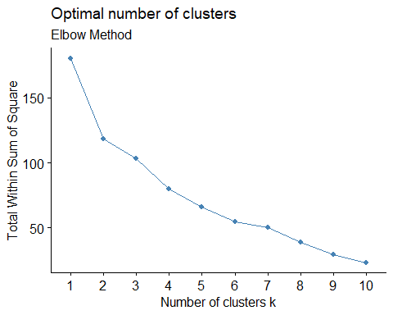

# Using silhouette method to calculate no.of clusters  
fviz_nbclust(Pharma2, kmeans, method = "silhouette")+ labs(subtitle = "Silhouette Method")

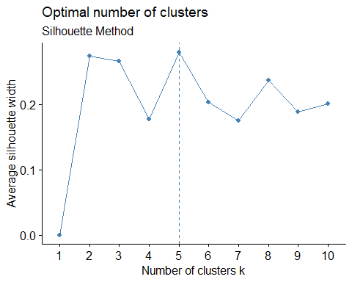

# Also using the gap_stat method for calculating the no.of clusters  
fviz_nbclust(Pharma2, kmeans, method = "gap_stat")+ labs(subtitle = "gap_stat Method")

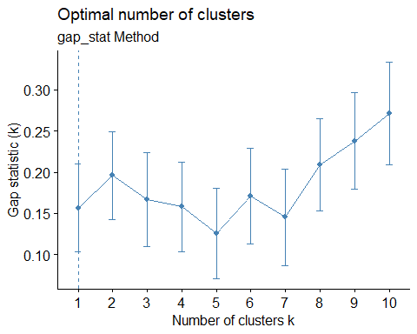 #In all the above plots,no.of clusters=5,which is sufficient to display the data variations.

set.seed(10)  
k5<- kmeans(Pharma2,centers=5,nstart = 25)  
#Visualizing the output  
k5$centers# for centroids

## Market_Cap Beta PE_Ratio ROE ROA Asset_Turnover  
## 1 1.69558112 -0.1780563 -0.19845823 1.2349879 1.3503431 1.1531640  
## 2 -0.03142211 -0.4360989 -0.31724852 0.1950459 0.4083915 0.1729746  
## 3 -0.76022489 0.2796041 -0.47742380 -0.7438022 -0.8107428 -1.2684804  
## 4 -0.87051511 1.3409869 -0.05284434 -0.6184015 -1.1928478 -0.4612656  
## 5 -0.43925134 -0.4701800 2.70002464 -0.8349525 -0.9234951 0.2306328  
## Leverage Rev_Growth Net_Profit_Margin  
## 1 -0.46807818 0.4671788 0.591242521  
## 2 -0.27449312 -0.7041516 0.556954446  
## 3 0.06308085 1.5180158 -0.006893899  
## 4 1.36644699 -0.6912914 -1.320000179  
## 5 -0.14170336 -0.1168459 -1.416514761

fviz_cluster(k5,data = Pharma2) # to Visualize the clusters

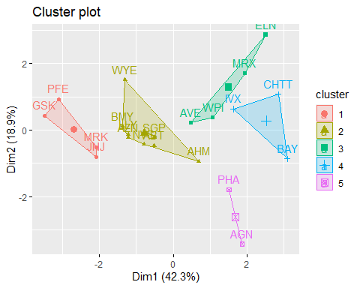

k5$size

## [1] 4 8 4 3 2

Distance<- dist(Pharma2, method = "euclidean")  
fviz_dist(Distance)

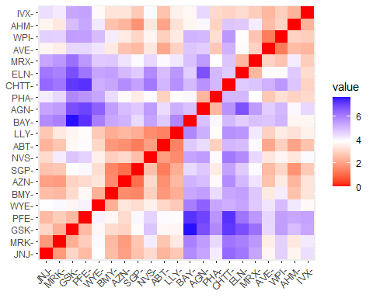 #To Fit the data with 5 clusters Using K-Means Cluster Analysis

Fit<-kmeans(Pharma2,5)

#calculate the mean of all quantitative variables in each cluster

aggregate(Pharma2,by=list(Fit$cluster),FUN=mean)

## Group.1 Market_Cap Beta PE_Ratio ROE ROA  
## 1 1 0.6733825 -0.3586419 -0.27635122 0.6565978 0.8344159  
## 2 2 -0.9767669 1.2630872 0.03299122 -0.1123792 -1.1677918  
## 3 3 -0.5246281 0.4451409 1.84984387 -1.0404550 -1.1865838  
## 4 4 -0.7307042 -0.4214928 -0.34867046 -0.5780744 -0.6181243  
## 5 5 -0.9668697 1.5162611 -0.57398880 -0.8382671 -0.9892673  
## Asset_Turnover Leverage Rev_Growth Net_Profit_Margin  
## 1 4.612656e-01 -0.33310678 -0.2902163 0.6823310  
## 2 -4.612656e-01 3.74279705 -0.6327607 -1.2488842  
## 3 1.480297e-16 -0.34435439 -0.5769454 -1.6095439  
## 4 -2.306328e-01 -0.02651224 0.5327995 -0.4793074  
## 5 -1.845062e+00 0.53024482 1.7123890 0.2445520

Pharma3<-data.frame(Pharma2,Fit$cluster)  
Pharma3

## Market_Cap Beta PE_Ratio ROE ROA Asset_Turnover  
## ABT 0.1840960 -0.80125356 -0.04671323 0.04009035 0.2416121 0.0000000  
## AGN -0.8544181 -0.45070513 3.49706911 -0.85483986 -0.9422871 0.9225312  
## AHM -0.8762600 -0.25595600 -0.29195768 -0.72225761 -0.5100700 0.9225312  
## AZN 0.1702742 -0.02225704 -0.24290879 0.10638147 0.9181259 0.9225312  
## AVE -0.1790256 -0.80125356 -0.32874435 -0.26484883 -0.5664461 -0.4612656  
## BAY -0.6953818 2.27578267 0.14948233 -1.45146000 -1.7127612 -0.4612656  
## BMY -0.1078688 -0.10015669 -0.70887325 0.59693581 0.8617498 0.9225312  
## CHTT -0.9767669 1.26308721 0.03299122 -0.11237924 -1.1677918 -0.4612656  
## ELN -0.9704532 2.15893320 -1.34037772 -0.70899938 -1.0174553 -1.8450624  
## LLY 0.2762415 -1.34655112 0.14948233 0.34502953 0.5610770 -0.4612656  
## GSK 1.0999201 -0.68440408 -0.45749769 2.45971647 1.8389364 1.3837968  
## IVX -0.9393967 0.48409069 -0.34100657 -0.29136529 -0.6979905 -0.4612656  
## JNJ 1.9841758 -0.25595600 0.18013789 0.18593083 1.0872544 0.9225312  
## MRX -0.9632863 0.87358895 0.19240011 -0.96753478 -0.9610792 -1.8450624  
## MRK 1.2782387 -0.25595600 -0.40231769 0.98142435 0.8429577 1.8450624  
## NVS 0.6654710 -1.30760129 -0.23677768 -0.52338423 0.1288598 -0.9225312  
## PFE 2.4199899 0.48409069 -0.11415545 1.31287998 1.6322239 0.4612656  
## PHA -0.0240846 -0.48965495 1.90298017 -0.81506519 -0.9047030 -0.4612656  
## SGP -0.4018812 -0.06120687 -0.40231769 -0.21181593 0.5234929 0.4612656  
## WPI -0.9281345 -1.11285216 -0.43297324 -1.03382590 -0.6979905 -0.9225312  
## WYE -0.1614497 0.40619104 -0.75792214 1.92938746 0.5422849 -0.4612656  
## Leverage Rev_Growth Net_Profit_Margin Fit.cluster  
## ABT -0.21209793 -0.52776752 0.06168225 1  
## AGN 0.01828430 -0.38113909 -1.55366706 3  
## AHM -0.40408312 -0.57211809 -0.68503583 4  
## AZN -0.74965647 0.14744734 0.35122600 1  
## AVE -0.31449003 1.21638667 -0.42597037 4  
## BAY -0.74965647 -1.49714434 -1.99560225 3  
## BMY -0.02011273 -0.96584257 0.74744375 1  
## CHTT 3.74279705 -0.63276071 -1.24888417 2  
## ELN 0.61983791 1.88617085 -0.36501379 5  
## LLY -0.07130879 -0.64814764 1.17413980 1  
## GSK -0.31449003 0.76926048 0.82363947 1  
## IVX 1.10620040 0.05603085 -0.71551412 4  
## JNJ -0.62166634 -0.36213170 0.33598685 1  
## MRX 0.44065173 1.53860717 0.85411776 5  
## MRK -0.39128411 0.36014907 -0.24310064 1  
## NVS -0.67286239 -1.45369888 1.02174835 1  
## PFE -0.54487226 1.10143723 1.44844440 1  
## PHA -0.30169102 0.14744734 -1.27936246 3  
## SGP -0.74965647 -0.43544591 0.29026942 1  
## WPI -0.49367621 1.43089863 -0.09070919 4  
## WYE 0.68383297 -1.17763919 1.49416183 1

#view of the cluster plot

clusplot(Pharma2,Fit$cluster,color = TRUE,shade = TRUE,labels = 2,lines = 0)

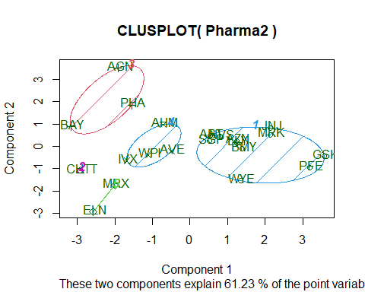 2.Interpret the clusters with respect to the numerical variables used in forming the clusters. Is there a pattern in the clusters with respect to the numerical variables (10 to 12)?

Based on mean values:

JNJ, MRK, PFE, and GSK comprise Cluster 1. The highest metrics in this cluster are Market_cap, ROA, ROE, and Asset_Turnover; the lowest are Beta and PE_Ratio.

Cluster 2 - AHM, WPI, AVE ~Cluster 2 has the lowest PE Ratio, Asset Turnover, and the highest Rev_Growth.

CHTT, ELN, MRX, and IVX make up Cluster 3; it has the lowest Market Cap, ROE, ROA, Leverage, Rev Growth, and Net Profit Margin, and the highest Beta and Leverage.

BAY, PHA, and AGN make up Cluster 4, which has the lowest leverage and asset turnover ratios and the highest PE ratio.

Cluster 5: AZN, ABT, NVS, BMY, WYE, SGP, LLY ~Cluster 5 has the lowest leverage, beta, and the highest Net Profit Margin.

clustdata <- Pharmac[12:14] %>% mutate(Clusters=k5$cluster)   
ggplot(clustdata, mapping = aes(factor(Clusters), fill = Median_Recommendation))+geom_bar(position='dodge')+labs(x= 'Clusters')

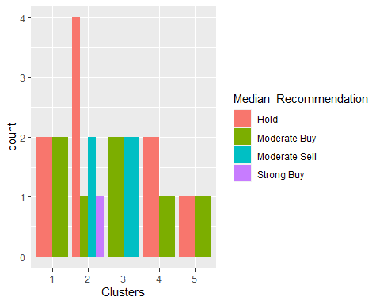

ggplot(clustdata, mapping = aes(factor(Clusters),fill = Location))+geom_bar(position = 'dodge')+labs(x ='Clusters')

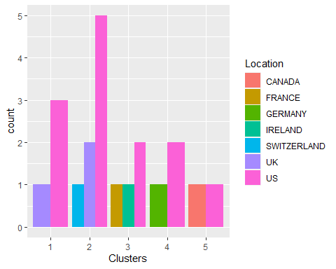

ggplot(clustdata, mapping = aes(factor(Clusters),fill = Exchange))+geom_bar(position = 'dodge')+labs(x ='Clusters')

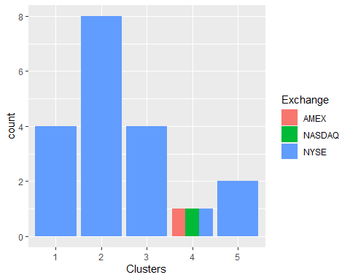 The variable and clusters there is a trend in the median recommendations. There doesn’t seem to be any discernable pattern among the clusters, locations, or exchanges other than the fact that the majority of the clusters/companies are listed on the NYSE and situated in the United States

3.Provide an appropriate name for each cluster using any or all of the variables in the dataset.

Cluster 1: Top Buying

Cluster 2: Significant Risk

Cluster 3: Attempt it

Cluster 4: Very Dangerous or Runaway

Cluster 5: A Perfect Asset