**INTRODUCTION**

Customer satisfaction has emerged as one of the most important factors that guarantee the success of online store; it has been posited as a key stimulant of purchase, repurchase intentions and customer loyalty.

In an age of ubiquitous, super-fast internet, online orders have been increasing exponentially. This, in turn, significantly increases the customer's options in terms of product range and price, and thus has an impact on the increased competition between companies. It was known that customers are often switching between offers and thus between companies or just stayed dormant. The associated decrease in the average order frequency therefore managing customer churn has a huge profit potential for each online retailer. For online retailers, customer loyalty and regular purchase behavior is an important part of achieving the sales and margin targets so that maintaining and preserving the customer base.

Major factors that contributed to the success of an e-commerce have been identified after studying the data carefully is :

customer details (at the time of sales)

customer's accessibility (during sales)

customer service details (after sales reviews)

customer gratification (attitude of customers after sales)

value for money (target column)

problem identification

E-commerce has provided new opportunities for both businesses and consumers to easily share information, find and buy a product, increasing the ease of movement from one company to another as well as to increase the risk of churn.

the e-retail success factors, which are very much critical for customer satisfaction

in this project we have tried to reorganize the data and given a meaningful structure to help upcoming online stores to identify the key areas for surviving and competing in the market.

**PROBLEM DEFINITION**

Online shoppers don’t shop the same way as they used to back in the day. Example: use Amazon to search for products (not just Google), ask for recommendations on Social Media, use their smartphones to read product reviews while in-store and pay for purchases using all sorts of payment methods.

The challenge is dynamic behavior including the way they consume content and communicate online. In this project we have rearranged the data and structured it in a way to give information on problem areas and help understand the aspects customers expect and other competitors are lacking.

**CONCEPTUAL BACKGROUND OF THE PROJECT**

A comprehensive review of the literature, theories and models have been carried out to propose the models for customer activation and customer retention. Five major factors that contributed to the success of an e-commerce store have been identified as: service quality, system quality, information quality, trust and net benefit. The research furthermore investigated the factors that influence the online customers repeat purchase intention. The combination of both utilitarian value and hedonistic values are needed to affect the repeat purchase intention (loyalty) positively. The data is collected from the Indian online shoppers. Results indicate the e-retail success factors, which are very much critical for customer satisfaction.

**TOOLS USED**

Python

Numpy

Pandas

Matplotlib

Seaborn

**EXPLORATORY DATA ANALYSIS**

exploratory data analysis is an approach of analyzing data sets to summarize their main characteristics, often using statistical graphics and other data visualization methods.

the critical process of performing initial investigations on data so as to discover patterns, to spot variances are the attempts we have made in this project

we have divided the entire data into groups of data sets for better analysis

customer details (at the time of sales)

customer's accessibility (during sales)

customer service details (after sales reviews)

customer gratification (attitude of customers after sales)

value for money (target column)

further analysis was carried on in:

* univariate analysis
* multivariate analysis
* correlation between data sets
* correlation of data with target columns
* univariate analysis

UNIVARIATE ANALYSIS

we have concentrated on customers details column in detail as it forms a foundation for complete analysis and major findings were as follows

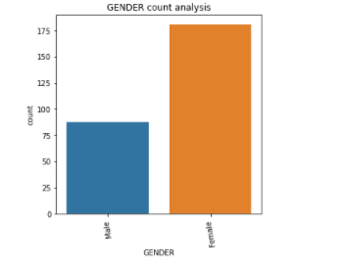

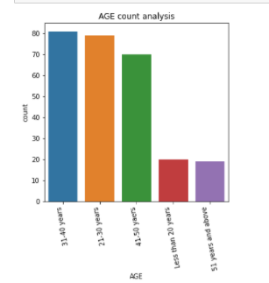

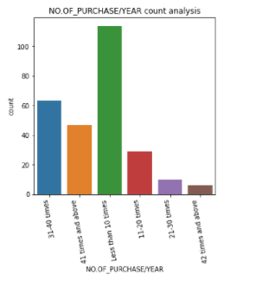

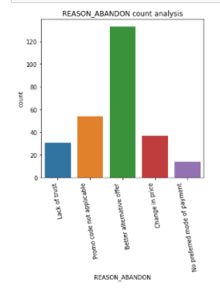

since customers details have high impact on on sales, after sales anlaysis we have choose to make for each column detailed analysis unlike other sets

from analysis we found

no of females are more in our sample and also found age range between 31 years to 50 years are involved in purchasing maximum

delhi, great noida, noida, bangalore are the cities with highest frequency of sales respectively

2-3 years and 4 years above is most expected vintage

frequency of purchases made in a year depicts that less than 10 times & 31-40 times is most frequent purchase which depicts the type of products are preferred on e-commerce

most of them use smartphones (windows - OS) and laptops to browse and make orders for this purpose internet is mostly from mobile data and wifi, & google chrome search engine is the preferred access.

The next analysis and understanding were about customer's accessibility

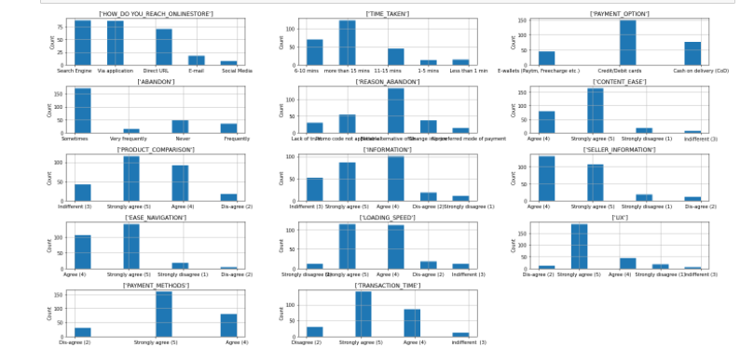

data accessibility depicts a set of information about how convenient it is for customers to reach the products we found search engine and application through customers are able to reach the ecommerce stores easily and most of the customers taken more than 15minutes to browse the items (categorical bifurcation & more filters preferred) while at the time of purchases it was found sometimes customers had left abandon due to better alternative offers customers are of opinion that content ease, product comparison, information, seller information, ease navigation, loading speed are appreciable parts of the of shopping site finally payment method are mostly cards or cash on delivery and payment options and transaction time are also appreciable

lastly customer gratification data set

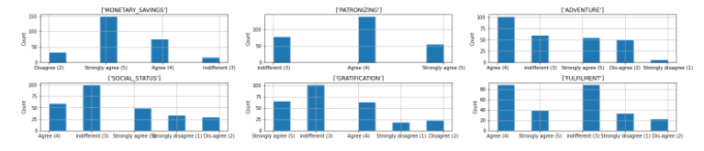

this set depicts the customers fulfillment and satisfaction in purchasing products through ecommerce

social status, gratification, fulfillment are the categories the ecommerce platforms have to improve

while patronizing, money saving and adventure attributes are satisfactory.

CORRELATION

* with customer details dataset

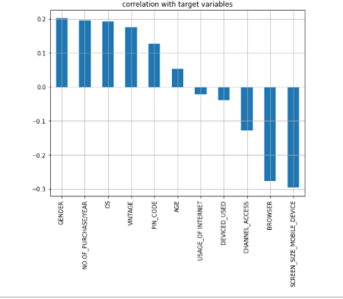

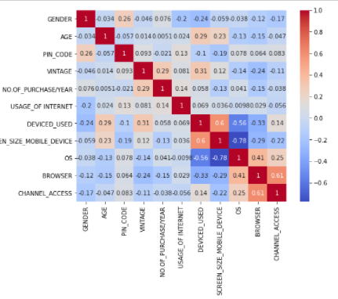

we can understand their is correlation existing between:

browser and channel access by 61%

device used and screen size of device by 60%

browser and operating system by 41%

no or high negative correlation is found between:

operating system and screen size of mobile

operating system and device used

browser and device used

* Data accessibility dataset shows

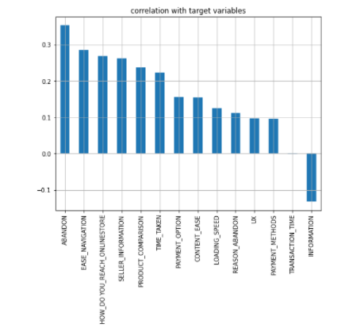

high correlation between

content ease and seller information 90%

ux and payment method 90%

product comparison and ease navigation by 86%

no correlation with transaction time

and negative correlation with information column

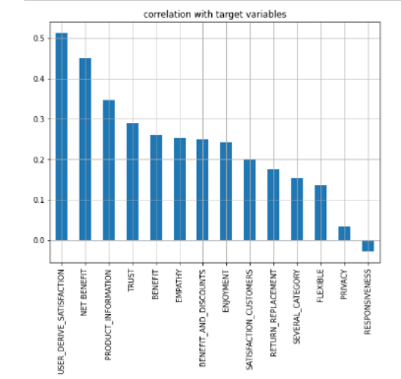

The above figure on customer sales details column

Showing high positive correlation with

User derive satisfaction

Net benefit

Product information

While negative correlation with responsiveness

* Customer gratification dataset shows

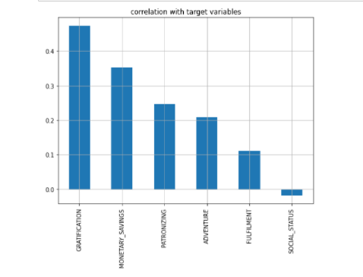

Gratification

Money savings and

Patronizing is high correlated comparatively

* Correlation of all features with target column

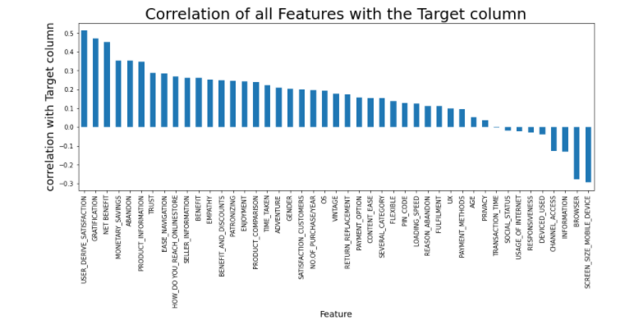

Screen size

Browser

Information

Device used and channel access are not correlated with the value for money column so preference should be given more on

User satisfaction

Gratification

Net benefit

Money savings

Abandon

Product information are the attributes to be given more priority

CONCLUSION

We could understand from the above analysis customer fulfillment and after sales services provided by e-commerce websites are the deciding factors of value for money

To be more successful and survive cut throat competition user satisfaction and gratification is the businesses main attributers to invest more time, money and research to improve and be best among competitors.

REFERENCES

* (Leppänen, 2016), CUSTOMER SATISFACTION SURVEY, RESULT ANALYSIS AND UTILIZATION IN A GLOBAL FORESTRY COMPANY
* Customers churn prediction and marketing retention strategies. An application of support vector machines based on the AUC parameter-selection technique in B2B e-commerce industry by Niccolo Gordini
* Advanced Analytics Techniques for Customer Activation and Retention in Online Retail by Joachim Keppler