FMS: Freight Management System.

FMS system facilitate tracking of Vehicle Inbound and Outbound in Depots and plants of HCCBPL and advice generation for Payments to transporters for their Vehicles used in HCCBPL.

Company Owned Vehicles are not pat of this Payment advice Generation.

Thirt party transporters Vehicles are either taken on leased/fixed to HCCBPL for or used on trip basis.

Below are the types of trips generated on given prerequisites and gets closed on required parameter like ERA,FRA or Invoice ack.

Trips first get closed in FMS , then only Freight advice can be generated.

Shipment/Delivery data comes from SAP to FMS system ,then FMS check below parametres to create a Trip number. (SQL job C1_Trip_creation on ingura11)

* There should not be company owned Vehicles used in shipment header.
* Shipment status should be 7 and should appear in Gate exit Module in FMS.

Query To check Vechile status:

select top 10 * from c1_fms.dbo.vehicle_master where Vehicle_License_No=''

Query To check shipment status:

select top 10 * from c1_fms.dbo.shipment_gate_exit where Shipment_No=''

select top 10 * from c1_fms.dbo.shipment_items where Shipment_Number=''

select top 10 * from c1_fms.dbo.delivery_header where Delivery_Number=''

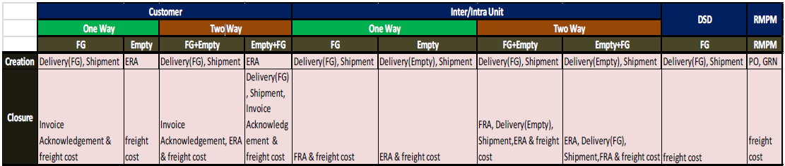

Basically 2 Types of trips are there.

1.Customer Trips: There trips are To or from Customer/Distributor to Depot/Plants.

2. Inter/Intra Unt: These trips are to or from one Depot/plants to other depot/plants within one Region/unit (intra) or to other Zone/Unit (Inter)

Step 1:

How to identify If trip is Customer Or Intra/inter unit.:

Take the shipment from Trip creation master.

select Shipment_Number from C1_fms.dbo.trip_creation_master where Lorry_Receipt_Number='20581A'

Then take delivery number.

select Delivery_Number from c1_fms.dbo.shipment_items where Shipment_Number in (select Shipment_Number from C1_fms.dbo.trip_creation_master where Lorry_Receipt_Number='20581A')

Then check in delivery header, if ship_to party is customer code, it is Customer trip

If sHip_to party is Plant/depot code then it is inter/intra unit trips.

select top 10 * from c1_fms.dbo.delivery_header where Delivery_Number in (select Delivery_Number from c1_fms.dbo.shipment_items where Shipment_Number in (select Shipment_Number from C1_fms.dbo.trip_creation_master where Lorry_Receipt_Number='20581A'))

|  |  |  |  |  |  |  |
| --- | --- | --- | --- | --- | --- | --- |
| **Delivery_Number** | **Ship_To_Party** | **Delivery_Type** | **Delivery_Date** | **Business_Type** | **Business_Type_Extension** | **Ship_To_Party_Original** |
| 0085000025 | HDK3 | YSTO | 2014-07-01 | 05 | F | AHDK3 |

Step 2: How to know one or two way trip ?

Need to check field in trip creation master.

select OneWay_TwoWay_MultipleIndicator from C1_fms.dbo.trip_creation_master where Lorry_Receipt_Number='20581A'

|  |
| --- |
| **OneWay_TwoWay_MultipleIndicator** |
| 2 |

Step 3:

How to it is FG+Empty or Empty+FG

In trip creation master , shipment number is available then it is FG+Empty

If shipment number is blank then it is Empty+FG.

select Shipment_Number from C1_fms.dbo.trip_creation_master where Lorry_Receipt_Number='20581A'

Now we know what is the trip category ,hence as per diagram we need find out what are the parameter required to close a trip.

Invoice acknowledgement , ERA(Empty Receive advice), FRA (Freight Receive advice) comes from SAP after users do it in SAP.

select top 10 * from c1_fms.dbo.era_detail_header

select top 10 * from c1_fms.dbo.FRA_detail_header

select top 10 * from c1_fms.dbo.invoiceack_header

If data matches between these ERA,FRA,Invoice ack and trip_creation_master detals then only trips get processed and closed by SQL job C1_Trip_closure On ingura11.

How to match data between trip creation master and ERA/FRA,Inv ack. ?

For Trip type Customers:

Shipment Vs Invoice Ack that is Trip Creation master Vs Invoiceack_header :

Invoice Number associated with shipment should be mentioned Invoice ack header.

Query To check how many and what are the invoice numbers associated with Trip Shipment.

select top 10 * from c1_fms.dbo.sales_invoice_header where Delivery_Number in (select Delivery_Number from c1_fms.dbo.shipment_items where Shipment_Number in (select Shipment_Number from C1_fms.dbo.trip_creation_master where Lorry_Receipt_Number='20581A'))

And same invoices should be available in invoiceack header.

select top 10 * from c1_fms.dbo.invoiceack_header where Invoice_No in ()

Shipment Vs ERA in case of Customer Trip 2 way.

Query To check all 6 parameters are matching Or not between Trip creation master and ERA details.

select top 10 T.Lorry_Receipt_Number,E.Lorry_Receipt_Number,T.Lorry_Receipt_Date,E.Lorry_Receipt_Date,T.Vehicle_Number,E.Vehicle_Number,T.Transporter_ID,E.Transporter,T.Vehicle_Type,E.Vehicle_Type,T.OneWay_TwoWay_MultipleIndicator,E.OneWay_2Way_Multiple,E.Start_ReturnIndicator from c1_fms.dbo.trip_creation_master T inner join c1_fms.dbo.era_detail_header E on T.Lorry_Receipt_Number=E.Lorry_Receipt_Number --where T.Lorry_Receipt_Number in ('3PL')

In ERA details Start_ReturnIndicator Should be R in case of 2 way trip.

Intra/Inter unit trip:

Shipment VS FRA: Delivery document should be matched

Take shipment number from trip creation master, find delivery number from C1_fms.dbo.shipment Item.

The same delivery number should be mentioned in FRA_detail_header in Invoice_no column.

Shipment Vs ERA :

Delivery No should match between shipment_item and ERA_detail_header

Shipment Vs Shipment:

All 6 parametre should match between FG shipment and Empty shipment in case of 2 way trip I/U.

How to check Freight Master for Transporter.

Knowledge base:

**Freight_Type_ID 1 is trip based, for trip based calculation vehicle should not be in vehicle master.**

**And distance matrix is not required.**

**In case of Empty trip ZE11, intra unit, from site and To site of trip should be in Freight rate and reverse of from site and To site also should be available in freight rate.**

* For dedicated vehicle no SPOT rate