ASSIGNMENT-MACHINE LEARNING

KEERTHI ALEKYA MUPPURI-700741949

Github link - <https://github.com/Keerthialekya12/Assignment-1.git>

Video link- <https://drive.google.com/file/d/1c-9QoEj1tOJG2Cj_sE_zPnLjTfkW9A_f/view?usp=sharing>

1st ANSWER-a

import numpy as np  
arr=[np.random.uniform(1,20) for i in range(15)]  
print(arr)  
amatrix=np.reshape(np.ravel(arr),(3,5))  
print(np.shape(amatrix))  
max_ind = np.argmax(amatrix, axis=1)  
row_ind = np.arange(amatrix.shape[0])  
multi_ind = np.array([row_ind, max_ind])  
linear_ind = np.ravel_multi_index(multi_ind, amatrix.shape)  
amatrix.reshape((-1))[linear_ind] = 0  
print(amatrix)

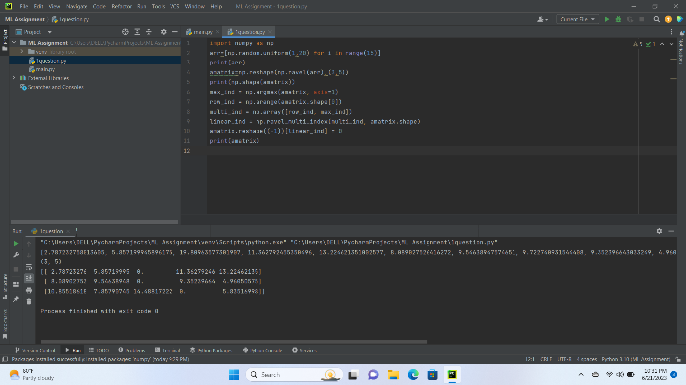

2nd ANSWER

import numpy as np  
arr=np.array([[1,3,5,7],[2,4,6,8],[10,20,30,40]],np.int32)  
print(np.shape(arr))  
print(type(arr))  
print(arr.dtype)

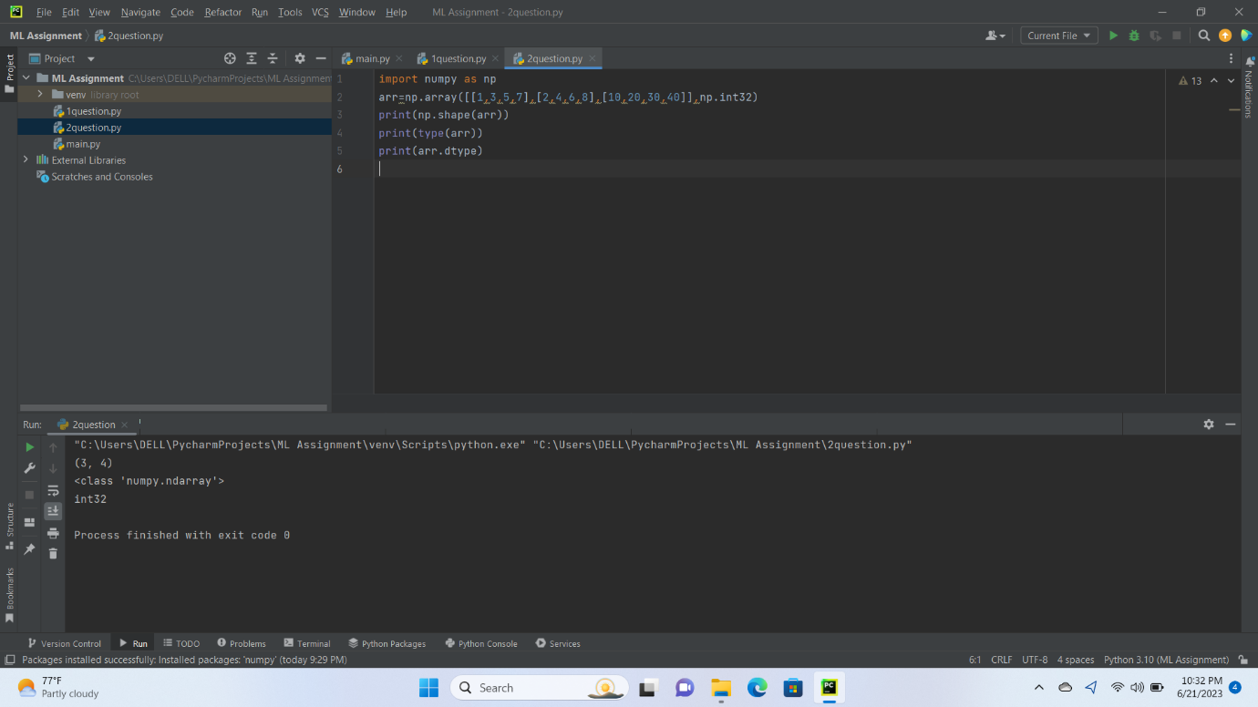

3rd ANSWER-b

import numpy as np  
from numpy import linalg as la  
arr=np.array([[3,-2],[1,0]])  
w,v=la.eig(arr)  
print("eign values:",w)  
print("eign vectors:",v)

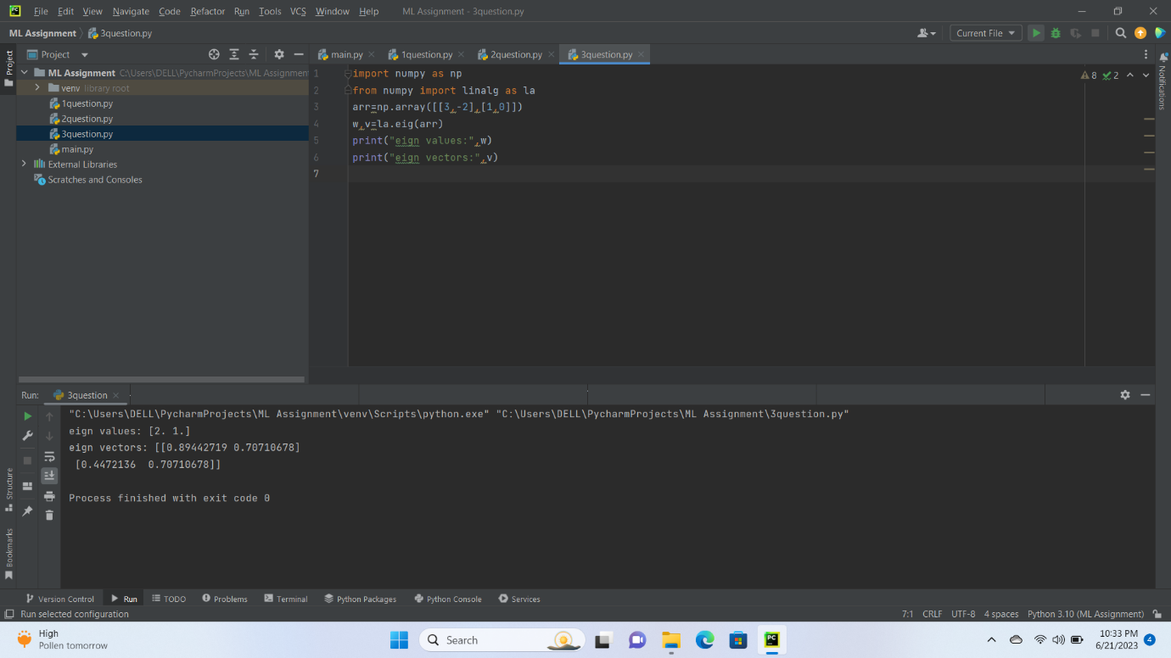

4th ANSWER-c

import numpy as np  
arr=np.array([[0,1,2],[3,4,5]])  
a=np.trace(arr)  
print("sum of diagonal elements is:",a)

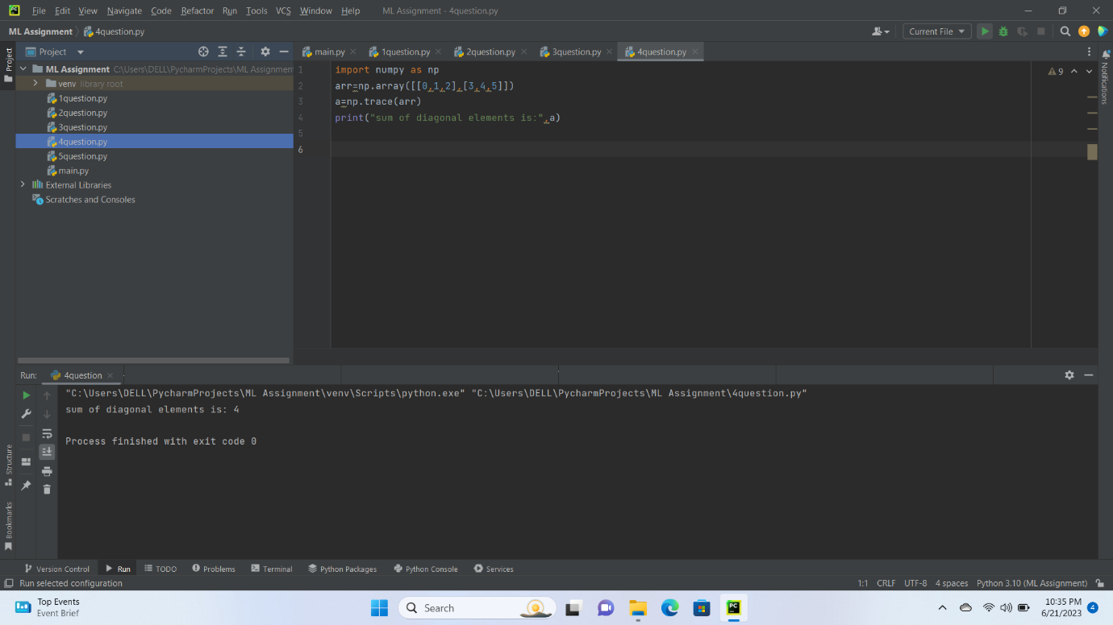

5th ANSWER-d

import numpy as np  
arr=np.array([[1,2],[3,4],[5,6]])  
amatrix=np.reshape(np.ravel(arr),(2,3))  
print(amatrix)

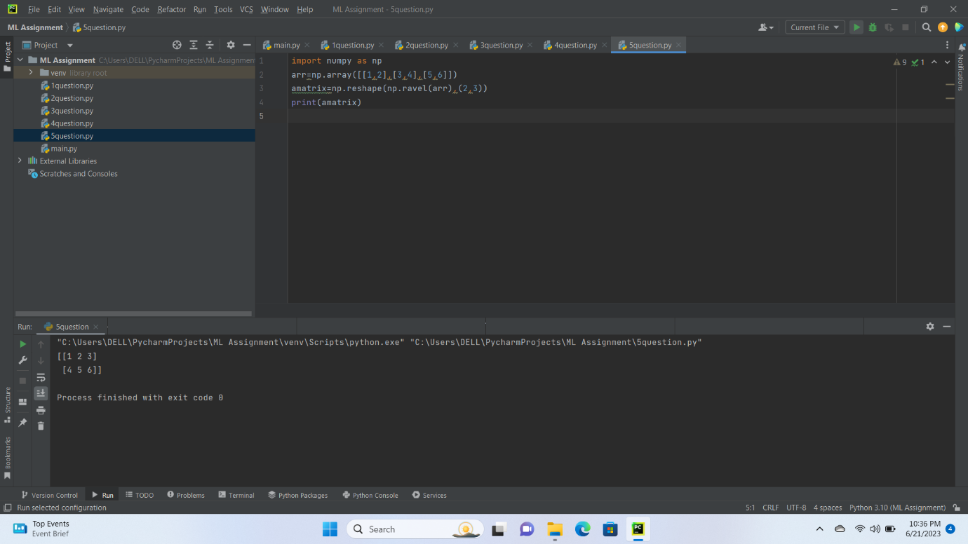

5th ANSWER-d

import numpy as np  
arr=np.array([[1,2],[3,4],[5,6]])  
amatrix=np.reshape(np.ravel(arr),(3,2))  
print(amatrix)

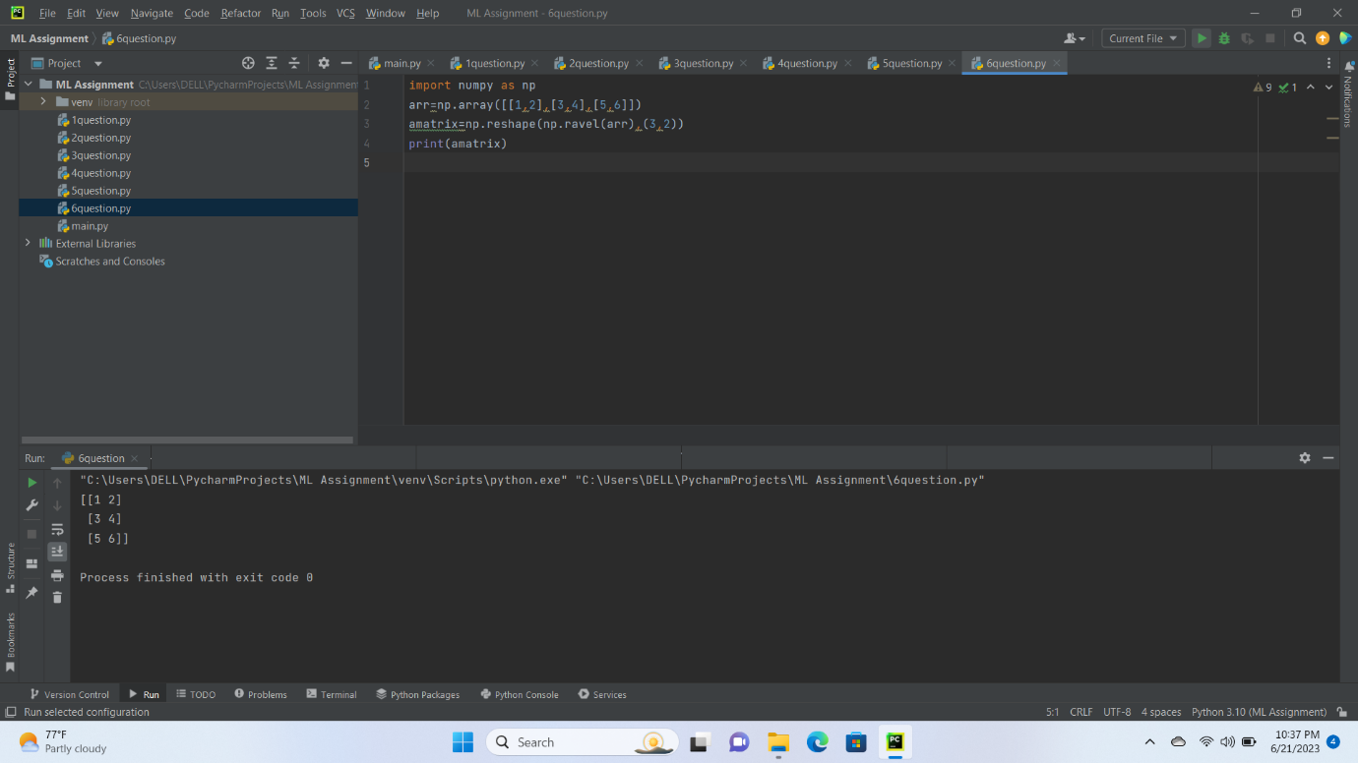

2nd SECTION ANSWER

from matplotlib import pyplot as plt  
slices = [22.2,17.6,8.8,8,7.7,6.7]  
labels = ['Java','Python','PHP','JavaScript','C#','C++']  
colors = ['#0000FF','#FFA500','#00FF00','#FF0000','#AF69EE','#964B00']  
plt.pie(slices, labels=labels, colors=colors,autopct='%1.1f%%',  
 wedgeprops={'edgecolor': 'black'})  
plt.tight_layout()  
plt.show()

