1. Write a SQL query to find those employees who receive a higher salary than the employee with ID 7566. Return their names.



OUTPUT:

2. Write a SQL query to find out which employees have the same designation as the employee whose ID is 7876. Return name, department no and job.



OUTPUT:

3. Write a SQL query to find those employees who report to that manager whose name starts with a 'B' or 'C'. Return first name, employee ID and salary.

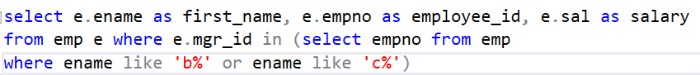

OUTPUT:

