1. List all employees whose name begins with 'A'.



OUTPUT:

2. Select all those employees who don't have a manager.



OUTPUT:

3. List employee name, number and salary for those employees who earn in the range 1200 to 1400.



OUTPUT:

4. Give all the employees in the RESEARCH department a 10% pay rise. Verify that this has been done by listing all their details before and after the rise.

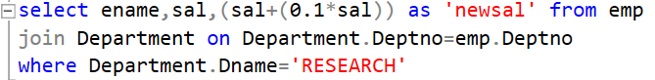

OUTPUT:

5. Find the number of CLERKS employed. Give it a descriptive heading.



OUTPUT:

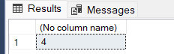

6. Find the average salary for each job type and the number of people employed in each job.



OUTPUT:

7. List the employees with the lowest and highest salary.



OUTPUT:

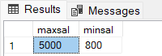

8. List full details of departments that don't have any employees.



OUTPUT:

9. Get the names and salaries of all the analysts earning more than 1200 who are based in department 20. Sort the answer by ascending order of name.

OUTPUT:

10. For each department, list its name and number together with the total salary paid to employees in that department.



OUTPUT:

11. Find out salary of both MILLER and SMITH.



OUTPUT:

12. Find out the names of the employees whose name begin with ‘A’ or ‘M’.



OUTPUT:

13. Compute yearly salary of SMITH.



OUTPUT:

14. List the name and salary for all employees whose salary is not in the range of 1500 and 2850.



OUTPUT:

15. Find all managers who have more than 2 employees reporting to them.



OUTPUT:

