**ASSIGNMENT 2 OUTPUT**

1. Write a C# Sharp program to swap two numbers.

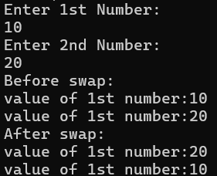

2. Write a C# program that takes a number as input and displays it four times in a row (separated by blank spaces), and then four times in the next row, with no separation. You should do it twice: Use the console. Write and use {0}.

3. Write a C# Sharp program to read any day number as an integer and display the name of the day as a word.

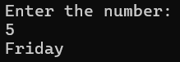

**ARRAYS**

1.Write a Program to assign integer values to an array and then print the following

a. Average value of Array elements

b. Minimum and Maximum value in an array

2.Write a program in C# to accept ten marks and display the following

a. Total

b. Average

c. Minimum marks

d. Maximum marks

e. Display marks in ascending order

f. Display marks in descending order

3. Write a C# Sharp program to copy the elements of one array into another array.(do not use any inbuilt functions)

