1. List unique departments of the EMP table.



OUTPUT:

2. List the name and salary of employees who earn more than 1500 and are in department 10 or 30. Label the columns Employee and Monthly Salary respectively.



OUTPUT:

3. Display the name, job, and salary of all the employees whose job is MANAGER or ANALYST and their salary is not equal to 1000, 3000, or 5000.

OUTPUT:

4. Display the name, salary and commission for all employees whose commission amount is greater than their salary increased by 10%.

OUTPUT:

5. Display the name of all employees who have two Ls in their name and are in department 30 or their manager is 7782.

OUTPUT:

6. Display the names of employees with experience of over 30 years and under 40 yrs. Count the total number of employees.





OUTPUT:

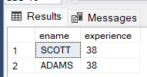

7. Retrieve the names of departments in ascending order and their employees in descending order.

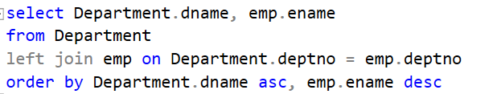

OUTPUT:

8. Find out experience of MILLER.



OUTPUT:

9. Write a query to display all employee information where ename contains 5 or more characters



OUTPUT:

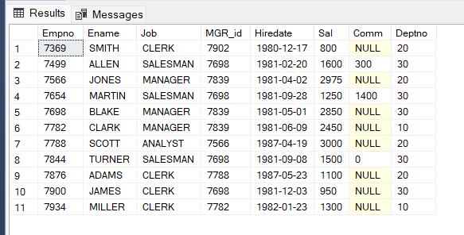

10. Copy empno, ename of all employees from emp table who work for dept 10 into a new table called emp10.

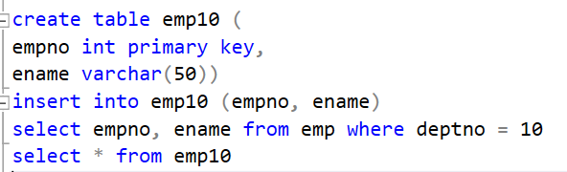

OUTPUT:

