Jenkins
Jenkins is an open source automation tool written in Java with plugins built for Continuous Integration purpose. Jenkins triggers a build for every change made in the source code repository for example Git repository. Once the code is built it deploys it on the test server for testing. Concerned teams are constantly notified about build and test results. Finally, Jenkins deploys the build application on the production server.

Simple work flow of jenkins :

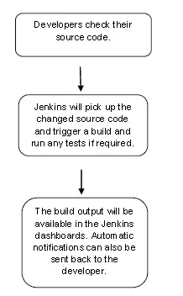
Continuous Integration :
Let us imagine a scenario where the complete source code of the application was built and then deployed on a test server for testing:
First, a developer commits the code to the source code repository.
Meanwhile, the Jenkins server checks the repository at regular intervals for changes.
Soon after a commit occurs, the Jenkins server detects the changes that have occurred in the source code repository.
Jenkins will pull those changes and will start preparing a new build.
If the build fails, then the pertinent team will be notified.
If the build is successful, then Jenkins deploys the build in the test server.
You could configure the pipeline (the script to run) to create the build with several steps:
Prepare, test (unit and integration tests), package, publish, deploy.
After running it, Jenkins generates a feedback, if these constraints are ok, the artifact is valid ( artifact is a source code compiled for testing, find more info here). And then Jenkins notifies the developers about the build and test results.
Jenkins will continue to check the source code repository for further changes made in the
source code, and the whole process will keep on repeating (functional tests).
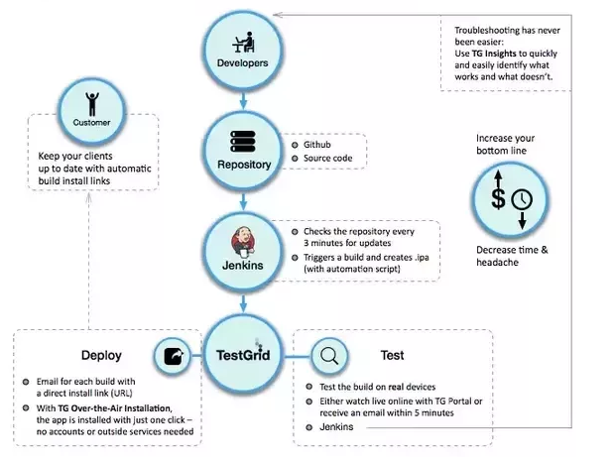
Continuous Development :

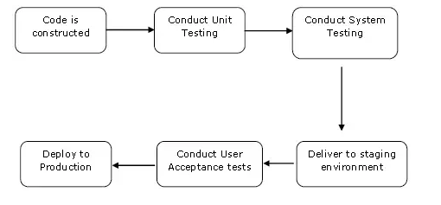
I will first explain you a generic flow diagram of Continuous Integration with Jenkins so that it becomes self explanatory, how Jenkins overcomes the above shortcomings:
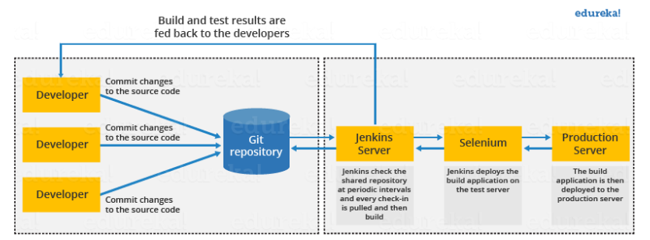
The above diagram is depicting the following functions:
- First, a developer commits the code to the source code repository. Meanwhile, the Jenkins server checks the repository at regular intervals for changes.
- Soon after a commit occurs, the Jenkins server detects the changes that have occurred in the source code repository. Jenkins will pull those changes and will start preparing a new build.
- If the build fails, then the concerned team will be notified.
- If built is successful, then Jenkins deploys the built in the test server.
- After testing, Jenkins generates a feedback and then notifies the developers about the build and test results.
- It will continue to check the source code repository for changes made in the source code and the whole process keeps on repeating.
You now know how Jenkins overcomes the traditional SDLC shortcomings. The table below shows the comparison between “Before and After Jenkins”.
Before Jenkins | After Jenkins
The entire source code was built and then tested. Locating and fixing bugs in the event of build and test failure was difficult and time consuming, which in turn slows the software delivery process. | Every commit made in the source code is built and tested. So, instead of checking the entire source code developers only need to focus on a particular commit. This leads to frequent new software releases.
Developers have to wait for test results | Developers know the test result of every commit made in the source code on the run.
The whole process is manual | You only need to commit changes to the source code and Jenkins will automate the rest of the process for you.

This single Jenkins server was not enough to meet certain requirements like:
- Sometimes you might need several different environments to test your builds. This cannot be done by a single Jenkins server.
- If larger and heavier projects get built on a regular basis then a single Jenkins server cannot simply handle the entire load.
To address the above stated needs, Jenkins distributed architecture was introduced.

Jenkins Distributed Architecture
Jenkins uses a Master-Slave architecture to manage distributed builds. In this architecture, Master and Slave communicate through TCP/IP protocol.
Jenkins Master
Your main Jenkins server is the Master. The Master’s job is to handle:
- Scheduling build jobs.
- Dispatching builds to the slaves for the actual execution.
- Monitor the slaves (possibly taking them online and offline as required).
- Recording and presenting the build results.
- A Master instance of Jenkins can also execute build jobs directly.

Jenkins Slave
A Slave is a Java executable that runs on a remote machine. Following are the characteristics of Jenkins Slaves:
- It hears requests from the Jenkins Master instance.
- Slaves can run on a variety of operating systems.
- The job of a Slave is to do as they are told to, which involves executing build jobs dispatched by the Master.
- You can configure a project to always run on a particular Slave machine, or a particular type of Slave machine, or simply let Jenkins pick the next available Slave.
The diagram below is self explanatory. It consists of a Jenkins Master which is managing three Jenkins Slave.
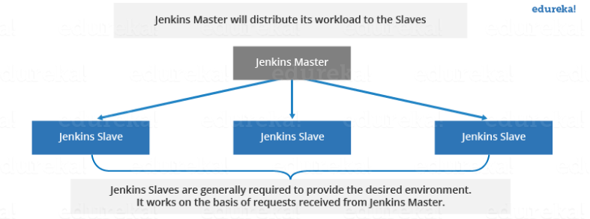
Now let us look at an example in which Jenkins is used for testing in different environments like: Ubuntu, MAC, Windows etc.
The diagram below represents the same:
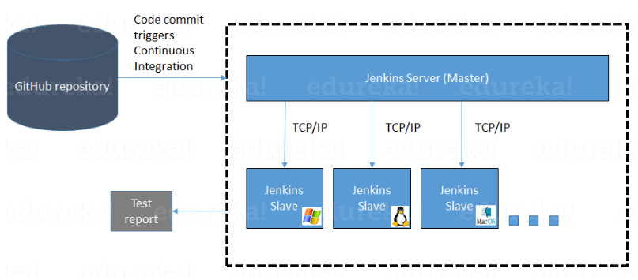
The following functions are performed in the above image:
- Jenkins checks the Git repository at periodic intervals for any changes made in the source code.
- Each builds requires a different testing environment which is not possible for a single Jenkins server. In order to perform testing in different environments Jenkins uses various Slaves as shown in the diagram.
- Jenkins Master requests these Slaves to perform testing and to generate test reports.

Jenkins Build Pipeline
It is used to know which task Jenkins is currently executing. Often several different changes are made by several developers at once, so it is useful to know which change is getting tested or which change is sitting in the queue or which build is broken. This is where pipeline comes into picture. The Jenkins Pipeline gives you an overview of where tests are up to. In build pipeline the build as a whole is broken down into sections, such as the unit test, acceptance test, packaging, reporting and deployment phases. The pipeline phases can be executed in series or parallel, and if one phase is successful, it automatically moves on to the next phase (hence the relevance of the name “pipeline”).The below image shows how a multiple build Pipeline looks like.
