Step 1: I chose the AI blog template in Wi

Step 2: Added blog post content and customized layout.

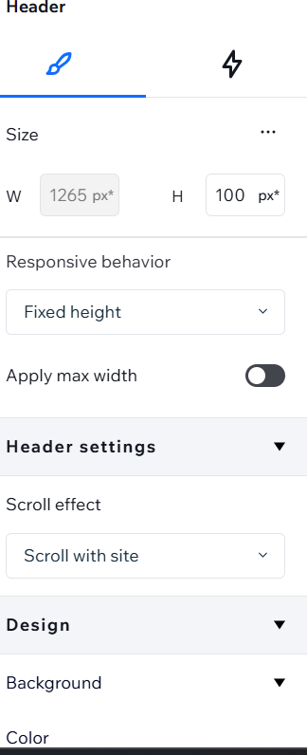

Step 3: Published and shared the blog link.

