**Technologies**

React JS, Spring Boot, H2, Maven, Junit

**For unit test :**

1. You can run “RetailerRewardsTest.java” to run unit testcases

**Please follow the below steps .**

1. Do maven clean install
2. Start the application
3. Type below url in browser, this will calculate the reward points and create dataset information in H2 DB.

<http://localhost:8080/createData>

Sample Data is inserted

1. Do npm install on rewards-web
2. Do npm start on rewards-web
3. Type below url in browser

<http://localhost:3000/>

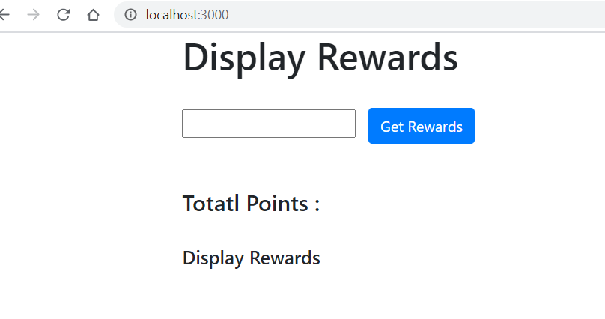

Enter customer1 and click on “Get Rewards” button.

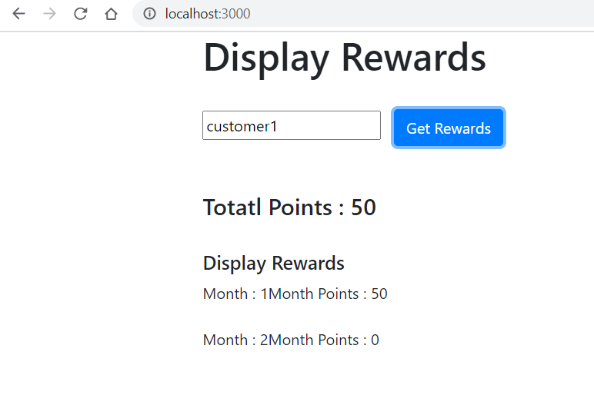

Enter customer2 and click on “Get Rewards” button.

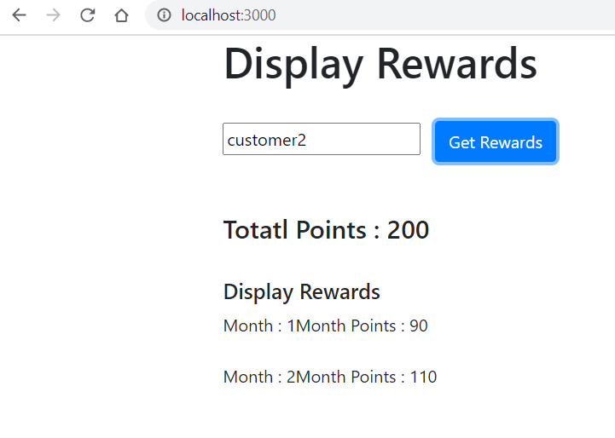

Enter any other value and click on “Get Rewards” button.

