Machine Learning

Introduction
Machine learning is a branch of artificial intelligence that enables computers to learn from data and make predictions.

Machine Learning Process
The following diagram represents the basic machine learning workflow:
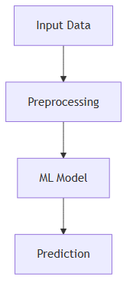
The process starts with input data, followed by preprocessing and model training. The trained model is then used to generate predictions.

