
NAME: Keerthika K
ROLL NO:241901046

EXPERIMENT 10

CRACK FTP CREDENTIALS USING A DICTIONARY ATTACK

AIM:
To perform a dictionary-based attack against an FTP service in the authorized Metasploitable 2 lab environment using Hydra and verify the recovered credentials through a manual FTP login.

ALGORITHM:
- Verify connectivity to the target machine at 192.168.56.101 using ping.
- Scan TCP port 21 with Nmap to identify the FTP service and its version.
- Create users.txt containing admin, msfadmin, root, and user.
- Create passwords.txt containing password, msfadmin, 123456, and admin.
- Run Hydra against the FTP service using the username and password wordlists.
- Record the valid credential pair reported by Hydra.
- Connect manually with the FTP client and verify that the recovered credentials are accepted, then exit the FTP session.

TOOLS REQUIRED:
  - Kali Linux
  - Metasploitable 2 target machine
  - Nmap
  - Hydra
  - Custom username and password wordlists • FTP client

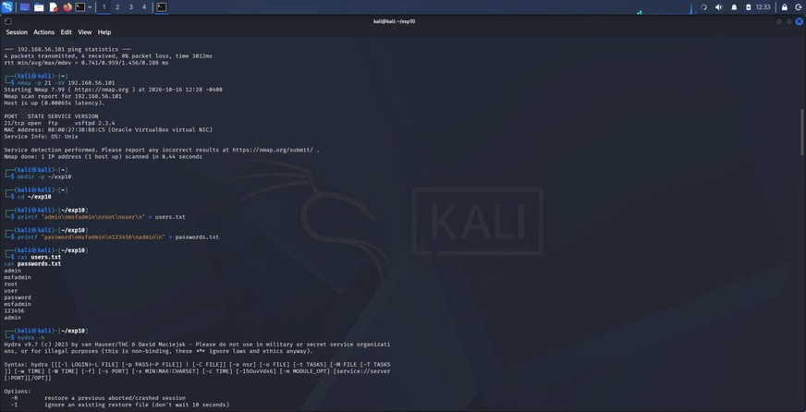
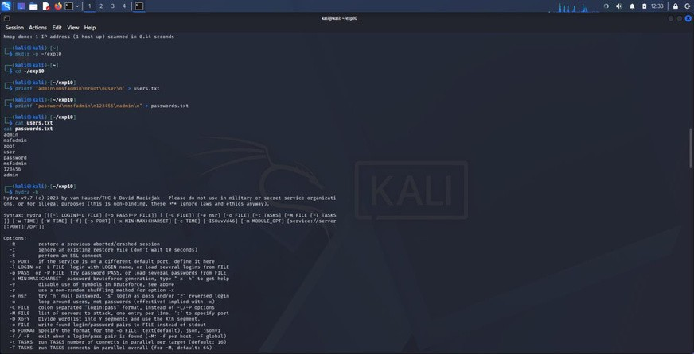
OUTPUT:

Fig1: Nmap scan identifying FTP on port 21 (vsftpd 2.3.4) and setup of the lab directory.

Fig 2: Creation and display of the username and password wordlists.

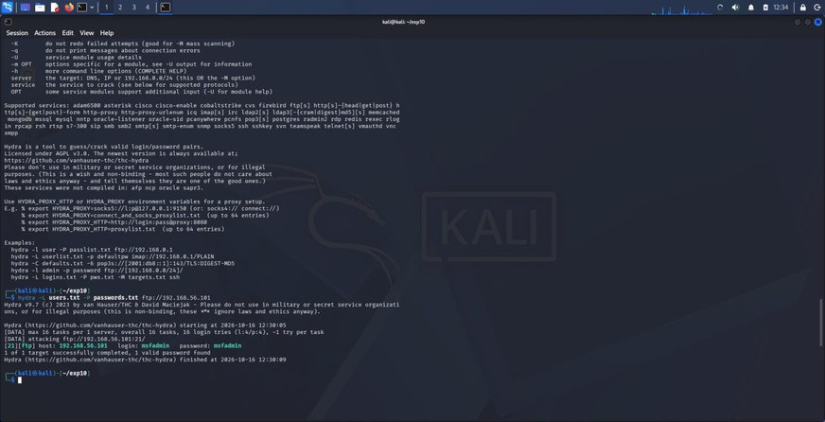
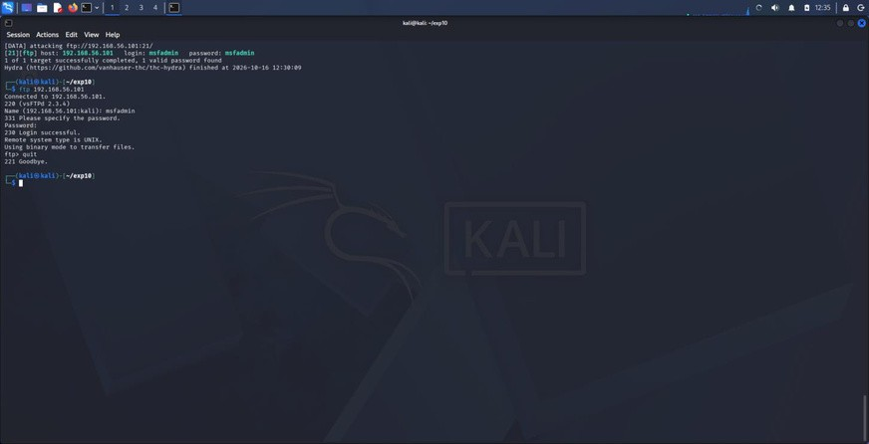

Fig: Hydra output showing the valid FTP credential pair found during the dictionary attack.

Fig 4: Manual FTP login verification showing successful authentication.

RESULT:
The FTP dictionary attack was completed successfully in the isolated lab environment. Nmap identified the FTP service running on 192.168.56.101 at port 21 as vsftpd 2.3.4. Hydra found the credential pair msfadmin / msfadmin from the supplied wordlists, and a manual FTP connection confirmed successful authentication. This demonstrates why weak or default credentials should be replaced with strong, unique passwords.

