
NAME: Keerthika K
ROLL No.:241901046

EXPERIMENT 13

DETECT WEB APPLICATION VULNERABILITIES USING VARIOUS SECURITY TOOLS

AIM:
To use automated web vulnerability scanners to identify common security flaws in a target web application.

THEORY:
Manual testing is slow and can miss issues. Automated scanners crawl the entire application, send thousands of test payloads (SQLi, XSS, broken authentication, misconfigurations, outdated components, etc.), and generate a structured report ranking vulnerabilities by severity. These tools are essential in a professional VAPT (Vulnerability Assessment and Penetration Testing) workflow.

TOOLS REQUIRED:
- Kali linux
- OWASP ZAP (Zed Attack Proxy)
- Nikto
- Target: OWASP Juice Shop (or DVWA)

PROCEDURE:
Step 1 — Basic scan with Nikto nikto -h http://<target-ip>:3000
Nikto checks for outdated server software, dangerous files, missing security headers, and default files.

Step 2 — Full scan using OWASP ZAP (GUI)
- Open ZAP: zaproxy from terminal or Applications menu.
- In the Quick Start tab, enter the target URL: http://<target-ip>:3000
- Click Automated Scan.
- ZAP will spider the site (map all pages) and then run an Active Scan, sending attack payloads to every input field found.

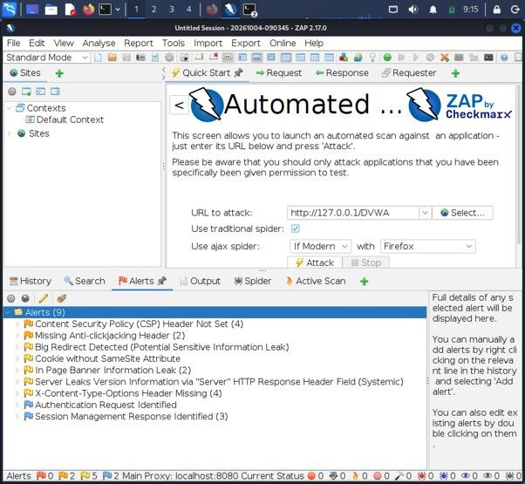

Step 3 — Review the Alerts tab
ZAP categorizes findings by risk: High, Medium, Low, Informational. Typical findings include:
  - Missing X-Frame-Options header (clickjacking risk)
  - SQL Injection points
  - Cross-Site Scripting points
  - Missing CSRF tokens

Step 4 — Export the report
Report → Generate Report → HTML/PDF. This report format is what real pentesters submit to clients.

OUTPUT:
- Alerts Tab

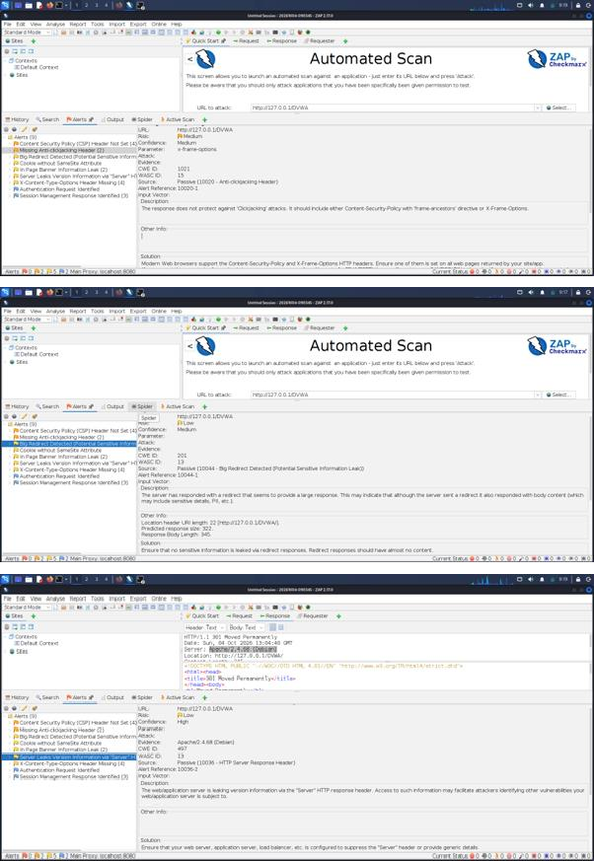
- Alerts with Description

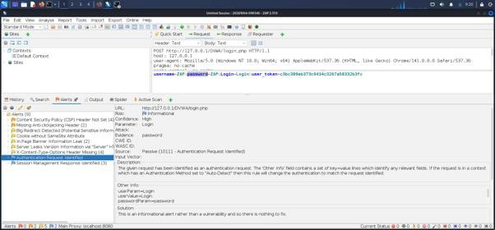

RESULT:
The web application was successfully scanned using Nikto and OWASP ZAP. Several security vulnerabilities and configuration issues were identified, including missing anti-clickjacking headers, cookies without the SameSite attribute, missing security headers, and exposed directories/configuration files. The findings were reviewed according to their risk levels, and a structured vulnerability report was generated using OWASP ZAP.

