
NAME: Keerthika K
ROLL NO: 241901046

EXPERIMENT 15

DETECT SQL INJECTION VULNERABILITIES USING VARIOUS SQL INJECTION DETECTION TOOLS

AIM:
To use automated tools to detect SQL Injection vulnerabilities before they can be exploited, as part of a security assessment.

THEORY:
Detection tools work by sending a wide range of crafted inputs (single quotes, boolean conditions, time-delay payloads) to every parameter of an application and analyzing the response differences (error messages, timing delays, content changes) to confirm whether the parameter is vulnerable — without necessarily extracting real data.

TOOLS REQUIRED:
- sqlmap (detection mode)
- OWASP ZAP (Active Scan — SQLi rules)
- Target: DVWA (SQL Injection module, Low security)

PROCEDURE:

Step 1 — Detection using sqlmap (no dumping, just confirm)
sqlmap -u "http://<target-ip>/dvwa/vulnerabilities/sqli/?id=1&Submit=Submit" --cookie="PHPSESSID=<session-id>; security=low" --batch --level=3 --risk=2
sqlmap reports which parameter is injectable and which injection technique works (boolean- based blind, time-based blind, UNION query, error-based, stacked queries).
Step 2 — Time-based blind detection concept sqlmap internally tests payloads like: 1 AND IF(1=1, SLEEP(5), 0)
If the response takes ~5 seconds longer, the parameter is confirmed vulnerable to blind SQLi — even with no visible error or data change.

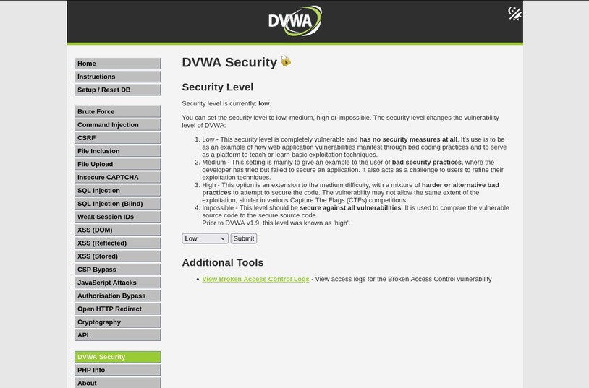

Step 3 — Detection using OWASP ZAP
- Set DVWA session cookie in ZAP as an authenticated context.
- Run Active Scan against the SQLi page URL.
- Check the Alerts tab for "SQL Injection" findings — ZAP shows the exact payload andparameter that triggered it.

Step 4 — Compare results
Cross-check sqlmap's findings against ZAP's findings for the same page — in a real assessment, using two tools reduces false negatives.

OUTPUT:

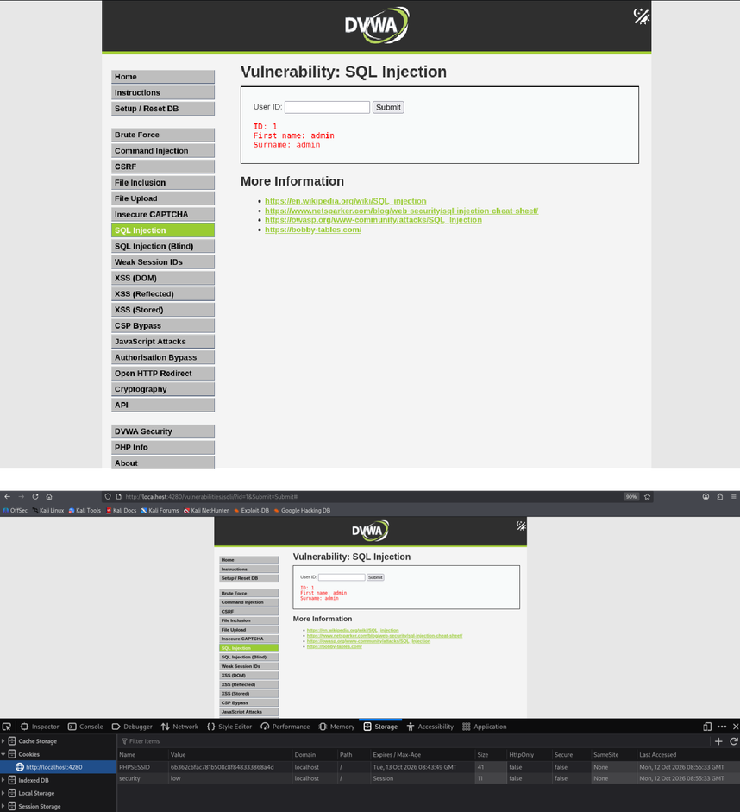

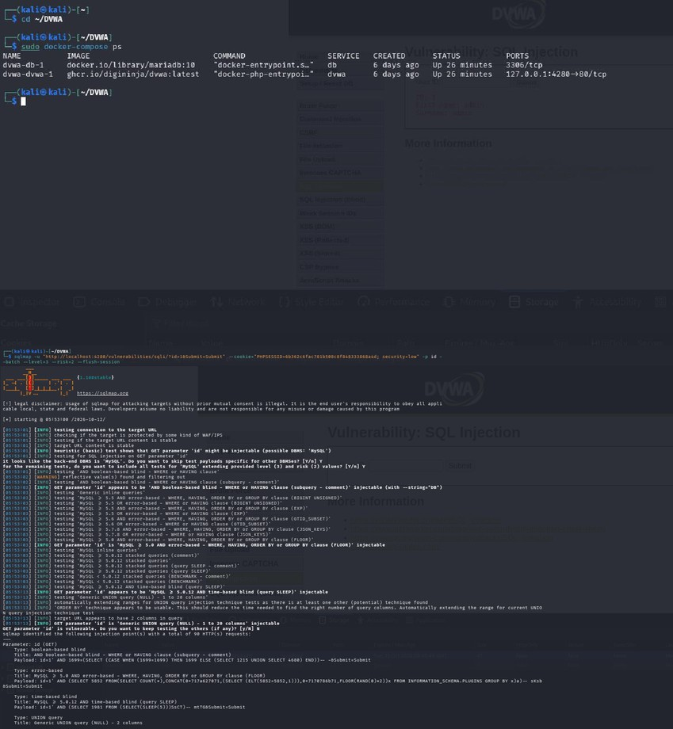

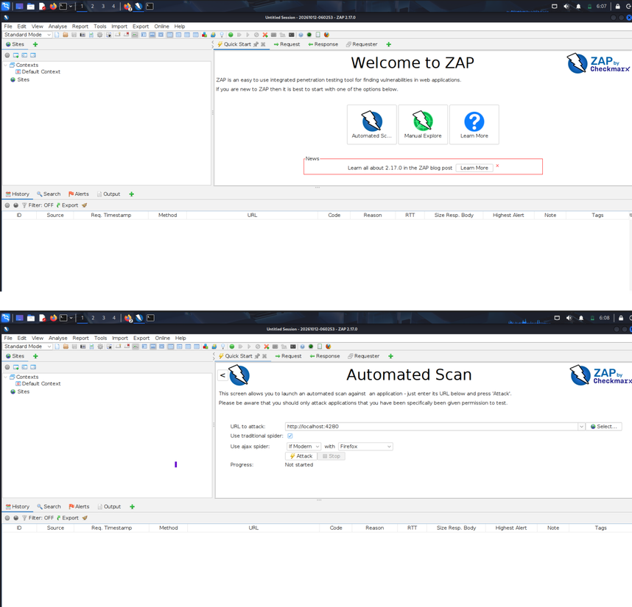

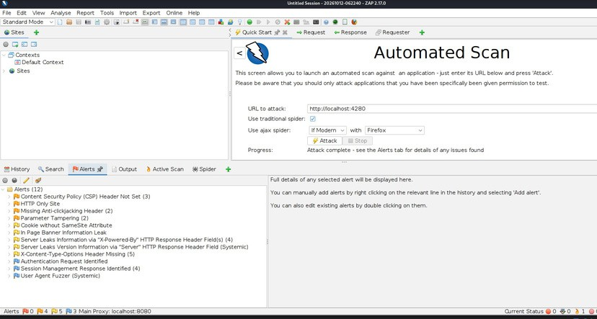

RESULT:
- sqlmap detected SQL injection in the id parameter of the DVWA application using error-based, time-based blind, and UNION-based techniques.
- It identified the backend database as MySQL-compatible (MariaDB).
- OWASP ZAP completed the scan and reported 12 alert types, including missing sechueriatyders and cookie issues.
- ZAP did not explicitly detect SQL injection in this scan.
- Thus, both tools provide complementary security findings and help identify webapplication vulnerabilities.

