NAME: Keerthika K
ROLL No: 2419101046

EXPERIMENT 17

CREATE A ROGUE ACCESS POINT TO CAPTURE DATA PACKETS

AIM:
To understand how a Rogue (fake) Access Point / "Evil Twin" attack works and to simulate the setup in a controlled lab to capture and analyse unencrypted test traffic.

THEORY:
A Rogue Access Point is an unauthorised wireless access point that may imitate a trusted network name (SSID). If a user connects to it, traffic routed through that access point may be observed by its operator. Plain HTTP traffic can expose its contents, while HTTPS encrypts application data in transit. The lab manual describes a contained simulation using two lab VMs, hostapd, dnsmasq, and Wireshark.

TOOLS REQUIRED
- Kali Linux – lab/monitoring machine.
- hostapd – access-point daemon; requires a supported wireless/AP interface.
- dnsmasq – DHCP/DNS service for the isolated test network.
- Wireshark – packet capture and protocol analysis tool.
- A second lab VM acting as the victim/test client, connected only to an isolated lab network.

PROCEDURE
- Install/check the required tools. The lab manual lists `sudo apt update` and `sudo apt install hostapd dnsmasq -y`. Wireshark was also installed for capture and analysis.
- Inspect available interfaces. Commands used: `ip -br addr`, `iw dev`, `ip route`, `ip -br link`,
`ip -d link show eth1`, and `sudo ethtool eth1`. The current VM shows eth0 at 10.0.2.15/24, eth1 as a second Ethernet interface, and no wireless interface in `iw dev`.
- Review the manual's AP and DHCP configuration. The manual proposes hostapd settings for SSID `Free_Lab_WiFi` and dnsmasq DHCP settings on `at0`. The manual notes that the interface name must be confirmed for the VM. In the current VM, `at0` has not been demonstrated and no wireless interface is detected, so the AP configuration has not been successfully run.
- Capture available diagnostic traffic. Wireshark was opened on the available interface and saved the capture as `experiment17-diagnostic.pcapng`. The supplied capture screenshot shows three ICMPv6 packets.

- Apply a display filter. The `icmpv6` display filter was applied. The visible packets are an IPv6 Router Advertisement and two Multicast Listener Report messages. This verifies packet display/filtering, not victim traffic through a rogue AP.
- Remaining lab validation. To complete the full experiment, use an instructor-approved isolated setup with an AP-capable wireless interface or a specifically configured virtual lab network, connect the test client, generate benign test traffic, and capture it. Do not use real credentials or intercept devices/networks without permission.

OBSERVATION:
TEST PERFORMED | OBSERVATION
Interface/IP inspection | eth0 is UP with IPv4 address 10.0.2.15/24. eth1 is UP but has no IPv4 address shown in the supplied `ip -br addr` output.
Wireless interface check | `iw dev` returned no output; no wireless interface was detected by this command.
Route inspection | Default route is via 10.0.2.2 on eth0 (VirtualBox NAT network).
Ethernet interface check | `ethtool eth1` reports a detected link at 1000 Mb/s, full duplex; this is a wired Ethernet interface.
Tool-version evidence | The supplied screenshot visibly reports Wireshark 4.6.6 and dnsmasq 2.93. A clear hostapd version result is not visible.
Wireshark capture | The diagnostic capture contains 3 ICMPv6 packets: one Router Advertisement and two Multicast Listener Report messages.
Rogue AP and victim traffic | Not demonstrated in the supplied evidence. No successful hostapd AP startup, victim connection, DHCP lease, HTTP POST, or test-form payload is shown.

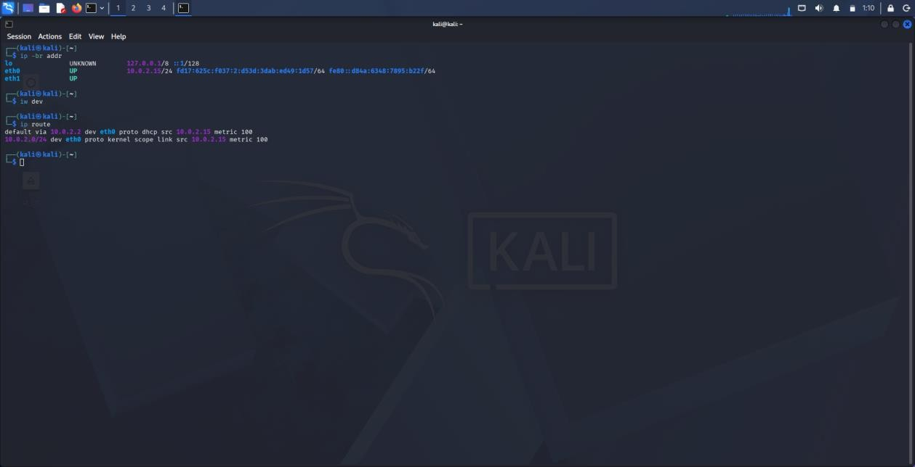
OUTPUT
Fig 1. Initial network configuration: eth0 has 10.0.2.15/24; no wireless interface is listed by iw dev.
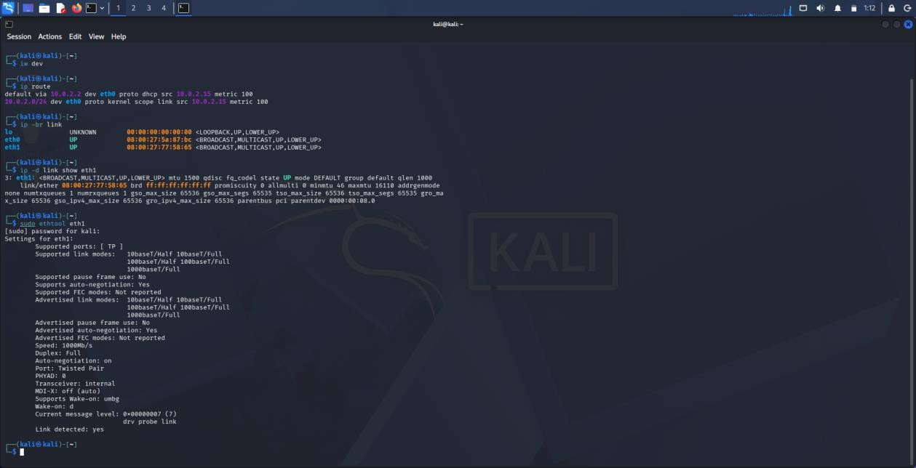
Fig 2. Interface details: eth0 and eth1 are Ethernet interfaces; ethtool reports a detected 1 Gbps link on eth1.

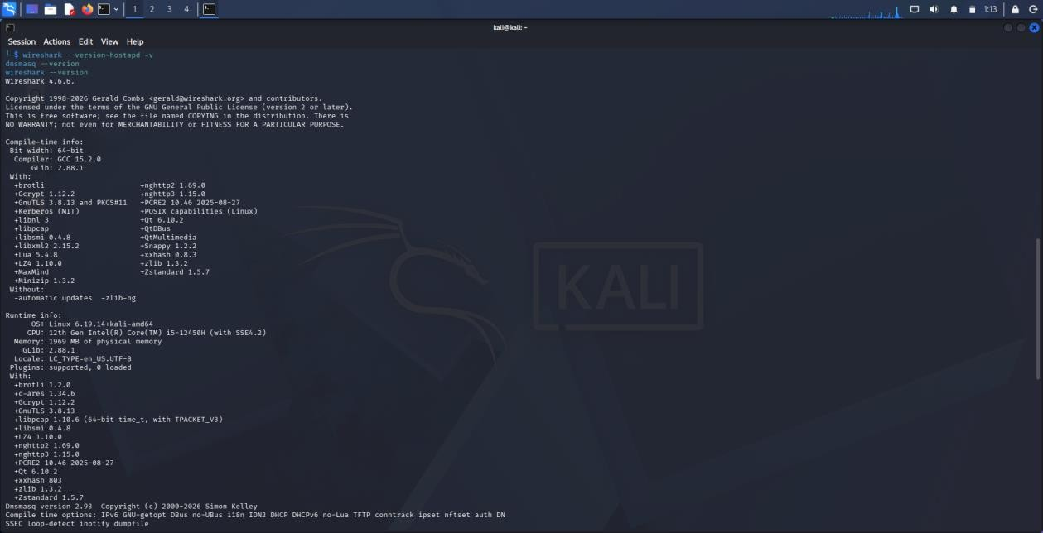
Fig 3. Tool-version checks: Wireshark 4.6.6 and dnsmasq 2.93 are visible. The hostapd version is not clearly shown in this screenshot.
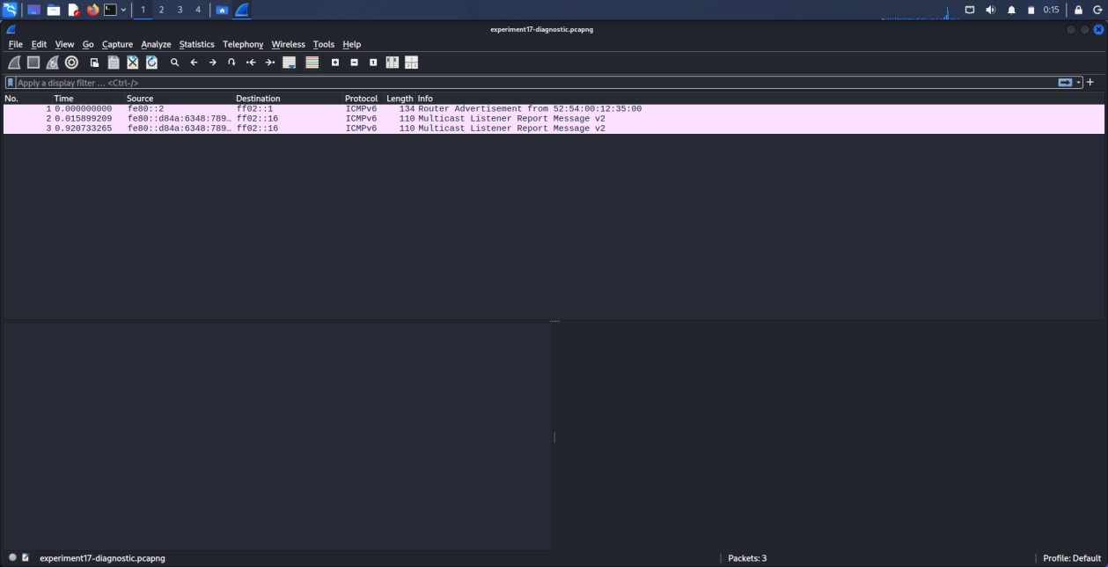
Fig 4. Wireshark capture file experiment17-diagnostic.pcapng contains three ICMPv6 packets.

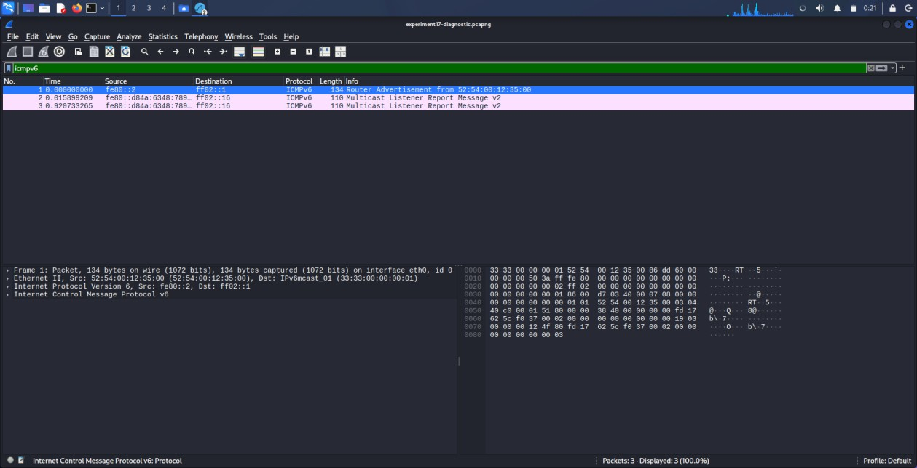
Figure 5. Wireshark with the icmpv6 display filter applied; the displayed packets are Router Advertisement and Multicast Listener Report messages.

RESULT:
The network interface inspection and Wireshark diagnostic capture were completed successfully, displaying three ICMPv6 packets using the icmpv6 filter. However, the full Rogue Access Point experiment is not yet verified because the Kali Linux VM currently exposes only Ethernet interfaces. Access point creation, victim connection, and HTTP traffic capture must be completed in an isolated, authorised lab before marking the experiment as complete.

