EXPERIMENT 4
NAME: Keerthika K
ROLL No: 241901046


DETECT SESSION HIJACKING

AIM:
To detect possible session hijacking by analysing network traffic and application logs using Wireshark and other security monitoring tools.

TOOLS REQUIRED:
- Kali Linux: Used as the monitoring machine for network traffic analysis.
- Metasploitable2: Used as the target machine in the isolated lab network.
- VirtualBox: Used to run both virtual machines.
- Wireshark: Used to capture and analyse ARP and ICMP packets.
- Terminal utilities: ping, arp -a, and ip neigh to verify connectivity and inspect IP-to-MAC address mappings.
- DVWA: Used in the lab to examine web session security, if required.

PROCEDURE:
- Start Kali Linux and Metasploitable2 in VirtualBox and ensure both machines are connected to the same isolated host-only network.
- Identify the IP addresses of the machines and verify connectivity using the ping command.
ping -c 4 192.168.56.102
- Open Wireshark in Kali Linux and start capturing network traffic on the eth0 interface.
- Apply the display filter arp to examine Address Resolution Protocol requests and replies.
- Apply the display filter icmp to observe ICMP echo requests and replies between Kali Linux and Metasploitable2.
- Inspect the ARP neighbour table using the following command: ip neigh

Alternatively, use arp -a to view available IP-to-MAC address mappings.
- Compare the observed IP-to-MAC mappings and examine the captured traffic for unexpected or duplicate ARP replies that could indicate ARP spoofing.
- Record the captured packets, connectivity results, and ARP neighbour information, and document whether any session hijacking indicators were confirmed.

OBSERVATION:
TEST PPERFORMED OBSERVATION


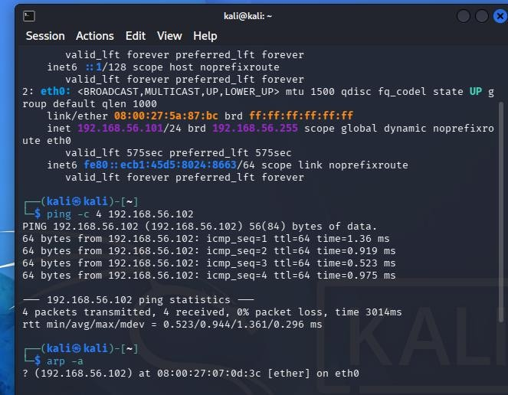
Checked IP addresses

Tested connectivity using ping Captured ARP packets using Wireshark Analysed ICMP traffic
Checked the ARP neighbour table using ip neigh
Checked for session hijacking indicators
Kali: 192.168.56.101;
Metasploitable2: 192.168.56.102
4 packets transmitted, 4 received, 0% packet loss.
An ARP request asking for 192.168.56.100 was observed.
Echo requests and replies between Kali and Metasploitable2 were captured Metasploitable2 was mapped to MAC
address 08:00:27:07:0d:3c, with state STALE.
No confirmed ARP spoofing or session hijacking was observed in the collected evidence.

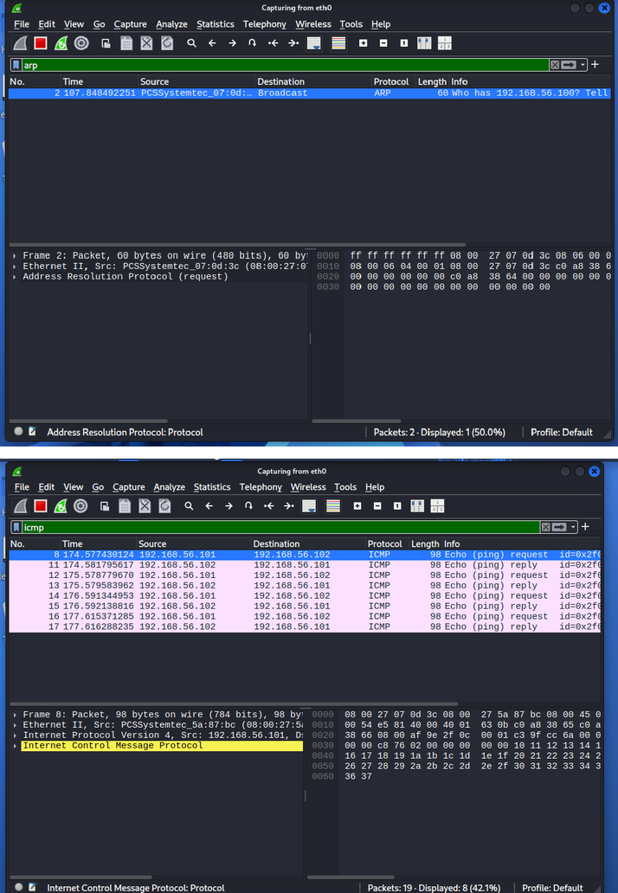

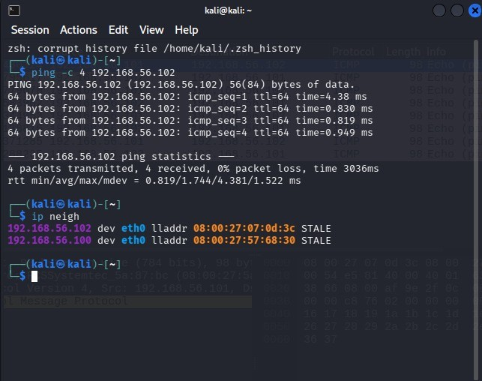

RESULT:
Network traffic was captured and analysed using Wireshark. Normal ARP requests and ICMP echo request/reply packets were observed. The ARP neighbour table was examined to understand IP-to-MAC address mapping and identify potential indicators of ARP spoofing.
No session hijacking was confirmed during the observation.

