EXPERIMENT 6
NAME: Keerthika K
ROLL No: 241901046


ENUMERATE WEBSERVER INFORMATION

AIM:
To gather detailed configuration and version information about a target web server using enumeration tools such as Nmap, curl, and Gobuster.

TOOLS REQUIRED:
- Kali Linux – Operating system containing the enumeration tools.
- Metasploitable2 – Vulnerable target machine hosting the web server.
- Nmap – To identify open ports and enumerate supported HTTP methods.
- curl – To inspect HTTP response headers and request common web files.
- Gobuster – To discover common directories and files using a wordlist.
- Web browser – To check the /uploads/ path.
- OpenSSL – For TLS inspection if HTTPS is available (not used because port 443 was closed).

PROCEDURE:
- Start Kali Linux and Metasploitable2 and verify network connectivity using ping. ping -c 4 192.168.56.101
- Inspect the HTTP response headers using curl to identify the server and PHP version. curl -X OPTIONS -i http://192.168.56.101
- Use Nmap's HTTP methods script to identify methods supported by the web server. nmap -p80 --script=http-methods 192.168.56.101
- Check whether the /uploads/ path is present by opening it in a web browser. http://192.168.56.101/uploads/
- Request robots.txt and sitemap.xml to check whether these common web files are available.
curl -i http://192.168.56.101/robots.txt curl -i http://192.168.56.101/sitemap.xml
- Use Gobuster to enumerate common web paths with the DIRB common wordlist.

gobuster dir -u http://192.168.56.101 -w /usr/share/wordlists/dirb/common.txt
- Check whether HTTPS is listening on port 443. If it is closed, TLS cipher enumeration cannot be performed.
nmap -p443 192.168.56.101
- Record the outputs obtained, analyse the web server information, and document potential security observations.

OBSERVATION:

TEST PERFORMED

HTTP response header inspection using curl

Nmap HTTP method enumeration

Check /uploads/ path

Check robots.txt and sitemap.xml

OBSERVATION
Server returned HTTP/1.1 200 OK. Headers identified Apache/2.2.8 (Ubuntu) DAV/2 and PHP/5.2.4-2ubuntu5.10. Content type was text/html.
Port 80/tcp was open. Supported methods reported by Nmap: GET, HEAD, POST, and OPTIONS.
The browser displayed Not Found. The requested
/uploads/ path returned 404; directory indexing was not demonstrated.
Both /robots.txt and /sitemap.xml returned HTTP/1.1 404 Not Found.
Discovered /.htpasswd, /.htaccess, /.hta, /cgi-bin/,


Directory and file enumeration Gobuster

HTTPS port check using Nmap
using
/adnadv, /server-status with status 403;
/phpMyAdmin, /test, and /twiki with status 301; and /index, /index.php, /phpinfo, and /phpinfo.php with status 200.
Port 443/tcp was closed while the target host was up. SSL/TLS cipher enumeration was therefore not performed.

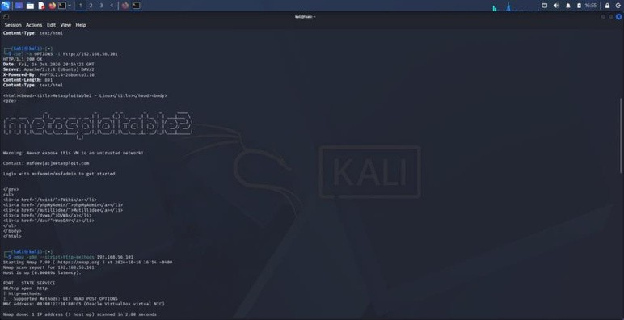
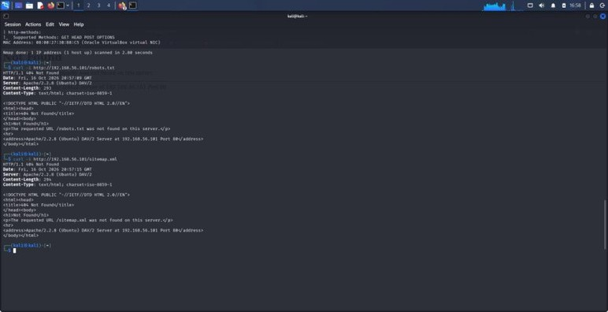
SCREENSHOTS

Fig. 1: curl response headers andNmap HTTP-method enumeration.

Fig. 2: robots.txt and sitemap.xmlchecks showing 404 Not Found.

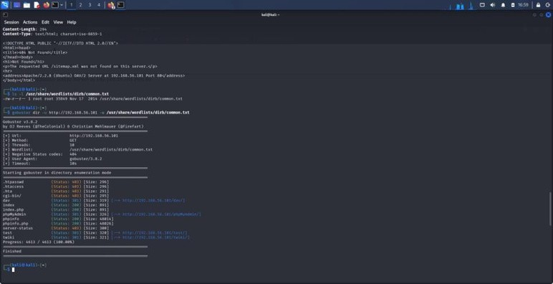
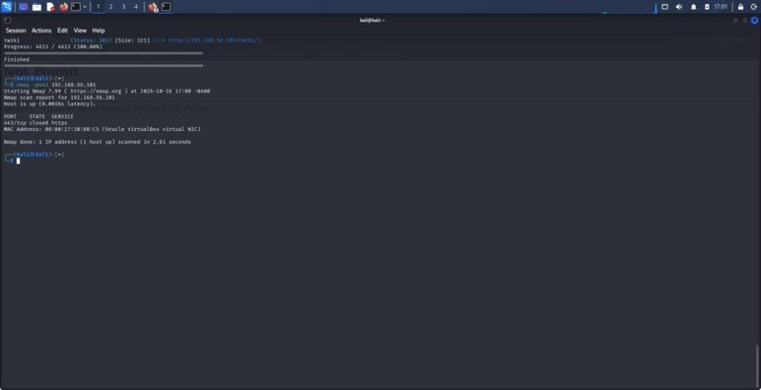

Fig. 3: Gobuster path enumeration results.

Fig. 4: Nmap scan showing TCP port 443 closed.

RESULT:
Web server enumeration was carried out using Nmap, curl, and Gobuster in an authorised lab environment to examine HTTP response headers, supported methods, common web paths, and HTTPS availability. The target reported Apache/2.2.8 (Ubuntu) DAV/2 and PHP/5.2.4-2ubuntu5.10. Gobuster identified paths returning 200, 301, and 403 status codes, while
/uploads/, robots.txt, and sitemap.xml returned 404 Not Found. Port 443 was closed.

