EXPERIMENT 8
NAME: Keerthika K
ROLL No.:241901046


PERFORM WEBSPIDERING

AIM:
To automatically map out the complete structure of a target website - every page, link, and form - using a web spidering (crawling) tool.

THEORY:
Web spidering (also called crawling) is the process of automatically following every link on a website to discover all its pages, directories, and forms — similar to how Google's crawler indexes the internet, but done locally against one target for security testing purposes.
Manually clicking through every page of a large application is slow and error-prone. A spider tool automates this by:
- Starting from a given URL
- Extracting all links/forms on that page
- Visiting each new link found
- Repeating until no new links are discovered

TOOLS REQUIRED
  - Burp Suite (Spider/Crawler feature, in the Community or Pro edition)
  - OWASP ZAP (alternative, has a free built-in spider)
  - Target: DVWA or OWASP Juice Shop

PROCEDURE

Step 1: Set Up the Target in Burp Suite
- Configure the browser proxy to route through Burp (127.0.0.1:8080) as done in Experiment 7.
- Browse to the home page of the target application once, so it appears under Burp's Target → Site map.

Step 2: Add the Target to Scope
- Right-click the target's entry in the Site map → Add to scope.
- This tells Burp to only crawl/act on this specific application, not the whole internet.

Step 3: Run the Crawler
(In Burp Suite Community Edition, this may be a manual "Spider" via passive browsing; Burp Pro has an automated Crawl button.)
If using OWASP ZAP instead (fully free automated spider):
zaproxy

- Enter the target URL in the Quick Start tab.
- Click Spider to begin the automated crawl.
- Watch the Spider tab — it will list every URL discovered in real time.

Step 4: Review the Discovered Site Map
Once the spider finishes, expand the Sites tree in ZAP (or Site map in Burp) to see the full structure: every folder, page, and parameter discovered.
Export the list of discovered URLs:
Right-click site root → Export → Export URLs to File

Step 5: Identify Forms Found During Spidering
Go through the discovered pages and note down every HTML form found (login, search, comment, upload), along with its input field names — this list becomes the target list for vulnerability scanning in Experiment 9.

Step 6: Record the Site Map Summary
Category Count / Details

Total Pages Discovered Forms Found Parameters Found
Hidden/Unlinked Pages Found

OUTPUT
42
Login, Search,
Comment
id, user, comment
/admin/settings.php

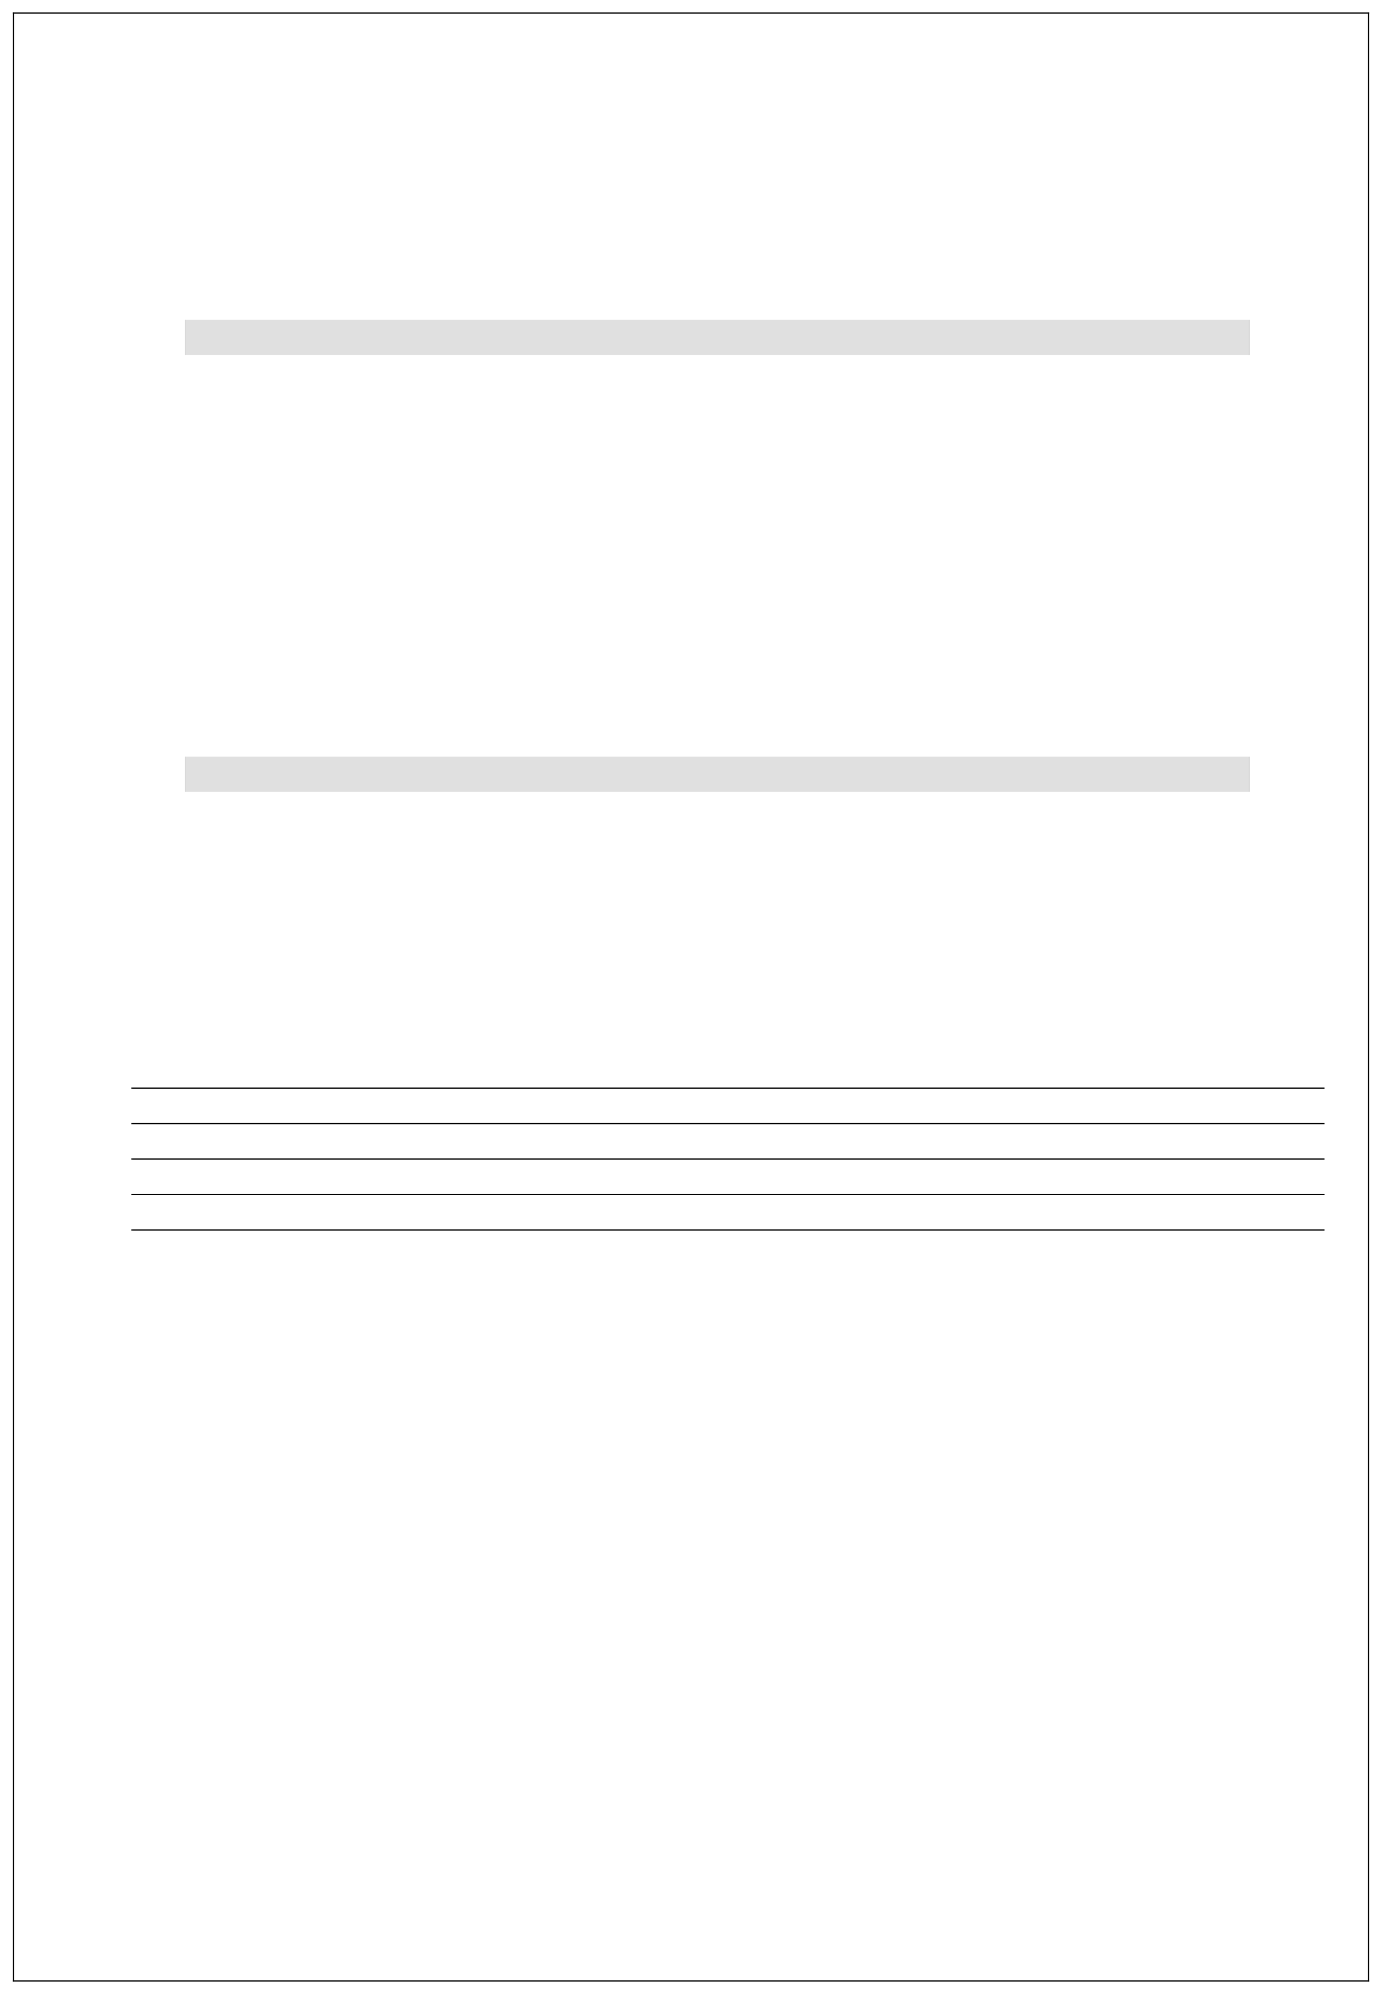
A complete, exported site map of the target application listing every discovered page, along with a list of forms and parameters found — ready to be used as input for
automated vulnerability scanning.

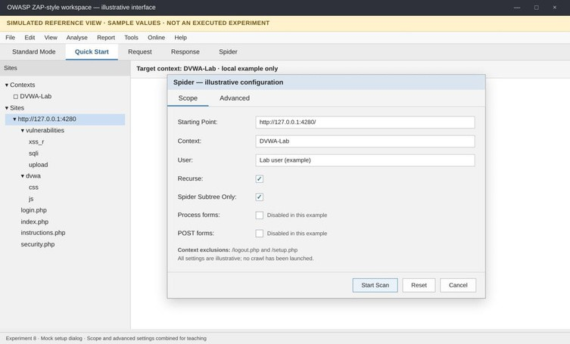
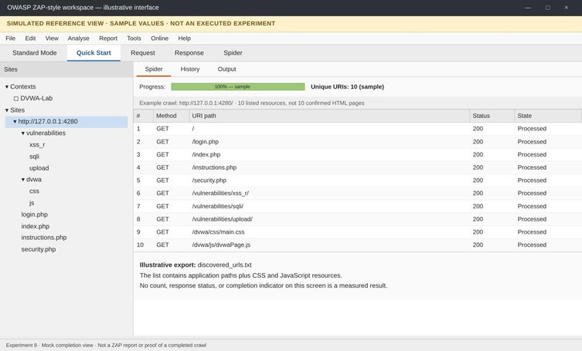

Fig. 1: Spider configuration (simulated reference).

Fig. 2: Discovered site map (simulated reference).

