
NAME: Keerthika K
ROLL NO:241901046

EXPERIMENT 9

PERFORM WEB APPLICATION VULNERABILITY SCANNING

AIM:
To run an automated vulnerability scan against a web application and identify common security weaknesses such as security misconfigurations and missing HTTP security headers.

ALGORITHM:
- Start the Kali Linux environment and launch OWASP ZAP.
- Start the DVWA target application and access it at http://127.0.0.1:8081/.
- Log in to DVWA and set the security level to Low.
- In ZAP Quick Start, enter the target URL http://127.0.0.1:8081/.
- Enable the traditional spider and start the automated scan against the local lab target.
- Wait until ZAP displays “Attack complete” and indicates that results are available in t7h.eOpen the Alerts tab and review the findings and their risk levels.
- Select alerts to inspect the details and affected URLs where available.
- Generate the ZAP report in HTML format.
- Record the observed findings and report as the output of the experiment.

TOOLS REQUIRED:
Kali Linux
OWASP ZAP (Zed Attack Proxy) DVWA running locally in Docker

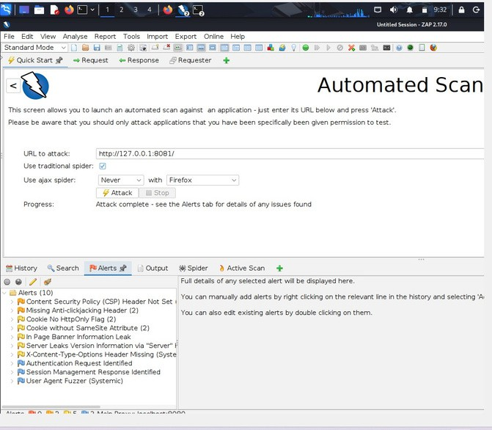
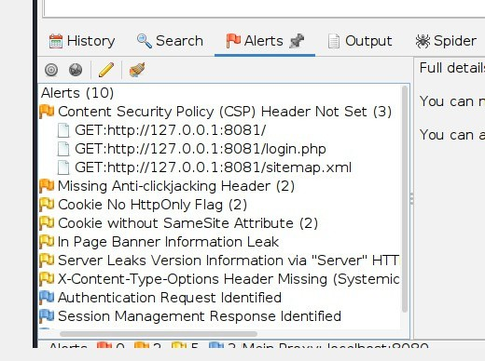
OUTPUT:

Fig 1: OWASP ZAP automated scan completedfor the local DVWA target; the Alerts panel shows 10alerts.

Fig: Actual ZAP Alerts tab showing the scan's detected alert categories, including CSPHeader Not Set and missing security headers.

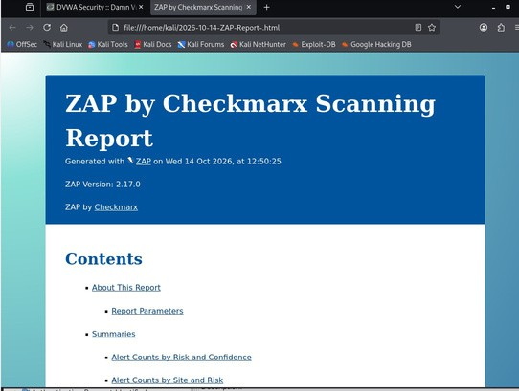

Figure 3: Actual ZAP HTML report openedinthe browser, showing the report title, generation time, andZAP version.

RESULT:
The local DVWA web application was scanned successfully using OWASP ZAP. The
completed scan displayed 10 alerts, including a Medium-risk Content Security Policy (CSP) Header Not Set finding, Low-risk missing security-header and cookie-configuration findings, and Informational observations. The ZAP HTML report was generated successfully.

