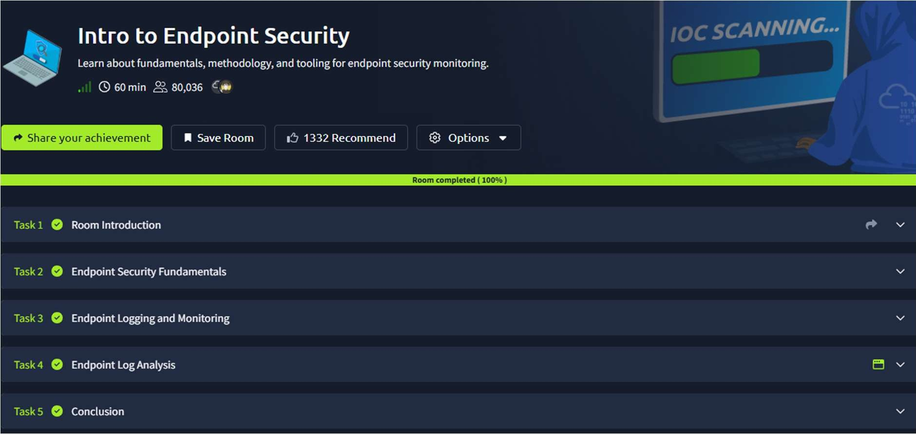
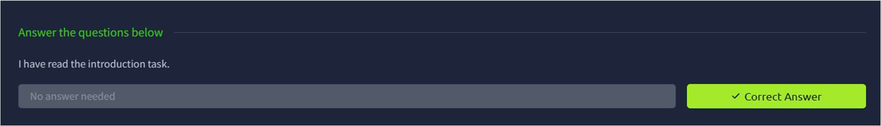
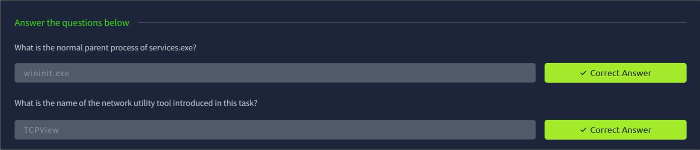

CR23431 - Network Security Lab 241901046-Keerthika.K

15. ENDPOINT SECURITY MONITORING
DATE: 22/04/2026
TAoimlea:rn about fundamentals, methodology, and tooling for endpoint security monitoring.

Procedure:

- Log into TryHackMe and open the Intro to Endpoint Security room.
- Study the fundamentals of endpoint security and its importance.
- Understand common threats targeting endpoints such as malware and exploits.
- Learn methodologies for monitoring and securing endpoint devices.
- Explore tools used for endpoint detection and response.
- Complete the tasks and answer the questions in the room.
- Review the summary and confirm completion.

Tasks:

TASK 1- Room Introduction

TASK 2 – Endpoint Security Fundamentals

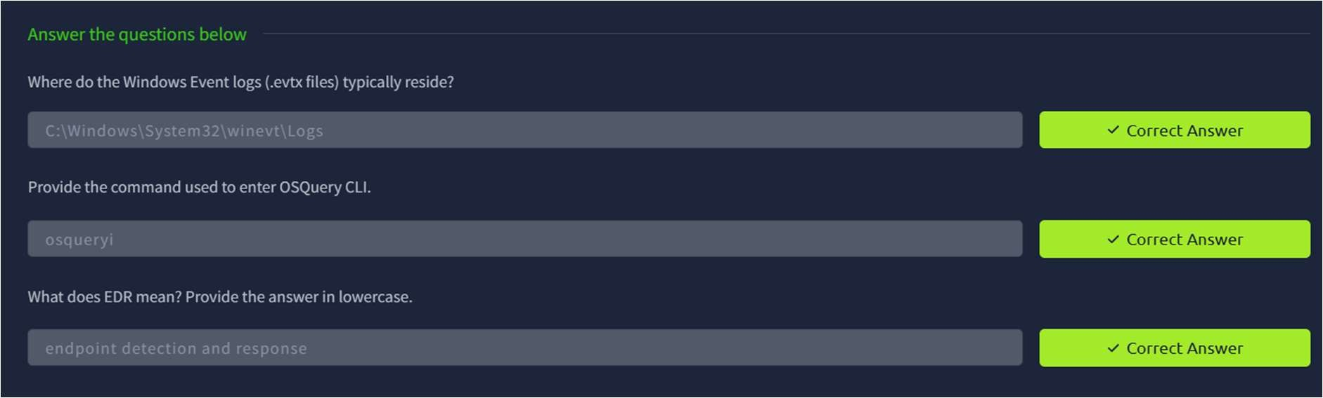
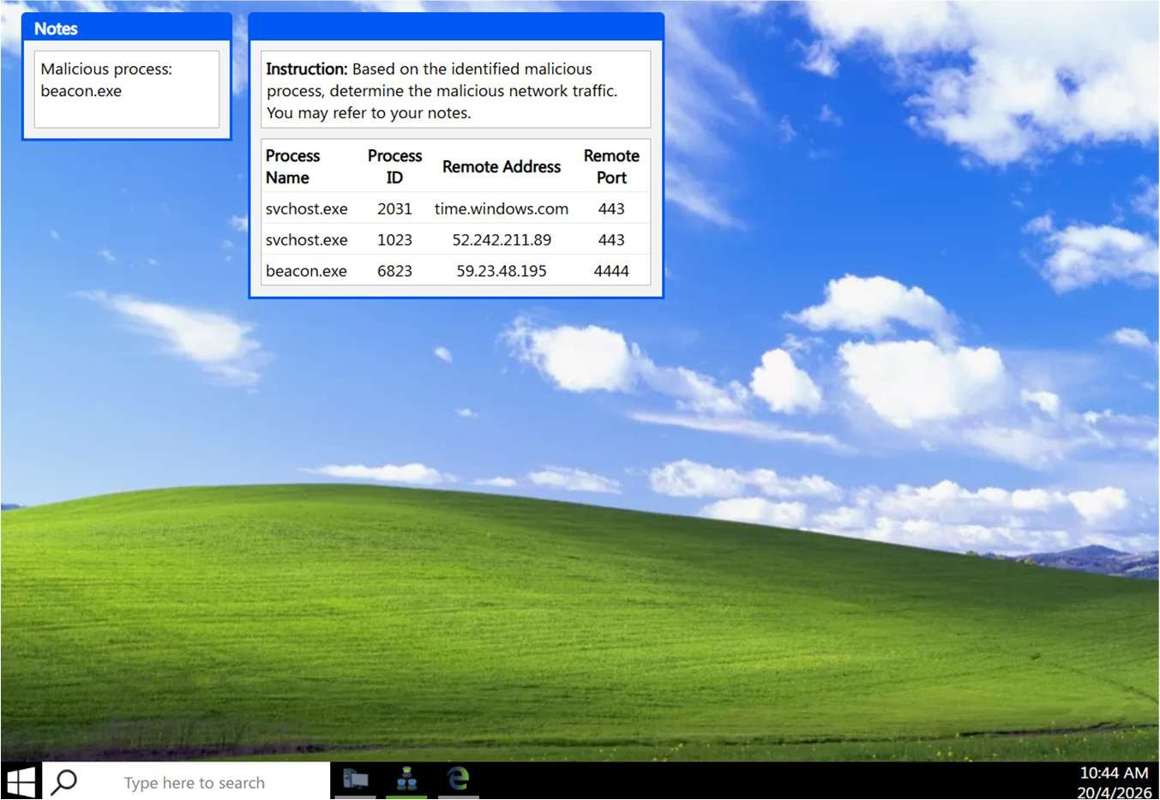
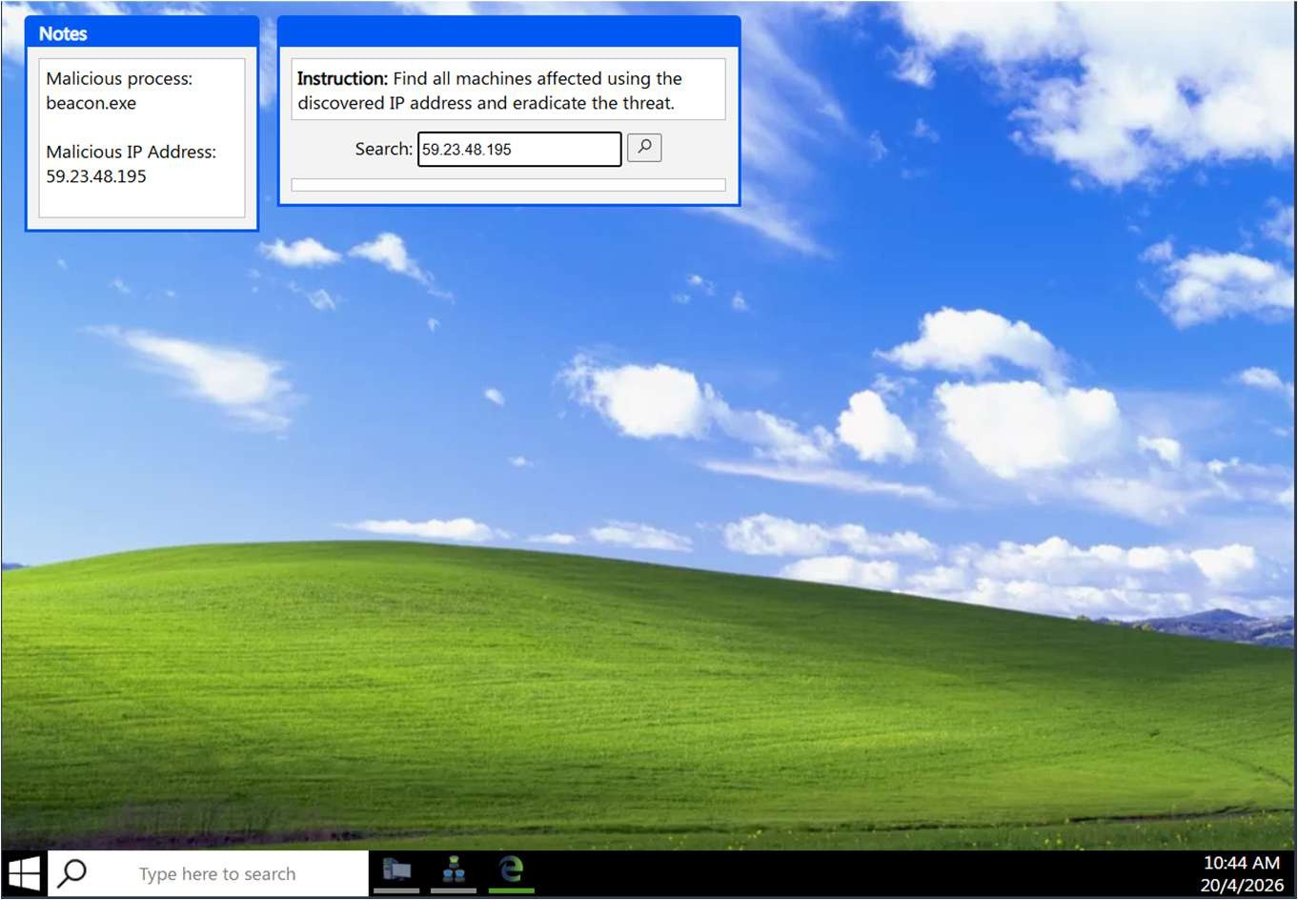

CR23431 - Network Security Lab
TASK 3 – Endpoint Logging and Monitoring

TASK 4 – Endpoint Log Analysis

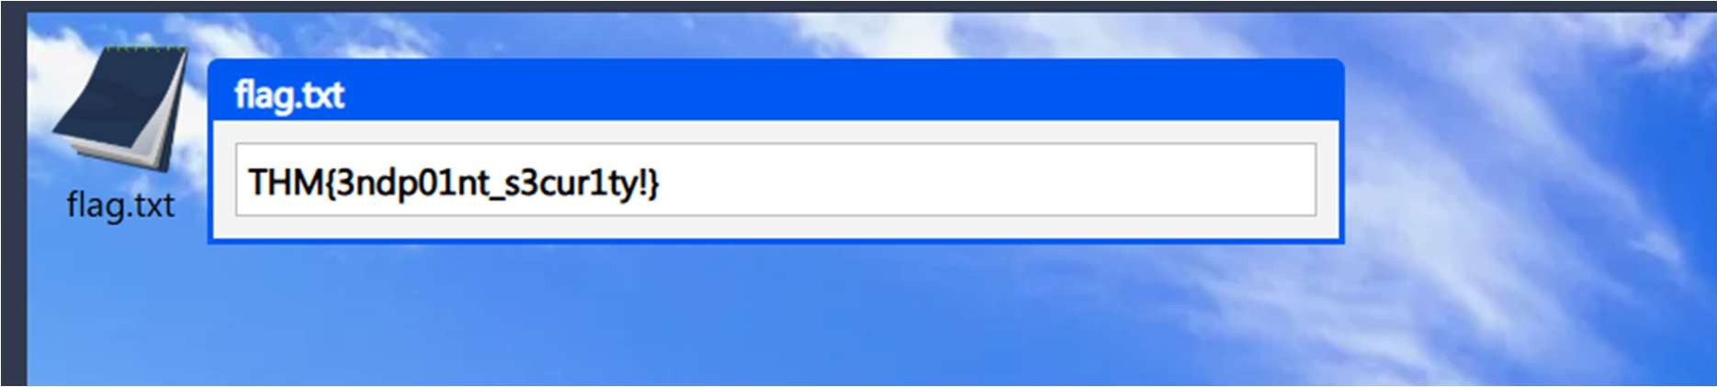
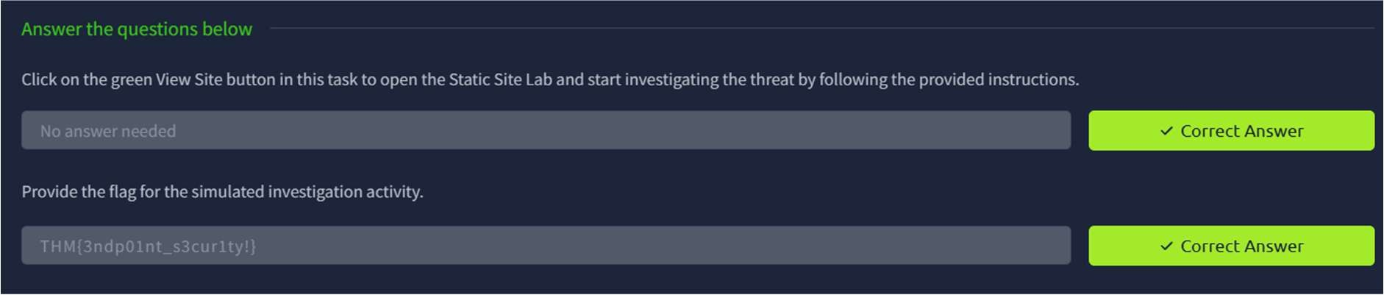
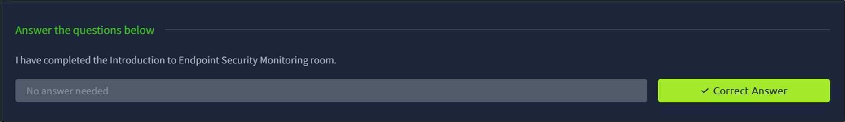

CR23431 - Network Security Lab

TASK 5 - Conclusion

Result:
Thus the TryHackMe room “Intro to Endpoint Security” was completed successfully.

