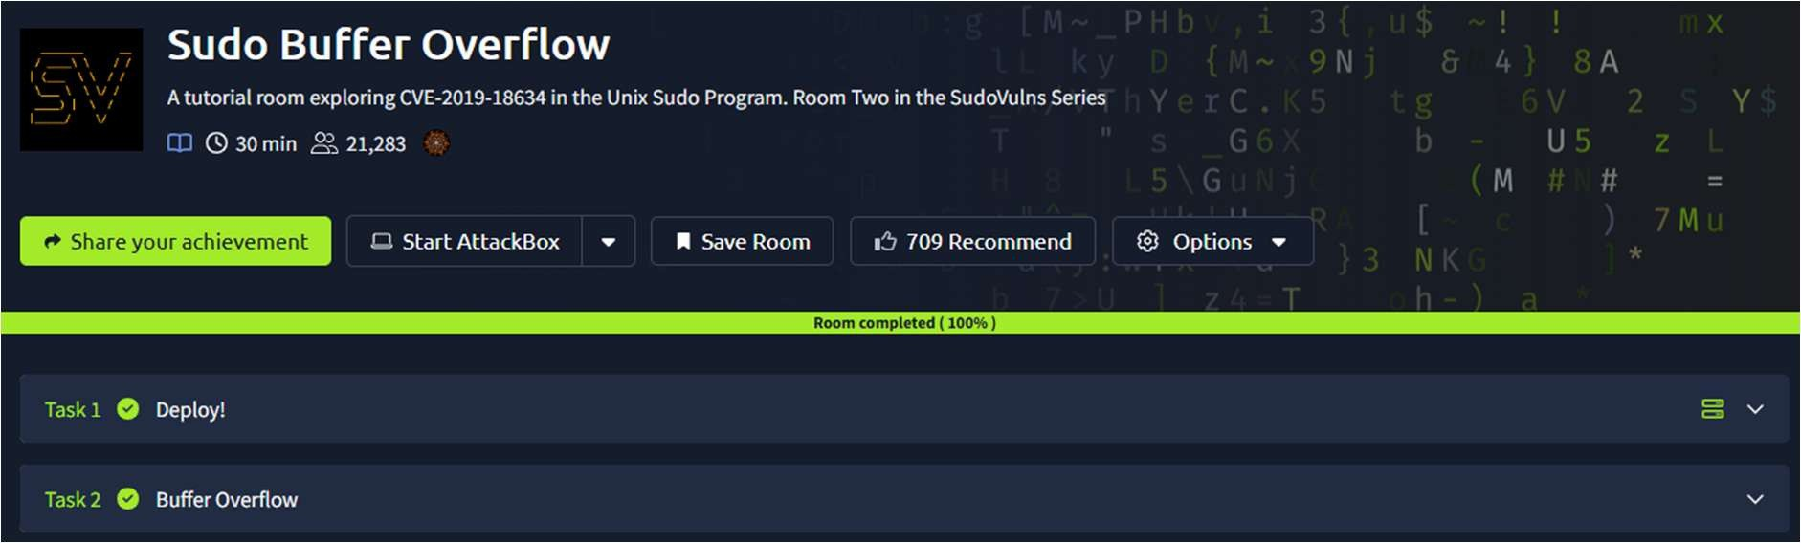
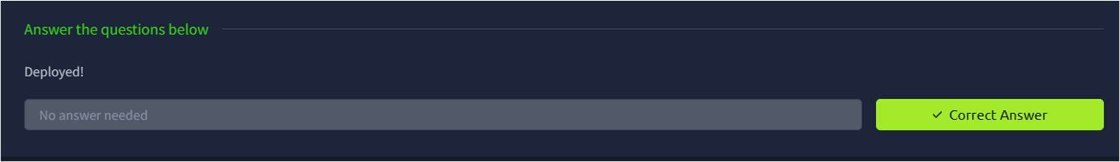
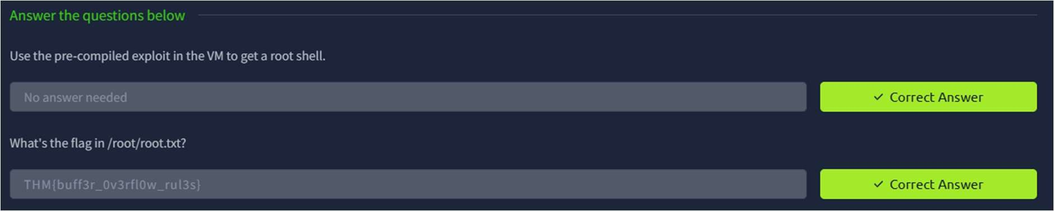

CR23431 - Network Security Lab 241901046-Keerthika.K

5. STACK BASED BUFFEROVERFLOW ATTACKS
DATE: 25/02/2026
TAoimexp:lore CVE-2019-18634 in the Unix Sudo Program.
Procedure:

- Log into TryHackMe and open the Sudo Buffer Overflow room.
- Study the basics of buffer overflow vulnerabilities in Unix systems.
- Understand the vulnerability CVE-2019-18634 in the Sudo program.
- Analyze how improper input handling leads to memory overflow.
- Explore the steps used to identify and exploit the vulnerability in a controlled
environment.
- Complete the tasks and answer the questions in the room.
- Review mitigation techniques and confirm completion.

Tasks:

TASK 1 – Deploy!

TASK 2 – Buffer Overflow

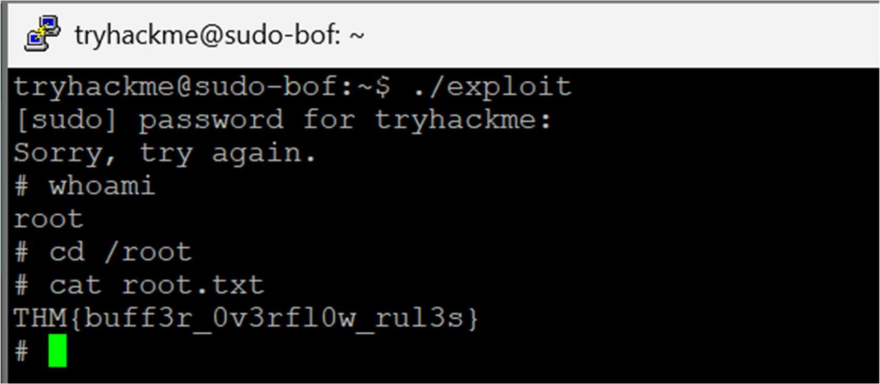

CR23431 - Network Security Lab

Result:
Thus the TryHackMe room Sudo Buffer Overflow was completed successfully.

