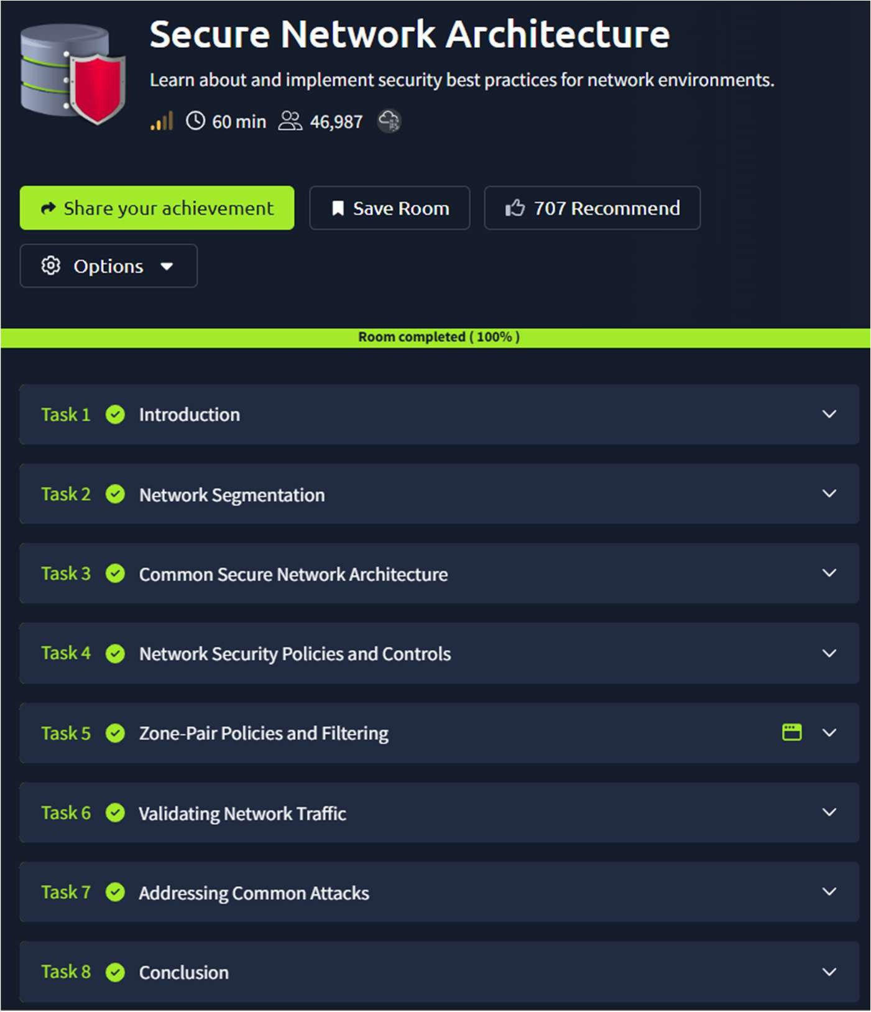

CR23431 - Network Security Lab 241901046-Keerthika.k

7. SECURE NETWORK ARCHITECTURE
DATE: 11/03/2026
TAoimlea:rn about and implement security best practices for network environments.

Procedure:

- Log into TryHackMe and open the Secure Network Architecture room.
- Study the fundamentals of secure network design and architecture.
- Understand concepts like network segmentation and zoning.
- Learn the role of security devices such as firewalls and IDS/IPS.
- Explore best practices for protecting network infrastructure.
- Complete the tasks and answer the questions in the room.
- Review the summary and confirm completion.

Tasks:

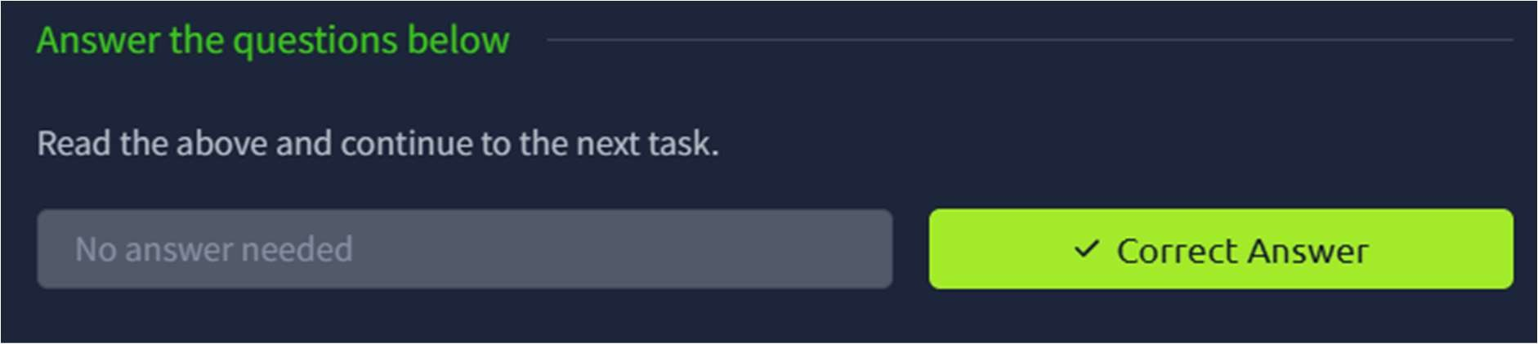
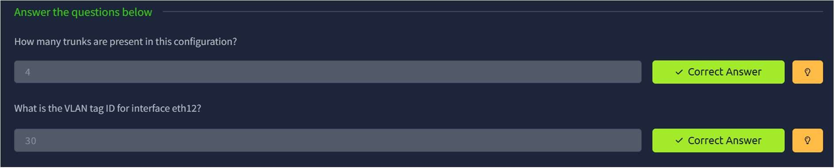
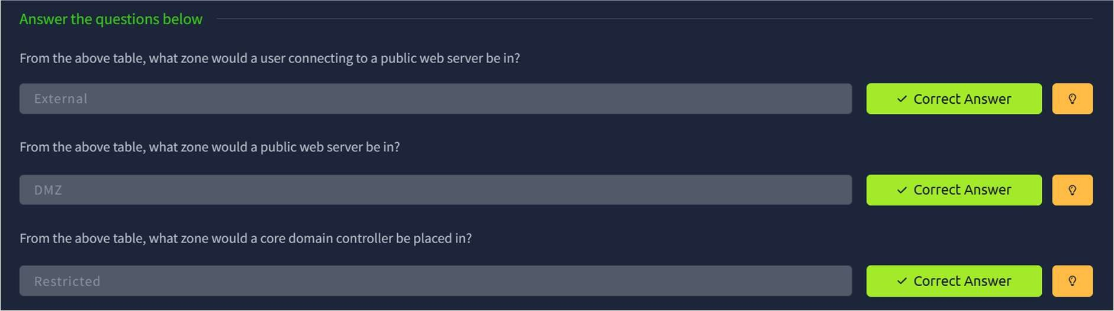
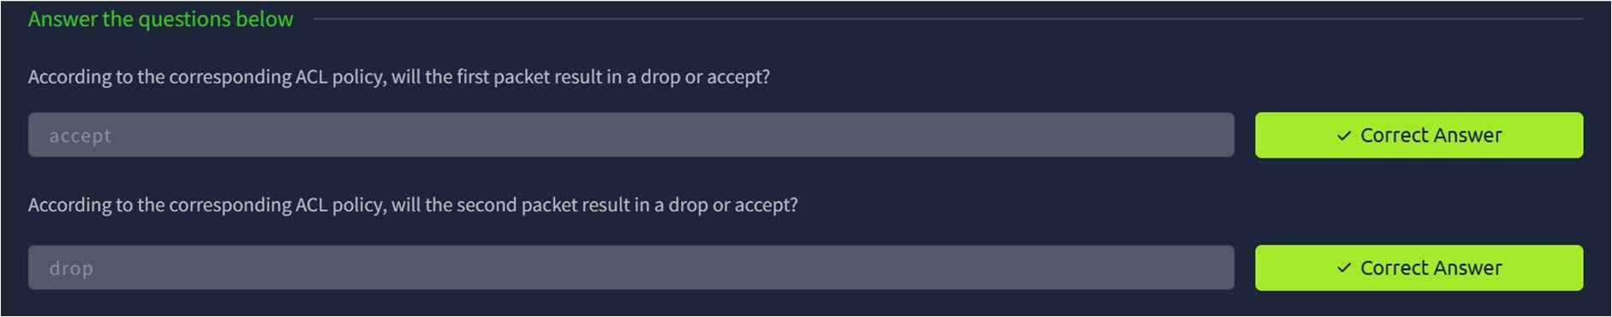
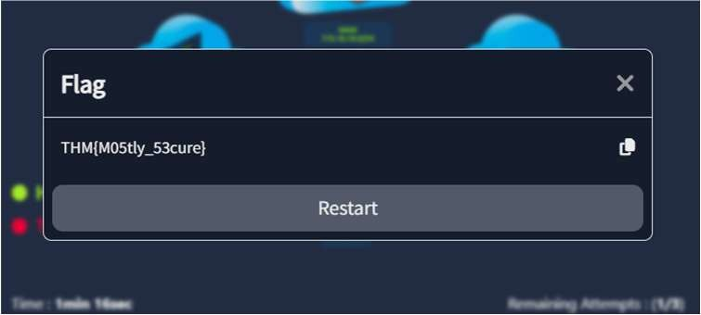

CR23431 - Network Security Lab
TASK 1 - Introduction

TASK 2 – Network segmentation

TASK 3 – Common Secure Network Architecture

TASK 4 – Network Security Policy and Controls

TASK 5 – Zone Pair Policies and Filtering

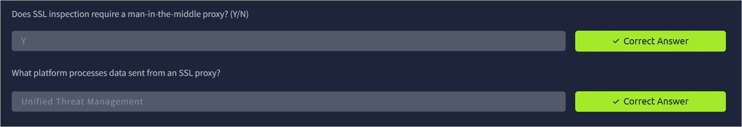
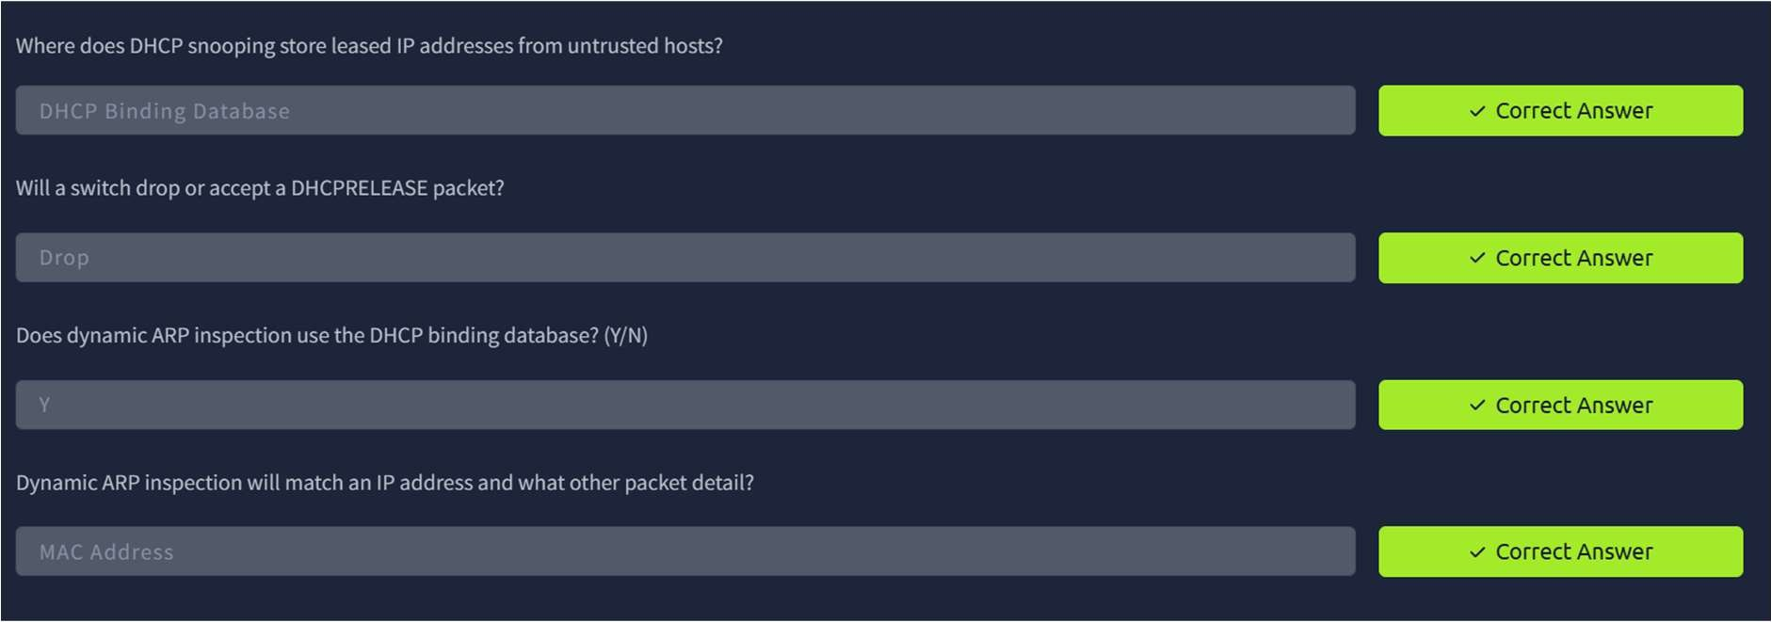
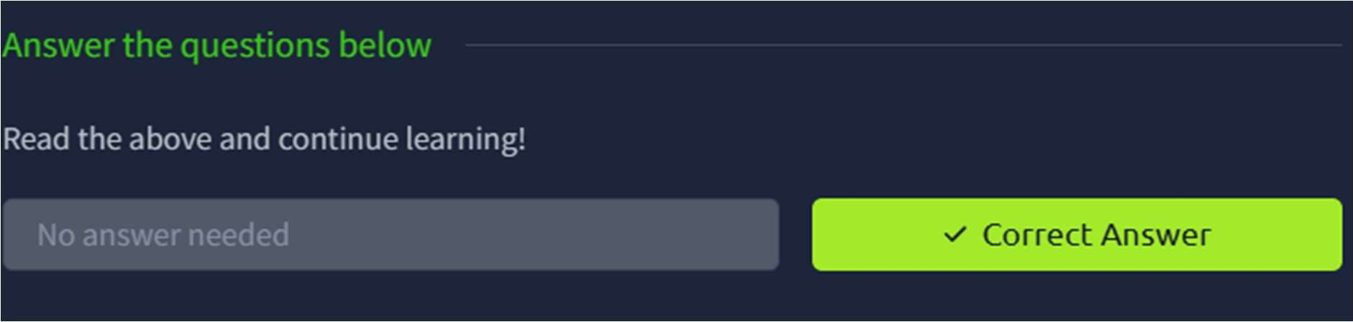

CR23431 - Network Security Lab
TASK 6 – Validating Network Traffic

TASK 7 – Addressing Common Attacks

TASK 8 – Conclusion

Result:
Thus the TryHackMe room Secure Network Architecture was completed successfully.

