**Experiment: 8**

**Create an Amazon Lex chatbot where the user can get the latest gold rate using web scraping.**

Step 1: **Set Up the Python Environment in AWS CloudShell**

**1.Open the AWS Management Console.**

**2.** **Run the following commands one by one to create the layer structure and install required packages:**

mkdir my-layer

cd my-layer

mkdir python

pip install requests -t python/

pip install beautifulsoup4 -t python/

cd ..



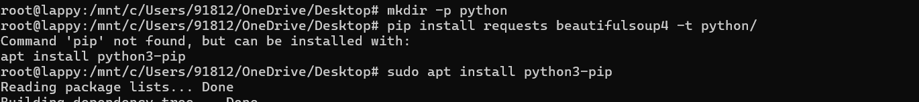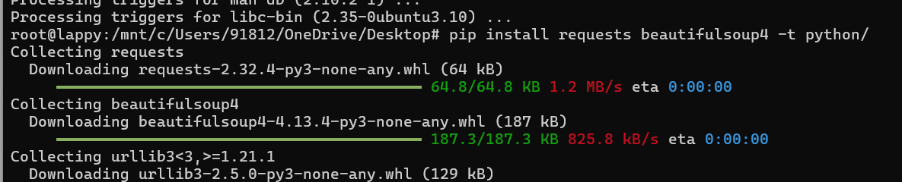

zip -r my-layer.zip my-layer/



Step 2: Create a Lambda Layer

1. Open the **Lambda service** in AWS Console.

2. Click on **“Layers”** in the left menu.

3. Click **Create layer**.

4. Enter the layer name (e.g., requests-bs4-layer).

5. Upload the my-layer.zip file.

6. Select **Compatible runtimes** as: Python 3.13.

7. Click **Create**.

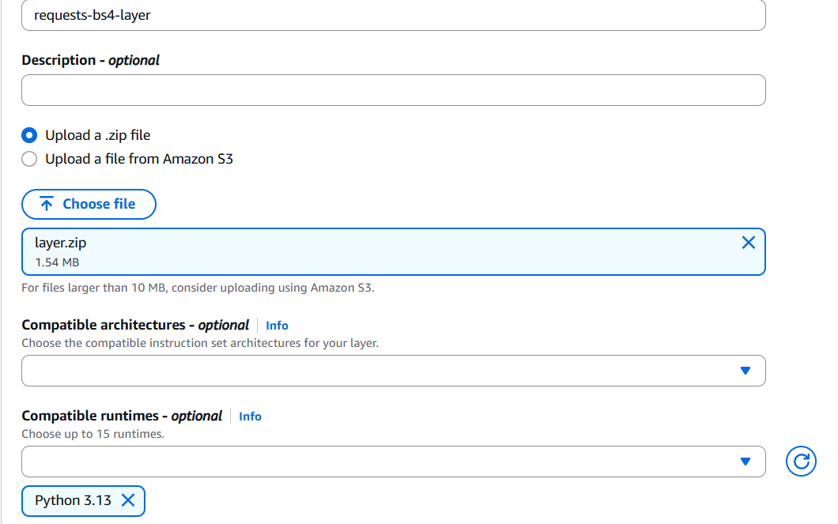

**Step 3: Create a Lambda Function**

1. Click **Create function**.
2. Choose **Author from scratch**.
3. Enter the function name as GetGoldRates.
4. Select **Python 3.13** as the runtime.
5. Click **Create function**.

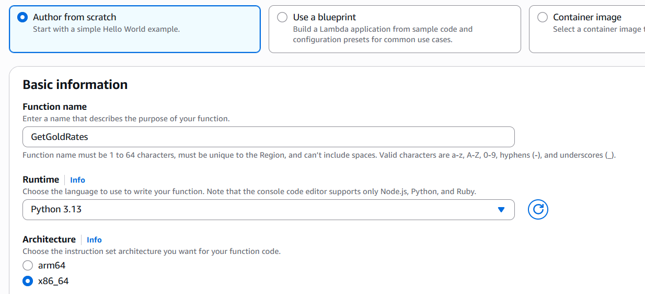

**Step 4: Attach the Lambda Layer to the Function**

1. Scroll down to the **Layers** section of the Lambda function page.
2. Click **Add a layer**.
3. Choose **Custom Layers**.
4. Select the requests-bs4-layer which we created earlier.
5. Version: 1
6. Click **Add**.

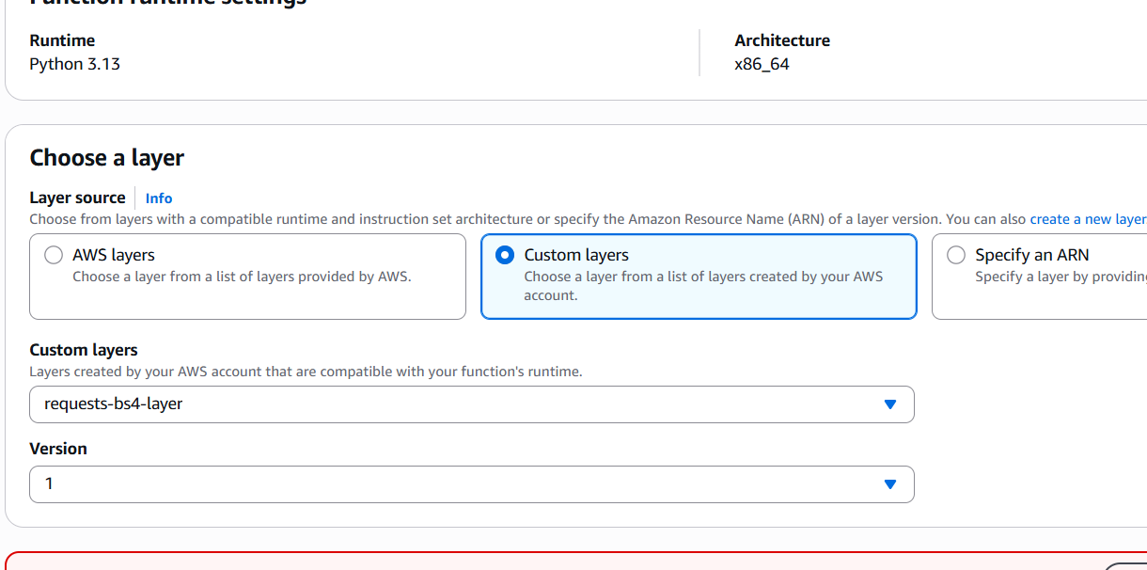

**Step 5: Edit the General Configuration**

1. Go to Configuration.
2. Click **Edit.**
3. Memory: **512 MB**.
4. Timeout: 45 sec (to ensure webscraping happens)
5. Click **Save**.

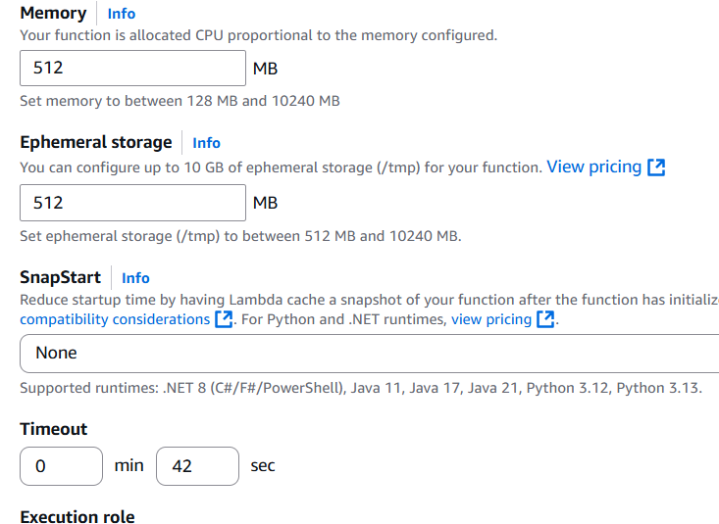

**Step 6:**

**Go to the Code section and paste the following code.**

import requests

from bs4 import BeautifulSoup

def lambda_handler(event, context):

    url = 'https://www.bankbazaar.com/gold-rate.html'

    headers = {"User-Agent": "Mozilla/5.0"}

    response = requests.get(url, headers=headers)

    soup = BeautifulSoup(response.content, 'html.parser')

    table = soup.find('table')

    hyderabad_rate_24k = None

    if table:

    rows = table.find_all('tr')

        for row in rows[1:]:

            cols = row.find_all('td')

            if len(cols) >= 3:

                city = cols[0].get_text(strip=True).lower()

                rate_24k = cols[2].get_text(strip=True).split('(')[0].strip()

                if city == 'hyderabad':

                    hyderabad_rate_24k = rate_24k

                    break

    if hyderabad_rate_24k:

        message = f"The current 24K gold rate in Hyderabad is {hyderabad_rate_24k}."

    else:

        message = "Sorry, I couldn’t find the gold rate for Hyderabad."

    # ✅ Very important: Return in Lex V2 format

    return {

        "sessionState": {

            "dialogAction": {

                "type": "Close"

            },

            "intent": {

                "name": "GetGoldRate",

                "state": "Fulfilled"

            }

        },

        "messages": [

            {

                "contentType": "PlainText",

                "content": message

            }

        ]

    }

**Note: Intent name in the code should match with the intent name which we are going to create later (in Lex).**

**Deploy the code.**

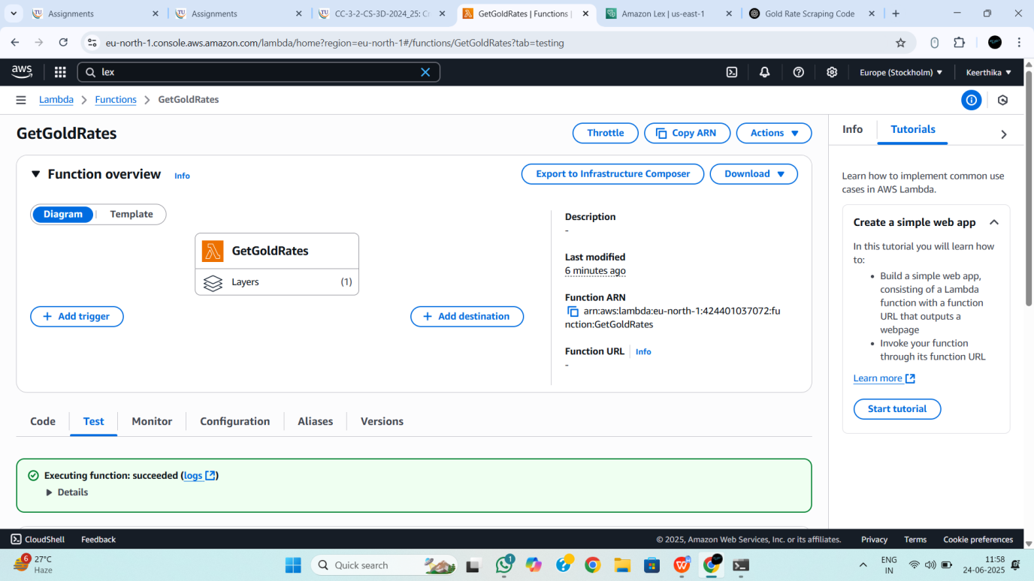

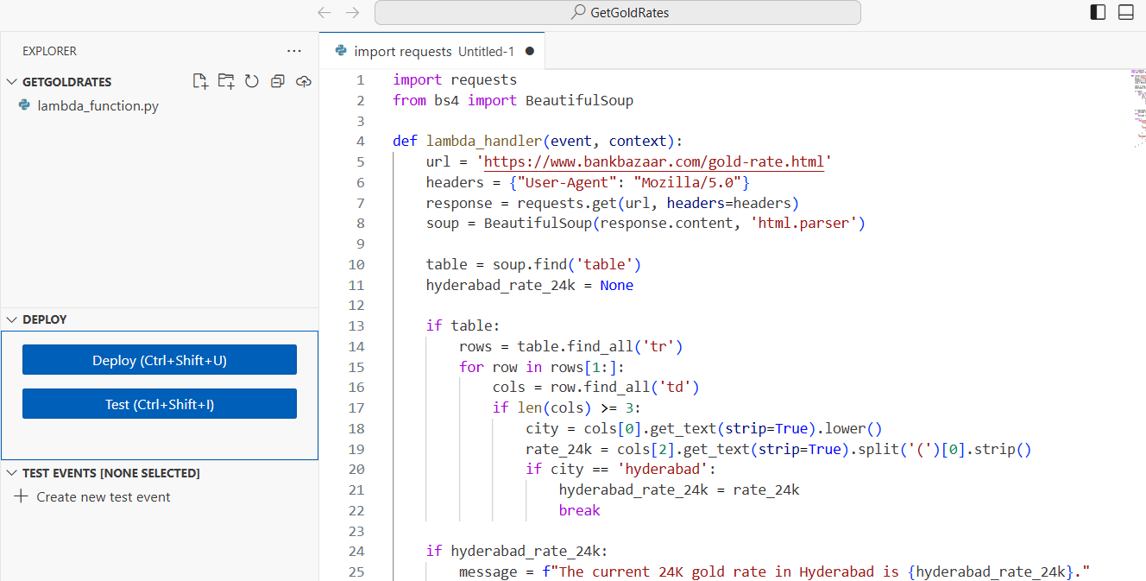

**Create a new test event.**

**Name: goldtest**

**Event JSON: {}**

**Click on Save**

**Run the test (On successful execution, we get Status: Succeeded).**

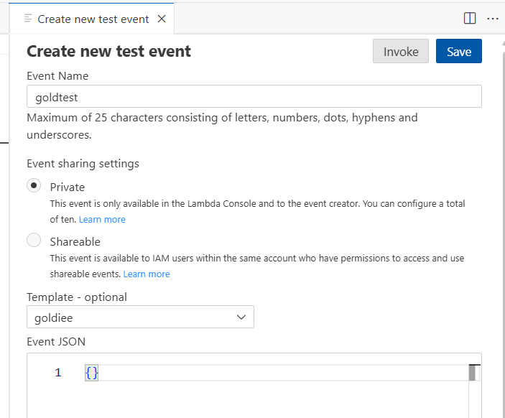 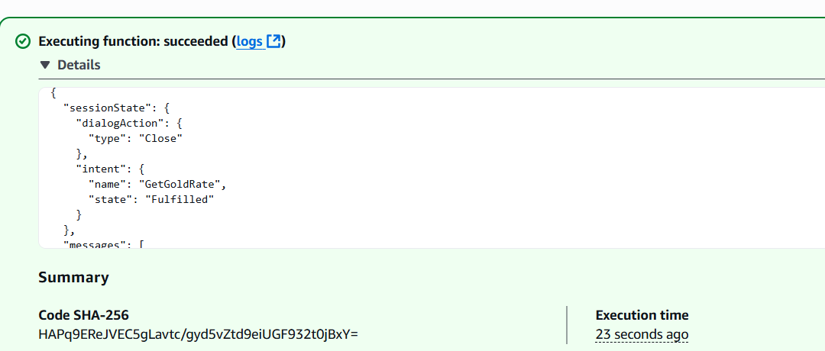

**Step 7: Create a Lex Bot**

1. **Open the Lex service from the AWS Console.**
2. **Click Create bot.**
3. **Enter the bot name as GoldRateBot.**
4. **Runtime role: Create a role with basic Amazon Lex permissions**
5. **COPPA: No**
6. **Select English (US) as the language.**
7. **Click Next, then click Done.**

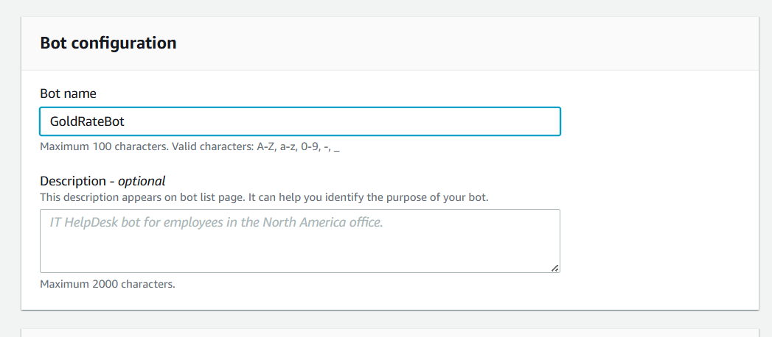

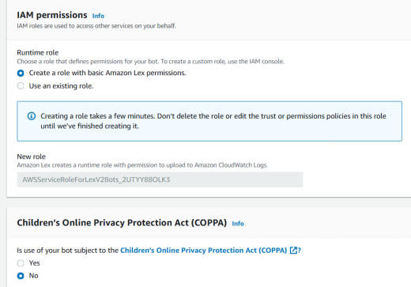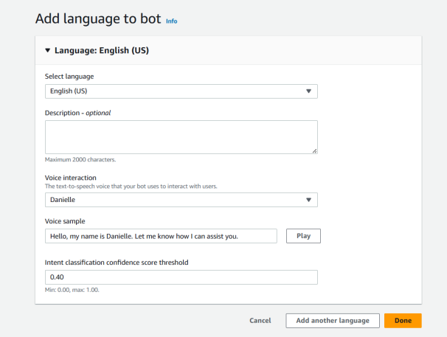

**Go Back to the intents list**

**Choose Add Intent**

**Name: GetGoldRate**

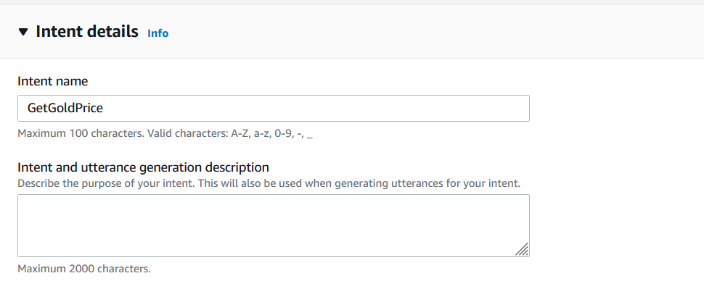

**Add the following sample utterances:**

**What is the gold rate?**

**Tell me Hyderabad gold price**

**Gold rate today**

**What is the gold price in Hyderabad?**

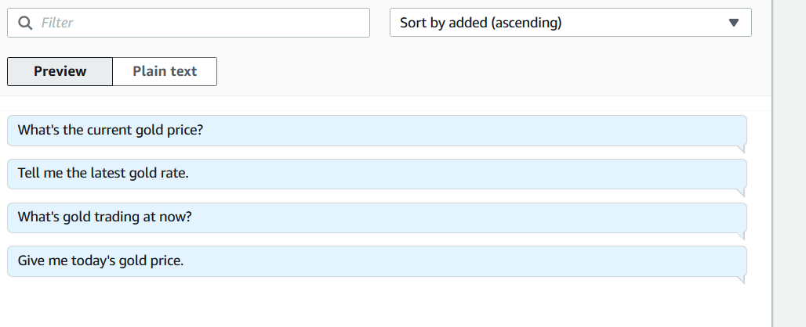

**Scroll to the Fulfillment section.**

**Turn on Lambda function fulfillment.**

**Click Save Intent.**

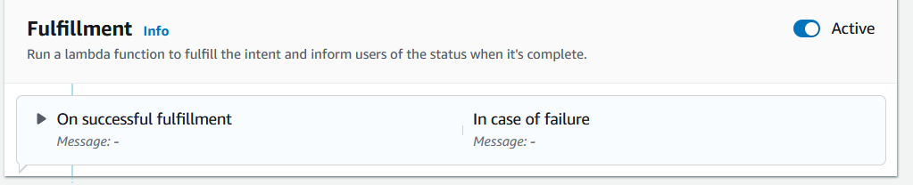

**Go to Aliases section**

**Click TestBotAlias**

**Go to Languages Section -> Click on English**

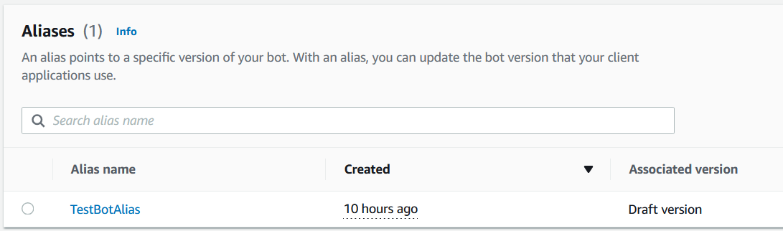

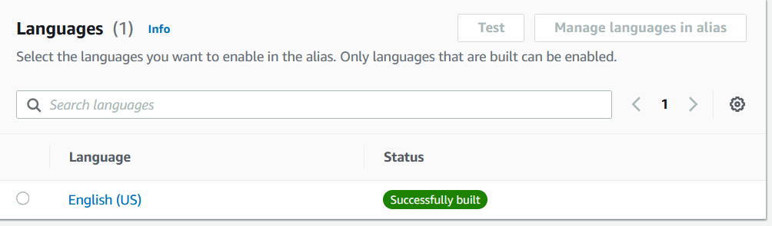

**Select the Lambda function from dropdown**

**Click Save.**

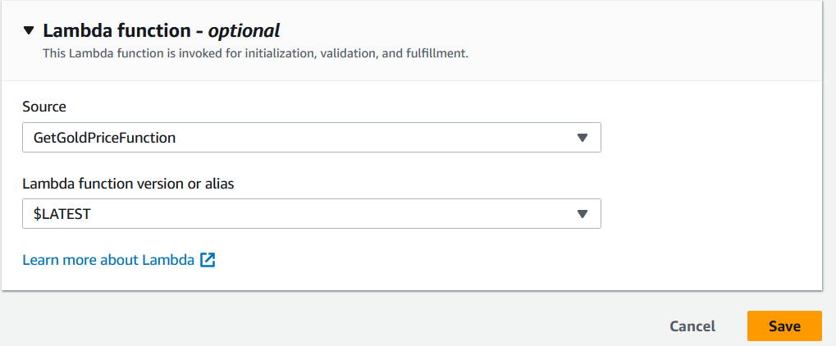

**Go back to the Intents list and Build the bot.**

**Finally, Test the bot**

