|  |
| --- |
| **Lab Experiment13: IAM User with S3 Read-Only and Full Access Groups**  **Objective**  Create a New IAM User with new programmatic access and restrict them to read only Access with Amazon S3 Bucket. the new Iam should be a roll no  Name: s3\_rollno  Access type: programmatic access  permission Amazons3 read only access. |

**Step 1: Sign in to the AWS Management Console**

* Go to: [https://console.aws.amazon.com/](https://console.aws.amazon.com/" \t "_new)
* Log in with your administrator credentials.

**Step 2: Open the IAM Console**

* In the AWS Console, search for **IAM** in the search bar.
* Click on **IAM (Manage Access to AWS resources)**.

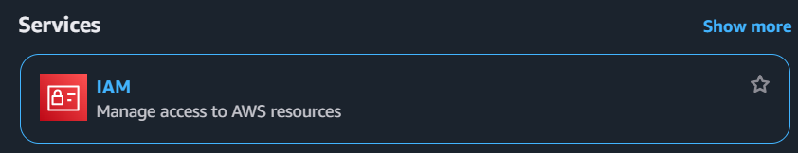

**Step 3: Create IAM Groups**

**🔹 Create Teacher (Full S3 Access)**

1. Go to **IAM** → **User groups** → **Create group**.
2. **Group name**: teacher
3. Click **Next**.
4. In **Permissions policies**, search for: AmazonS3ReadOnly
5. Select it → Click **Next** → **Create group**

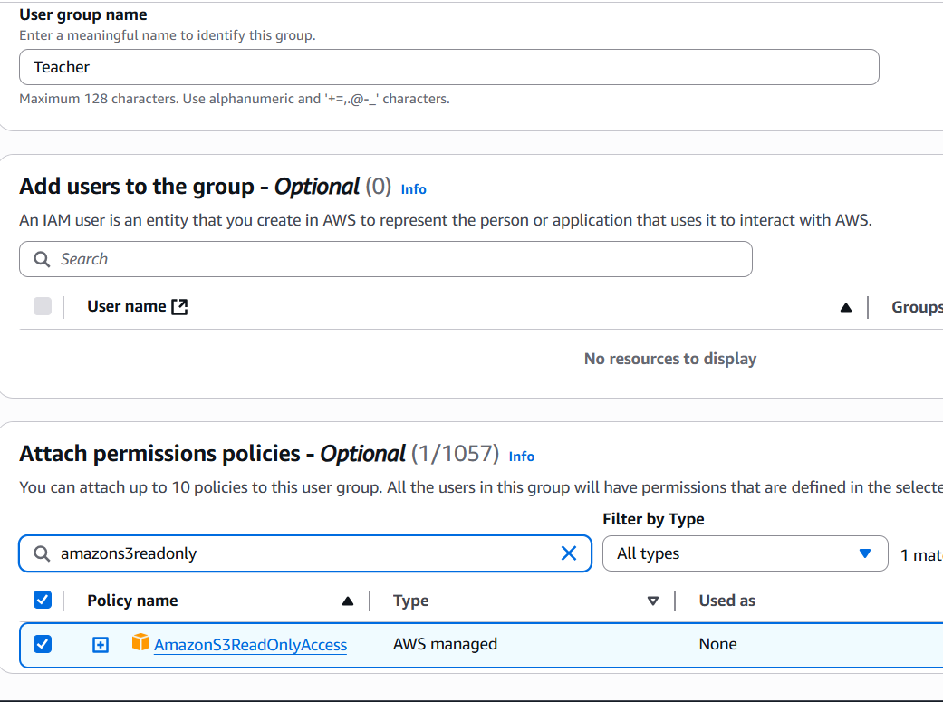

**🔹 Create Student (Read-Only S3 Access)**

1. Again, go to **User groups** → **Create group**.
2. **Group name**: grp2
3. Click **Next**.
4. Search: AmazonS3ReadOnlyAccess
5. Select it → Click **Next** → **Create group**

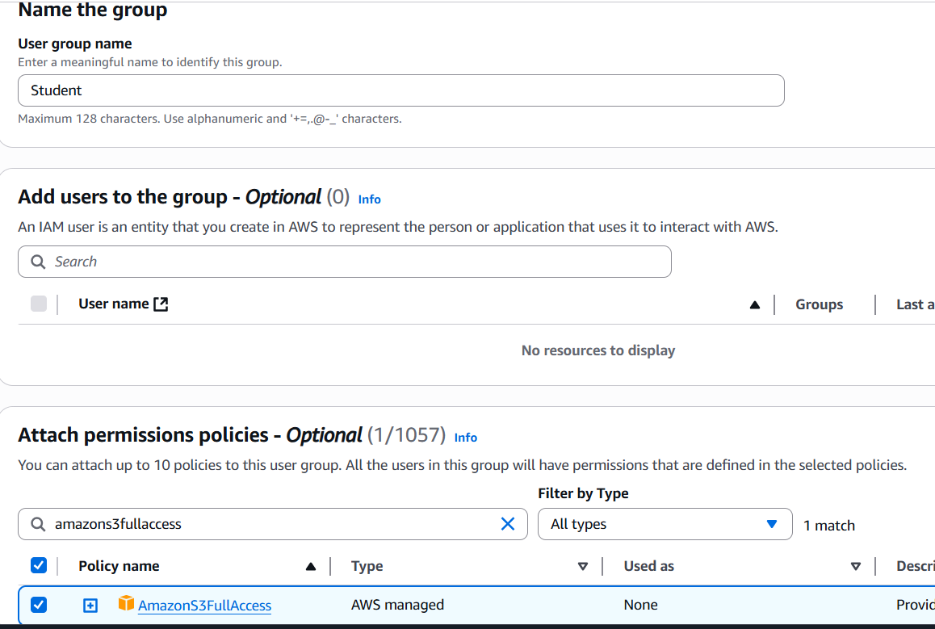

**Step 4: Create iam\_teacher (Read-only user)**

1. **Go to IAM Console → Users → Add users**
2. **User name: iam\_teacher**
3. **✅ Enable Console access**
4. **Select:**
   * **Autogenerated password (or create your own)**
   * **✅ Require password reset on first sign-in (recommended)**
5. **Click Next**

**➡️ On Permissions:**

* **Choose Add user to group**
* **Select ✅ teacher group**
* **Click Next → Create user**

**📝 Note: AWS will show a login link like:  
https://your-account-alias.signin.aws.amazon.com/console**

**Save it and share it with the user.**

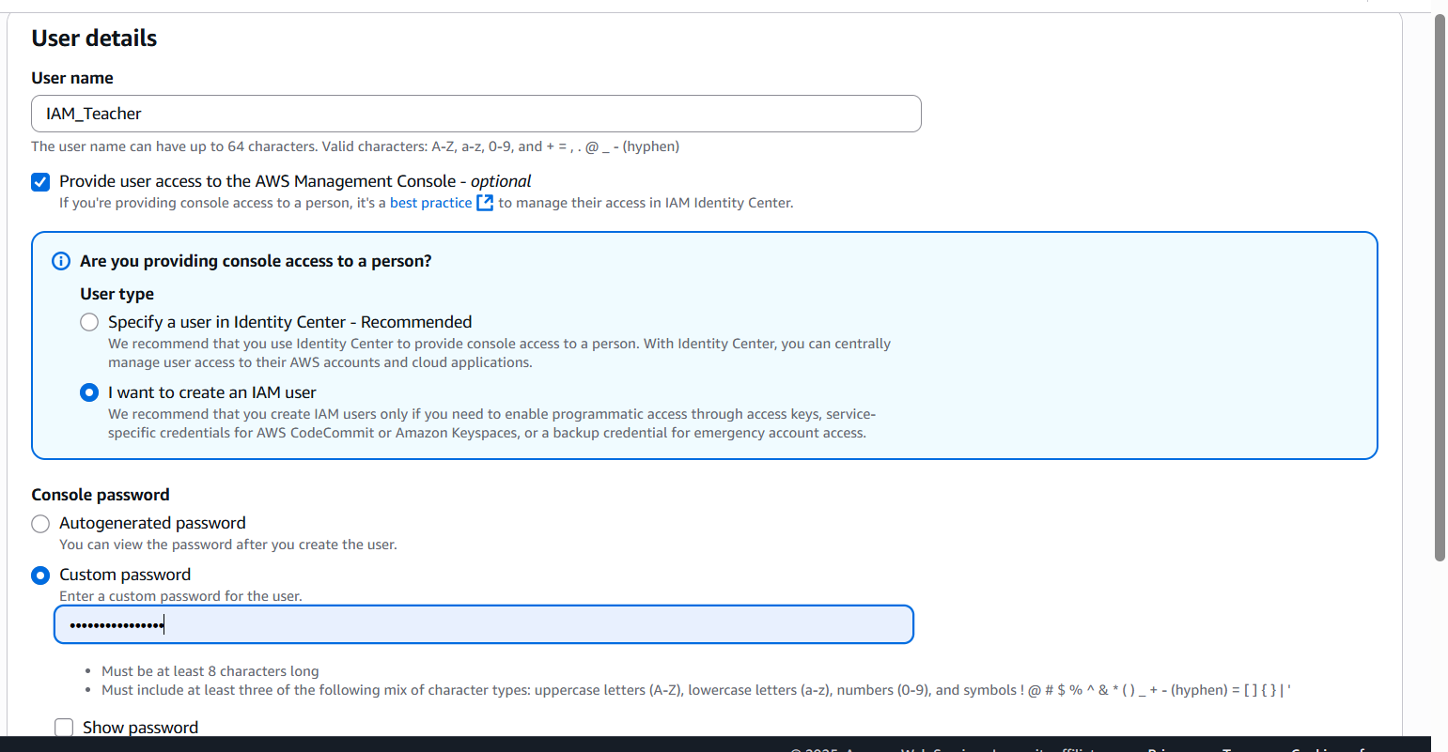

**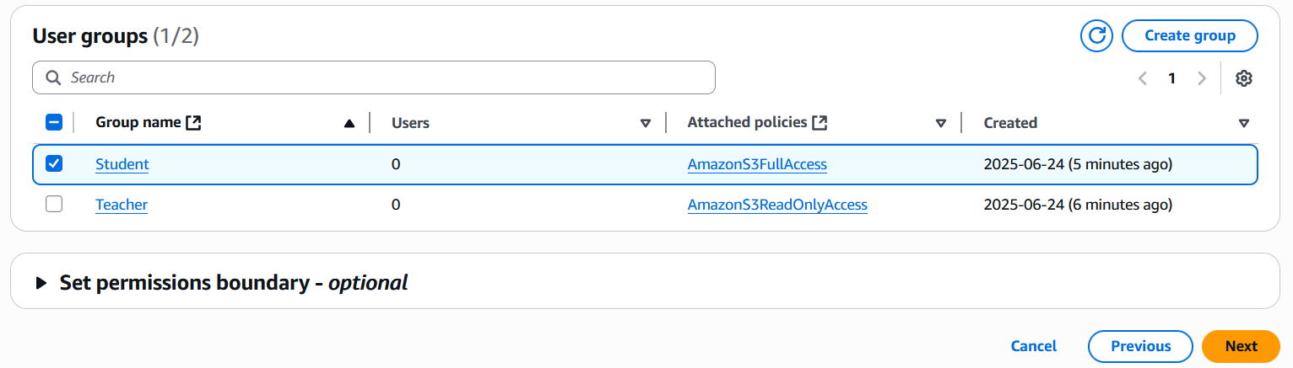**

**👤 2.2 Create iam\_student (Full-access user)**

**Repeat the same steps:**

1. **User name: iam\_student**
2. **✅ Console access**
3. **Assign to student group**
4. **Complete user creation**

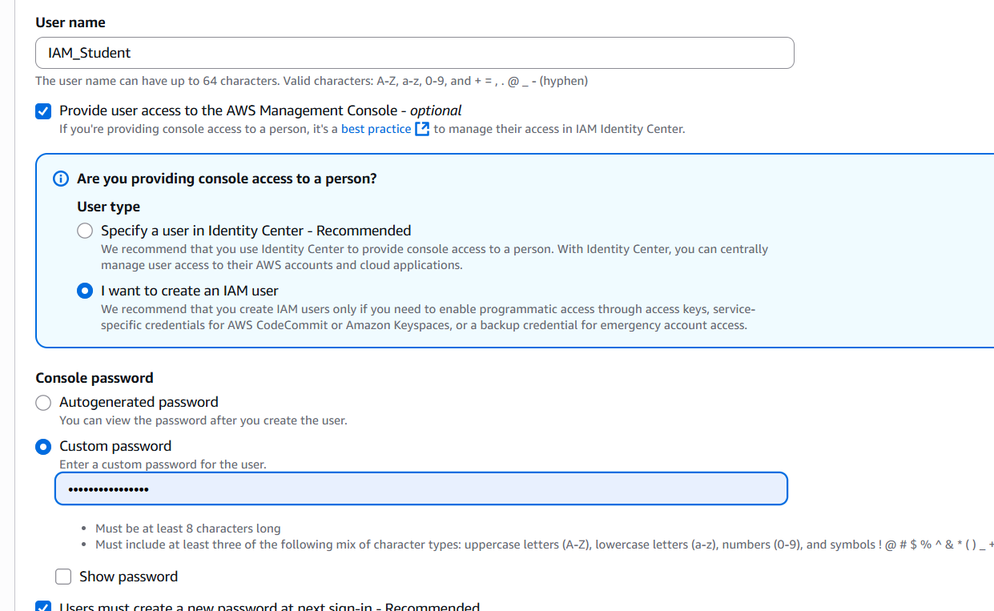

**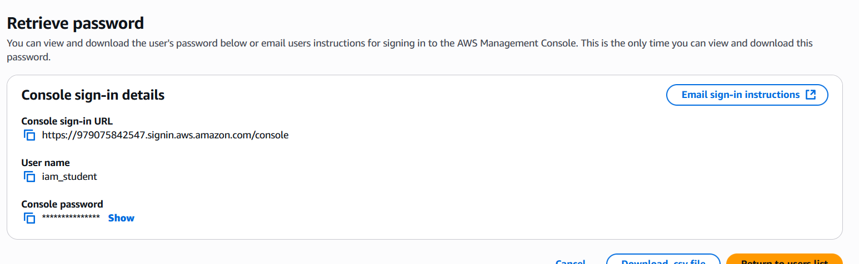**

**🔍 Step 3: Test via AWS Console Login**

Give each user their login URL, username, and password.

**🧪 For iam\_student:**

* Login to AWS Console
* ✅ Can fully interact with S3 (create/upload/delete objects and buckets)
* Uploading a file and checking the permissions

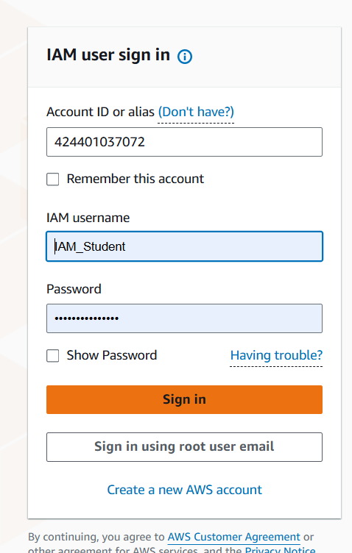

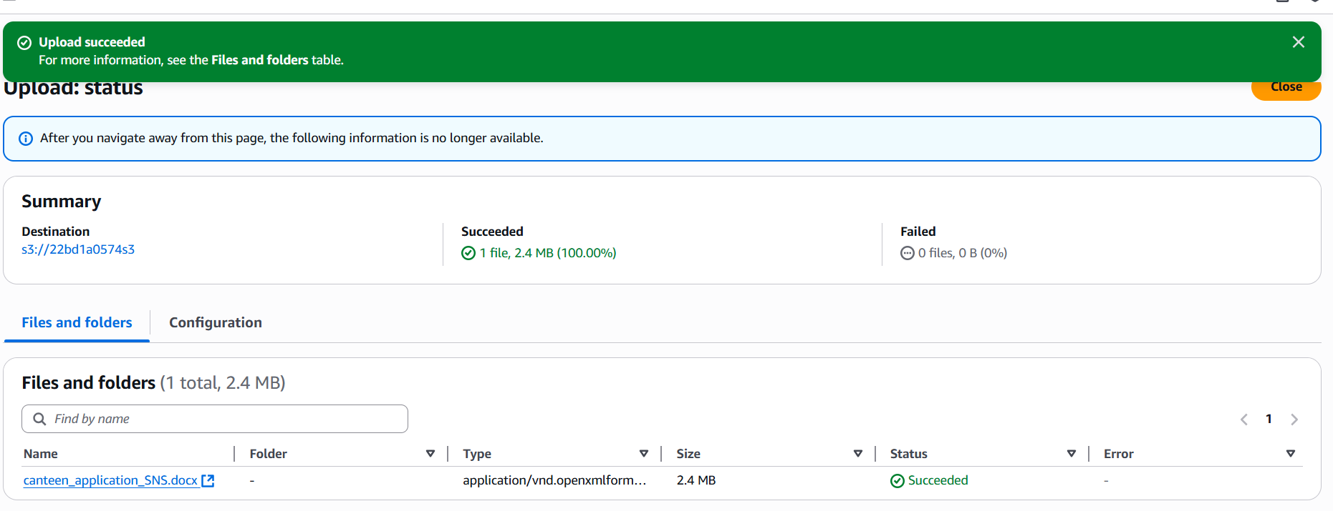

**🧪 For iam\_teacher:**

* Login to AWS Console
* Try opening **S3**
* ✅ Can **view buckets**, **list contents**
* ❌ Cannot upload/delete files

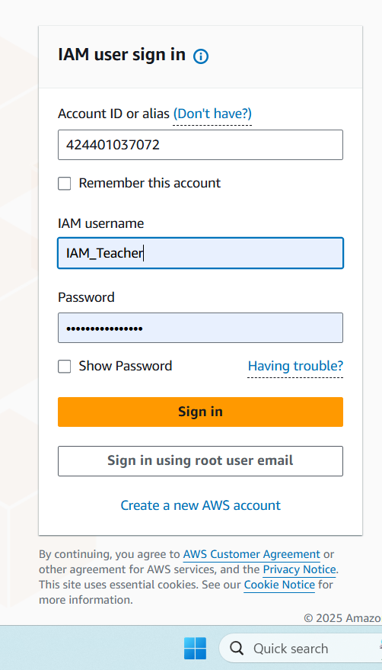

While uploading a random file we get “upload failed” message as its readonly access.

