|  |
| --- |
| **Experiment-11: SQS Activity** |

**Create an SQS Queue**

* Go to [Amazon SQS Console](https://console.aws.amazon.com/sqs/home" \t "_new).
* Click **Create queue**.

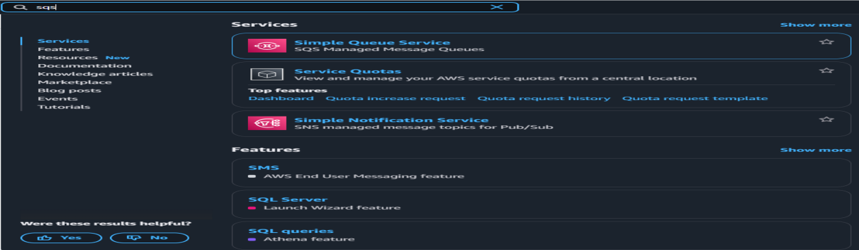

* Enter queue name (e.g.,SQSQueueExample).

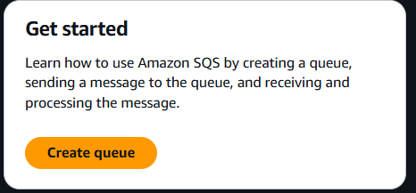

* Choose queue type (Standard or FIFO).

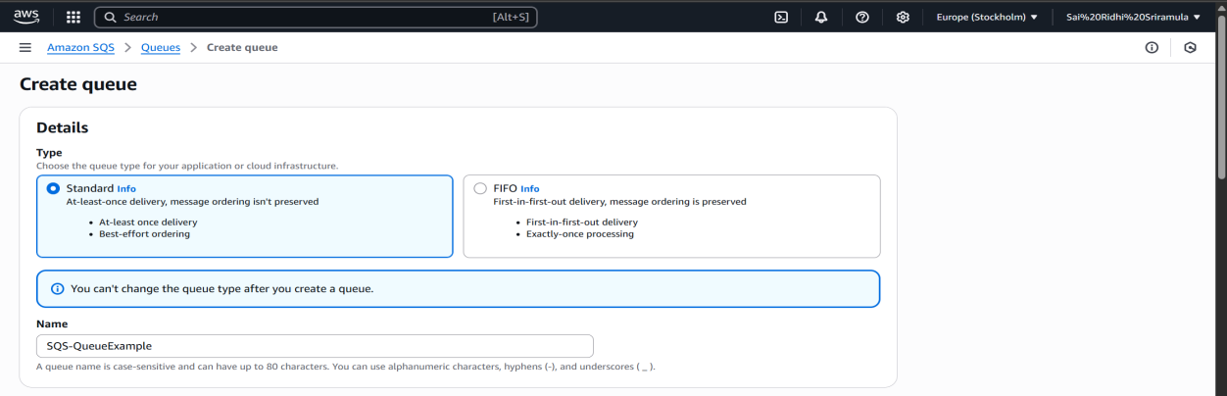

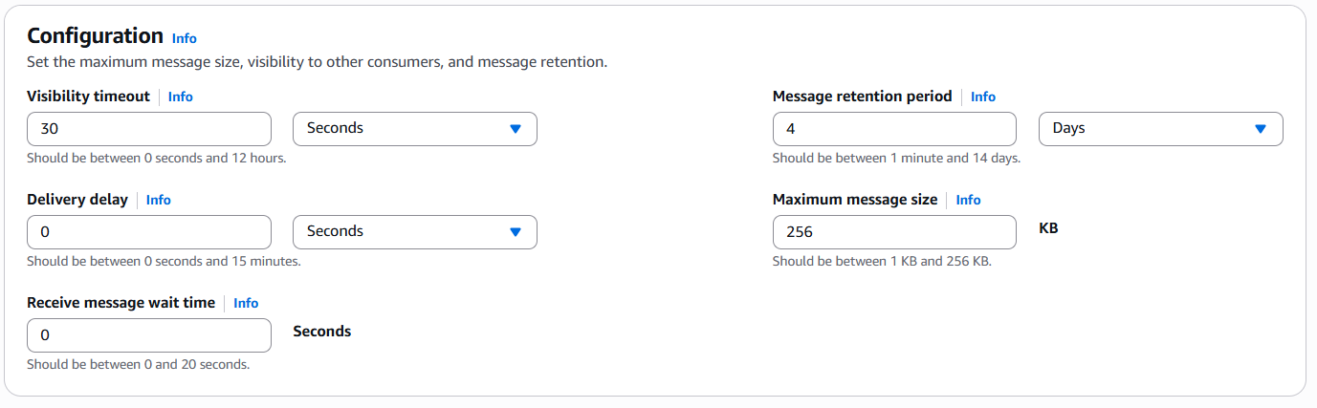

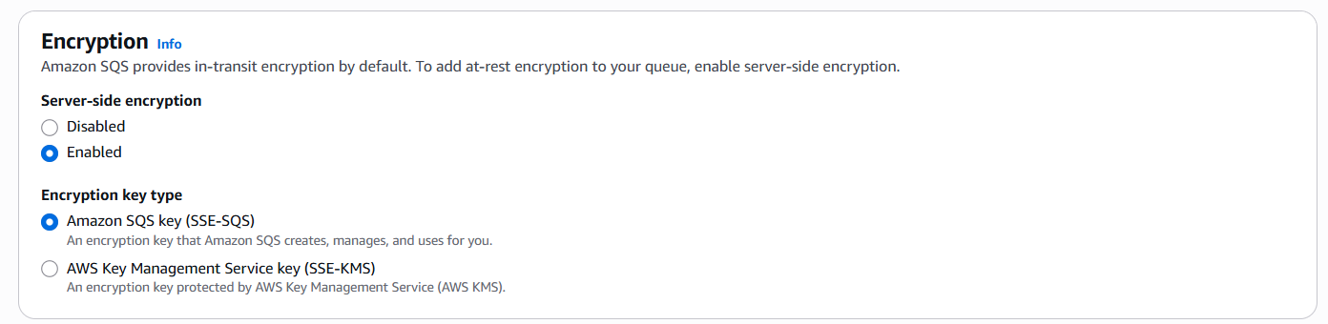

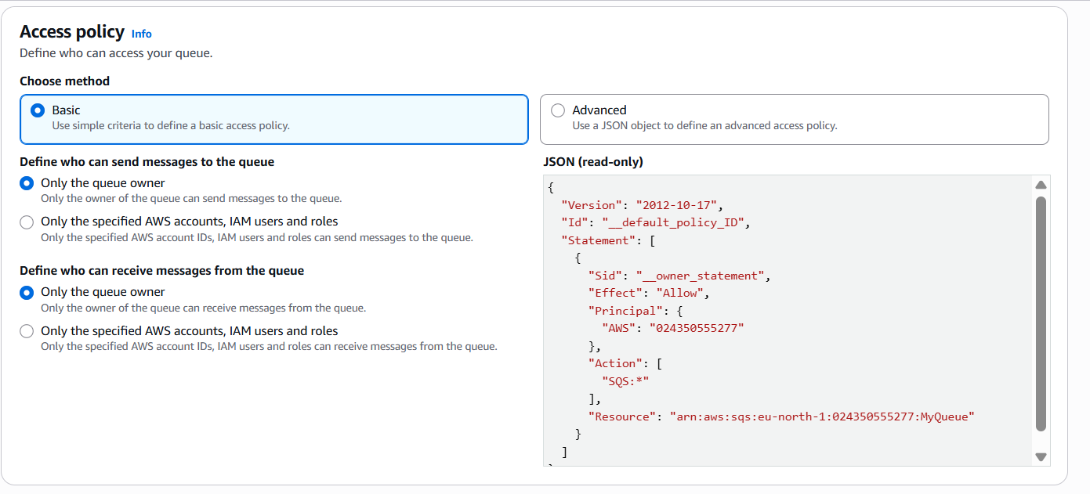

* Configure settings as needed.
* Create the queue.

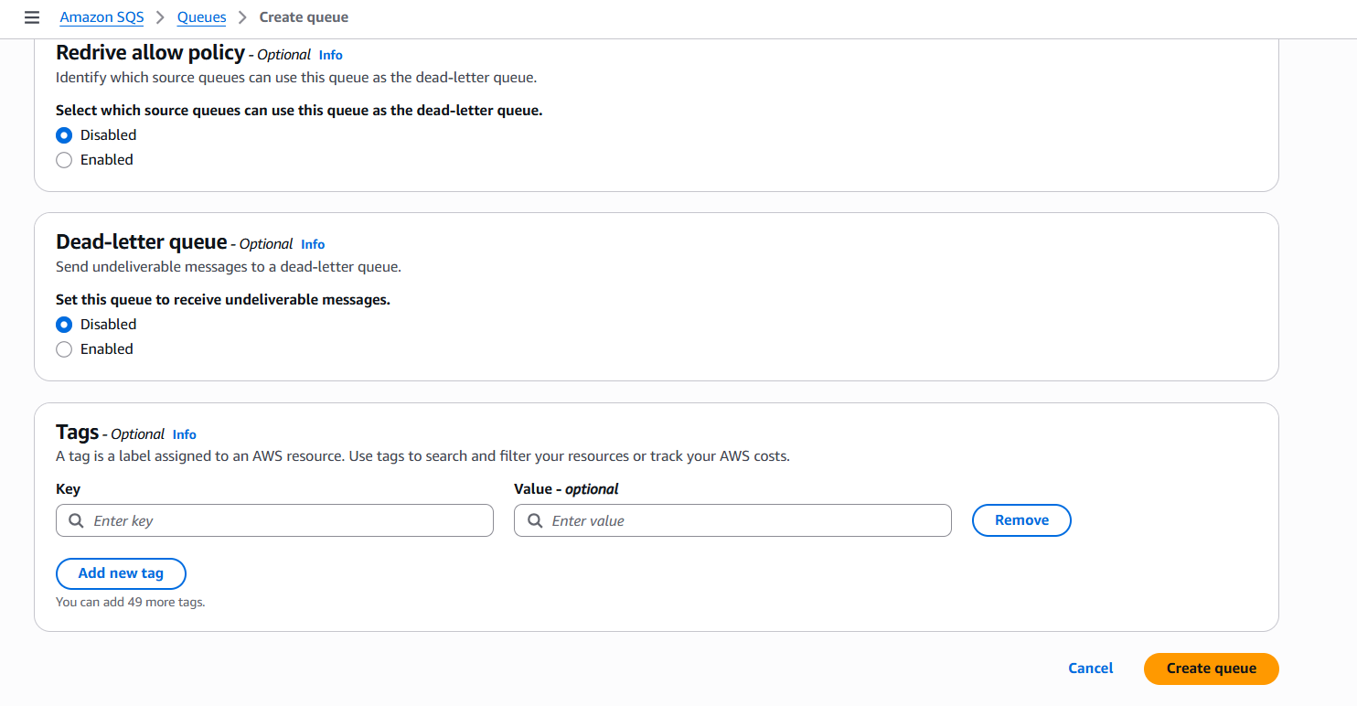

* Note the **Queue URL** (e.g. <https://sqs.eu-north-1.amazonaws.com/558762402600/SQS-QueueExample>).

**Create IAM Role for Lambda:**

**Step 1: Open IAM Console**

1. Go to: [https://console.aws.amazon.com/iam](https://console.aws.amazon.com/iam" \t "_new)
2. In the left sidebar, click **“Roles”**
3. Click the **“Create role”** button

**Step 2: Choose Trusted Entity**

* **Select type of trusted entity**: AWS service
* **Use case**: Select **Lambda**
* Click **Next**

**Step 3: Attach Permissions**

You can either attach a predefined AWS policy or create a custom one.

**Option A: Attach AWS Managed Policy**

For SQS access, search and select:

* AmazonSQSFullAccess *(for testing only — overly permissive)*
* or create a custom policy with least privileges.

**Step 4: Name and Create Role**

* Give your role a name, like LambdaSQSRole
* Click **Create role**

**Create or Choose a Lambda Function**

1. **Go to Lambda service and click on create function.**

* Go to the Lambda function → change role->Role we created previously.

Paste this code in code body section of lambda function:

import { SQSClient, SendMessageCommand, ReceiveMessageCommand } from "@aws-sdk/client-sqs";

const region = "eu-north-1"; // Change to your queue region

const queueUrl = "https://sqs.eu-north-1.amazonaws.com/123456789012/MyQueue"; // Replace with your actual SQS URL

const sqs = new SQSClient({ region });

export const handler = async (event) => {

// Send a message

const sendCommand = new SendMessageCommand({

QueueUrl: queueUrl,

MessageBody: "Hello from Lambda!"

});

await sqs.send(sendCommand);

// Receive a message

const receiveCommand = new ReceiveMessageCommand({

QueueUrl: queueUrl,

MaxNumberOfMessages: 1,

WaitTimeSeconds: 5

});

const response = await sqs.send(receiveCommand);

return {

statusCode: 200,

body: JSON.stringify({

sent: "Message sent to SQS.",

received: response.Messages || []

})

};

};

After testing the function:

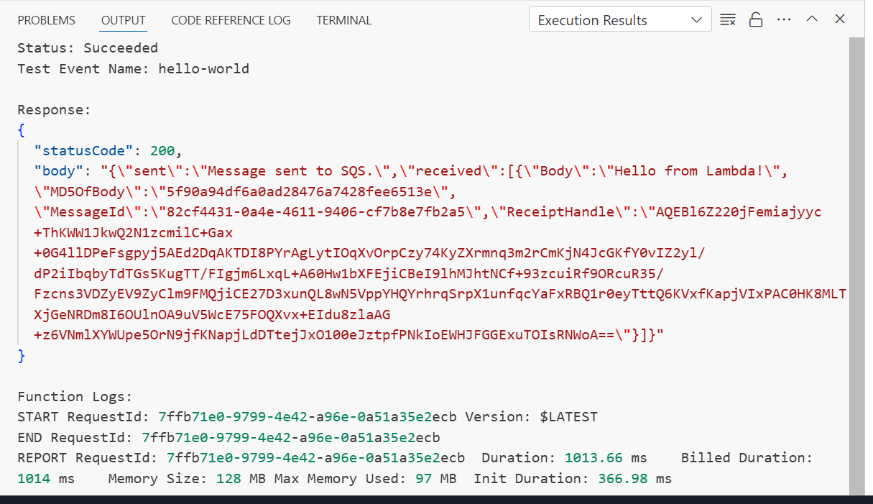

**8. Verify Message in AWS Console**

* Open [Amazon SQS Console](https://console.aws.amazon.com/sqs/home" \t "_new).
* Select your queue (MyQueue).

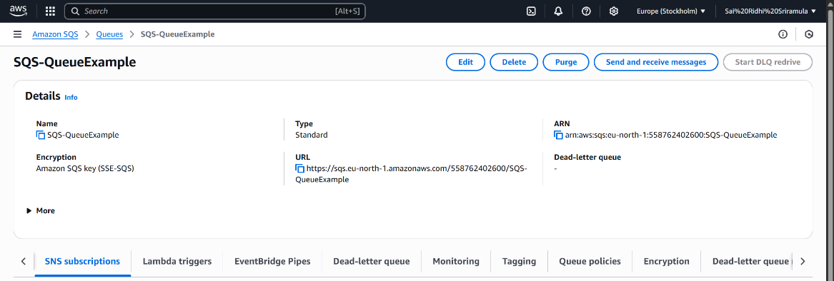

* Click **Send and receive messages**.
* Click **Poll for messages**.

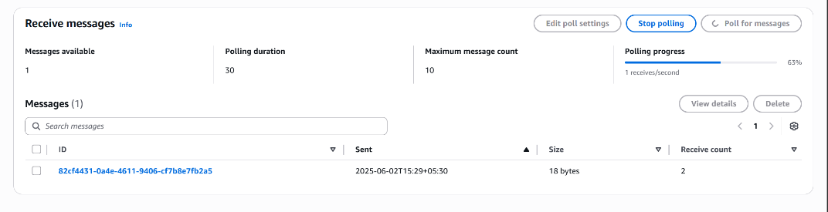

* You will see the message(s) you sent.

