|  |
| --- |
| **Experiment-4:**  Create and configure storage services and upload files and objects using Amazon EBS, Amazon EFS and Amazon S3  **Part-1:  Attach and Mount Extra EBS (Amazon Elastic Block Store) Volume to Linux EC2 in AWS** |

**Step 1: Access AWS Academy and Start the Lab**

1. Log in to [**AWS Academy**](https://awsacademy.instructure.com/).
2. Navigate to **Launch AWS Academy Learner Lab** and start the lab.
3. Click the **AWS Button** to activate your session.

**Step 2: Add an Extra EBS Volume (10GB) to an Existing EC2 Instance**

1. Open the **EC2 Dashboard** in the AWS Management Console.
2. Locate and select your **EC2 instance** (associated with your Roll Number).
3. In the instance details, click on the **Storage** tab.

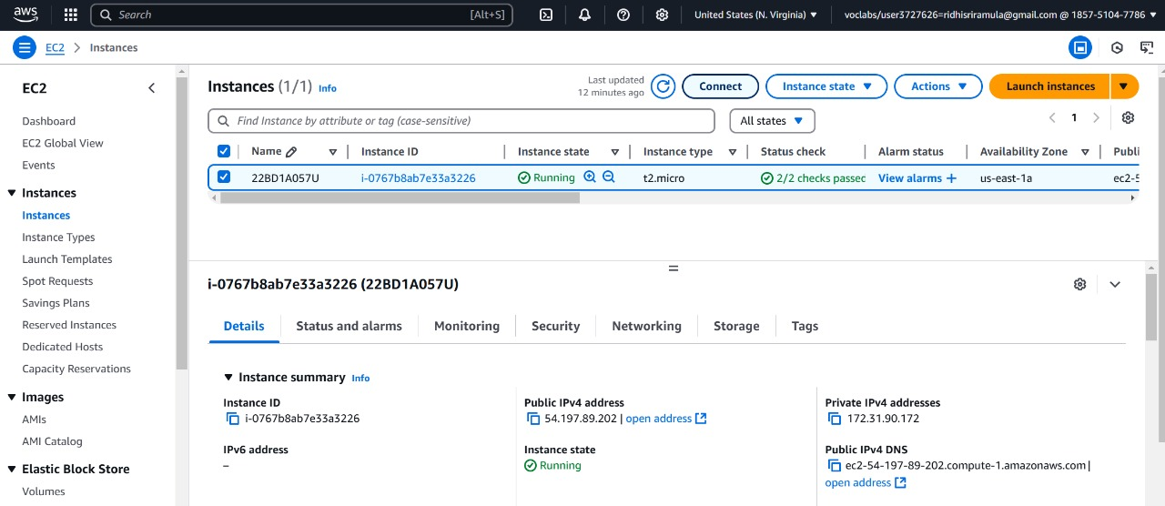

**Figure 4.1:** Launch an instance

1. 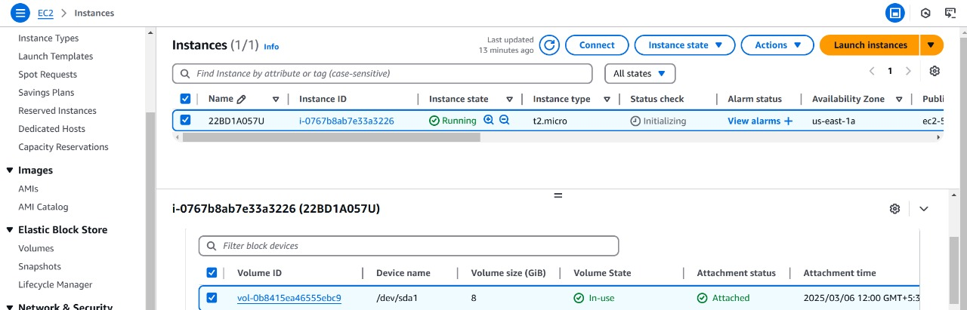Here, you will see information about existing storage, including the **current volume size (8 GiB)** and **Volume ID**.

**Figure 4.2:** Checking the volume state

**Step 3: Create a New 10GB EBS Volume**

1. In the left-hand menu, go to **Elastic Block Store (EBS)** → **Volumes**.
2. Click **Create Volume** (top-right corner of the page).

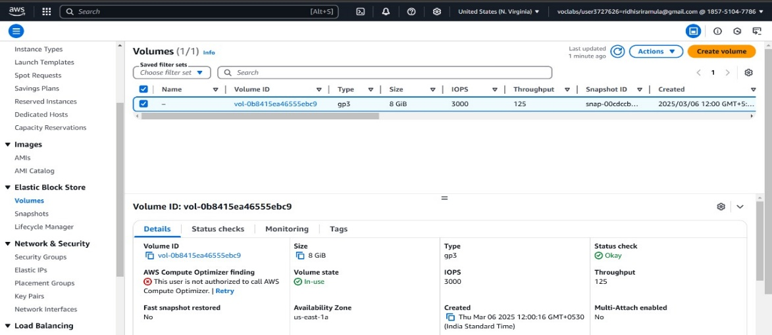

**Figure 4.4**

1. Configure the new volume:
   * **Volume Type**: General Purpose SSD (**gp2**) *(or choose as per your need)*
   * **Size**: **10 GiB**
   * **Availability Zone**: Must match your EC2 instance’s availability zone. *(Example: us-east-1a)*
   * **Tags (Optional)**:
     + **Key**: Roll No
     + **Value**: Extra-Volume-RollNo

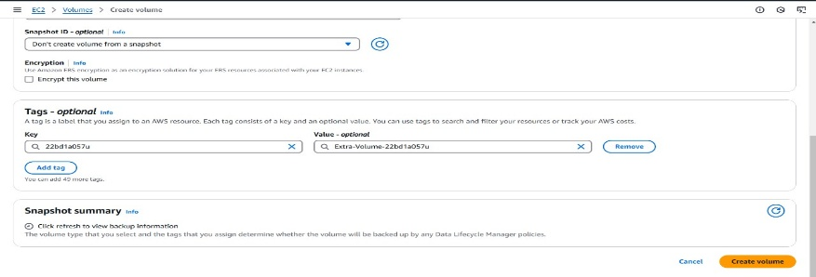

**Figure 4.5**

4.Click **Create Volume** to finalize.

5.Verify that the **Volume ID** of your instance matches the new EBS volume’s **Availability Zone**.

**Step 4: Attach the Newly Created Volume**

1. In the **EBS Volumes** section, locate the volume you just created.

2.Select the volume, click **Actions** (beside "Create Volume"), and choose **Attach Volume**.

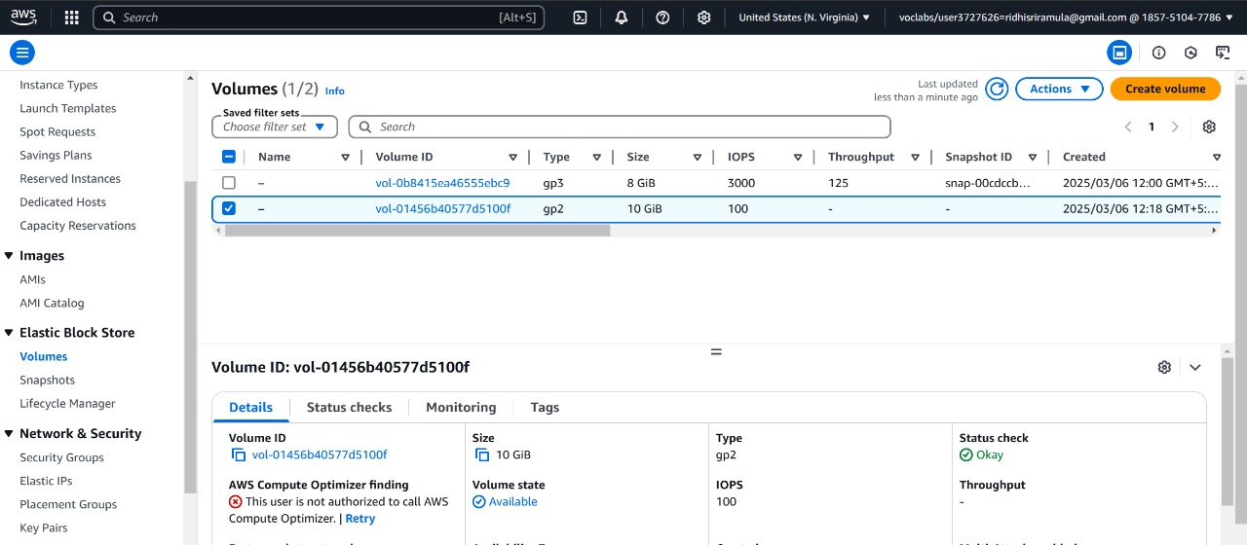

**Figure 4.6:Attach Volume**

3.Select your EC2 instance (linked to your Roll Number).

4.Set the **Device Name** as /dev/sdf *(default name)*.

5.Click **Attach Volume**.

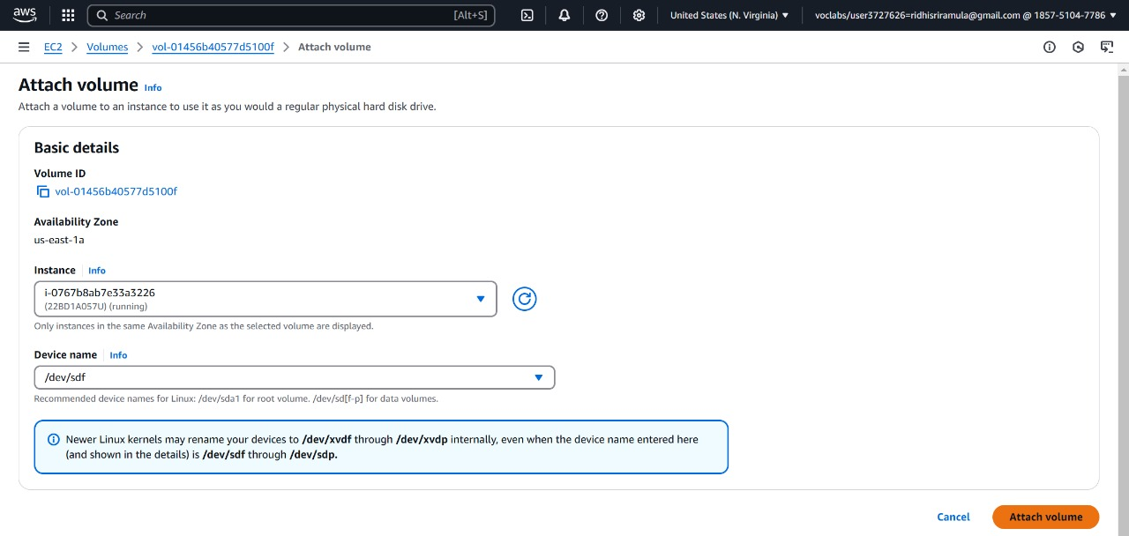

**Figure 4.7:** Attach the volume

6.The new volume will now be in the **in-use** state.

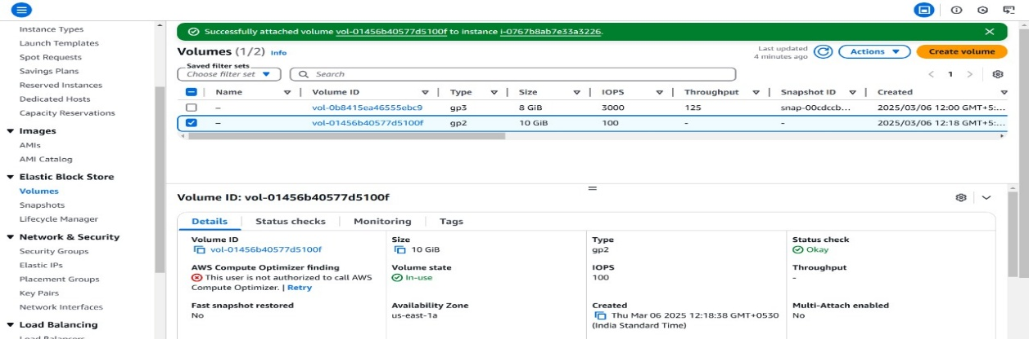

**Figure 4.8: Checking the volume**

**Step 5: Verify and Mount the Attached Volume**

1. Connect to your EC2 instance:
   * Go to the **EC2 Dashboard** → **Instances**.
   * Select your instance and click **Connect** → **EC2 Instance Connect**.
2. Switch to the root user:

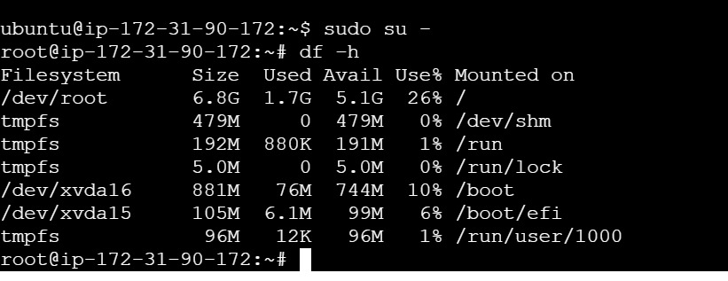

**Figure 4.9: terminal**

*(At this point, the new volume will not appear because it is not yet formatted or mounted.)*

1. List all block devices to confirm the new volume:

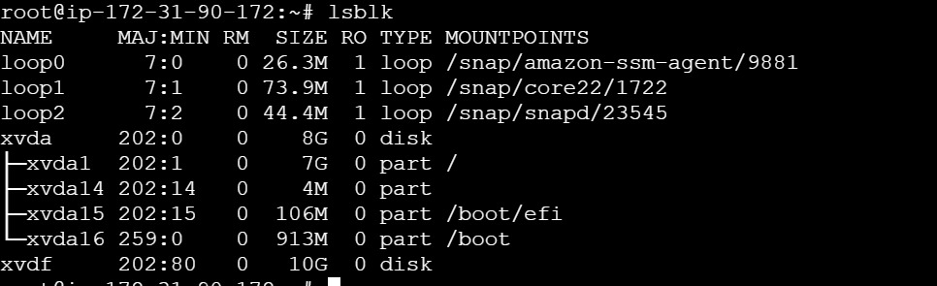

**Figure 4.10**

4.Check if a filesystem exists on the new volume:



**Figure 4.11**

If the output shows **"data"**, it means the volume is blank and needs to be formatted.

5.Format the new volume with the XFS file system:

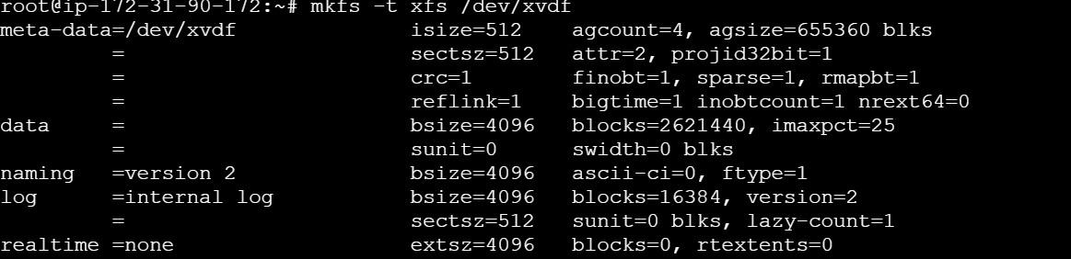

**Figure 4.12**

6.Verify that the file system is now created:



**Figure 4.13**

*(The output should now indicate an XFS file system.)*

**Step 6: Mount the Volume to the EC2 Instance**

1. Create a new directory to mount the volume:
2. Mount the volume to the directory:
3. Verify the mounted directory:
4. Check the mounted file system:

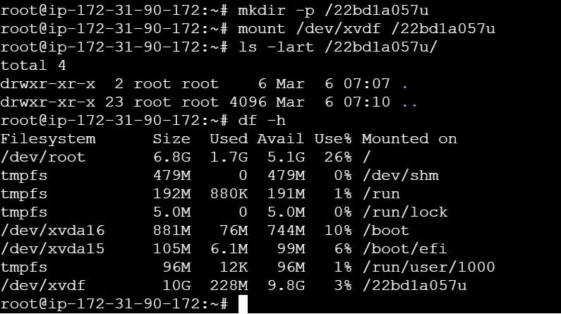

**Figure 4.14**

5.Creating a File called 1.txt

6.Open vi editor & Insert your Roll no

7.To save 1.txt File

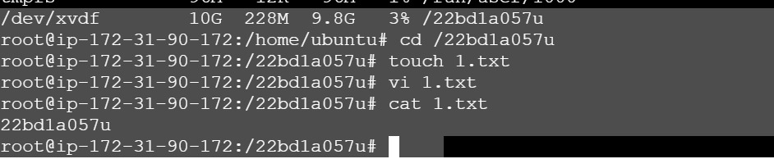

**Figure 4.15**

8.To confirm the total size of the attached volume:

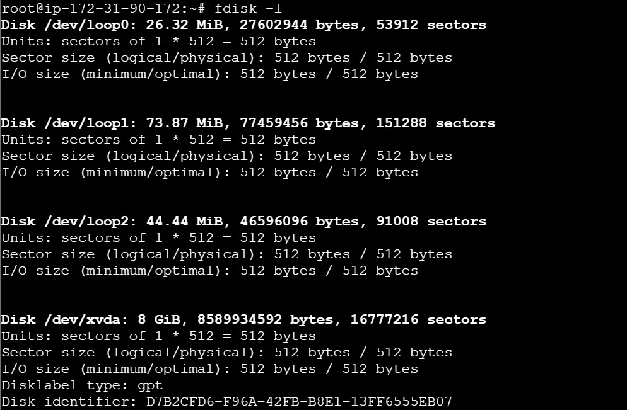

**Figure 4.16**

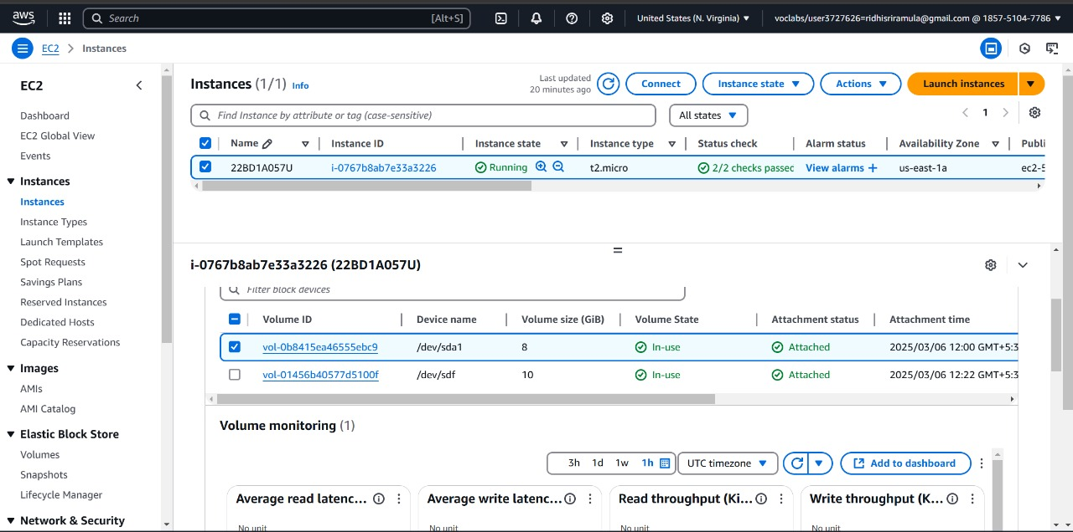

**Figure 4.17**

**Step 7: Modifying the Volume Size (Optional)**

* If you need to **increase** the volume size:
  1. Go to **EBS Volumes** in the AWS Console.
  2. Select the volume → Click **Modify Volume**.
  3. Enter the new size (e.g., increase from **10 GiB** to **20 GiB**).
  4. Click **Modify** to apply changes.
* **Note**: You can increase the volume size but **cannot** decrease it.

**Part-2: Creating Files in EBS, taking a Snapshot & Attaching to Another Region**

**Step 1: Creating Files in EBS**

1. Navigate to the mounted directory
2. Verify the current directory
3. Create files and add content
   * Create a Python file for adding two numbers
   * Create a Java file with a welcome message

4.Check if the files were created successfully.

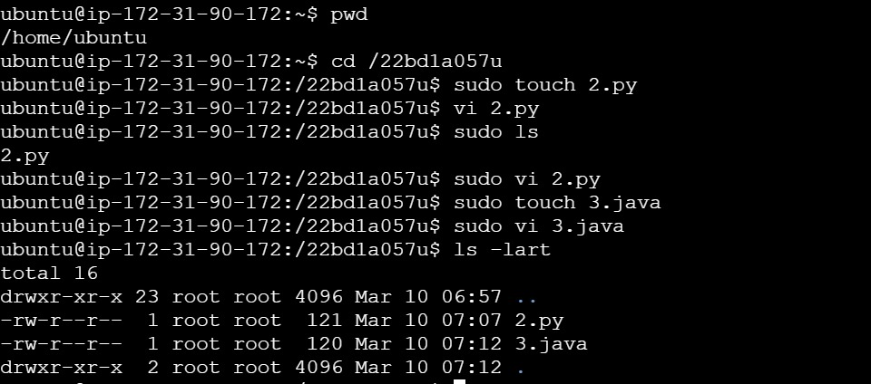

Figure 4.18

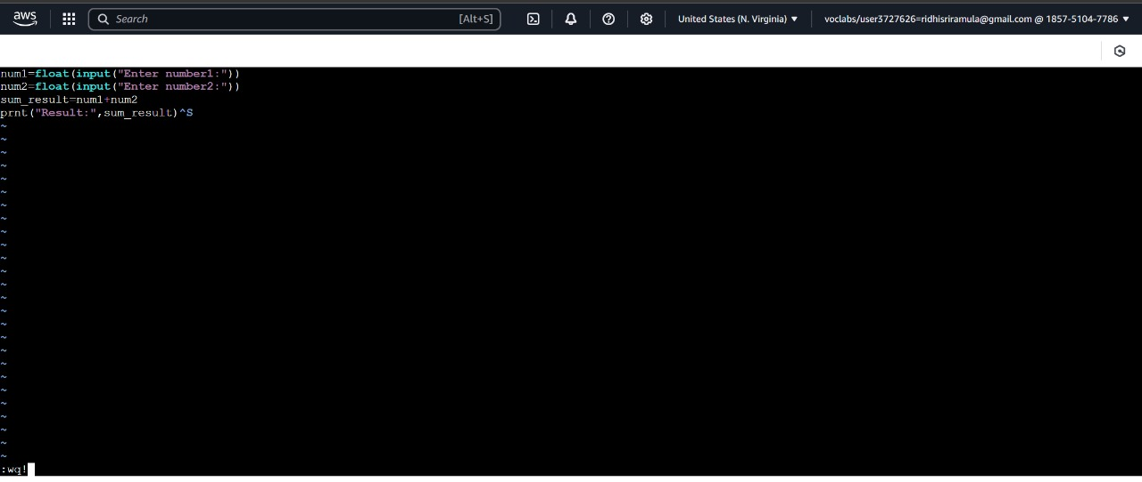

Figure 4.19

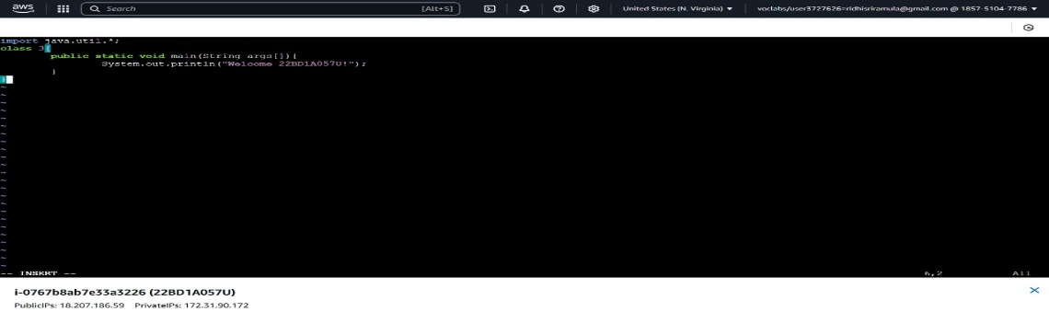

Figure 4.20

**Step 2: Import the Key Pair into the New AWS Region**

1. Go to AWS Management Console → EC2 Dashboard.
2. In the top-right corner, click on the region selector (e.g., "US East (N. Virginia)") and select your new region (e.g., "US West (Oregon)").
3. In the left sidebar, scroll down to Network & Security → Click Key Pairs.
4. Click Import Key Pair (Top-right corner).
5. Enter a name (e.g., my-key-new-region).
6. Upload your PEM file (my-key.pem).
7. Click Import Key Pair.

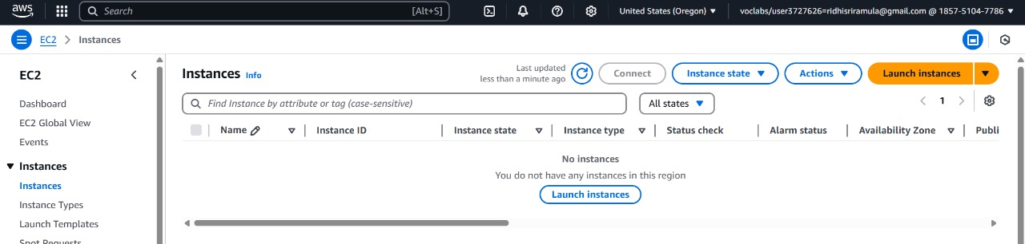

Figure 4.21

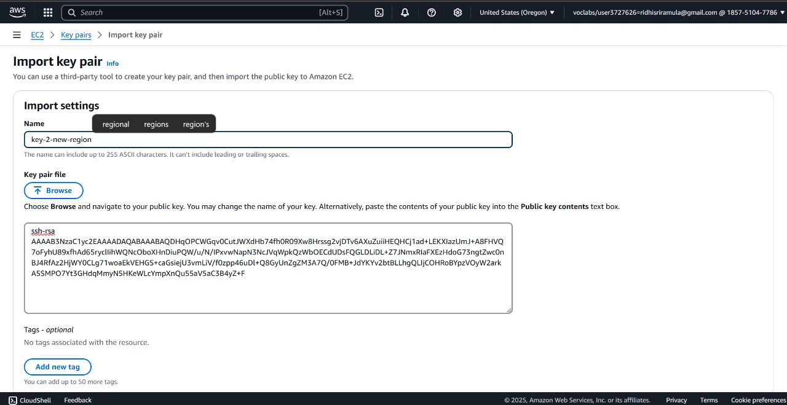

NOTE::::::::::::::::::ssh-keygen -y -f keypair.pem>keypair.pub

Figure 4.22

**Step 3: Create Another EC2 Instance in a Different AWS Region**

1. **Go to EC2 Dashboard in another region (e.g., Oregon - us-west-2)**.
2. **Create a new EC2 instance**:
   * **Instance Name:** Rollno_EBS_OtherRegion
   * **Key Pair:** Use the **same existing key pair**.
   * **Storage:** 8 GiB (Default).
   * **Launch the instance**.

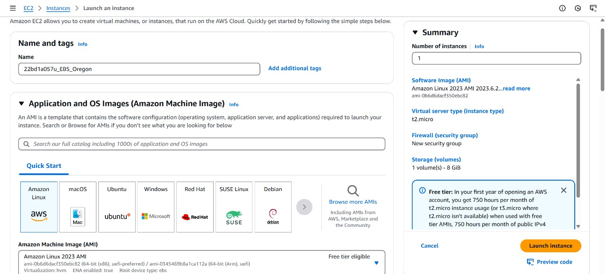

Figure 4.23

1. **Connect to the new EC2 instance via SSH**:

* ssh -i your-key.pem ec2-user@<new-instance-public-ip>
* Replace <new-instance-public-ip> with the new instance’s public IP.

1. **Check the disk size**:

* sudo fdisk -l
* You should see **only the default 8 GiB disk**.

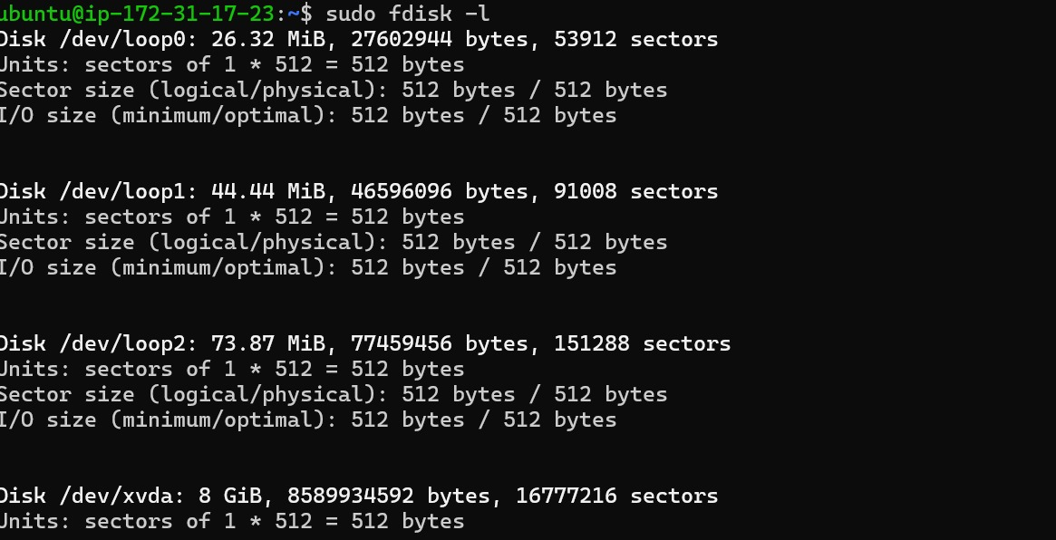

Figure 4.24

**Step 4: Create a Snapshot from the Old Instance**

1. Go to the AWS EC2 Console (Old Region).
2. Navigate to: Elastic Block Store → Volumes.
3. Select the 10 GiB volume.
4. Click "Actions" → "Create Snapshot".
5. Provide snapshot details:
   * Description: Snapshot_Rollno
6. Click "Create Snapshot".

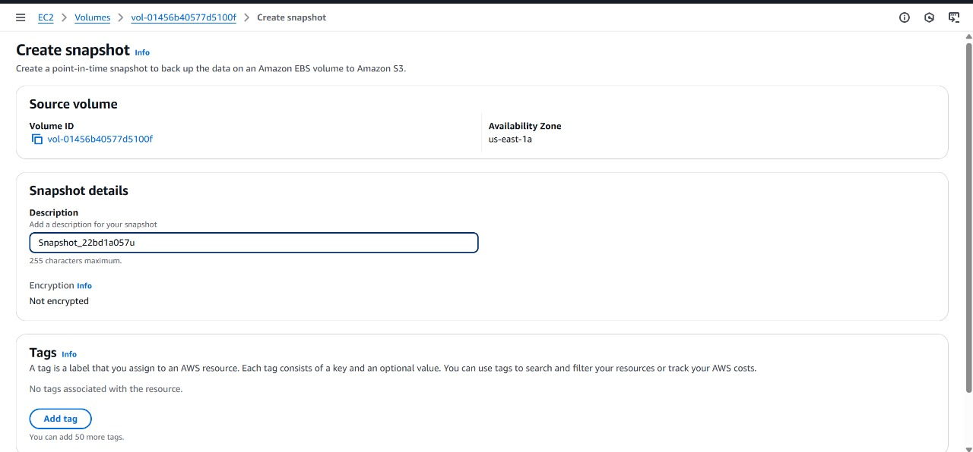

Figure 4.25

1. Verify the snapshot:
   * Go to Elastic Block Store → Snapshots.
   * Check Snapshot ID & Status (Wait for it to show "available").

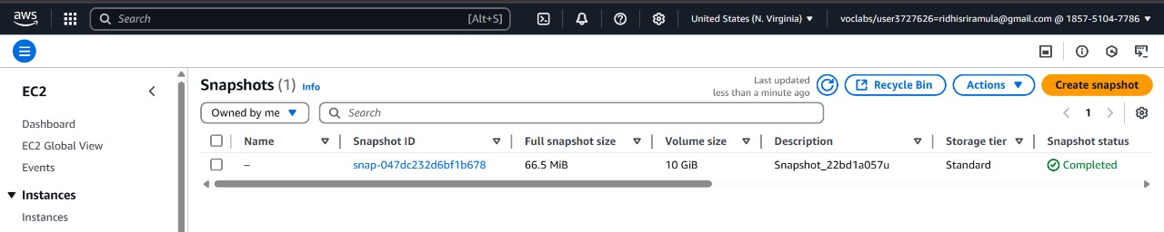

Figure 4.26

**Step 5: Copy the Snapshot to the New Region**

1. Go to **EC2 Dashboard → Snapshots** (in the old region).
2. Select the **snapshot you just created**.
3. Click **Actions → Copy Snapshot**.
4. Under **Destination Region**, select the **new region** where you are setting up the second EC2 instance.
5. Click **Copy**.

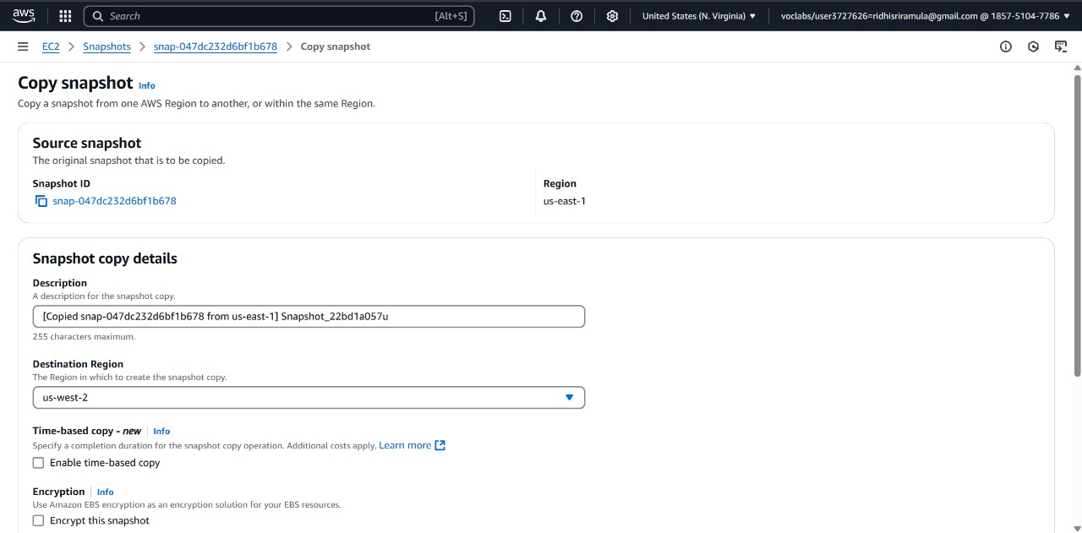

Figure 4.27

1. Wait until the copy process is complete (status will change to **"available"** in the new region).

**Step 6: Attach the Snapshot to the New EC2 Instance**

1. Go to Snapshots (New Region).
2. Select the Snapshot → Click Actions → Create Volume from Snapshot.
3. Choose the New Region (Same as the new EC2 instance).
4. Click "Create Volume".

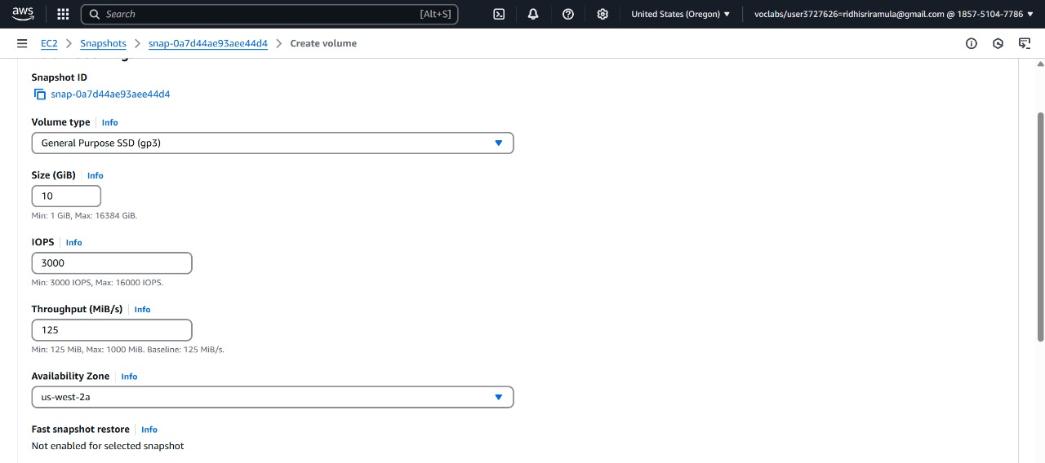 Figure 4.28

5.Rename the new volume as Snap-Rollno-OtherRegion (Optional).

6.Attach the Volume to the New Instance:

* + Go to **Elastic Block Store → Volumes**.
  + Select the new **10 GiB volume**.
  + Click **Actions → Attach Volume**.
  + Select the **new EC2 instance**.
  + **Device Name:** /dev/sdf
  + Click **Attach**.

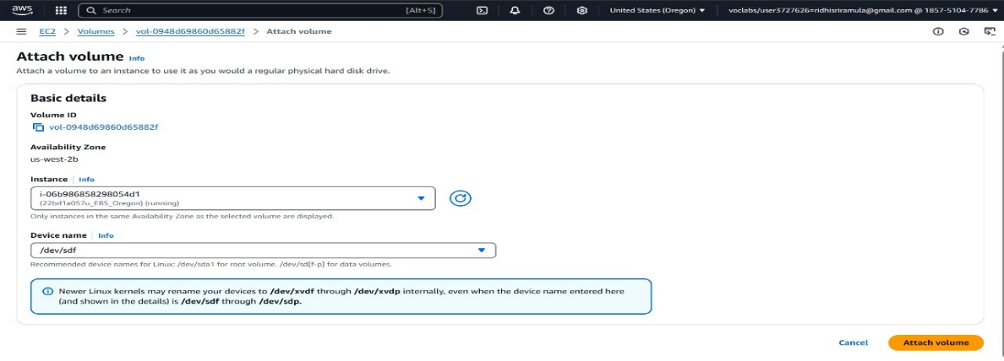

Figure 4.29

7.Verify the Attached Volume in the New EC2 Instance. You should now see **the 10 GiB volume** attached.

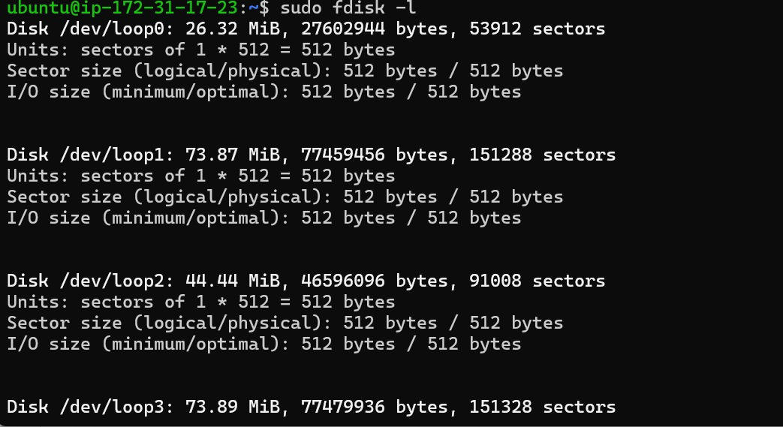

Figure 4.30

8.Mount the volume in the new instance

9.Check if files are available. You should see **1.txt**, **2.py and 3.java**

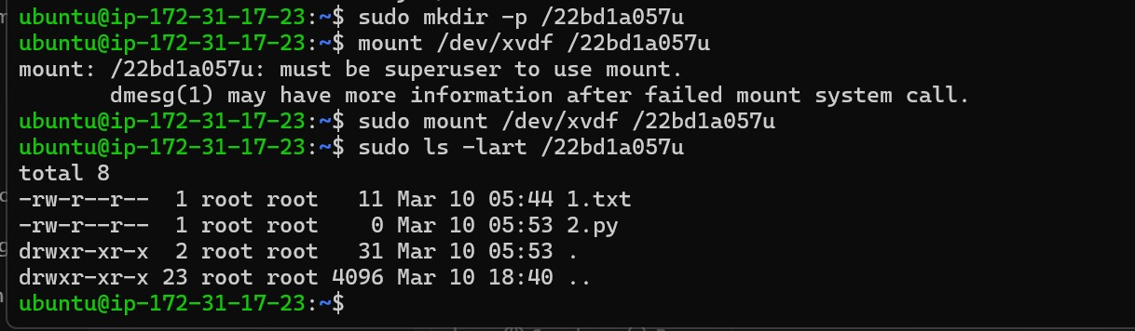

Figure 4.31