|  |
| --- |
| **Experiment-4:**  Create and configure storage services and upload files and objects using Amazon EBS, Amazon EFS and Amazon S3  **Part-3: ELASTIC FILE SYSTEM (EFS)** |

**Agenda : Creating EFS and mounting to EC2**

1. Create 2 Instance namely Rollno-KMIT, Rollno-NGIT
2. Creating EFS System
3. Communicate with two servers

**A.Creating 2 instances namely Rollno-KMIT,Rollno-NGIT :**

**Step 1: Launch Two EC2 Instances**

1. **Go to AWS Console → EC2 Dashboard → Launch Instance**
2. **Create two instances (For example: Rollno-KMIT and Rollno-NGIT)** 
   * **Select Amazon Linux 2 AMI**
   * **Choose an instance type (t2.micro for free tier)**
   * **Configure default VPC & Subnet**
   * **Add Security Group (Will be created in Step 2)**
   * **Launch both instances and note their Private Ips**

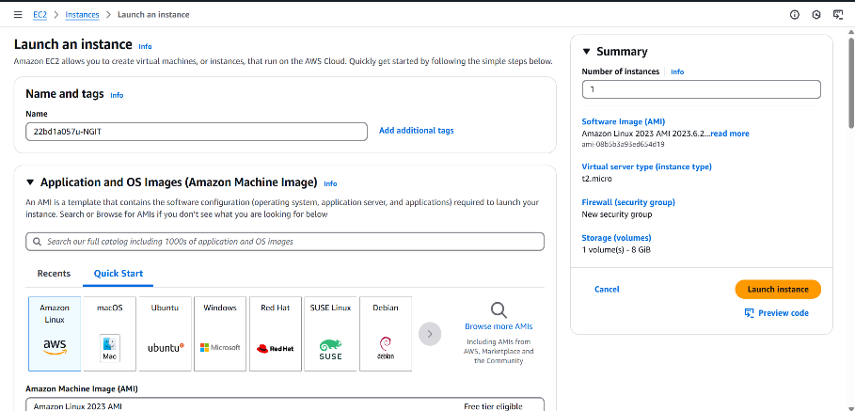

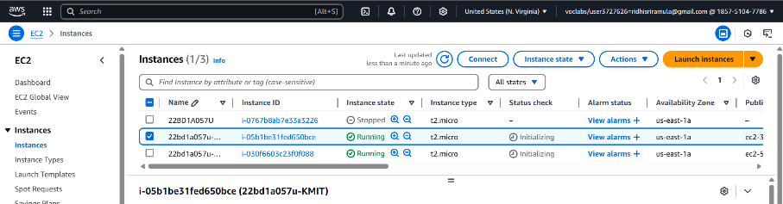

**Figure-1**

**B.Creating EFS System:**

**Step 2: Create Security Group for EFS**

1. **Go to EC2 → Security Groups → Create Security Group**
2. **Provide details:** 
   * **Security Group Name: Rollno_EFS**
   * **Description: EFS SG**
   * **VPC: Default**
3. **Add Inbound Rule:** 
   * **Type: NFS**
   * **Port Range: 2049**
   * **Source: Select Custom, and add the EC2 Security Group**
4. **Create Security Group**

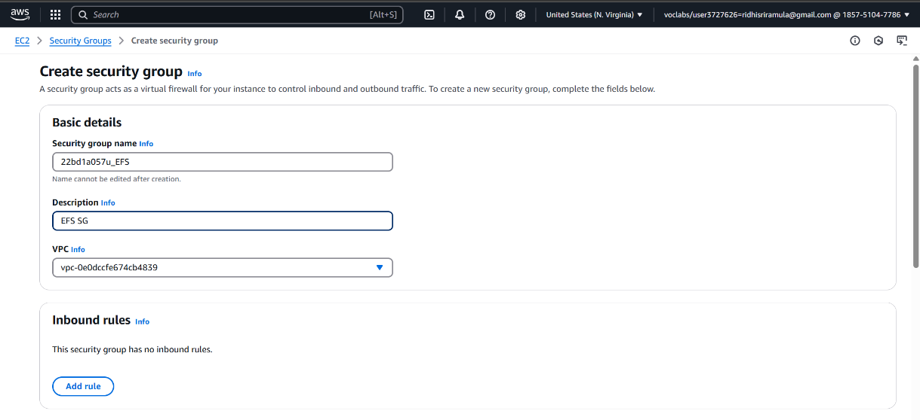

**Figure 4.3.3**

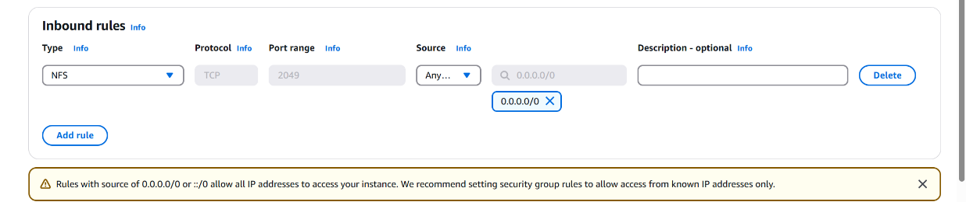

**Figure 4.3.4**

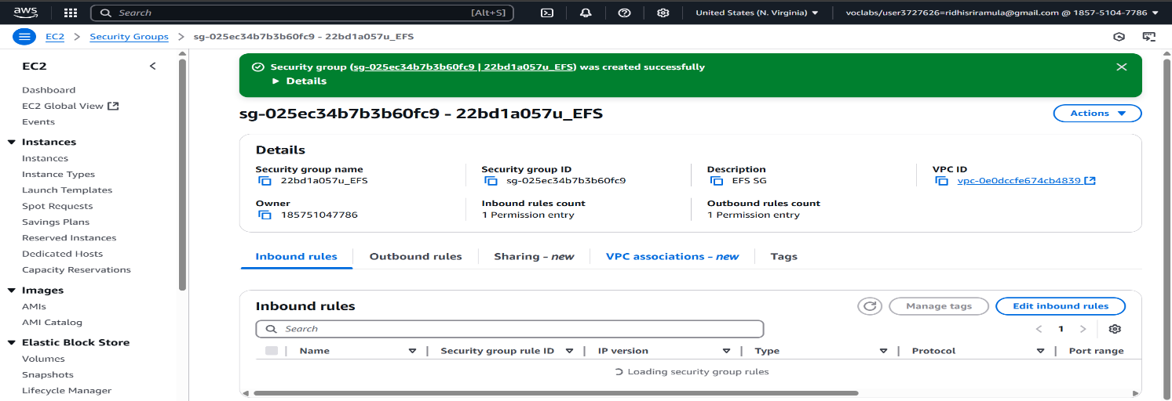

Figure 4.3.5

**Step 3: Create EFS File System**

1. **Go to AWS Console → Search "EFS" → Click "Create File System"**
2. **Provide basic details:** 
   * **Name: Rollno**
   * **VPC: Default**
   * **Storage Class: Standard or One Zone**
   * **Lifecycle Management: Move to Infrequent Access after 7 days**
   * **Performance Mode: General Purpose**
   * **Throughput Mode: Elastic**
   * **Encryption: Disable**
3. **Network Configuration:** 
   * **VPC: Default**
   * **Availability Zone: Add the created Security Group (Rollno_EFS)**
4. **Review & Create**

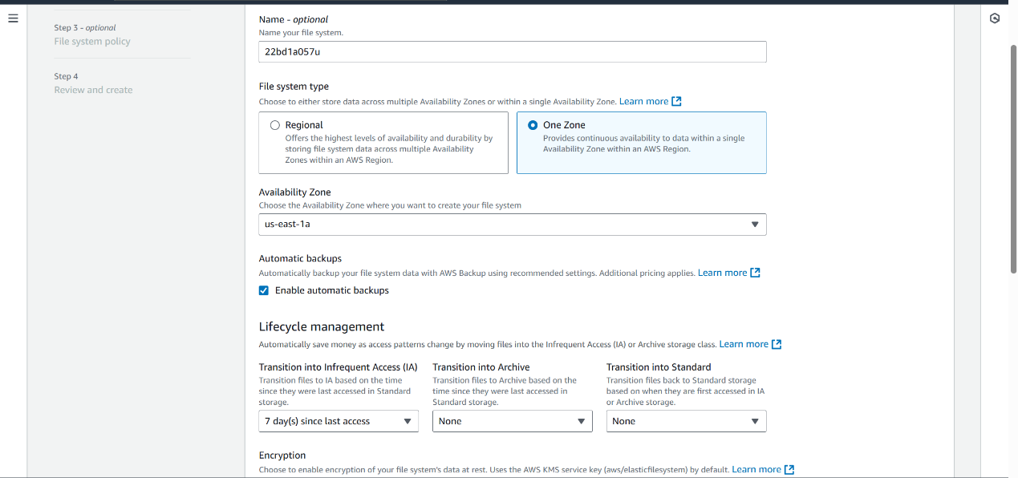

**Figure 4.3.6**

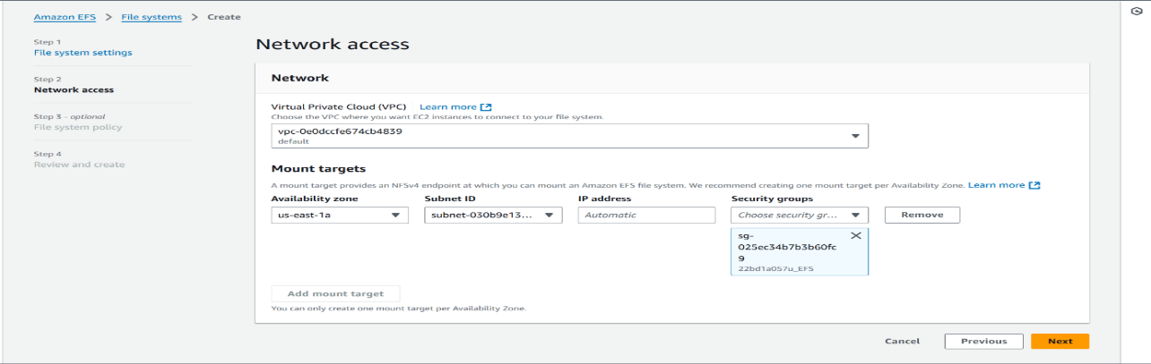

**Figure 4.3.7**

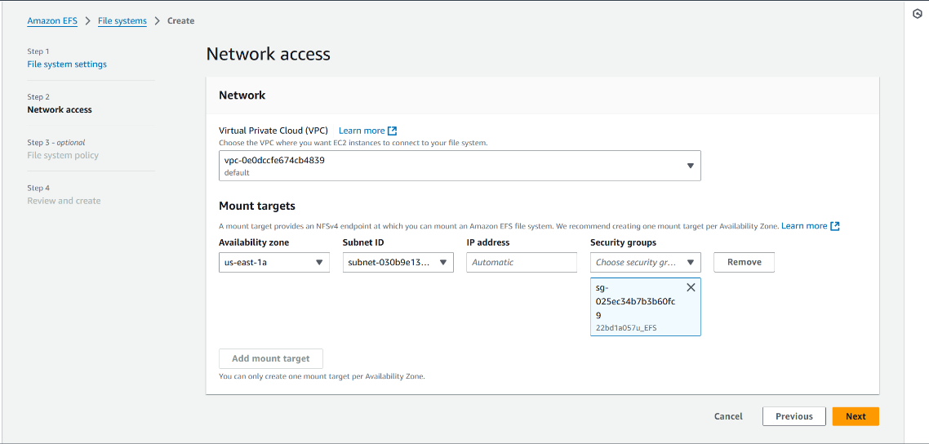

**Figure 4.3.8**

**Step :4 Connect to Instance-1(Server1) from Putty using PEM File**

1. sudo su
2. Create a Folder with Roll No-EBS1
3. **yam install -y amazon-efs-utils**
4. **Create** File1.html (Insert code)
5. Mount the EFS

  PATH: goto EFS(just now created)

1. Select the EFS Created by you → Click Attach

g.(**Mount**) :Select created EFS & Click on Attach & copy the Command from **Using NFS Client**

1.   **Figure 4.3.9**

i.Instead of /efs provide your Directory Roll No-EBS1

g.Copy the above code & paste the link for mounting

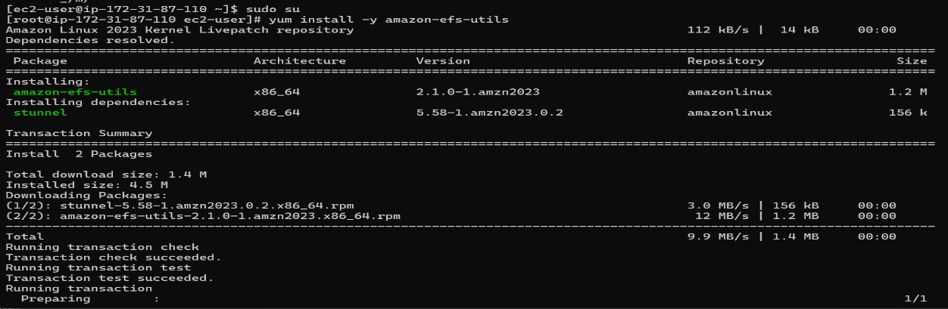



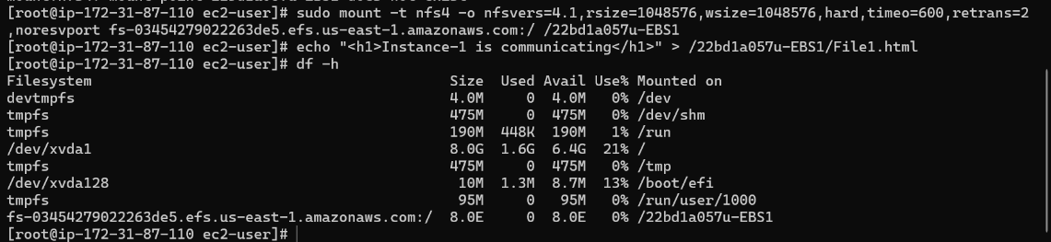

Figure 4.3.10

Step 4: **Connect to Instance-2 (Server2) from Putty using PEM File**

1. Create a Folder with Roll No-EBS2
2. **Create** File2.html (Insert code)
3. Mount the EFS like above
4. Press df -h (To check the whether its mounted or not)

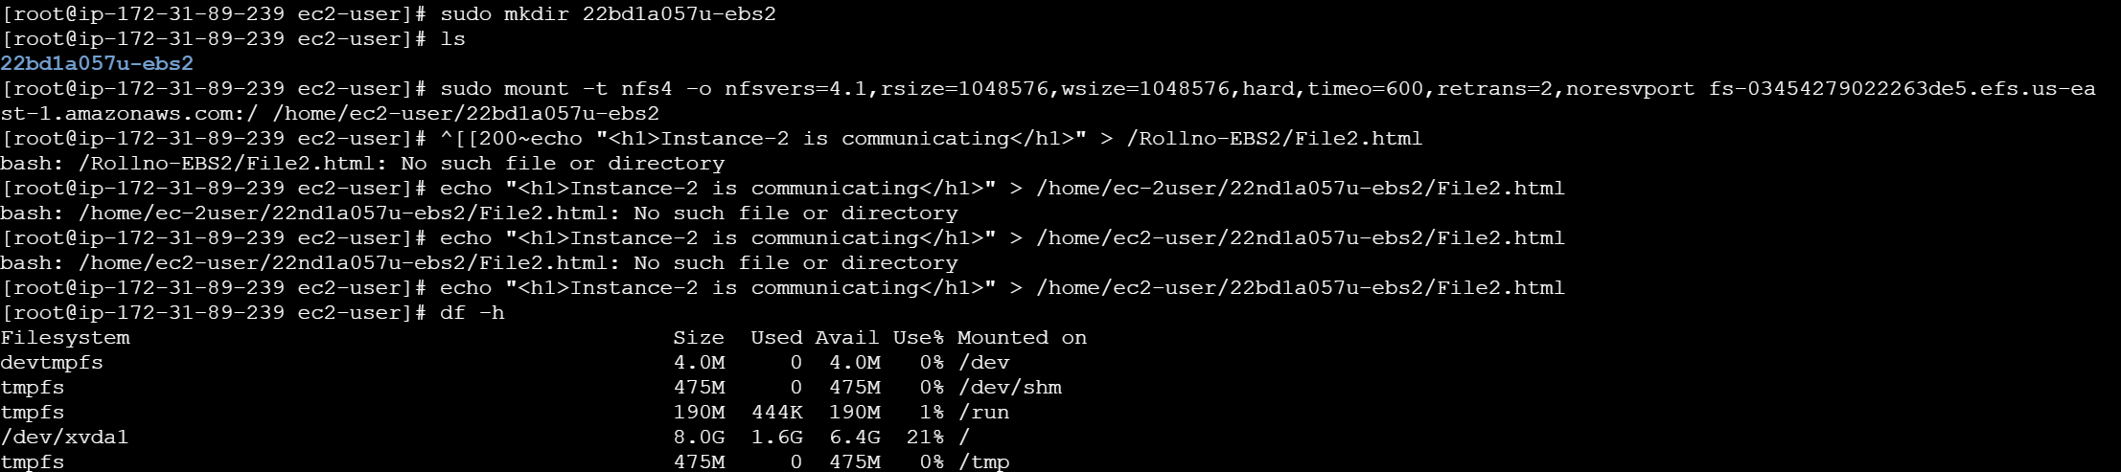

Figure 4.3.11

Step 5: Verify Communication Between Instances

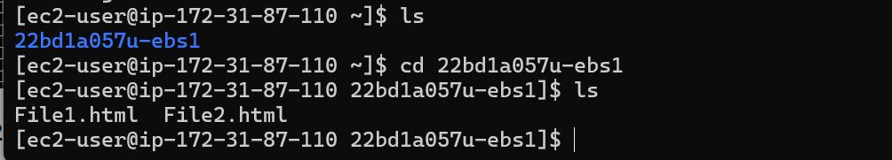

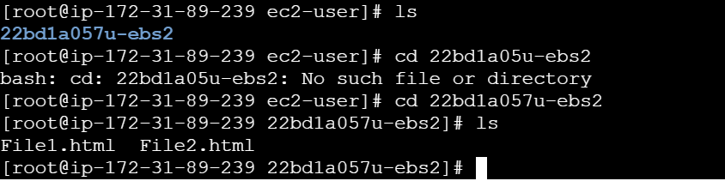

Figure 4.3.12