1.careers

Careers Toggle dropdown button is functioning correctly->Careers Toggle dropdown button is not functioning correctly

Source code:

package automationFramework;

import org.openqa.selenium.By;

import org.openqa.selenium.JavascriptExecutor;

import org.openqa.selenium.WebDriver;

import org.openqa.selenium.chrome.ChromeDriver;

public class Homepagepinesphere {

public static void main(String[] args) {

System.setProperty("webdriver.chrome.driver","D:\\selenium\\eclipse-jee-oxygen-3a-win32-x86_64\\eclipse\\chromedriver-win64 (1)\\chromedriver-win64\\chromedriver.exe");

WebDriver driver=new ChromeDriver();

driver.manage().window().maximize();

driver.get("https://pinesphere.com/");

driver.findElement(By.*xpath*("//a[normalize-space()='CAREERS']")).click();

driver.findElement(By.*linkText*("INTERNSHIP")).click();

String url7 = "https://pinesphere.com/";

System.***out***.println("Page load time for " + url7 + ": " + loadTime + " seconds");

**if** (statusCode == 200)

{

System.***out***.println("URL is reachable (status code: 200)");

}

**else**

{

System.***err***.println(statusCode);

}

driver.findElement(By.*xpath*("//a[normalize-space()='CAREERS']")).click();

driver.findElement(By.*linkText*("WORK WITH US")).click();

System.***out***.println("Page load time for " + url + ": " + loadTime + " seconds");

**if** (statusCode == 200)

{

System.***out***.println("URL is reachable (status code: 200)");

}

**else**

{

System.***err***.println(statusCode);

}

}

}

Refimage:01

[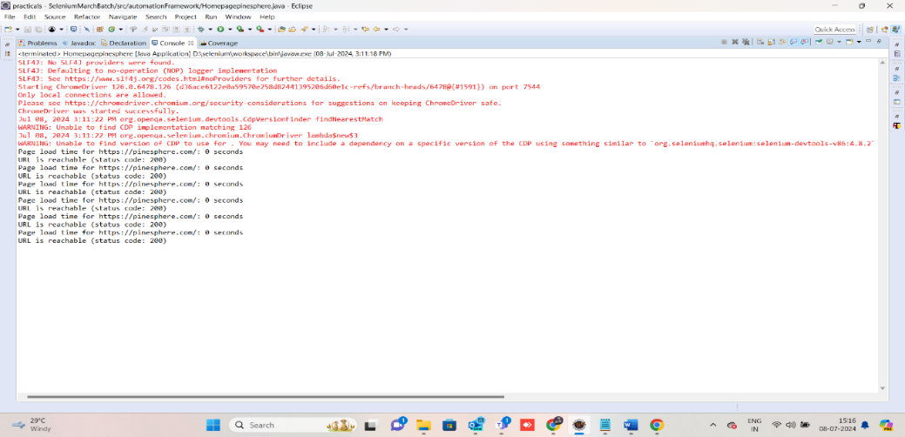](https://d.docs.live.net/8d8413edb85660d3/logfiles.docx)

2.Home->free consultation

In the phone number column on pinesphere.com auto suggested phone number should display->In the phone number column on pinesphere.com auto suggested names should display.

Source code:

package automationFramework;

import org.openqa.selenium.By;

import org.openqa.selenium.JavascriptExecutor;

import org.openqa.selenium.WebDriver;

import org.openqa.selenium.WebElement;

import org.openqa.selenium.chrome.ChromeDriver;

public class pinespherefunc {

public static void main(String[] args) {

System.setProperty("webdriver.chrome.driver","D:\\selenium\\eclipse-jee-oxygen-3a-win32-x86_64\\eclipse\\chromedriver-win64 (1)\\chromedriver-win64\\chromedriver.exe");

WebDriver driver=new ChromeDriver();

driver.manage().window().maximize();

driver.get("https://pinesphere.com/");

System.out.println(driver.getTitle());

JavascriptExecutor js = (JavascriptExecutor) driver;

js.executeScript("window.scrollBy(0, 4500)");

WebElement name = driver.findElement(By.xpath("//input[@id='name']"));

name.sendKeys(" ");

WebElement mail = driver.findElement(By.xpath("//input[@id='email']"));

mail.sendKeys("keerthika@pinesphere.co.in");

WebElement phone = driver.findElement(By.xpath("//input[@id='phone']"));

phone.sendKeys("abcdefghij");

driver.findElement(By.id("submit")).submit();

}

}

Refimage:02

[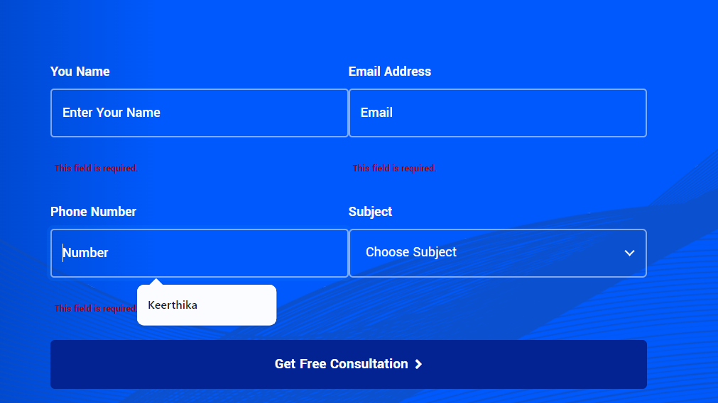](https://d.docs.live.net/8d8413edb85660d3/logfiles.docx)

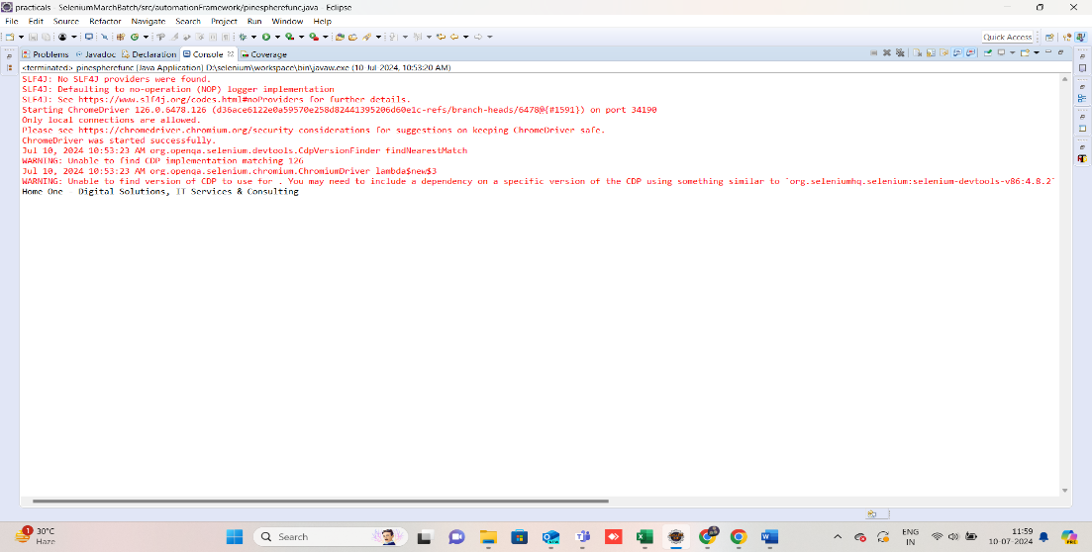

3.Why us

When clicking on "Why us", The page should redirect to corresponding "why us" content->"Why us" and "Home " page displaying the same content on the web pages.

Source code:

package automationFramework;

import org.openqa.selenium.By;

import org.openqa.selenium.JavascriptExecutor;

import org.openqa.selenium.WebDriver;

import org.openqa.selenium.chrome.ChromeDriver;

public class Homepagepinesphere {

public static void main(String[] args) {

System.setProperty("webdriver.chrome.driver","D:\\selenium\\eclipse-jee-oxygen-3a-win32-x86_64\\eclipse\\chromedriver-win64 (1)\\chromedriver-win64\\chromedriver.exe");

WebDriver driver=new ChromeDriver();

driver.manage().window().maximize();

driver.get("https://pinesphere.com/");

driver.findElement(By.xpath("//a[normalize-space()='WHY US']")).click();

String url = "https://pinesphere.com/";

long startTime = System.currentTimeMillis();

long endTime = System.currentTimeMillis();

long loadTime = (endTime - startTime) / 1000;

System.out.println("Page load time for " + url + ": " + loadTime + " seconds");

JavascriptExecutor js = (JavascriptExecutor) driver;

String url1 = "https://pinesphere.com/";

Long statusCode = (Long) js.executeScript("" +

"var xhr = new XMLHttpRequest();" +

"xhr.open('GET', arguments[0], false);" +

"xhr.send(null);" +

"return xhr.status;" +

"", url1);

if (statusCode == 200)

{

System.out.println("URL is reachable (status code: 200)");

}

else

{

System.err.println(statusCode);

}

Ref fig:03

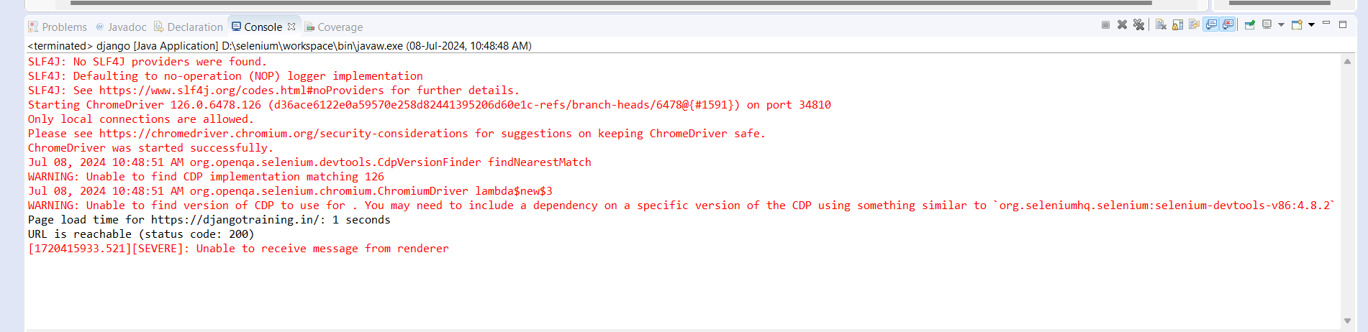

4.careers->Internship->Gender

In the internship user should able to select the "Gender" radio button->In the internship form , the male option for the radio button is selected by default

Source code:

package automationframework;  
import org.openqa.selenium.By;  
import org.openqa.selenium.WebDriver;  
import org.openqa.selenium.WebElement;  
import org.openqa.selenium.chrome.ChromeDriver;

public class pinesphere {

  public static void main(String[] args) {  
    System.setProperty("webdriver.chrome.driver","C:\\Users\\Priya Dhar\\Downloads\\chromedriver-win64\\chromedriver-win64\\chromedriver.exe");

WebDriver driver=new ChromeDriver();  
    driver.manage().window().maximize();  
    driver.get("[https://pinesphere.com/internship/");](https://pinesphere.com/internship/%22);)  
     WebElement Gender = driver.findElement(By.name("radio-909"))  
  
    if ( Gender.isSelected())  
    {  
        System.out.println("radio button is selected.");  
    } else  
    {  
        System.out.println("radio button selection might have failed.");  
    }  
  
       
  
  }  
}

Ref fig:04

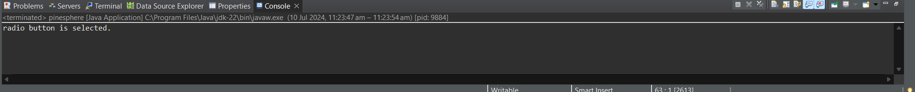

5.Contact->Location->Check Location

When Viewing the "Contact Us" page and checking the location, the exact location shown on the map-> When viewing the "Contact Us" page and Checking the location, the displayed address matches the location shown on the map

Source code:

package automationFramework;

import org.openqa.selenium.By;

import org.openqa.selenium.JavascriptExecutor;

import org.openqa.selenium.WebDriver;

import org.openqa.selenium.WebElement;

import org.openqa.selenium.chrome.ChromeDriver;

public class Contact {

public static void main(String[] args) {

System.setProperty("webdriver.chrome.driver", "D:\\\\selenium\\\\eclipse-jee-oxygen-3a-win32-x86_64\\\\eclipse\\\\chromedriver-win64 (1)\\\\chromedriver-win64\\\\chromedriver.exe"); // Replace with your actual ChromeDriver path

WebDriver driver = new ChromeDriver();

driver.manage().window().maximize();

driver.get("https://pinesphere.com/");

driver.findElement(By.linkText("CONTACT")).click();

JavascriptExecutor js = (JavascriptExecutor) driver;

js.executeScript("window.scrollBy(0, 1015)");

WebElement name = driver.findElement(By.id("name"));

name.sendKeys(" ");

WebElement phone= driver.findElement(By.id("phone"));

phone.sendKeys(" ");

WebElement mail = driver.findElement(By.name("email-568"));

mail.sendKeys("keerthika@pinesphere.co.in");

WebElement tellus= driver.findElement(By.id("comments"));

tellus.sendKeys(" ");

JavascriptExecutor js1 = (JavascriptExecutor) driver;

js.executeScript("window.scrollBy(0, -200)");

WebElement paragraphElement = driver.findElement(By.xpath("//p[contains(text(), 'No.22, Kalapatti Main Rd,')]"));

String paragraphText = paragraphElement.getText();

System.out.println("Text from the paragraph: " + paragraphText);

driver.findElement(By.xpath("//a[normalize-space()='Check Location']")).click();

WebElement paragraphElement1 = driver.findElement(By.xpath("//span[contains(text(), 'Kalapatti Main Rd')]"));

String paragraphText1 = paragraphElement1.getText();

System.out.println("Text from the paragraph: " + paragraphText1);

}

}

Ref fig:05

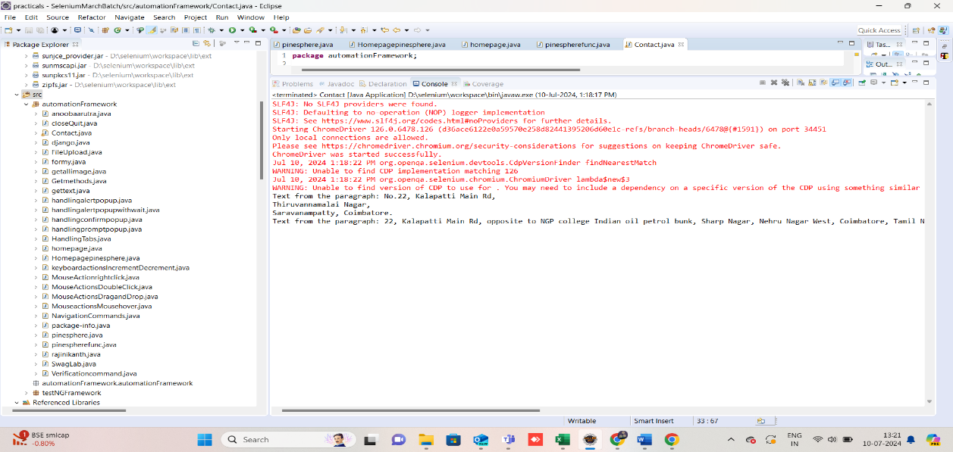

6.Contact->Location->Get in touch

User can able to enter the name, phone, and tell us details->the name, phone, and tell us fields are accepting spaces without requiring any text entry.

Source code:

package automationFramework;

import org.openqa.selenium.By;

import org.openqa.selenium.JavascriptExecutor;

import org.openqa.selenium.WebDriver;

import org.openqa.selenium.WebElement;

import org.openqa.selenium.chrome.ChromeDriver;

public class Contact {

public static void main(String[] args) {

System.setProperty("webdriver.chrome.driver", "D:\\\\selenium\\\\eclipse-jee-oxygen-3a-win32-x86_64\\\\eclipse\\\\chromedriver-win64 (1)\\\\chromedriver-win64\\\\chromedriver.exe"); // Replace with your actual ChromeDriver path

WebDriver driver = new ChromeDriver();

driver.manage().window().maximize();

driver.get("https://pinesphere.com/");

driver.findElement(By.linkText("CONTACT")).click();

JavascriptExecutor js = (JavascriptExecutor) driver;

js.executeScript("window.scrollBy(0, 1015)");

WebElement name = driver.findElement(By.id("name"));

name.sendKeys(" ");

WebElement phone= driver.findElement(By.id("phone"));

phone.sendKeys(" ");

WebElement mail = driver.findElement(By.name("email-568"));

mail.sendKeys("keerthika@pinesphere.co.in");

WebElement tellus= driver.findElement(By.id("comments"));

tellus.sendKeys(" ");

JavascriptExecutor js1 = (JavascriptExecutor) driver;

js.executeScript("window.scrollBy(0, -200)");

WebElement paragraphElement = driver.findElement(By.xpath("//p[contains(text(), 'No.22, Kalapatti Main Rd,')]"));

String paragraphText = paragraphElement.getText();

System.out.println("Text from the paragraph: " + paragraphText);

driver.findElement(By.linkText("Check Location")).click();

WebElement paragraphElement1 = driver.findElement(By.xpath("//span[contains(text(), 'Kalapatti Main Rd')]"));

String paragraphText1 = paragraphElement1.getText();

System.out.println("Text from the paragraph: " + paragraphText1);

}

}

Ref fig:06

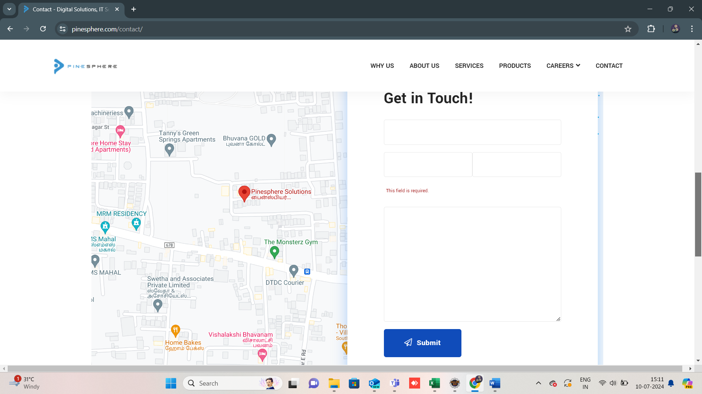

7.Contact->Location->Get in touch

User can able to enter Text in Mandatory Tell us (description) before submitting-> Without entering any input, user can able to submit the get in touch.

Source code:

package automationFramework;

import org.openqa.selenium.By;

import org.openqa.selenium.JavascriptExecutor;

import org.openqa.selenium.WebDriver;

import org.openqa.selenium.WebElement;

import org.openqa.selenium.chrome.ChromeDriver;

public class Contact {

public static void main(String[] args) {

System.setProperty("webdriver.chrome.driver", "D:\\\\selenium\\\\eclipse-jee-oxygen-3a-win32-x86_64\\\\eclipse\\\\chromedriver-win64 (1)\\\\chromedriver-win64\\\\chromedriver.exe"); // Replace with your actual ChromeDriver path

WebDriver driver = new ChromeDriver();

driver.manage().window().maximize();

driver.get("https://pinesphere.com/");

driver.findElement(By.linkText("CONTACT")).click();

JavascriptExecutor js = (JavascriptExecutor) driver;

js.executeScript("window.scrollBy(0, 1015)");

WebElement name = driver.findElement(By.id("name"));

name.sendKeys(" ");

WebElement phone= driver.findElement(By.id("phone"));

phone.sendKeys(" ");

WebElement mail = driver.findElement(By.name("email-568"));

mail.sendKeys("keerthika@pinesphere.co.in");

WebElement tellus= driver.findElement(By.id("comments"));

tellus.sendKeys(" ");

JavascriptExecutor js1 = (JavascriptExecutor) driver;

js.executeScript("window.scrollBy(0, -200)");

WebElement paragraphElement = driver.findElement(By.xpath("//p[contains(text(), 'No.22, Kalapatti Main Rd,')]"));

String paragraphText = paragraphElement.getText();

System.out.println("Text from the paragraph: " + paragraphText);

driver.findElement(By.linkText("Check Location")).click();

WebElement paragraphElement1 = driver.findElement(By.xpath("//span[contains(text(), 'Kalapatti Main Rd')]"));

String paragraphText1 = paragraphElement1.getText();

System.out.println("Text from the paragraph: " + paragraphText1);

}

}

Ref fig:07



8.careers->Internship->Experience

In the internship form, User can able to enter the valid value in experience field-> Able to enter negative value for experience in increment and decrement bar , which does not meet the acceptance criteria

Source code:

package automationframework;  
import org.openqa.selenium.By;  
import org.openqa.selenium.WebDriver;  
import org.openqa.selenium.WebElement;  
import org.openqa.selenium.chrome.ChromeDriver;

public class pinesphere {

  public static void main(String[] args) {  
    System.setProperty("webdriver.chrome.driver","C:\\Users\\Priya Dhar\\Downloads\\chromedriver-win64\\chromedriver-win64\\chromedriver.exe");

    WebDriver driver=new ChromeDriver();  
    driver.manage().window().maximize();  
    driver.get("[https://pinesphere.com/internship/");](https://pinesphere.com/internship/%22);)  
    WebElement nameField = driver.findElement(By.id("name"));  
    nameField.sendKeys("priya");  
    WebElement DOBfield = driver.findElement(By.name("date-913"));  
    DOBfield.sendKeys("1232002");  
    WebElement EmailField = driver.findElement(By.name("email-83"));  
    EmailField.sendKeys("priyadharshini@pinesphere.co.in");  
    WebElement Phonenumber = driver.findElement(By.id("phone"));  
    Phonenumber.sendKeys("1234567894");  
    WebElement Gender = driver.findElement(By.name("radio-909"));  
  
  
    if ( Gender.isSelected())  
    {  
        System.out.println("radio button is selected.");  
    } else  
    {  
        System.out.println("radio button selection might have failed.");  
    }  
  
    WebElement experienceField = driver.findElement(By.name("number-549"));  
    experienceField.sendKeys(String.valueOf(-1));  
    WebElement previouscompany = driver.findElement(By.name("text-666"));  
    previouscompany.sendKeys("xyz");  
    WebElement Position = driver.findElement(By.name("text-274"));  
    Position.sendKeys("xyee");  
    WebElement CurrentCTC = driver.findElement(By.name("text-551"));  
    CurrentCTC.sendKeys("0000");  
    WebElement Githublink= driver.findElement(By.name("url-165"));  
    Githublink.sendKeys("softwaredeveloper.com");  
    WebElement College= driver.findElement(By.name("text-576"));  
    College.sendKeys("softwaredeveloper");  
    WebElement YearofPassing = driver.findElement(By.name("text-404"));  
    YearofPassing.sendKeys("0000");  
    WebElement Department = driver.findElement(By.name("text-121"));  
    Department.sendKeys("softwaredeveloper");  
  
    WebElement UploadResume = driver.findElement(By.name("file-95"));  
    String resumePath = "C:\\Users\\Priya Dhar\\Desktop\\SOFTWARE TESTING\\upload documents\\9df40754-8269-472f-8379-03f232235420.pdf";  
    UploadResume.sendKeys(resumePath);  
    WebElement TechnicalSkills = driver.findElement(By.name("textarea-498"));  
    TechnicalSkills.sendKeys("softwaredeveloper,java,python,sql,c#");  
    WebElement formElement = driver.findElement(By.xpath("//input[@value='Submit']"));  
    formElement.submit();  
  
  }  
}

Ref fig:08

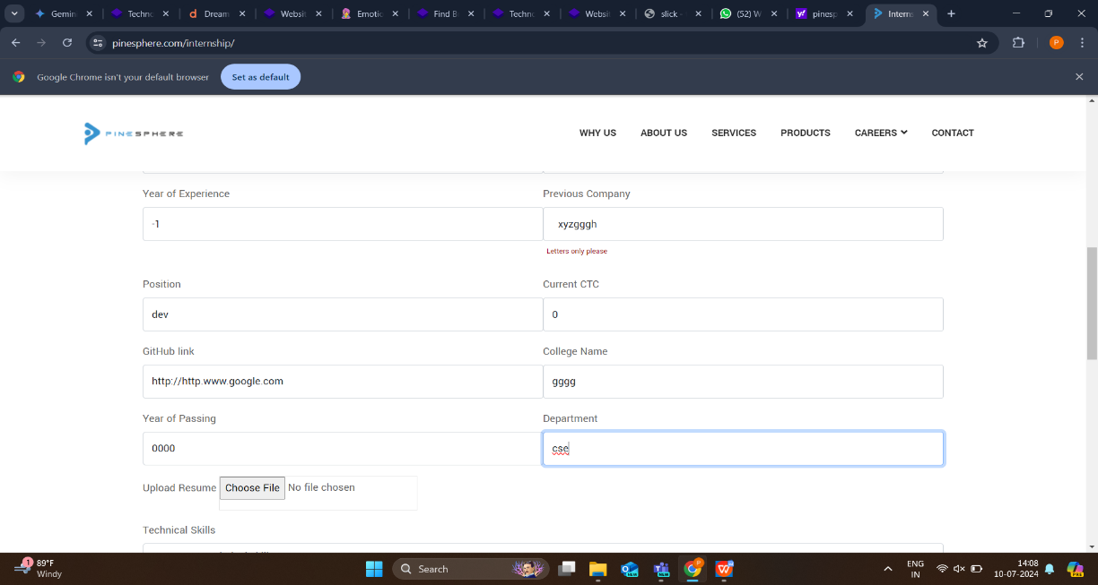

9.careers->Internship->Phone number

User can able to enter phone number in 10 digit format ensure it does not exceed 10 digit upon entering 10 digit a notification alert will appear -> User can able to enter phone number more than 10 digit and notification alert is not appear.

Source code:

package automationframework;  
import org.openqa.selenium.By;  
import org.openqa.selenium.WebDriver;  
import org.openqa.selenium.WebElement;  
import org.openqa.selenium.chrome.ChromeDriver;

public class pinesphere {

  public static void main(String[] args) {  
    System.setProperty("webdriver.chrome.driver","C:\\Users\\Priya Dhar\\Downloads\\chromedriver-win64\\chromedriver-win64\\chromedriver.exe");

    WebDriver driver=new ChromeDriver();  
    driver.manage().window().maximize();  
    driver.get("[https://pinesphere.com/internship/");](https://pinesphere.com/internship/%22);)  
    WebElement nameField = driver.findElement(By.id("name"));  
    nameField.sendKeys("priya");  
    WebElement DOBfield = driver.findElement(By.name("date-913"));  
    DOBfield.sendKeys("1232002");  
    WebElement EmailField = driver.findElement(By.name("email-83"));  
    EmailField.sendKeys("priyadharshini@pinesphere.co.in");  
    WebElement Phonenumber = driver.findElement(By.id("phone"));  
    Phonenumber.sendKeys("1234567894");  
    WebElement Gender = driver.findElement(By.name("radio-909"));  
  
  
    if ( Gender.isSelected())  
    {  
        System.out.println("radio button is selected.");  
    } else  
    {  
        System.out.println("radio button selection might have failed.");  
    }  
  
    WebElement experienceField = driver.findElement(By.name("number-549"));  
    experienceField.sendKeys(String.valueOf(-1));  
    WebElement previouscompany = driver.findElement(By.name("text-666"));  
    previouscompany.sendKeys("xyz");  
    WebElement Position = driver.findElement(By.name("text-274"));  
    Position.sendKeys("xyee");  
    WebElement CurrentCTC = driver.findElement(By.name("text-551"));  
    CurrentCTC.sendKeys("0000");  
    WebElement Githublink= driver.findElement(By.name("url-165"));  
    Githublink.sendKeys("softwaredeveloper.com");  
    WebElement College= driver.findElement(By.name("text-576"));  
    College.sendKeys("softwaredeveloper");  
    WebElement YearofPassing = driver.findElement(By.name("text-404"));  
    YearofPassing.sendKeys("0000");  
    WebElement Department = driver.findElement(By.name("text-121"));  
    Department.sendKeys("softwaredeveloper");  
  
    WebElement UploadResume = driver.findElement(By.name("file-95"));  
    String resumePath = "C:\\Users\\Priya Dhar\\Desktop\\SOFTWARE TESTING\\upload documents\\9df40754-8269-472f-8379-03f232235420.pdf";  
    UploadResume.sendKeys(resumePath);  
    WebElement TechnicalSkills = driver.findElement(By.name("textarea-498"));  
    TechnicalSkills.sendKeys("softwaredeveloper,java,python,sql,c#");  
    WebElement formElement = driver.findElement(By.xpath("//input[@value='Submit']"));  
    formElement.submit();  
  
  }  
}

Ref fig:09

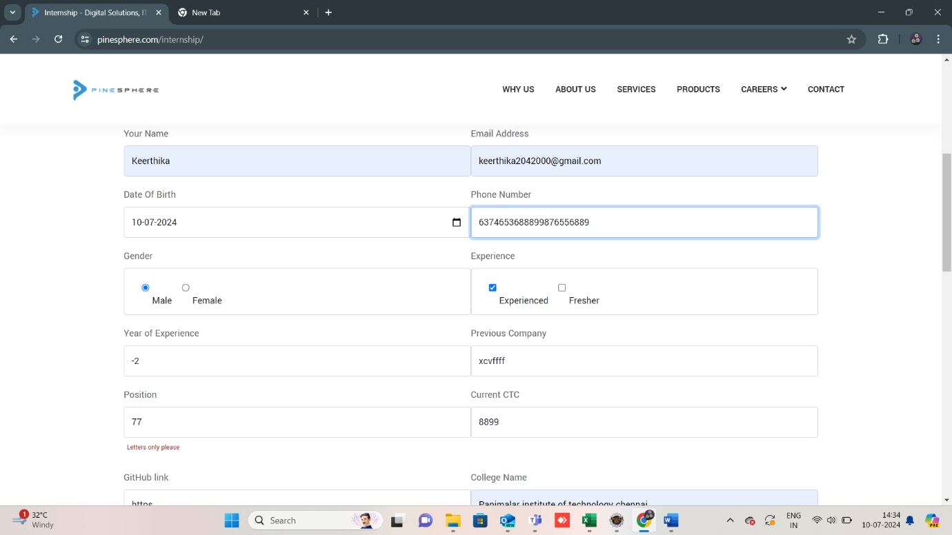

10.careers->Internship->year of passed out

In the internship form,User can able to enter the valid value in year of passed out field->Able to enter invalid value for year of passed out , which does not meet the acceptance criteria.

Source code:

package automationframework;  
import org.openqa.selenium.By;  
import org.openqa.selenium.WebDriver;  
import org.openqa.selenium.WebElement;  
import org.openqa.selenium.chrome.ChromeDriver;

public class pinesphere {

  public static void main(String[] args) {  
    System.setProperty("webdriver.chrome.driver","C:\\Users\\Priya Dhar\\Downloads\\chromedriver-win64\\chromedriver-win64\\chromedriver.exe");

    WebDriver driver=new ChromeDriver();  
    driver.manage().window().maximize();  
    driver.get("[https://pinesphere.com/internship/");](https://pinesphere.com/internship/%22);)  
    WebElement nameField = driver.findElement(By.id("name"));  
    nameField.sendKeys("priya");  
    WebElement DOBfield = driver.findElement(By.name("date-913"));  
    DOBfield.sendKeys("1232002");  
    WebElement EmailField = driver.findElement(By.name("email-83"));  
    EmailField.sendKeys("priyadharshini@pinesphere.co.in");  
    WebElement Phonenumber = driver.findElement(By.id("phone"));  
    Phonenumber.sendKeys("1234567894");  
    WebElement Gender = driver.findElement(By.name("radio-909"));  
  
  
    if ( Gender.isSelected())  
    {  
        System.out.println("radio button is selected.");  
    } else  
    {  
        System.out.println("radio button selection might have failed.");  
    }  
  
    WebElement experienceField = driver.findElement(By.name("number-549"));  
    experienceField.sendKeys(String.valueOf(-1));  
    WebElement previouscompany = driver.findElement(By.name("text-666"));  
    previouscompany.sendKeys("xyz");  
    WebElement Position = driver.findElement(By.name("text-274"));  
    Position.sendKeys("xyee");  
    WebElement CurrentCTC = driver.findElement(By.name("text-551"));  
    CurrentCTC.sendKeys("0000");  
    WebElement Githublink= driver.findElement(By.name("url-165"));  
    Githublink.sendKeys("softwaredeveloper.com");  
    WebElement College= driver.findElement(By.name("text-576"));  
    College.sendKeys("softwaredeveloper");  
    WebElement YearofPassing = driver.findElement(By.name("text-404"));  
    YearofPassing.sendKeys("0000");  
    WebElement Department = driver.findElement(By.name("text-121"));  
    Department.sendKeys("softwaredeveloper");  
  
    WebElement UploadResume = driver.findElement(By.name("file-95"));  
    String resumePath = "C:\\Users\\Priya Dhar\\Desktop\\SOFTWARE TESTING\\upload documents\\9df40754-8269-472f-8379-03f232235420.pdf";  
    UploadResume.sendKeys(resumePath);  
    WebElement TechnicalSkills = driver.findElement(By.name("textarea-498"));  
    TechnicalSkills.sendKeys("softwaredeveloper,java,python,sql,c#");  
    WebElement formElement = driver.findElement(By.xpath("//input[@value='Submit']"));  
    formElement.submit();  
  
  }  
}

Ref no.10

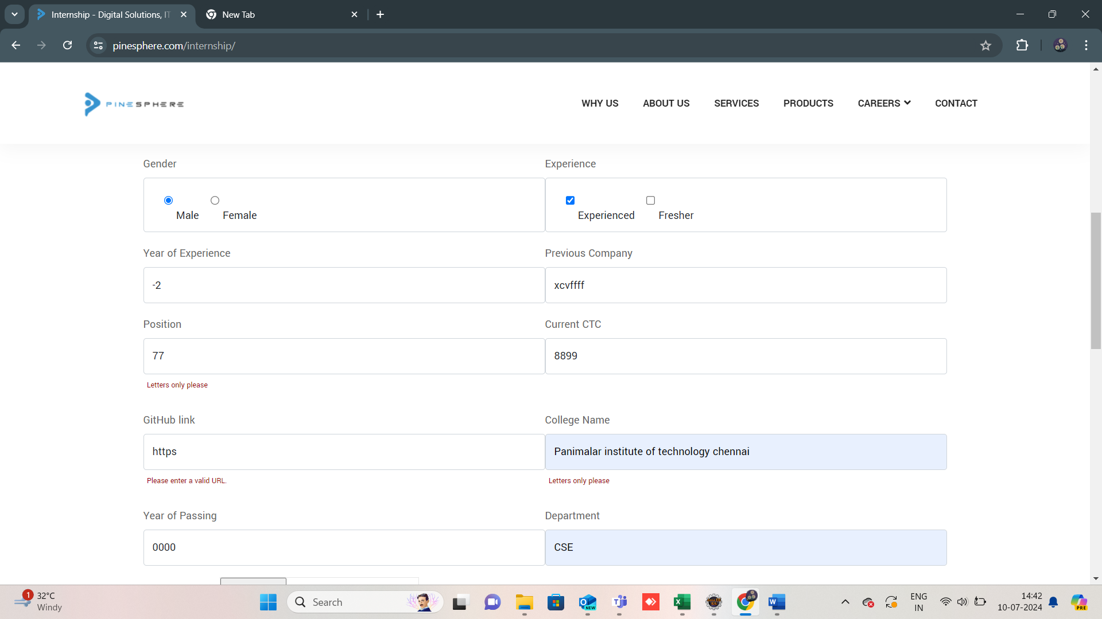

11.Home->Free consultation->phone number

User can able to enter the valid phone number on pinesphere.com ->Able to enter the invalid test data on phone number field. without any alert

Source code

package automationFramework;

import org.openqa.selenium.By;

import org.openqa.selenium.JavascriptExecutor;

import org.openqa.selenium.WebDriver;

import org.openqa.selenium.WebElement;

import org.openqa.selenium.chrome.ChromeDriver;

public class pinespherefunc {

public static void main(String[] args) {

System.setProperty("webdriver.chrome.driver","D:\\selenium\\eclipse-jee-oxygen-3a-win32-x86_64\\eclipse\\chromedriver-win64 (1)\\chromedriver-win64\\chromedriver.exe");

WebDriver driver=new ChromeDriver();

driver.manage().window().maximize();

driver.get("https://pinesphere.com/");

System.out.println(driver.getTitle());

JavascriptExecutor js = (JavascriptExecutor) driver;

js.executeScript("window.scrollBy(0, 4500)");

WebElement name = driver.findElement(By.xpath("//input[@id='name']"));

name.sendKeys(" ");

WebElement mail = driver.findElement(By.xpath("//input[@id='email']"));

mail.sendKeys("keerthika@pinesphere.co.in");

WebElement phone = driver.findElement(By.xpath("//input[@id='phone']"));

phone.sendKeys("abcdefghij");

driver.findElement(By.id("submit")).submit();

}

}

Ref fig:11

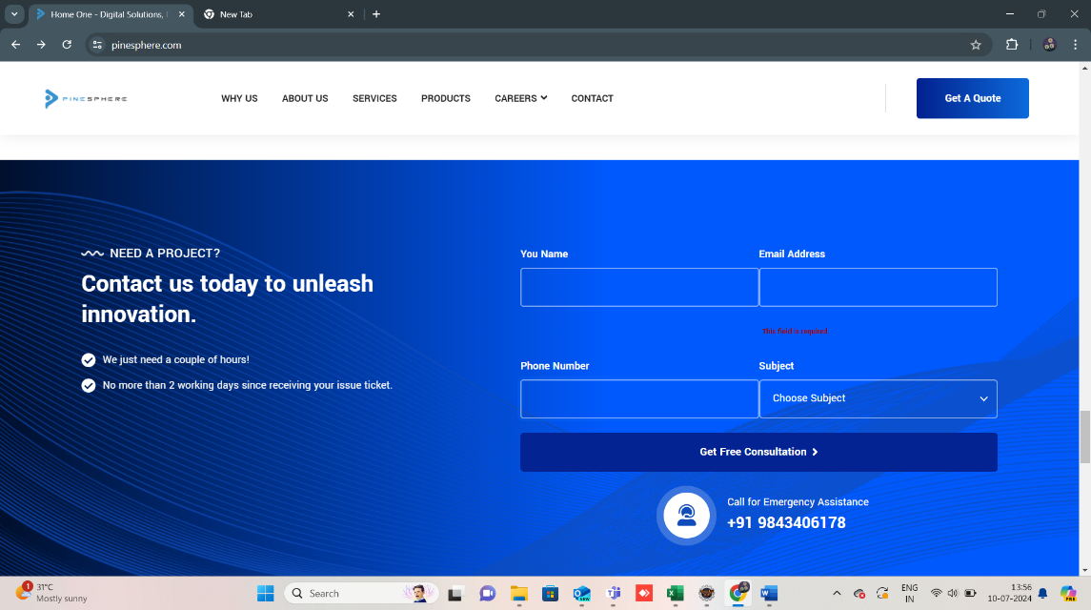

12.Home->Free consultation->Name

User can able to enter valid name in the given text box->Able to enter the inavlid test data on name and accepting spaces. without any alert

Source code:

package automationFramework;

import org.openqa.selenium.By;

import org.openqa.selenium.JavascriptExecutor;

import org.openqa.selenium.WebDriver;

import org.openqa.selenium.WebElement;

import org.openqa.selenium.chrome.ChromeDriver;

public class pinespherefunc {

public static void main(String[] args) {

System.setProperty("webdriver.chrome.driver","D:\\selenium\\eclipse-jee-oxygen-3a-win32-x86_64\\eclipse\\chromedriver-win64 (1)\\chromedriver-win64\\chromedriver.exe");

WebDriver driver=new ChromeDriver();

driver.manage().window().maximize();

driver.get("https://pinesphere.com/");

System.out.println(driver.getTitle());

JavascriptExecutor js = (JavascriptExecutor) driver;

js.executeScript("window.scrollBy(0, 4500)");

WebElement name = driver.findElement(By.xpath("//input[@id='name']"));

name.sendKeys(" ");

WebElement mail = driver.findElement(By.xpath("//input[@id='email']"));

mail.sendKeys("keerthika@pinesphere.co.in");

WebElement phone = driver.findElement(By.xpath("//input[@id='phone']"));

phone.sendKeys("abcdefghij");

driver.findElement(By.id("submit")).submit();

}

}

Ref fig:12

