## 

**YOGASPIRE**

A J Component Report

TEAM MEMBERS:

|  |  |  |
| --- | --- | --- |
| SNO | NAME | REG NO: |
| 1. | KEERTHIKA REDDY | 20BCE0919 |
| 2. | SAI RUTHVIK ATOHA | 20BDS0003 |
| 3. | PENTAMSETTY SAI HARSHITA | 20BCE0839 |
| 4. | GAURAV GAUR | 20BCE0774 |

**In partial fulfillment for the award of the degree**

**of B.Tech in**

**COMPUTER SCIENCE ENGINEERING**

Under the Guidance of

**Faculty: Prof. Delhi Babu R**

**School of Computing Science And Engineering**

APRIL 2022

## 

School of Computer Science and Engineering

**DECLARATION**

I hereby declare that the J Component report entitled “**YOGASPIRE**” submitted by me to Vellore Institute of Technology, Vellore in partial fulfillment of the requirement for the award of the degree of **B.Tech in Computer science and engineering** is a record of bonafide undertaken by me under the supervision of **Dr. R. Delhi Babu** I further declare that the work reported in this report has not been submitted and will not be submitted, either in part or in full, for the award of any other degree or diploma in this institute or any other institute or university.

**TABLE OF CONTENTS**

|  |  |  |
| --- | --- | --- |
| CHAPTER NO: | TITLE | PAGE NO. |
| 1. | Introduction | 4 |
| 2. | Abstract | 5 |
| 3. | Requirement | 6 |
| 4. | Input | 7 |
| 5. | Output | 9 |
| 6. | Pose recognition using OpenCV and MediaPipe | 9 |
| 7. | About the Regression model | 11 |
| 8. | Flowchart | 12 |
| 9. | Screenshot | 13 |
| 10. | Conclusion | 14 |
| 11. | Appendices | 15 |

**INTRODUCTION**

With the stressful lifestyle and heavy work schedule , people fail to reach their daily physical goals , even if they want to . hiring a trainer will raise problems like :time , feasibility,economic limit etc . in addition , not everyone is confident to work with a trainer. Hence , in-order to counter this issue ,we made our software YOGASPIRE.

This project is a go-to, to all the fitness and health freaks. It is way better than any yoga center out there, as it's smarter, trained, and offers easy and effective methods to reach the target and give you personal attention.

In the current scenario like a global pandemic, where people aren’t able to visit the yoga centers and are worried about their health, fitness, and stress, this software would be of great help to them as yoga not only brings in physical fitness, it also relaxes one’s soul and maintains mental health. From a busy person to an introvert, this software is a savior!

Yogaspire is an AI yoga trainer who helps the user to correct their yoga poses and help the user to do the poses in the right way. Yogaspire also has a field to calculate the work-life balance score of an individual. This score helps the user to understand how much more time they can devote towards personal health.

The Work-Life Balance Score is divided as follows: a poor score is below 550, a good score is above 680, an excellent score is above 700.

**ABSTRACT**

Effective outcome of any activity comes when it’s done in the right way and by using this Yogaspire app, we get to know the exact/accurate way of doing a particular yoga pose and also corrects our postures and guides us the proper and effective way to do yoga for a better result. it recommends us the mount of time we have to spend on doing yoga per day by determining our work-life balance ratio .This software is a go to, to all the fitness and health freaks. it is way better than a personal gym assistant, as its smarter, trained and offers easy and effective methods to reach the target.

In the current scenario like a global pandemic, where people aren’t able to visit the yoga centers and are worried about their health and fitness, this software would be of great help to them as exercise not only brings in physical fitness, it also relaxes one’s soul and maintains mental health.

**REQUIREMENTS**

Software Specification:

* MediaPipe and OpenCV should be installed
* Python 3 and above should be supported

Hardware Specification:

* 4GB RAM
* GPU is an added advantage

Libraries Used:

* Numpy
* MediaPipe
* Sklearn
* OpenCV

**INPUT**

This application is open to two different set of inputs :

1. **Pose detection:**

The input for pose detection would be an individual opening his/her camera and trying out the yoga poses . the model would process the posture and indicate if the user is performing the yoga pose correctly or not.

1. **Work life balance score prediction:**

In order to detect the stress levels in an individuals life , we would be putting forward a series of questions , based on the answers for the same we would be able to determine the work-life balance score in the persons life and in-turn this would be helpful in determining the number of hours the person has to perform yoga per day.

Questions Asked :

1. HOW WELL DO YOU COMPLETE YOUR WEEKLY TO-DO LISTS?
2. IN A TYPICAL WEEK, HOW MANY TIMES DO YOU HAVE THE OPPORTUNITY TO THINK ABOUT YOURSELF?
3. HOW MUCH STRESS DO YOU TYPICALLY EXPERIENCE EVERYDAY?
4. HOW OFTEN DO YOU SHOUT OR SULK AT SOMEBODY?
5. HOW SUFFICIENT IS YOUR INCOME TO COVER BASIC LIFE EXPENSES?
6. ABOUT HOW LONG DO YOU TYPICALLY SLEEP?
7. HOW MANY PEOPLE ARE VERY CLOSE TO YOU?
8. WHAT IS YOUR BODY MASS INDEX (BMI) RANGE?
9. WITH HOW MANY PEOPLE DO YOU INTERACT WITH DURING A TYPICAL DAY?
10. HOW MANY FRUITS OR VEGETABLES DO YOU EAT EVERYDAY?
11. HOW MANY NEW PLACES DO YOU VISIT?
12. HOW MANY HOURS DO YOU SPEND EVERYDAY DOING WHAT YOU ARE PASSIONATE ABOUT?
13. HOW MANY STEPS (IN THOUSANDS) DO YOU TYPICALLY WALK EVERYDAY?
14. FOR HOW MANY YEARS AHEAD IS YOUR LIFE VISION VERY CLEAR FOR?
15. HOW MANY PEOPLE DO YOU HELP ACHIEVE A BETTER LIFE?
16. HOW MANY DAYS OF VACATION DO YOU TYPICALLY LOSE EVERY YEAR ?
17. IN A TYPICAL DAY, HOW MANY HOURS DO YOU EXPERIENCE "FLOW"?
18. HOW MANY RECOGNITIONS HAVE YOU RECEIVED IN YOUR LIFE?
19. HOW MANY REMARKABLE ACHIEVEMENTS ARE YOU PROUD OF?
20. HOW MANY TIMES DO YOU DONATE YOUR TIME OR MONEY TO GOOD CAUSES?
21. YOUR AGE RANGE
22. YOUR GENDER

**OUTPUT**

**Pose Detection:**

The software gives a result of the name of the yoga poses the user is doing and also determines if he/she is performing the pose accurately or not.

**Work life Balance score prediction:**

The project also tells the user how much time he/she should spend on doing per day based on their work-life balance score .

**POSE RECOGNITION USING MEDIAPIPE AND OPENCV**

MediaPipe Pose is a ML solution for high-fidelity body pose tracking, inferring 33 3D landmarks and background segmentation mask on the whole body from RGB video frames utilizing our [BlazePose](https://ai.googleblog.com/2020/08/on-device-real-time-body-pose-tracking.html) research that also powers the [ML Kit Pose Detection API](https://developers.google.com/ml-kit/vision/pose-detection). Current state-of-the-art approaches rely primarily on powerful desktop environments for inference, whereas our method achieves real-time performance on most modern [mobile phones](https://google.github.io/mediapipe/solutions/pose.html#mobile), [desktops/laptops](https://google.github.io/mediapipe/solutions/pose.html#desktop), in [python](https://google.github.io/mediapipe/solutions/pose.html#python-solution-api) and even on the [web](https://google.github.io/mediapipe/solutions/pose.html#javascript-solution-api).

The solution utilizes a two-step detector-tracker ML pipeline, proven to be effective in our [MediaPipe Hands](https://google.github.io/mediapipe/solutions/hands.html) and [MediaPipe Face Mesh](https://google.github.io/mediapipe/solutions/face_mesh.html) solutions. Using a detector, the pipeline first locates the person/pose region-of-interest (ROI) within the frame. The tracker subsequently predicts the pose landmarks and segmentation mask within the ROI using the ROI-cropped frame as input. Note that for video use cases the detector is invoked only as needed, i.e., for the very first frame and when the tracker could no longer identify body pose presence in the previous frame. For other frames the pipeline simply derives the ROI from the previous frame’s pose landmarks.

The pipeline is implemented as a MediaPipe [graph](https://github.com/google/mediapipe/tree/master/mediapipe/graphs/pose_tracking/pose_tracking_gpu.pbtxt) that uses a [pose landmark subgraph](https://github.com/google/mediapipe/tree/master/mediapipe/modules/pose_landmark/pose_landmark_gpu.pbtxt) from the [pose landmark module](https://github.com/google/mediapipe/tree/master/mediapipe/modules/pose_landmark) and renders using a dedicated [pose renderer subgraph](https://github.com/google/mediapipe/tree/master/mediapipe/graphs/pose_tracking/subgraphs/pose_renderer_gpu.pbtxt). The [pose landmark subgraph](https://github.com/google/mediapipe/tree/master/mediapipe/modules/pose_landmark/pose_landmark_gpu.pbtxt) internally uses a [pose detection subgraph](https://github.com/google/mediapipe/tree/master/mediapipe/modules/pose_detection/pose_detection_gpu.pbtxt) from the [pose detection module](https://github.com/google/mediapipe/tree/master/mediapipe/modules/pose_detection).

**ABOUT THE REGRESSION MODEL**

We made use of an XGBoost model to predict the work life balance score of an individual. We import the libraries, the dataset and pre-process the dataset. We perform One-Hot encoding to convert all the strings into integer values for the model to understand. Following which we split the dataset into training and test set. We then trained the model and predicted the accuracy. The accuracy of the model we achieved is 98%.

**FLOWCHARTS**

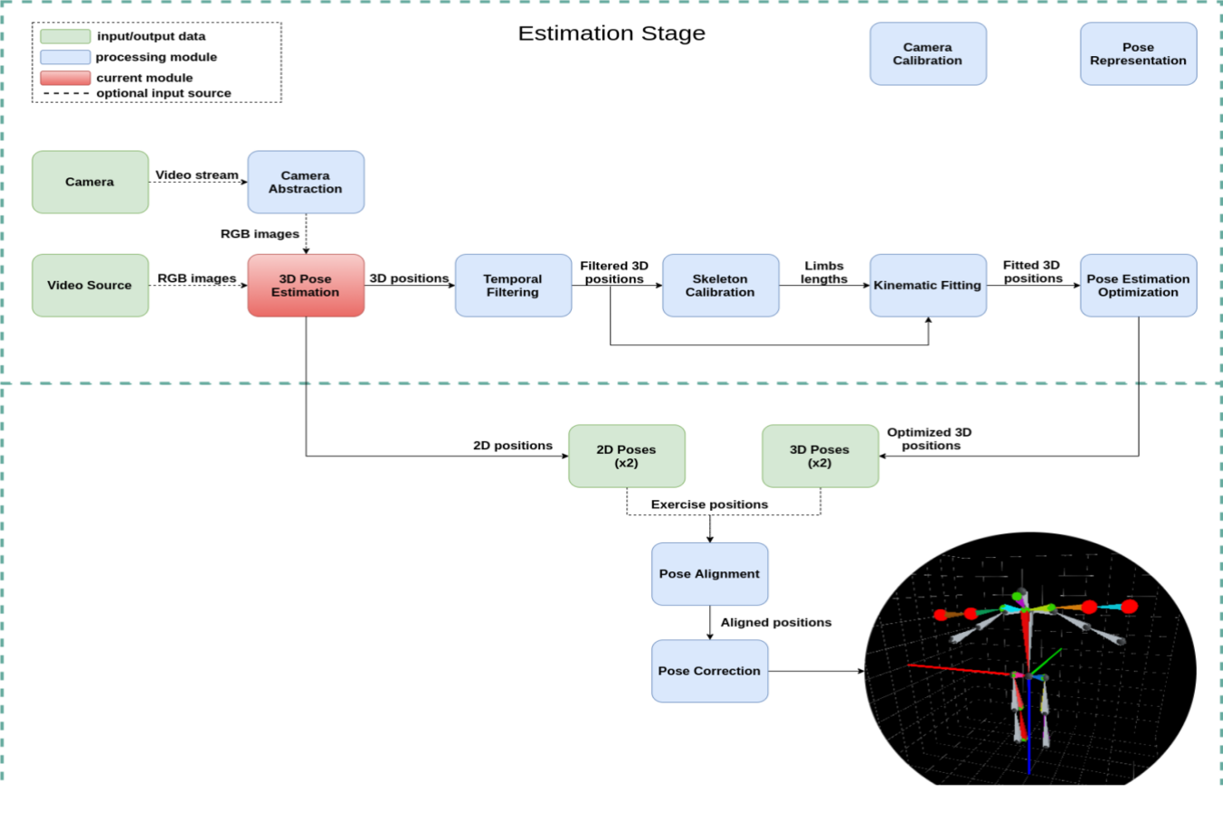

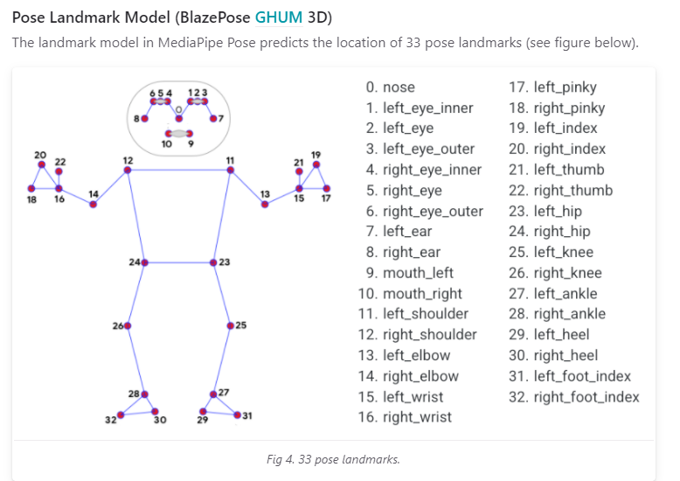

**SCREENSHOTS**

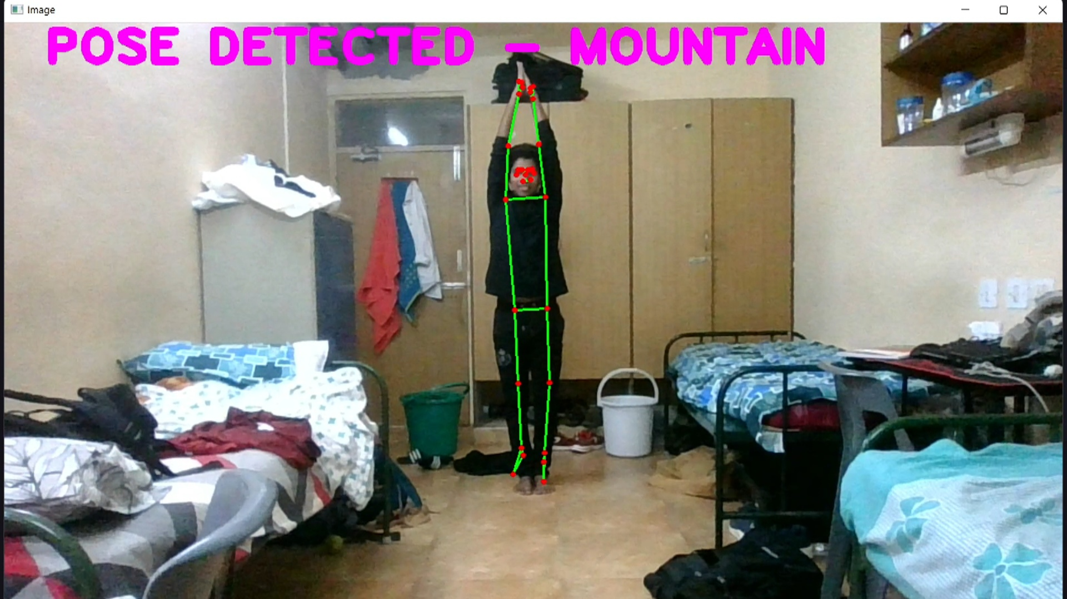

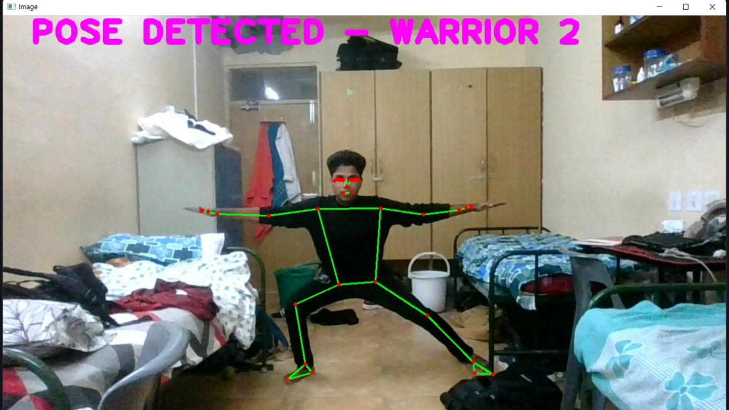

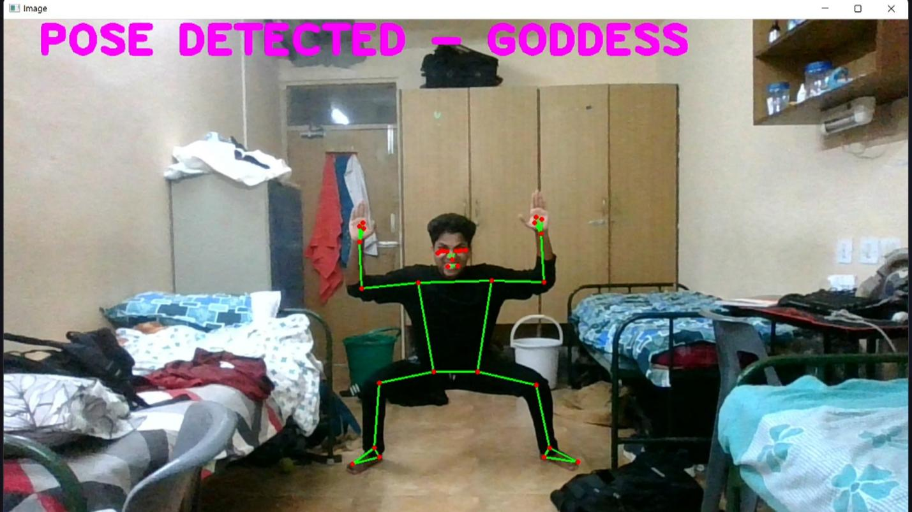

**CONCLUSION**

In conclusion, this project is extremely beneficial for individuals who want to save on time and money, It is way better than any yoga center out there, as it's smarter, trained, and offers easy and effective methods to reach the target and give you personal attention. Through this project we have learnt how to make use of OpenCV for pose detection and using regression to predict values.

**Link for the project -** https://GitHub.com/SaiRuthvik12/Yogaspire

**APPENDICES**

Appendix 1: OpenCV

OpenCV is the huge open-source library for the computer vision, machine learning, and image processing and now it plays a major role in real-time operation which is very important in today’s systems. By using it, one can process images and videos to identify objects, faces, or even handwriting of a human. When it integrated with various libraries, such as NumPy, python is capable of processing the OpenCV array structure for analysis. To Identify image pattern and its various features we use vector space and perform mathematical operations on these features.

Appendix 2: Mediapipe

MediaPipe is a Framework for building machine learning pipelines for processing time-series data like video, audio, etc. This cross-platform Framework works in Desktop/Server, Android, iOS, and embedded devices like Raspberry Pi and Jetson Nano.

Appendix 3: Scikit-learn

Scikit-learn (Sklearn) is the most useful and robust library for machine learning in Python. It provides a selection of efficient tools for machine learning and statistical modeling including classification, regression, clustering and dimensionality reduction via a consistence interface in Python. This library, which is largely written in Python, is built upon NumPy, SciPy and Matplotlib.