1) Jacoco Report
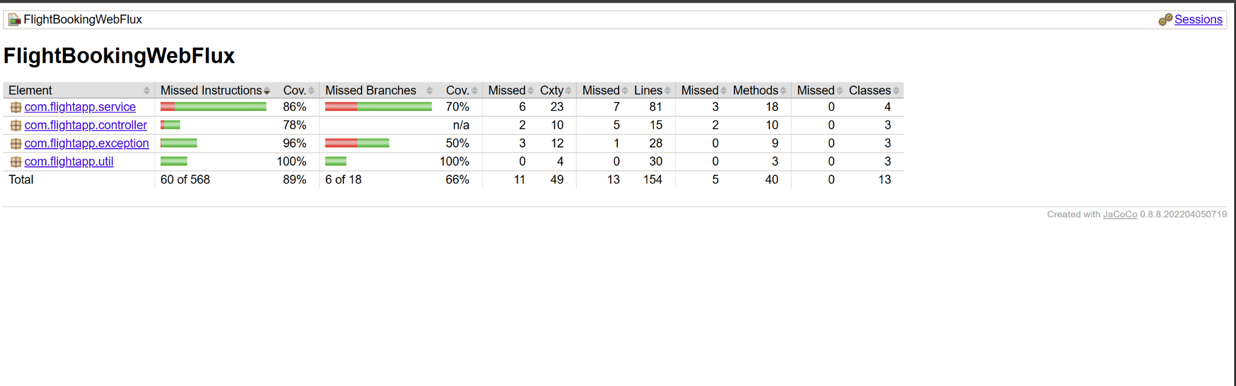
2) SonarCube Report
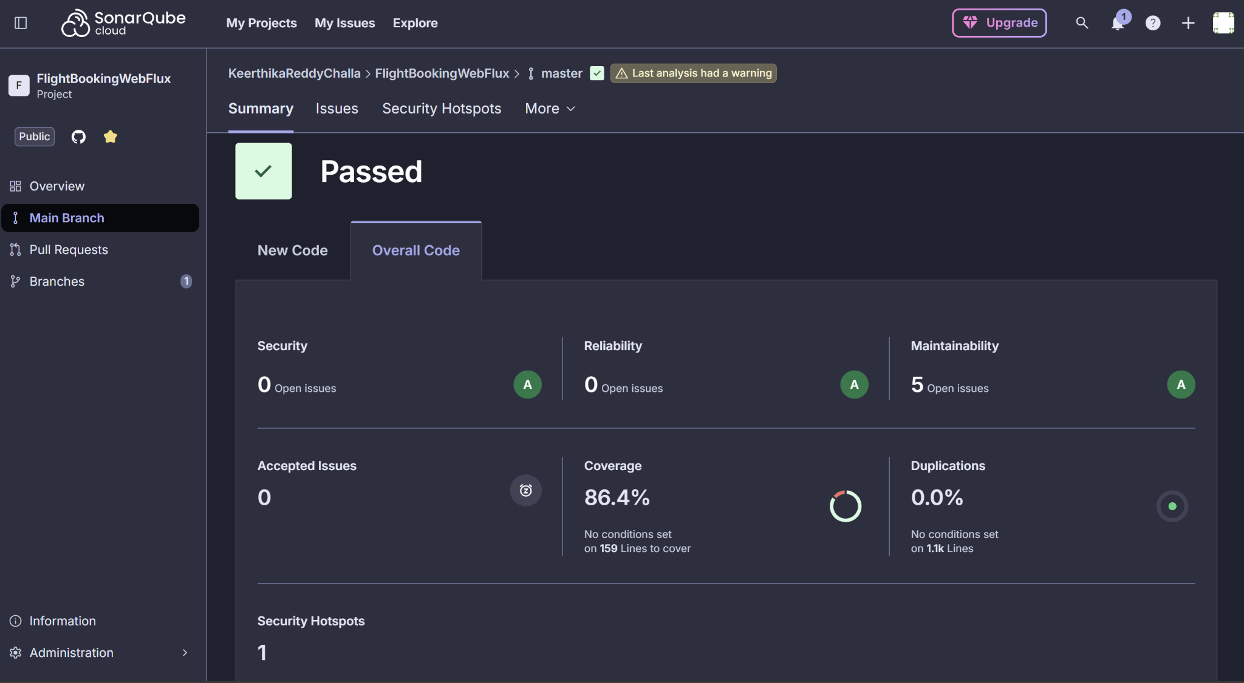
3)Jmeter result-tree
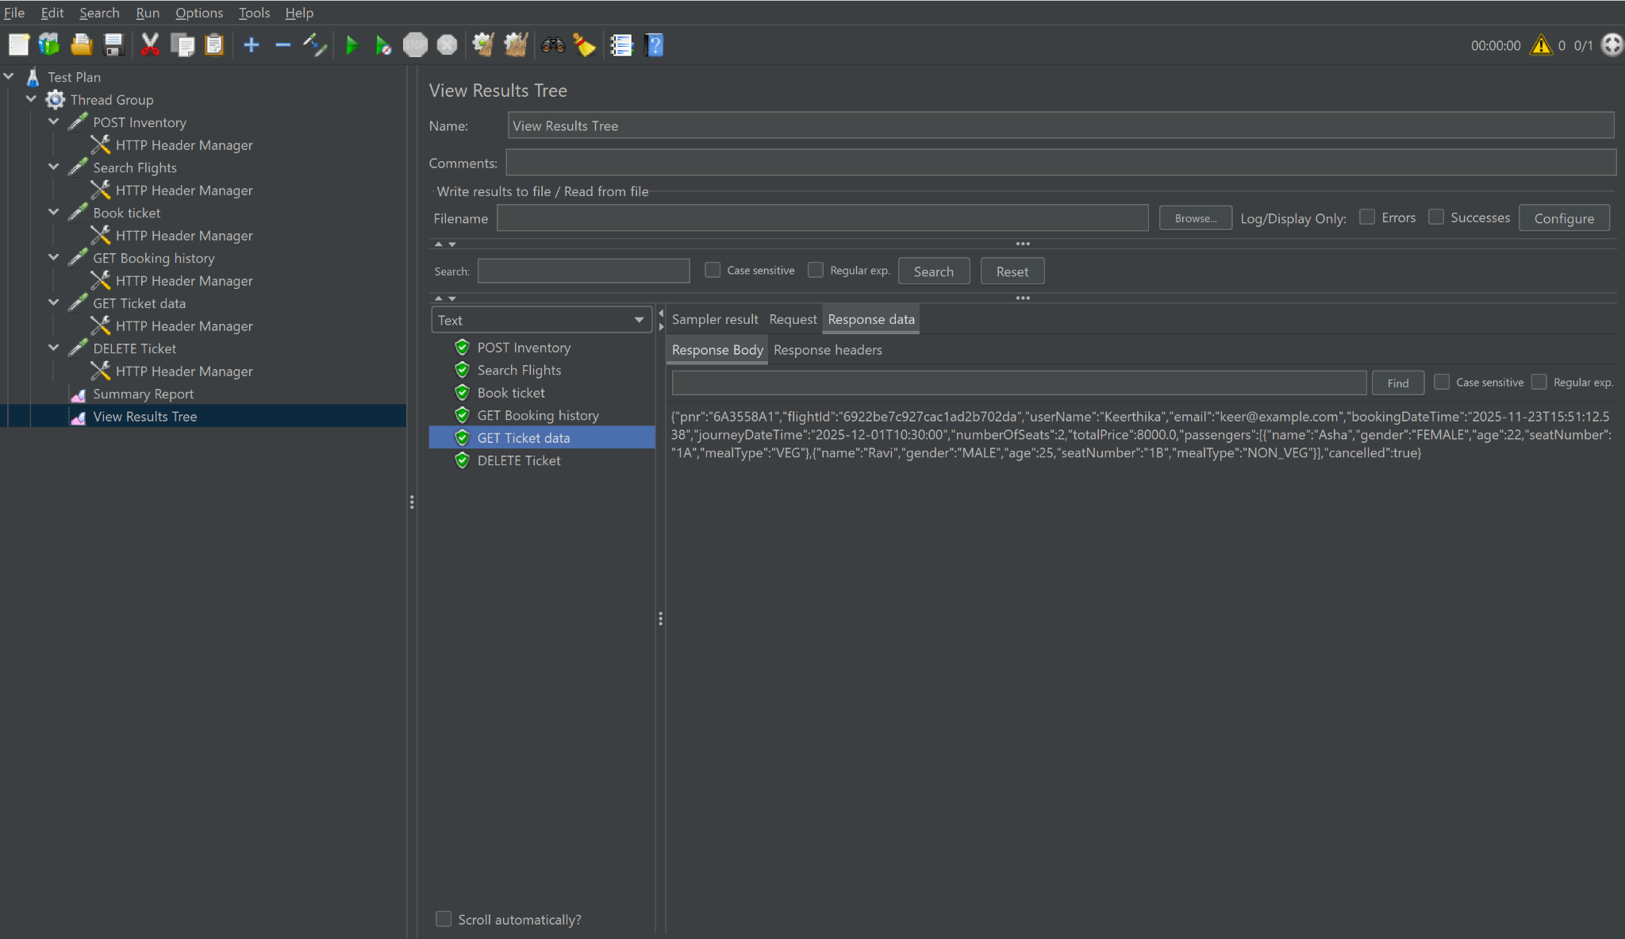
4) Jmeter Summary-report (1-sample)

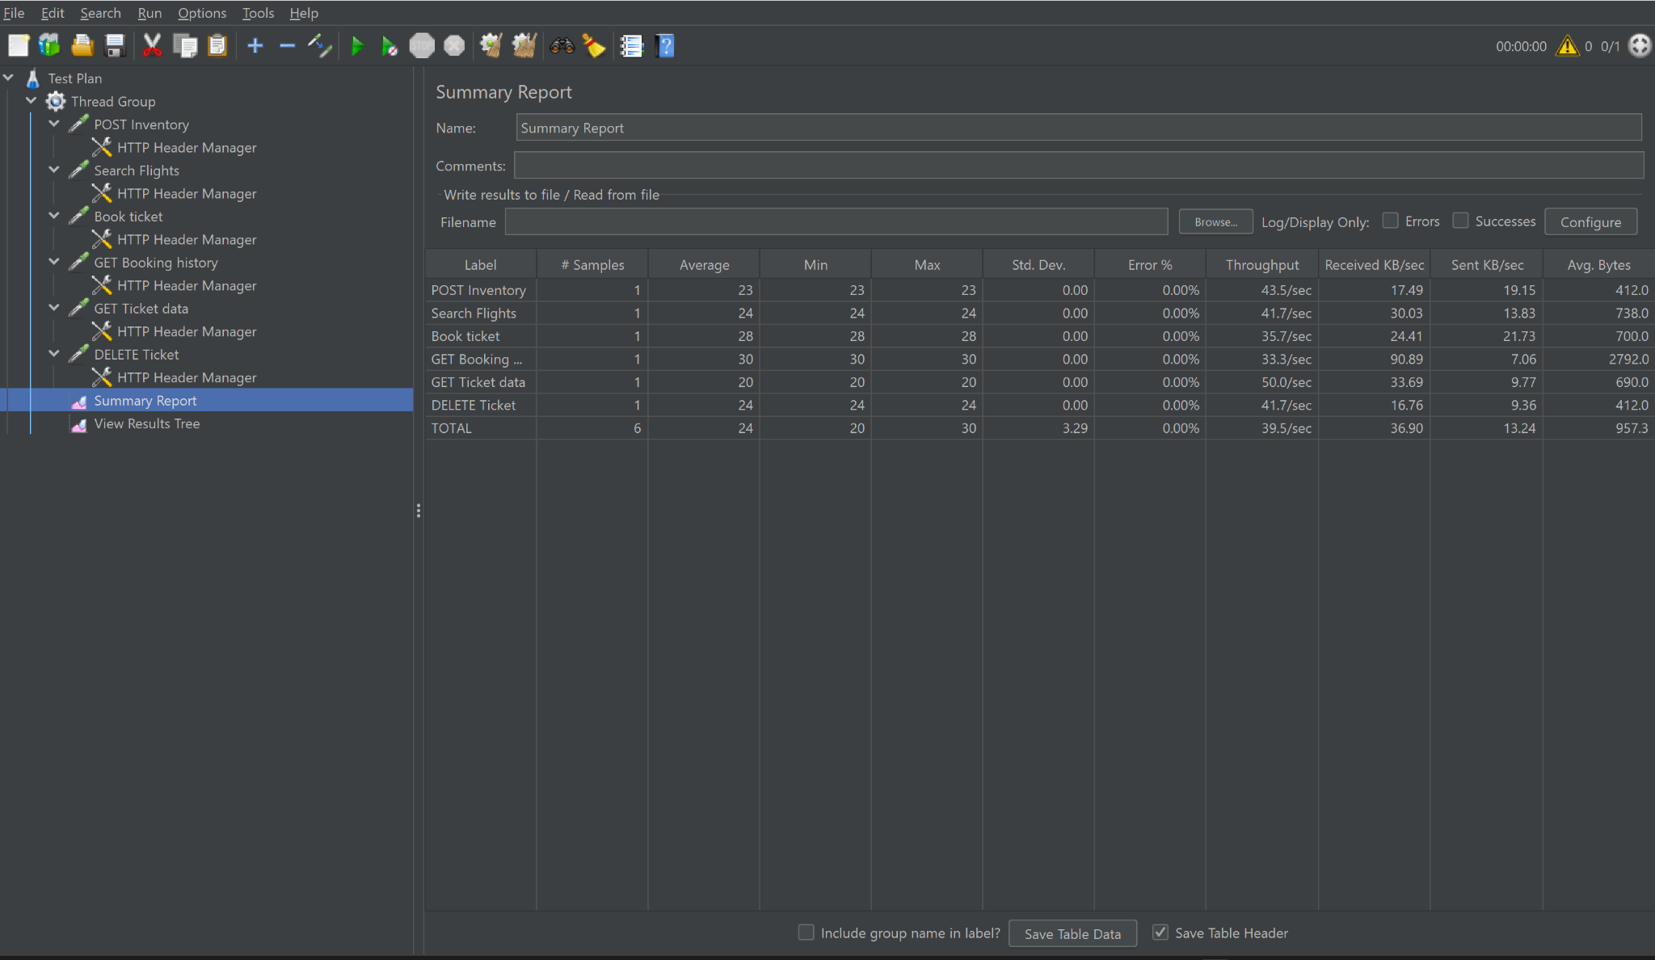

5) Jmeter Summary-report (9-samples)

