Service Dashboard

- Eureka Server Dashboard

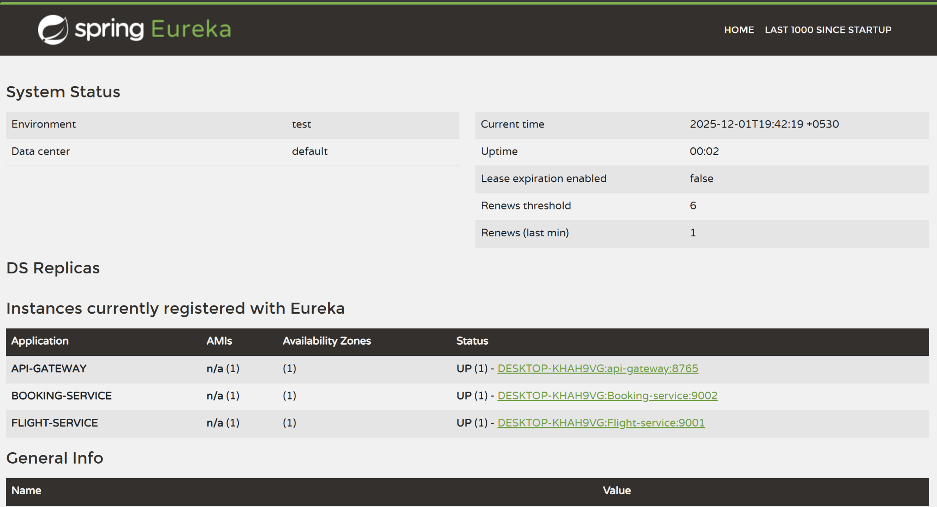

- Config Server Console (flight-service)

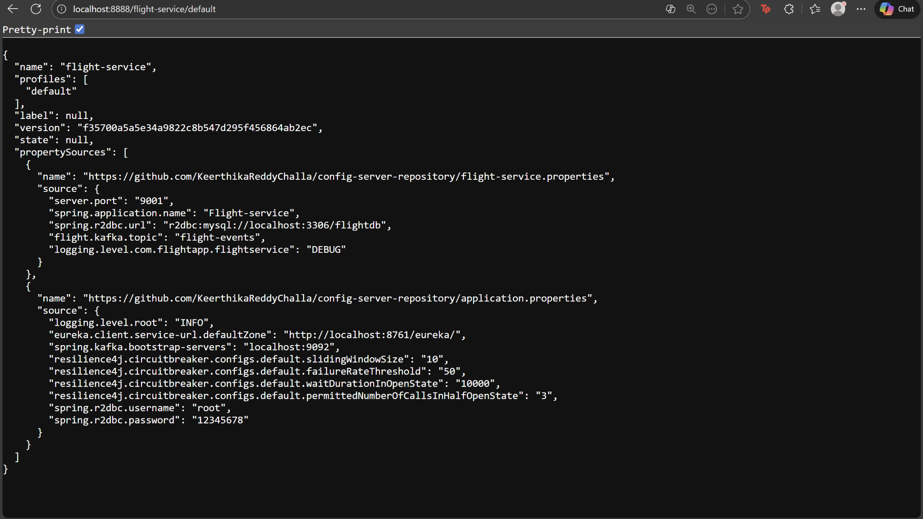

- Config Server Console (booking-service)

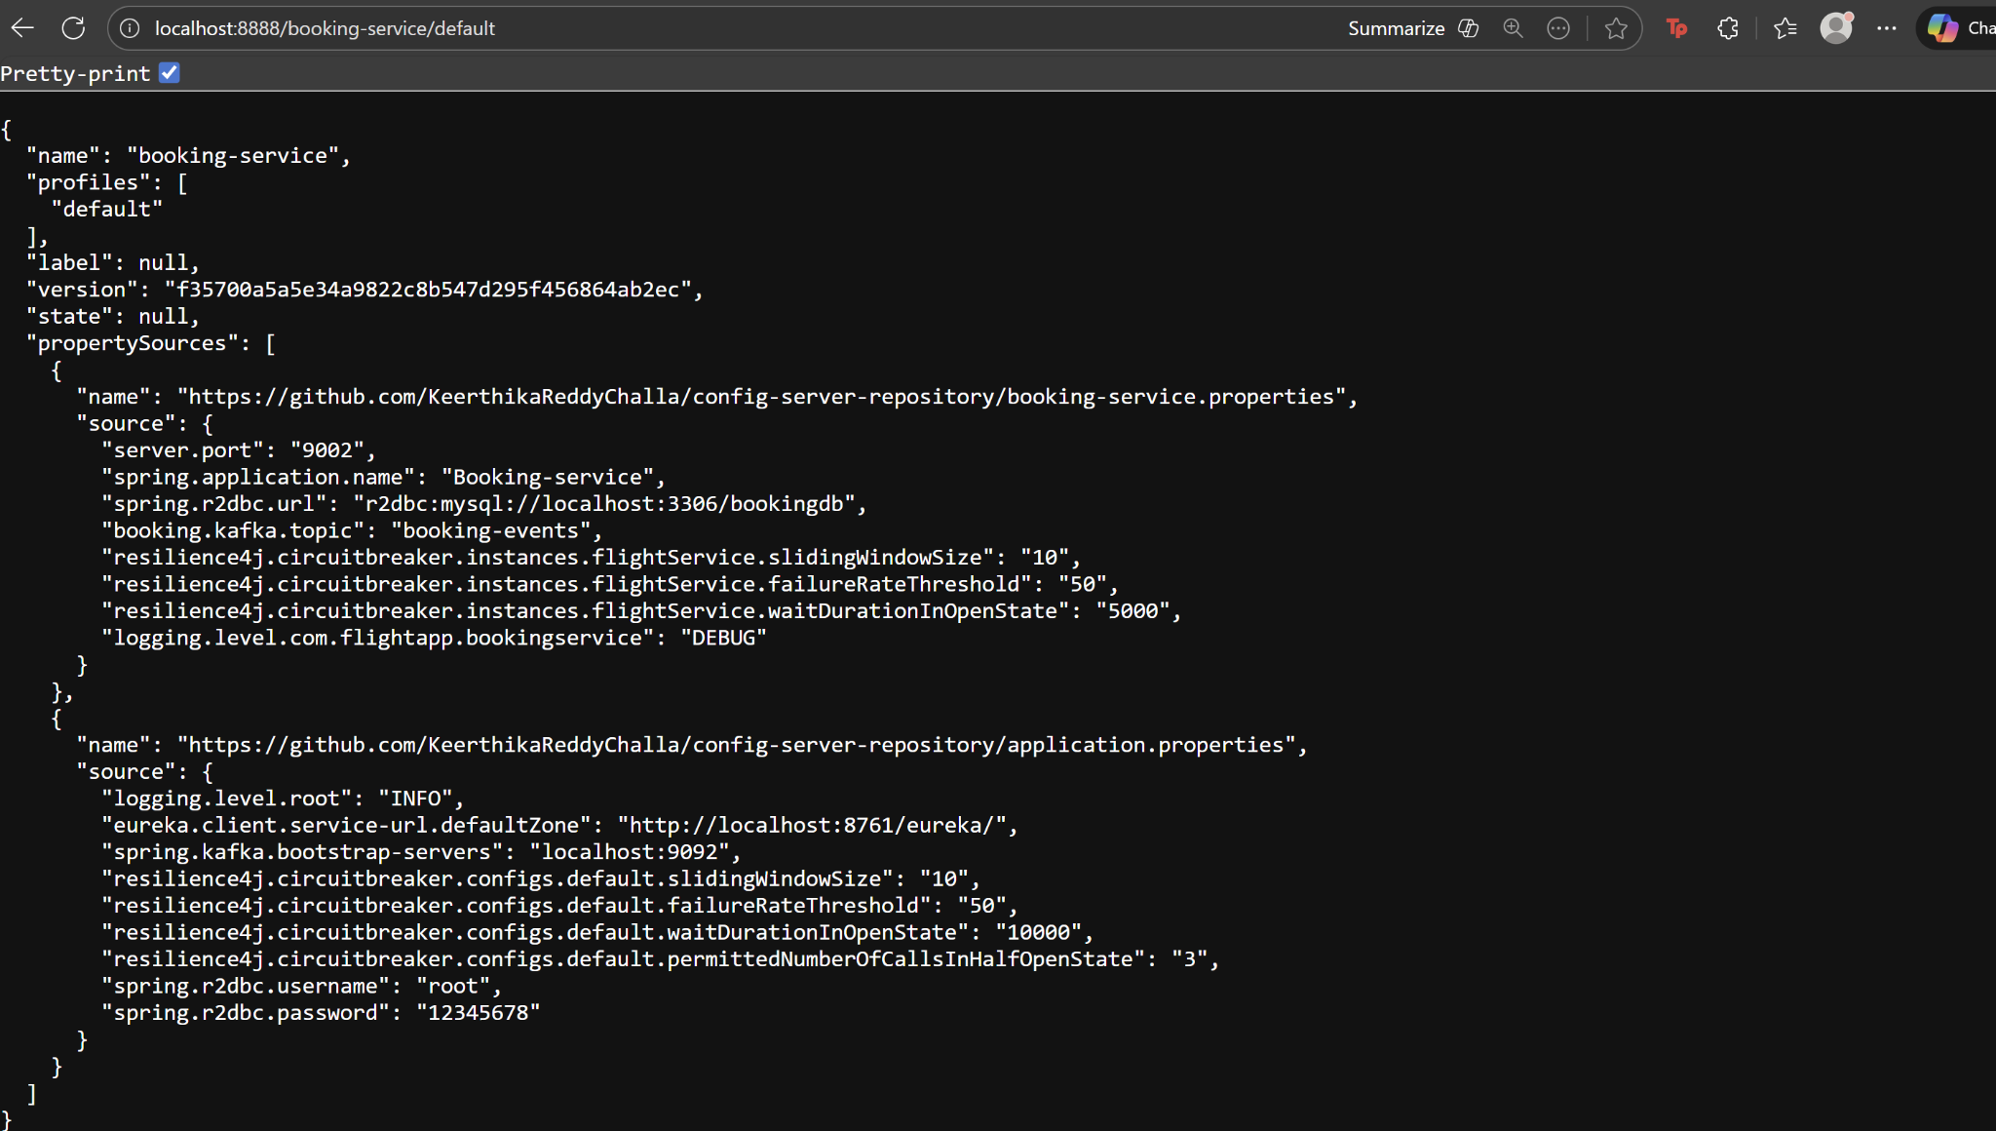

Performance Evaluation using JMeter

- Jmeter Results tree

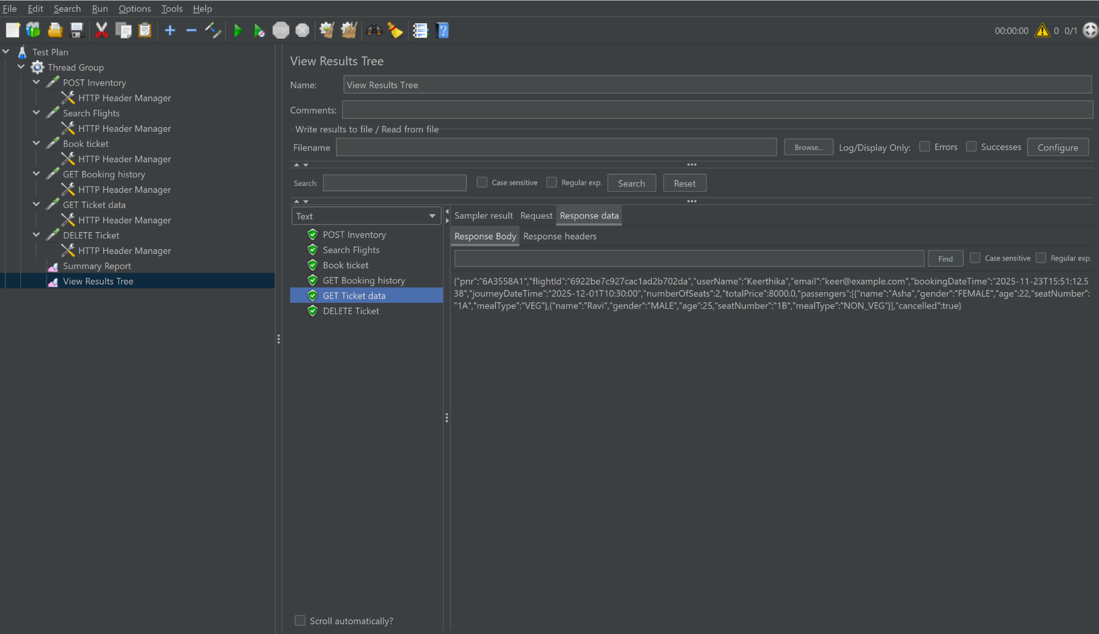

- Jmeter Summary-report (1-sample)

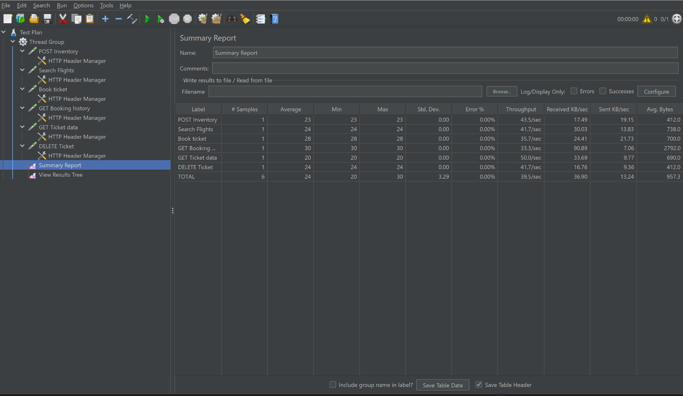

- Jmeter Summary-report (20-samples)

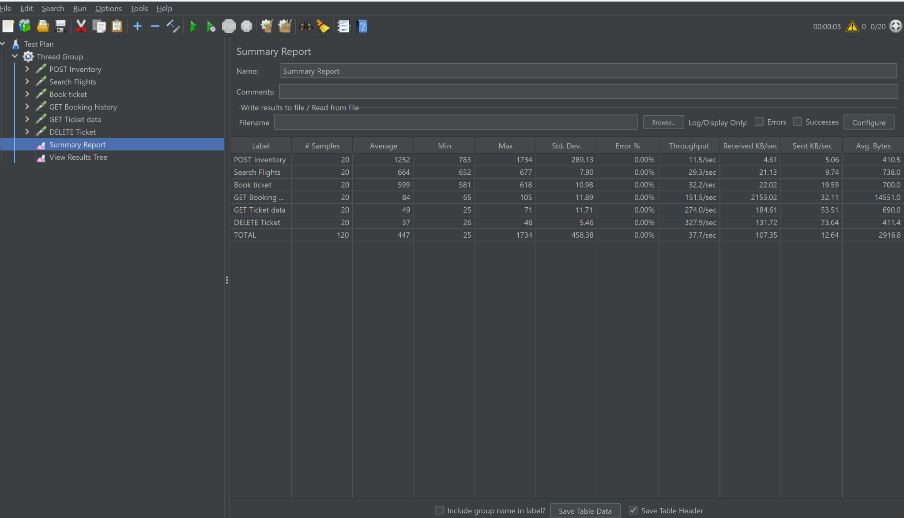

Jacoco Test coverage report

- Flight-Service JaCoCo Report

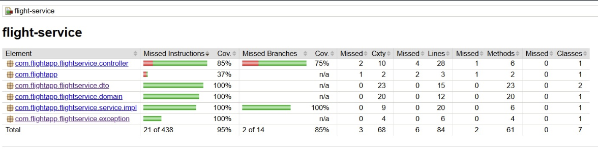

- Booking-Service JaCoCo Report

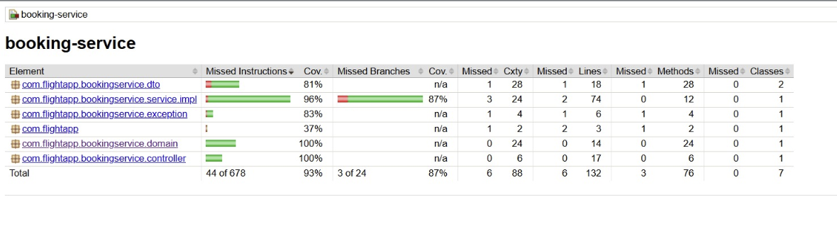
Code Coverage using SonarCloud

