Report

Team ID | MCA
Project Name | Online Learning Engagement and Student Performance Analysis

This report presents an analysis of student engagement and academic performance in an online learning programme covering 22,422 students across 13 regions of the UK and Ireland. It examines how students interact with the platform (total clicks and engagement level), how they perform (average score and final result), and which learners are most at risk of failing or dropping out. The findings are intended for course designers, academic leaders and student-support teams who need to identify where early intervention can improve completion and success rates.
The report was designed in Power BI and is organised into two interactive dashboards. The first, Student Performance & Engagement Overview, covers average score by region, students by engagement level and final result, total clicks by engagement level, and a decomposition tree that drills from risk level to education, gender and region. The second, Risk, Dropout & Demographic Analysis, covers dropout rate and pass rate by highest education, students by risk level, final result by gender, and a decomposition tree linking engagement level to final result.
Dashboard 1: Student Performance & Engagement Overview
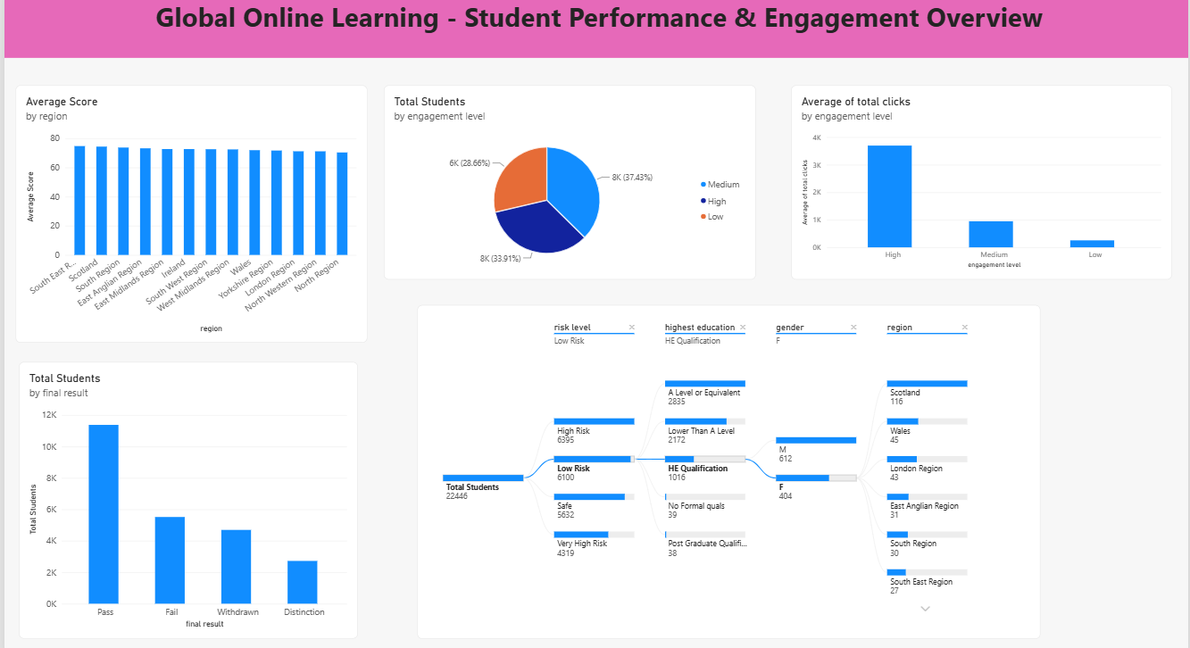
Figure 1: Global Online Learning – Student Performance & Engagement Overview
Observations drawn from this dashboard:
1. Regional Performance:
- Average scores are high and tightly clustered across all 13 regions, at roughly 71–75. The South East Region and Scotland lead and the North Region is lowest, so region does not appear to be a major driver of differences in performance.
2. Engagement Levels:
- Of 22,422 students, 8,400 (37.46%) show Medium engagement, 7,612 (33.95%) High and 6,410 (28.59%) Low. About two-thirds of learners are therefore at Medium or Low engagement.
3. Platform Activity (Clicks):
- High-engagement students generate about 32M clicks, compared with about 9M for Medium and 2M for Low. Roughly three-quarters of all clicks come from about a third of the students, showing how concentrated learning activity is.
4. Final Results:
- Pass is the most common outcome (about 11K students), followed by Fail (about 5.5K), Withdrawn (about 4.7K) and Distinction (about 2.8K). Fail and Withdrawn together are almost as large as Pass, which makes retention a significant challenge.
5. Risk Level Drill-down:
- Students are spread across four risk levels: High Risk (6,391), Low Risk (6,099), Safe (5,632) and Very High Risk (4,300).
- Drilling into Low Risk students with an HE Qualification (1,016) shows 612 male and 404 female learners. Among the women, Scotland has the most (116), followed by Wales (45) and London Region (43). This shows how the decomposition tree lets users drill down to any segment.
Dashboard 2: Risk, Dropout & Demographic Analysis
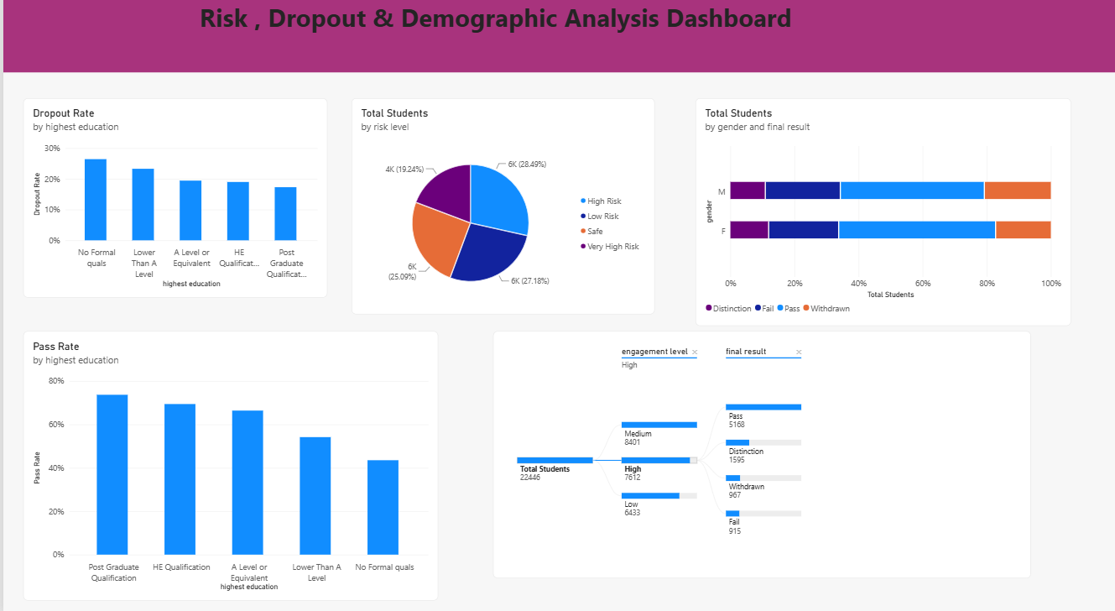
Figure 2: Risk, Dropout & Demographic Analysis Dashboard
Observations drawn from this dashboard:
1. Dropout Rate by Prior Education:
- Dropout falls steadily as prior education rises: about 28% for students with No Formal quals, about 24% for Lower Than A Level, about 20% for both A Level and HE Qualification, and about 18% for Post Graduate learners. Students with no formal qualifications drop out about 1.5 times as often as post-graduates.
2. Pass Rate by Prior Education:
- The pass rate mirrors this pattern: about 67% for Post Graduate, 65% for HE Qualification, 62% for A Level, 50% for Lower Than A Level and only about 42% for No Formal quals, a gap of roughly 25 percentage points between the highest and lowest groups.
3. Risk Profile:
- High Risk (28.5%) and Very High Risk (19.18%) students together total 10,691, nearly 48% of all learners. Low Risk (27.2%) and Safe (25.12%) make up the remaining, just over half.
4. Gender and Final Result:
- Outcomes are broadly similar for both genders, but women do slightly better: about 49% of female students Pass compared with about 45% of male students, and about 17% of women Withdraw compared with about 21% of men. Distinction rates are close (about 11–12%).
5. Engagement and Final Result:
- For High-engagement students the decomposition tree shows Pass (5,168), Distinction (1,595), Withdrawn (967) and Fail (915). About 78% finish with a Pass or Distinction and only about 22% fail or withdraw, compared with roughly 40% across all students on Dashboard 1. High engagement is therefore associated with about half the rate of failure or withdrawal.
Key Insights and Recommendations
- Engagement is closely linked to success. Highly engaged students fail or withdraw about half as often, so the 14,810 students at Medium or Low engagement should be the focus of reminders, nudges and more interactive content.
- Prior education matters more than region. Regional average scores differ by only a few points, while dropout and pass rates vary widely with prior education. Support such as bridging modules, mentoring and study-skills sessions should target learners with No Formal quals or Lower Than A Level.
- Prioritise high-risk learners. With 10,691 students (about 48%) at High or Very High risk, early-warning alerts and adviser follow-ups should be triggered as soon as engagement drops.
- Monitor continuously. The interactive drill-downs allow advisers to filter by region, education, gender and engagement level and to act on the segments that need attention.

