GOVolunteer
Use Case Diagram

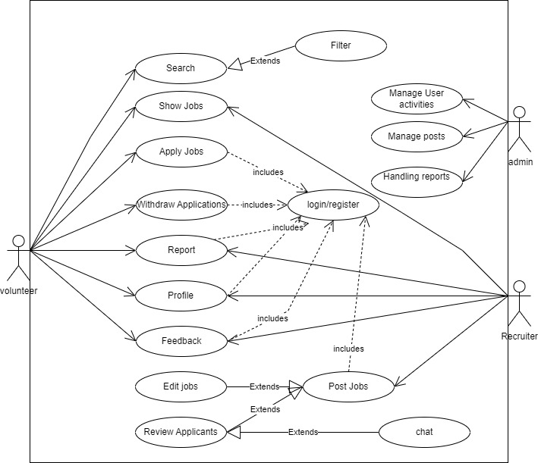

ACTORS:
Volunteer can search, show jobs, apply for jobs, withdraw applications, report issues, view their profile and provide feedback. They must log in or register to access these features.
Admin can manage user activities, posts and handle reports. They oversee the platform’s content and users’ actions.
Recruiter can edit jobs, post jobs, review applicants and chat with admins. They interact with volunteers through the application process via chat functionality. They ensure that job postings are up-to-date and relevant.

USE CASES:
Search allows the volunteer to search for jobs based on keywords or criteria. It includes a filter option that extends the search functionality by allowing the volunteer to specify more details such as location, category, duration, etc.
Show Jobs allows the volunteer to view the available jobs that match their search criteria. It shows the job title, description, requirements, benefits, etc.
Apply Jobs allows the volunteer to apply for a job that they are interested in. It requires them to fill in their personal information. It includes a withdraw application option that extends the apply job functionality by allowing the volunteer to cancel their application if they change their mind or find another opportunity.
Report allows the volunteer to report any issues or problems they encounter on the platform. It requires them to select a category of issue, describe the problem, and attach any screenshots or evidence.
Profile option allows the volunteers and recruiters to view and edit their personal information and preferences.
Feedback allows the volunteer to provide feedback on their experience on the platform. It requires them to rate the platform on various aspects such as usability, design, functionality, etc. and write any comments or suggestions
Edit Jobs allows the recruiter to edit the details of a job that they have posted. It requires them to update the job title, description, requirements, benefits, etc. It extends the post job option that allows the recruiter to create a new job posting on the platform.
Review Applicants allows the recruiter to review the applicants who have applied for their job postings. It shows the applicant’s personal details. It extends the edit job option that allows the recruiter to edit the details of a job that they have posted.
Chat allows the recruiter to chat with volunteers on the platform. It enables them to ask questions, and allows them to send and receive messages, attachments, and emojis.
Manage User Activities allows the admin to manage the activities of users on the platform. It enables them to view, edit, delete, or block users accounts, profiles, posts, applications, reports, feedback, etc.
Manage Posts allows the admin to manage the posts on the platform. It enables them to view, edit, delete, or approve posts created by recruiters or volunteers. It also allows them to monitor and moderate the content and quality of posts.
Handling Reports allows the admin to handle reports submitted by users on the platform. It enables them to view, investigate, resolve, or escalate reports related to issues or problems on the platform.

