GROUP-03

GOVolunteer

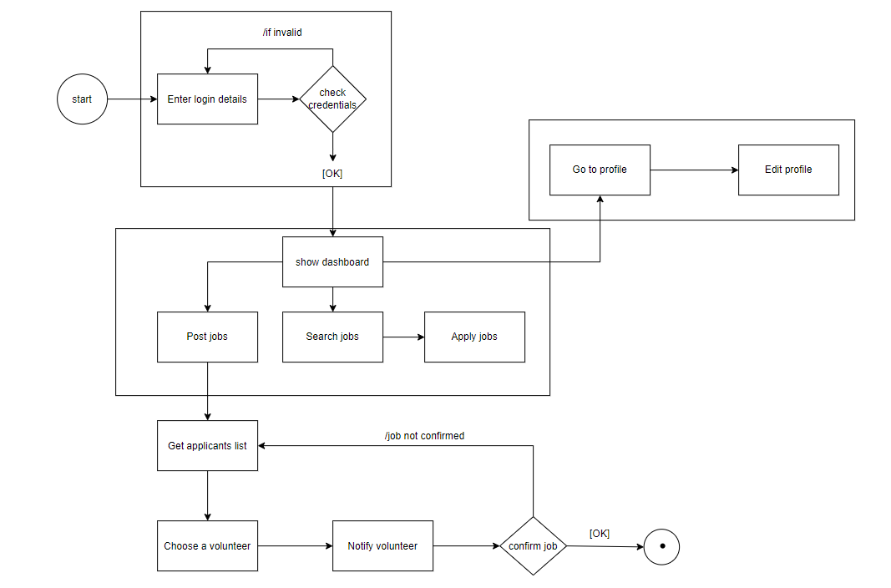State Diagram: