**SMQA – BreakUp Application**

1. Open the breakup project in intellij.
2. Build the breakup project.

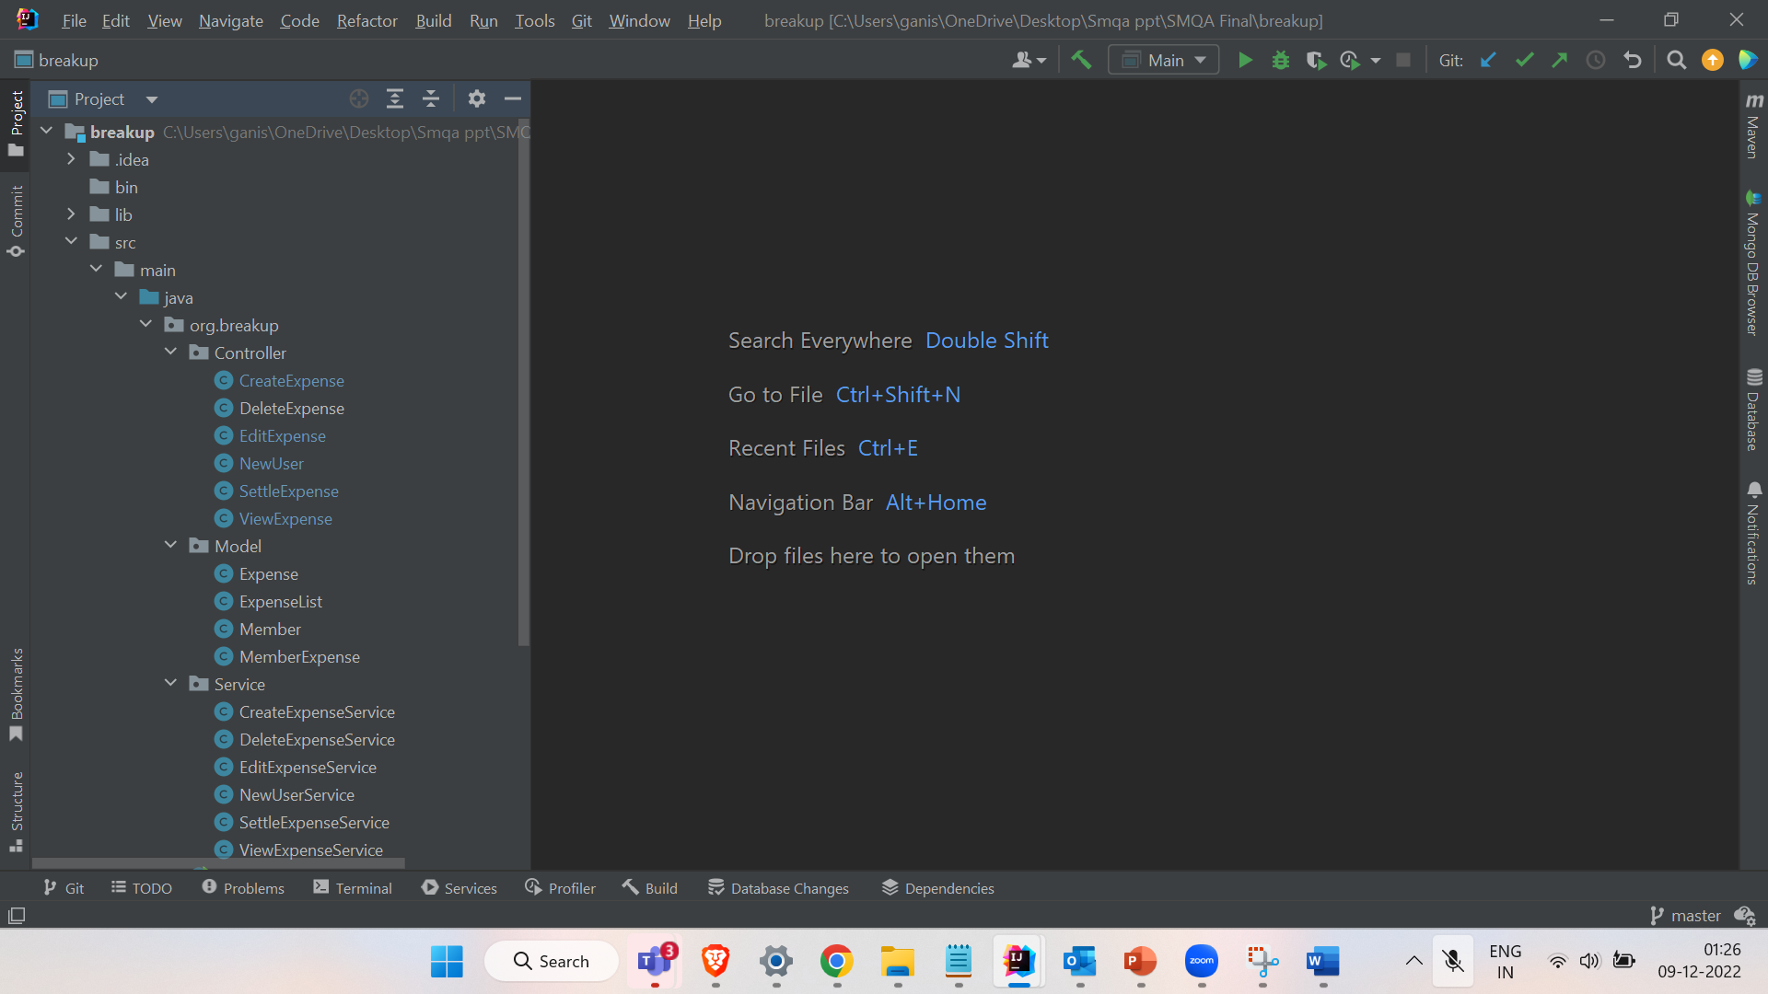

1. Required libraries and jar files:

1. Run main method

1. **Blackbox testing:**

Create a new file *classList.txt* under *target\classes*

Include below in the text file : *classList.txt*

*org.breakup.Model.Member*

*org.breakup.Model.Expense*

*org.breakup.Model.MemberExpense*

*org.breakup.Model.ExpenseList*

*org.breakup.Service.NewUserService*

*org.breakup.Service.CreateExpenseService*

*org.breakup.Service.ViewExpenseService*

*org.breakup.Service.EditExpenseService*

*org.breakup.Service.DeleteExpenseService*

*org.breakup.Service.SettleExpenseService*

Create a directory named *bin* under \breakup

Open Terminal

Run the command *cd bin*

Now run the below command to generate blackbox (Randoop) testcases:

**For Windows:**

*java -classpath "..\target\classes;..\lib\randoop-all-4.3.1.jar" randoop.main.Main gentests --classlist="..\target\classes\classList.txt" --junit-output-dir="..\src\test" --time-limit=1000*

**For Mac:**

*java -classpath "../target/classes:../lib/randoop-all-4.3.1.jar" randoop.main.Main gentests --classlist="../target/classes/classList.txt" --junit-output-dir="../src/test" --time-limit=1000*

Mark test(*breakup\src\test*) directory as *Test sources root*.

Run the RegressionTest (*breakup\src\test\RegressionTest.java*) generated from running above command.

**Blackbox coverage:**

For Coverage run the same RegressionTest (*breakup\src\test\RegressionTest.java*) with coverage option

1. **Whitebox testing**

The whitebox testcases are at *..\src\test\org\breakup\Service*

Run the tests under *org.break.Service*

**Whitebox coverage**

For coverage run the same test cases with option “Run Tests in *org.breakup.Service* with coverage”

