|  |  |
| --- | --- |
| **Ex.no:** | **READ AND DISPLAY FILE CONTENT IN C** |
| **Date:** |

**AIM:**

To write a C program that reads data from a text file and displays it on the screen.

**ALGORITHM:**

STEP 1: Start.

STEP 2: Declare necessary variables, including a file pointer.

STEP 3: Open the text file in read mode (r) using fopen().

* If the file cannot be opened, display an error message and exit.

STEP 4: Read the contents of the file using fgetc() or fgets() in a loop.

STEP 5: Display the content on the screen as it is read .

STEP 6: Close the file using fclose().

STEP 7: End.

**SOLUTION CODE:**

#include<stdio.h>

int main()

{

FILE *file;

char ch;

file = fopen("input.txt", "r");

if(file == NULL)

{

printf("Error: Could not open the file.\n");

return 1;

}

printf("Contents of the file:\n");

while ((ch = fgetc(file)) !=EOF)

{

putchar(ch);

}

fclose(file);

return 0;

}

**INPUT:**

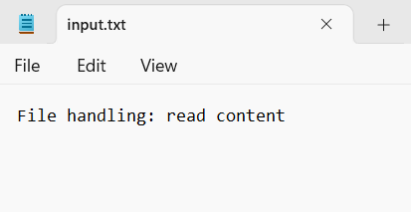

**OUTPUT:**

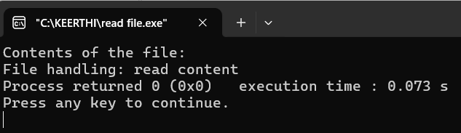

**RESULT:**

|  |  |
| --- | --- |
| **Ex.no:** | **APPEND DATA FROM ONE FILE TO ANOTHER IN C** |
| **Date:** |

**AIM:**

To write a C program that reads data from one text file and appends it to another file.

**ALGORITHM:**

STEP 1: Start.

STEP 2: Declare necessary variables, including two file pointers.

STEP 3: Open the source file in read mode (r) and the destination file in append mode (a).

STEP 4: If either file cannot be opened, display an error message and exit.

STEP 5: Read the contents of the source file using a loop and append the data to the destinatiom file.

STEP 6: Close both files using fclose().

STEP 7: End.

**SOLUTION CODE:**

#include<stdio.h>

int main()

{

FILE *src, *dest;

char ch;

src = fopen("src.txt", "r");

if(src == NULL)

{

printf("Error: Could not open source file.\n");

return 1;

}

dest = fopen("dest.txt", "a");

if(dest == NULL)

{

printf("Error: Could not open destination file.\n");

fclose(src);

return 1;

}

while ((ch = fgetc(src)) != EOF)

{

fputc(ch, dest);

}

printf("Data successfully appended to destination file.\n");

fclose(src);

fclose(dest);

return 0;

}

**INPUT:**

**1.Source file:**

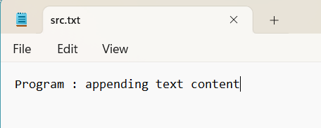

**OUTPUT:**

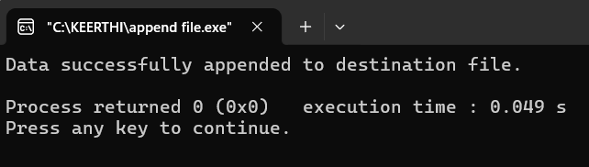

**Destination.txt file after appending data from source file**

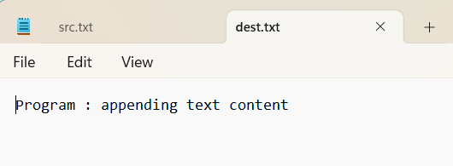

**RESULT:**