**1)Write the program to evaluate the expression 4>3>2, 2+3>4+5 , 6>3+2<5**

KEERTHI SHREE EK

B.TECH AI&DS -A

RTC2024BAI188

#include<stdio.h>

int main()

{

int a,b,c,d,e;

a=4;

b=3;

c=2;

d=5;

e=6;

printf("%d\n",a>b>c);

printf("%d\n",c+b>a+d);

printf("%d\n",e>b+c<d);

return 0;

}

**OUTPUT:**

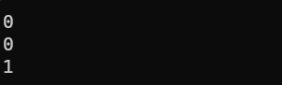

**2) Write the program to evaluate the expression 5+3*5>=25%2<=8=5-3*2>=8+3!=5**

#include<stdio.h>

int main()

{

int a,b,c,d,e;

a=2;

b=3;

c=5;

d=8;

e=25;

printf("%d",c+b*c>=e%a<=d==c-b*a>=d+b!=c);

return 0;

}

**OUTPUT:**

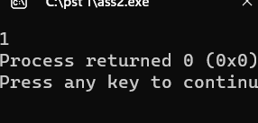

**3) Write the program to evaluate the expression 10 && 8 ,0 && 8,0 && 0, 8 && 0.**

#include<stdio.h>

int main()

{

int a,b,c;

a=0;

b=8;

c=10;

printf("%d\n",c&&b);

printf("%d\n",a&&b);

printf("%d\n",a&&a);

printf("%d",b&&a);

return 0;

}

**OUTPUT:**

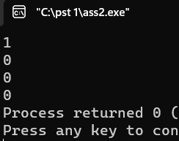

**4) . Write the program to evaluate the expression ! -8, ! 100 ,! 0,! 0.0**

#include<stdio.h>

int main()

{

printf("%d\n",!-8);

printf("%d\n",!100);

printf("%d\n",!0);

printf("%d\n",!0.0);

return 0;

}

**OUTPUT:**

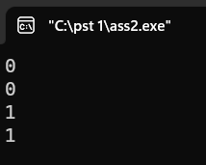

**5) Write a program for left shift with 4 shifts <<=4 and right shift with 3 shifts >>=3.**

#include<stdio.h>

int main()

{

int a,b;

a=4;

b=3;

printf("%d\n",a<<4);

printf("%d\n",b>>3);

return 0;

}

**OUTPUT:**

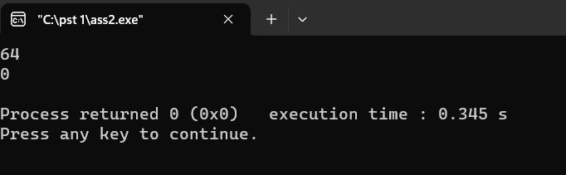

**6) Write the program to evaluate the expression**

**4 > 5 , 4 < 5, 4 >= 5, 5 = 5, 4 == 5,**

#include<stdio.h>

int main()

{ int a,b;

a=4;

b=5;

printf("%d\n",a>b);

printf("%d\n",a<b);

printf("%d\n",a>=b);

printf("%d\n",b==b);

printf("%d\n",a==b);

return 0;

}

**OUTPUT:**

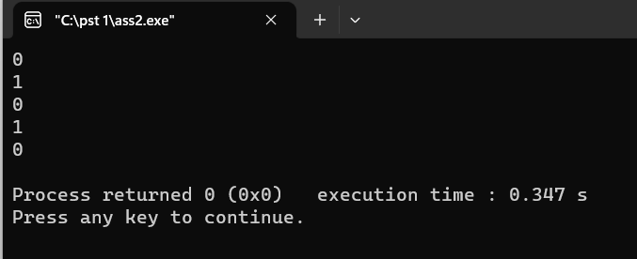

**7) Write the program to evaluate the expression 4>3 && 3>2,**

#include<stdio.h>

int main()

{

int a,b,c;

a=2;

b=3;

c=4;

printf("%d",c>b&&b>a);

return 0;

}

**OUTPUT:**

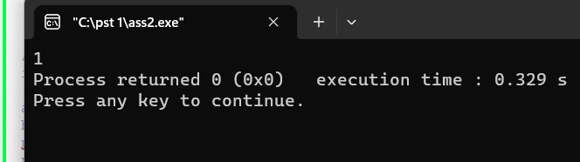

**8) Write the program to evaluate the expression !!!!a**

#include<stdio.h>

int main()

{

int a;

printf("Enter the value a =");

scanf("%d",&a);

printf("%d",!!!!a);

return 0;

}

**OUTPUT:**

a=0

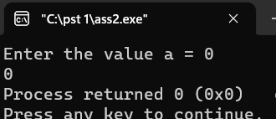

a=+ve numbers

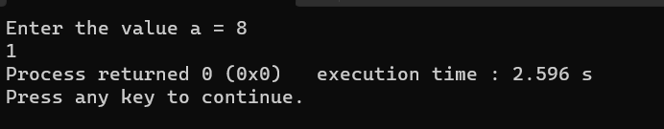

**9) How many tokens in the given program and what are the tokens**

#include<stdio.h>

Int main()

{

Int num=10,num=20,num3=0;

num3=num1+num2;

printf(“%d”,num3);

return 0;

}

In the code there are totally 40 tokens.

* + 1. Pre processor directive - #include
    2. Datatype – int
    3. Function name – main , printf
    4. Statement – return
    5. Identifiers – num , num1 ,num2 ,num3
    6. Constants – 10 , 20, 0
    7. Operators - +,=
    8. Separators – ( , ) , { , } , , ; ,<,>
    9. String literals - %d

**10) Write a program to divide two numbers without using / operator.**

#include<stdio.h>

int main()

{

int d1,d2,q;

printf("enter the dividend and divisor");

scanf("%d %d",&d1,&d2);

for(q=0;d1>=d2;q++)

{

d1-=d2;

}

printf("the result=%d",q);

return 0;

}

**OUTPUT:**

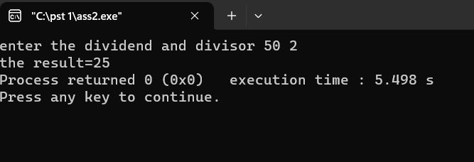

**APPLICATION 1:**

**Write the c program for super store , get the item name ,no of items and price of the item from the user and calculate the total amount with tax and deduction for festive season.**

#include <stdio.h>

#define TAX 0.08

#define DISCOUNT 0.05

int main() {

int total_no_of_items;

float total = 0, tax = 0, discount = 0, total_amount = 0;

printf("SUPER STORE BILLING\n");

printf("-------------------\n");

printf("Enter total number of items: ");

scanf("%d", &total_no_of_items);

for(int i = 1; i <= total_no_of_items; i++) {

char itemname[50];

float price;

int quantity;

printf("%d. Enter item name: ", i);

scanf("%s", itemname);

printf("Enter price: ");

scanf("%f", &price);

printf("Enter quantity: ");

scanf("%d", &quantity);

float itemtotal = price * quantity;

float itemtax = itemtotal * TAX;

float itemdiscount = itemtotal * DISCOUNT;

total += itemtotal;

tax += itemtax;

discount += itemdiscount;

printf("Item total = %.2f\n", itemtotal);

printf("Tax = %.2f\n", itemtax);

printf("Discount = %.2f\n", itemdiscount);

}

total_amount = total +tax -discount;

printf("\nTOTAL BILLING\n");

printf("-------------\n");

printf("SUBTOTAL = %.2f\n", total);

printf("TAX = %.2f\n", tax);

printf("DISCOUNT = %.2f\n", discount);

printf("TOTAL AMOUNT = %.2f\n", total_amount);

return 0;

}

**OUTPUT:**

