WEEK-2 Hands-on
Exercise 1: Control Structures
DROP TABLE customers CASCADE CONSTRAINTS;
CREATE TABLE customers (
customer_id NUMBER,
c_name VARCHAR2(50),
age NUMBER,
interest_rate NUMBER
);

INSERT INTO customers VALUES (1, 'Aarav', 63, 7.4);
INSERT INTO customers VALUES (2, 'Diya', 46, 6.8);
INSERT INTO customers VALUES (3, 'Manoj', 68, 7.9);
INSERT INTO customers VALUES (4, 'Neha', 60, 5.2);
INSERT INTO customers VALUES (5, 'Karan', 56, 8.1);
INSERT INTO customers VALUES (6, 'Priya', 24, 9.2);
INSERT INTO customers VALUES (7, 'Ramesh', 71, 5.3);
INSERT INTO customers VALUES (8, 'Sana', 59, 6.6);
INSERT INTO customers VALUES (9, 'Vikram', 36, 4.6);

COMMIT;
ALTER TABLE customers ADD (balance NUMBER);
ALTER TABLE customers ADD (is_vip VARCHAR2(5));
ALTER TABLE customers ADD (due NUMBER);

UPDATE customers SET balance = 15000 WHERE customer_id = 1;
UPDATE customers SET balance = 9000 WHERE customer_id = 4;
UPDATE customers SET balance = 22000 WHERE customer_id = 5;
UPDATE customers SET balance = 3000 WHERE customer_id = 7;

BEGIN
FOR cust IN (SELECT * FROM customers) LOOP
IF cust.age > 60 THEN
UPDATE customers
SET interest_rate = interest_rate - 1
WHERE customer_id = cust.customer_id;
DBMS_OUTPUT.PUT_LINE('Reduced interest rate for ' || cust.c_name || ' due to senior age.');
END IF;
END LOOP;
END;
/

BEGIN
FOR cust IN (SELECT * FROM customers) LOOP
IF cust.balance > 10000 THEN
UPDATE customers
SET is_vip = 'TRUE'
WHERE customer_id = cust.customer_id;
DBMS_OUTPUT.PUT_LINE('Promoted to VIP: ' || cust.c_name);
END IF;
END LOOP;
END;
/

UPDATE customers SET due = 10 WHERE customer_id = 8;
UPDATE customers SET due = 5 WHERE customer_id = 3;
UPDATE customers SET due = 25 WHERE customer_id = 2;
COMMIT;

BEGIN
FOR cust IN (SELECT * FROM customers) LOOP
IF cust.due <= 30 THEN
DBMS_OUTPUT.PUT_LINE('Reminder: ' || cust.c_name || ', your loan is due in ' || cust.due || ' days.');
END IF;
END LOOP;
END;
/
Output:
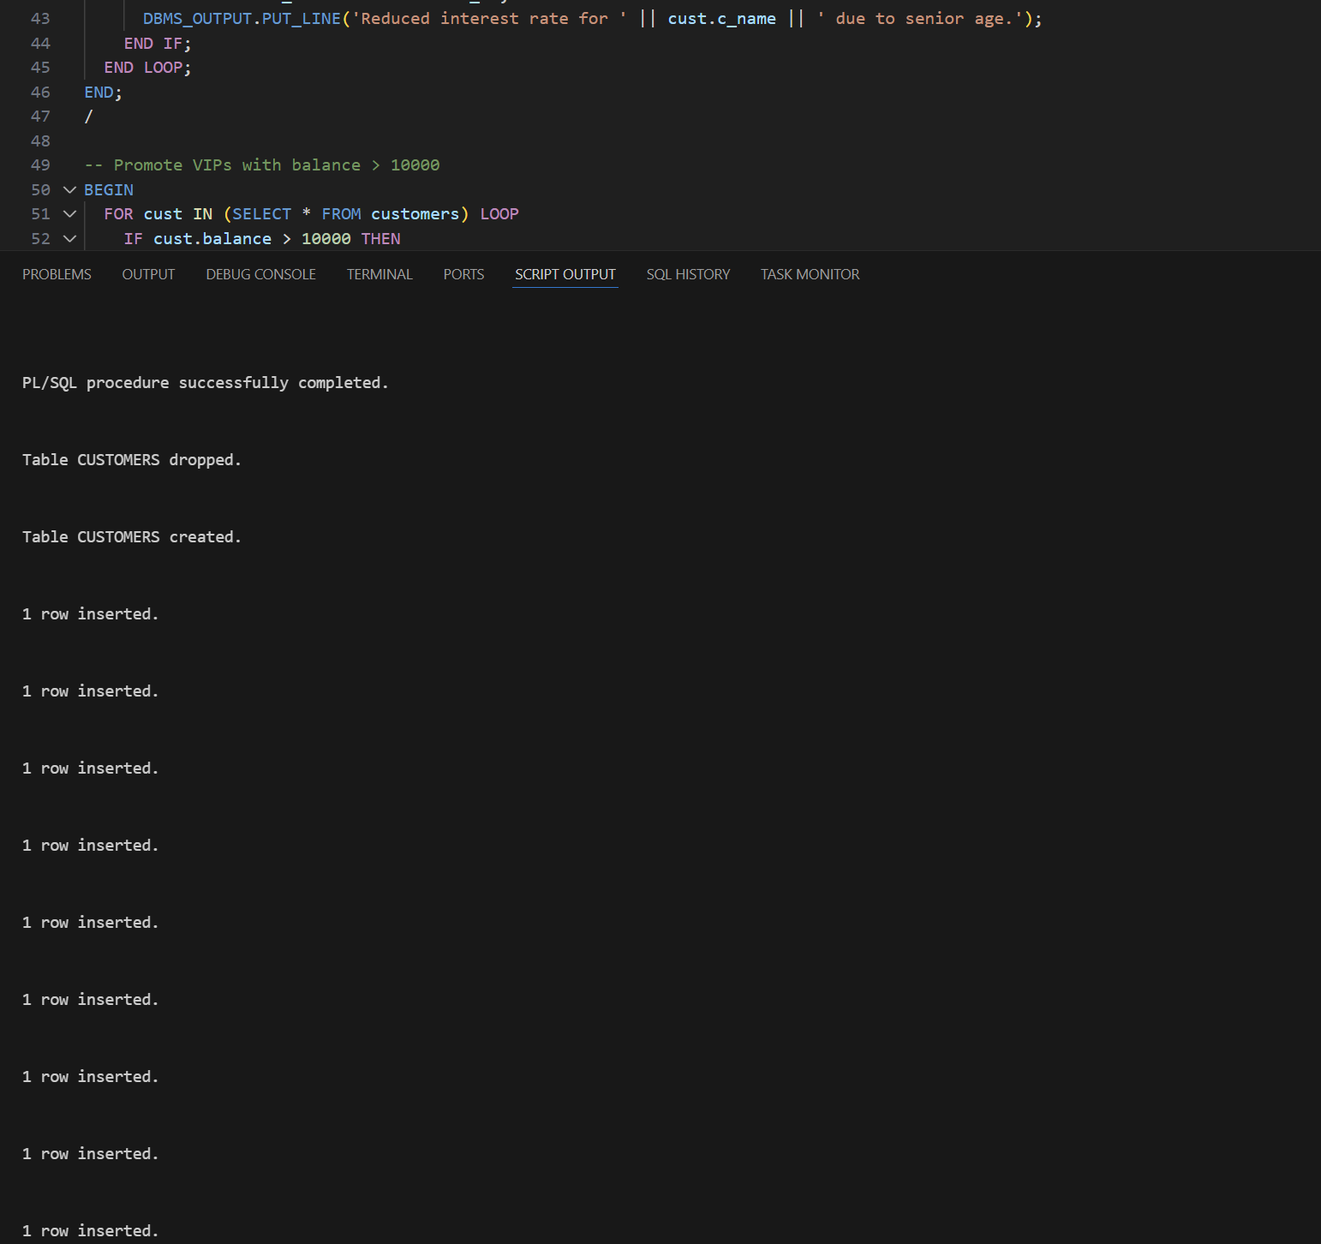

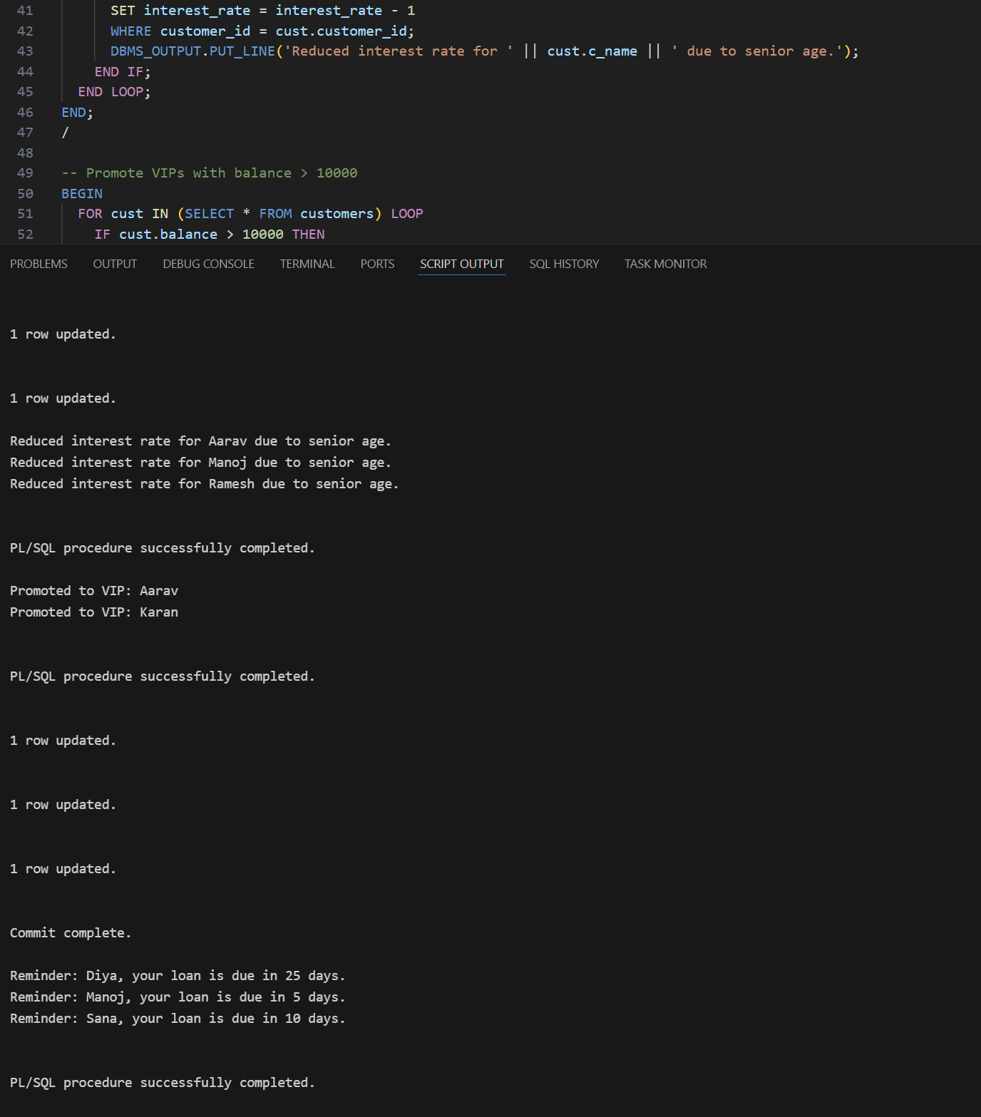

Exercise 3: Stored Procedures
CREATE TABLE savings_acc (
acc_id NUMBER PRIMARY KEY,
acc_holder VARCHAR2(50),
balance NUMBER
);
INSERT INTO savings_acc VALUES (101, 'Ankit', 12000);
INSERT INTO savings_acc VALUES (102, 'Sneha', 18500);
INSERT INTO savings_acc VALUES (103, 'Ravi', 6000);
INSERT INTO savings_acc VALUES (104, 'Pooja', 7500);
INSERT INTO savings_acc VALUES (105, 'Divya', 27000);
INSERT INTO savings_acc VALUES (106, 'Rohan', 35000);
COMMIT;

CREATE TABLE employees (
emp_id NUMBER PRIMARY KEY,
emp_name VARCHAR2(50),
salary NUMBER,
department_id NUMBER
);

INSERT INTO employees VALUES (201, 'Kiran', 40000, 501);
INSERT INTO employees VALUES (202, 'Megha', 45000, 502);
INSERT INTO employees VALUES (203, 'Varun', 38000, 501);
INSERT INTO employees VALUES (204, 'Ayesha', 52000, 503);
INSERT INTO employees VALUES (205, 'Paul', 56000, 502);
COMMIT;

--------------------------------------------------------------------------------
-- Procedure 1: Add 1% monthly interest to all savings accounts
--------------------------------------------------------------------------------
CREATE OR REPLACE PROCEDURE ApplyMonthlyInterest IS
BEGIN
UPDATE savings_acc
SET balance = balance + (balance * 0.01);
DBMS_OUTPUT.PUT_LINE('Monthly interest of 1% has been credited to all accounts.');
COMMIT;
END;
/

EXEC ApplyMonthlyInterest;

--------------------------------------------------------------------------------
-- Procedure 2: Give bonus to employees of a given department
--------------------------------------------------------------------------------
CREATE OR REPLACE PROCEDURE AddBonusToDeptEmployees (
dept_number IN NUMBER,
bonus_percent IN NUMBER
) IS
BEGIN
UPDATE employees
SET salary = salary + (salary * bonus_percent / 100)
WHERE department_id = dept_number;

DBMS_OUTPUT.PUT_LINE('Bonus of ' || bonus_percent || '% applied to Department ' || dept_number);
COMMIT;
END;
/

EXEC AddBonusToDeptEmployees(502, 8);
—----------------------------------------------------------------------------------
--Procedure 3: Transfer money between two accounts
—----------------------------------------------------------------------------------
CREATE OR REPLACE PROCEDURE TransferFundsBetweenAccounts (
from_acc IN NUMBER,
to_acc IN NUMBER,
transfer_amt IN NUMBER
) IS
sender_balance NUMBER;
BEGIN
-- Fetch balance of sender
SELECT balance INTO sender_balance
FROM savings_acc
WHERE acc_id = from_acc;

IF sender_balance < transfer_amt THEN
DBMS_OUTPUT.PUT_LINE('Transfer failed: Insufficient funds in Account ' || from_acc);
ELSE

UPDATE savings_acc
SET balance = balance - transfer_amt
WHERE acc_id = from_acc;
UPDATE savings_acc
SET balance = balance + transfer_amt
WHERE acc_id = to_acc;

DBMS_OUTPUT.PUT_LINE('₹' || transfer_amt || ' transferred from Account ' || from_acc || ' to Account ' || to_acc);
COMMIT;
END IF;
END;
/
EXEC TransferFundsBetweenAccounts(101, 102, 3000);
EXEC TransferFundsBetweenAccounts(104, 106, 50000);

Output:

