# Full Stack Development with MERN

## Project Documentation

## 1. Introduction

• **Project Title:** House Rent App

• **Team Members:**

- Keerthi varman M – Project Manager & Testing: Responsible for testing, overseeing the entire project, ensuring timelines are met, and leading the team.

- Mohamed Imraan Hussain J – Database Administrator: Manages and optimizes the database, ensuring data integrity and efficient querying.

- Mohammed Imam Ahsen P – Backend Developer: In charge of designing and implementing the server-side logic, APIs, and database interactions.

- Yousuf Ali M – Frontend Developer: Develops and styles the user interface, ensuring a seamless and responsive user experience.

## 2. Project Overview

• **Purpose:** The House Rent App aims to simplify the process of renting and managing rental properties by providing an intuitive platform for property owners and renters.

• **Features:**

- **Property Listing & Management:** Users can add, edit, and delete property listings.

- **User Registration & Login:** Secure authentication for property owners, renters, and administrators.

- **Search & Filter Options:** Users can filter properties by location, price range, property type, etc.

- **Booking System:** Renters can book properties and view their booking status.

- **Admin Panel:** Admins can manage user accounts and oversee bookings and listings.

- **Responsive UI:** Optimized for use on various devices, including desktops, tablets, and smartphones.

## 3. Architecture

• **Frontend:**

- Developed using React, the app utilizes functional components and React Hooks for state management.

- The design is component-based, making it scalable and easy to maintain. React-Bootstrap is used for a sleek and responsive UI design.

• **Backend:**

- The server is built with Node.js and Express.js. It handles CRUD operations, user authentication, and integrates with a MongoDB database.

- RESTful API structure is implemented for clean and efficient communication between the frontend and backend.

• **Database:**

- MongoDB is used as the database. The schema is designed using Mongoose to handle data efficiently, with collections for users, properties, and bookings.

## 4. Setup Instructions

• **Prerequisites:**

- Node.js: Ensure you have the latest version installed.

- MongoDB: A running instance of MongoDB is required for database operations.

- npm (Node Package Manager): Comes with Node.js.

• **Installation:**

1. Clone the repository:



1. Navigate to the project directory:



3. Install dependencies for both frontend and backend:

- For frontend:



- For backend:



4. Set up environment variables:

- Create a .env file in the server directory and define variables such as MongoDB URI, JWT Key & Port number.

## 5. Folder Structure

• **Frontend:**

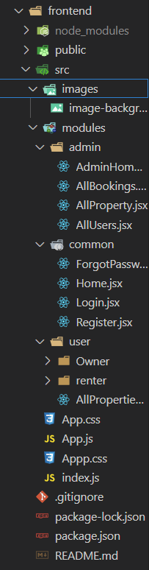

• **Backend:**

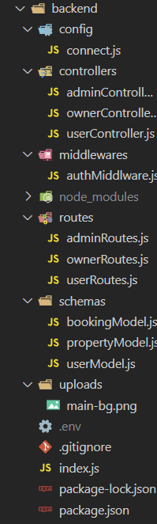

## 6. Running the Application

• Frontend:

• Backend:



• Access the app at: <http://localhost:3000>

## 7. API Documentation

Base URL: All endpoints are prefixed with /api.

1. User Routes (/api/user):
2. Register User:

* **Endpoint:** POST /api/user/register
* **Request Body:**
  + email (string, required)
  + password (string, required)
  + type (string, required)
* **Example Request:**

{

"email": "example@example.com",

"password": "securepassword123",

"type": "Owner"

}

* **Example Responses**
  + **200:** { "message": "User already exists", "success": false }
  + **201:** { "message": "Registered Successfully", "success": true }
  + **500:** { "message": "Error details", "success": false }

1. Login User:

* **Endpoint:** POST /api/user/login
* **Request Body:**
  + email (string, required)
  + password (string, required)
* **Example Request:**

{

"email": "example@example.com",

"password": "securepassword123"

}

* **Example Responses:**
  + **200:** {"message": "Login successfully", "success": true, "token": "jwt_token_here", "user": {"email": "example@example.com", "type": "UserType"}}
  + **200:** { "message": "User not found", "success": false } or { "message": "Invalid email or password", "success": false }
  + **500:** { "message": "Error details", "success": false }

1. Forgot Password:

* **Endpoint:** POST /api/user/forgotpassword
* **Request Body:**
  + email (string, required)
  + password (string, required)
* **Example Request:**

{

"email": "example@example.com",

"password": "newsecurepassword123"

}

* **Example Responses:**
  + **200:** { "message": "Password changed successfully", "success": true }
  + **200:** { "message": "User not found", "success": false }
  + **500:** { "message": "Error details", "success": false }

1. Get All Properties:

* **Endpoint:** GET /api/user/getAllProperties
* **Headers:** Authorization: Bearer <token>
* **Example Request:**

GET /api/user/getAllProperties

* **Example Responses:**
  + **200:** {"success": true, "data": [{"_id": "propertyId1", "name": "Beautiful Beach House", "location": "California", "price": 5000000, "description": "A luxurious beach house with ocean views.", "owner": "User123", "createdAt": "2024-01-15T12:00:00Z"}]}
  + **404:** {"success": false, "message": "No properties available"}
  + **500:** {"success": false, "message": "An error occurred while fetching properties", "error": "Error details here"}

1. Book Property:

* **Endpoint:** POST /api/user/bookinghandle/:propertyid
* **Request Body:**
  + **UserDetails:** fullName (string), phone (string)
  + status (string)
  + userId (string)
  + ownerId (string)
* **Example Request:**

{

"userDetails": {

"fullName": "Alice Smith",

"phone": "987-654-3210"

},

"status": "pending",

"userId": "user789",

"ownerId": "owner321"

}

* **Example Responses:**
  + **200:** {"success": true, "message": "Booking status updated"}
  + **500:** {"success": false, "message": "Error handling booking"}

1. Get All Bookings:

* **Endpoint:** GET /api/user/getallbookings
* **Request Query Parameters:**
  + userId (string, required)
* **Example Request:**

GET /api/user/bookings?userId=user123

* **Example Responses:**
  + **200:** {"success": true, "data": [{"_id": "bookingId1", "propertyId": "propertyId123", "userID": "user123", "ownerID": "owner456", "userName": "John Doe", "phone": "123-456-7890", "bookingStatus": "confirmed"}]}
  + **500:** {"message": "Internal server error", "success": false}

1. Admin Routes (/api/admin):
   1. Get All Users:
      * **Endpoint:** GET /api/admin/getallusers
      * **Example Request:**

GET /api/admin/getallusers

* + - **Example Responses:**
      * **200:** {"success": true, "message": "All users", "data": [{"_id": "userId1", "email": "user1@example.com", "type": "User"}, {"_id": "userId2", "email": "user2@example.com", "type": "Owner"}]}
      * **401:** {"success": false, "message": "No users present"}
      * **500:** {"success": false, "message": "Error retrieving users"}
  1. Handle User Status:
     + **Endpoint:** POST /api/admin/handlestatus
     + **Request Body:**
       - userid (string, required)
       - status (string, required)
* **Example Request:**

{

"userid": "userId1",

"status": "active"

}

* **Example Responses:**
  + **200:** {"success": true, "message": "User has been active"}
  + **500:** {"success": false, "message": "Error updating user status"}
  1. Get All Properties:
     + **Endpoint:** GET /api/admin/getallproperties
     + **Example Request:**

GET /api/admin/properties

* + - **Example Responses:**
      * **200:** {"success": true, "message": "All properties", "data": [{"_id": "propertyId1", "name": "Beachfront Villa", "location": "California", "price": 2000000, "description": "A luxury villa with a stunning view of the beach.", "owner": "owner123", "createdAt": "2024-01-10T12:00:00Z"}]}
      * **401:** {"success": false, "message": "No properties present"}
      * **500:** {"success": false, "message": "Error retrieving properties"}
  1. Get All Bookings:
     + **Endpoint:** GET /api/admin/getallbookings
     + **Example Request:**

GET /api/admin/bookings

* + - **Example Responses:**
      * **200:** {"success": true, "data": [{"_id": "bookingId1", "propertyId": "propertyId123", "userID": "user123", "ownerID": "owner456", "userName": "John Doe", "phone": "123-456-7890", "bookingStatus": "confirmed"}]}
      * **500:** {"success": false, "message": "Error retrieving bookings"}

1. Owner Routes (/api/owner)
2. Add Property:

* **Endpoint:** POST /api/owner/addproperty
* **Request Body:**
  + userId (string, required)
  + propertyTitle (string, required)
  + propertyDescription (string, required)
  + propertyType (string, required)
  + price (number, required)
  + location (string, required)
  + propertyImage (Array of files, optional)
* **Example Request:**

{"userId": "602d2149e773f2a3990b47f5",

"propertyTitle": "Luxury Villa in Beverly Hills",

"propertyDescription": "A beautiful luxury villa with ocean views",

"propertyType": "Villa",

"price": 2500000,

"location": "Beverly Hills, CA"

}

* **Example Responses:**
  + **200:** {"success": true, "message": "New Property has been stored"}
  + **500:** {"success": false, "message": "An error occurred while adding the property."}

1. Get All Properties by Owner:

* **Endpoint:** POST /api/owner/getallproperties
* **Request Parameters:**
  + userId (string, required)
* **Example Request:**

{"userId": "602d2149e773f2a3990b47f5"}

* **Example Responses:**
  + **200:**{"success":true,"data":[{"_id":"propertyId1","propertyTitle":"Luxury Villa in Beverly Hills","propertyDescription":"A beautiful luxury villa with ocean views","propertyType":"Villa","price":2500000,"location":"Beverly Hills, CA","propertyImage":[{"filename":"image1.jpg","path":"/uploads/image1.jpg"},{"filename":"image2.jpg","path":"/uploads/image2.jpg"}],"ownerId":"602d2149e773f2a3990b47f5","ownerName":"John Doe","isAvailable":"Available"}]}
  + **500:** {"success": false, "message": "Internal server error"}

1. Delete Property:

* **Endpoint:** DELETE /api/owner/deleteproperty/:propertyid
* **Path Parameters:**
  + propertyid (string, required)
* **Example Request:**

DELETE /api/owner/deleteproperty/602d2149e773f2a3990b47f5

* **Example Responses:**
  + **200:** {"success": true, "message": "The property is deleted"}
  + **500:** {"success": false, "message": "Internal server error"}

1. Update Property:

* **Endpoint:** PUT /api/owner/updateproperty/:propertyid
* **Path Parameters:**
  + propertyid (string, required)
* **Request Parameters:**
  + propertyTitle (string, optional)
  + propertyDescription (string, optional)
  + propertyType (string, optional)
  + price (number, optional)
  + location (string, optional)
  + userId (string, required)
* **Example Request:**

PUT /api/owner/updateproperty/602d2149e773f2a3990b47f5

{

"propertyTitle": "Updated Villa Title",

"propertyDescription": "Updated description for the luxury villa",

"price": 2750000,

"location": "Malibu, CA",

"userId": "602d2149e773f2a3990b47f5"

}

* **Example Responses:**
  + **200:** {"success": true, "message": "Property updated successfully."}
  + **500:** {"success": false, "message": "Failed to update property."}

1. Get All Bookings:

* **Endpoint:** GET /api/owner/getbookings/:userId
* **Path Parameters:**
  + userId (string, required)
* **Example Request:**

GET /api/owner/getbookings/602d2149e773f2a3990b47f5

* **Example Responses:**
  + **200:**{"success":true,"data":[{"_id":"bookingId1","propertyId":"propertyId1","propertyName":"Luxury Villa in Beverly Hills","ownerID":"602d2149e773f2a3990b47f5","userId":"603e2149e773f2a3990b47a3","bookingDate":"2024-11-13T00:00:00.000Z","status":"Confirmed"}]}
  + **500:** {"success": false,"message": "Internal server error"}

1. Handle Booking Status:

* **Endpoint:** PUT /api/owner/handlebookingstatus
* **Request Parameters:**
  + bookingId (string, required)
  + propertyId (string, required)
  + status (string, required)
* **Example Request:**

{

"bookingId": "bookingId1",

"propertyId": "propertyId1",

"status": "booked"

}

* **Example Responses:**
  + **200:** {"success": true, "message": "Changed the status of property to booked"}
  + **500:** {"success": false, "message": "Internal server error"}

## 8. Authentication

• Token-based Authentication:

- Upon successful login, users receive a JSON Web Token (JWT), which is stored in local storage.

- Protected routes on the backend require a valid token, verified using middleware.

## 9. User Interface

• UI: Screenshots of the main user interface features will be included.

## 10. Testing

• Testing: Unit and integration tests are implemented using tools like Jest for the frontend and Mocha for the backend.

## 11. Screenshots or Demo

Home page:

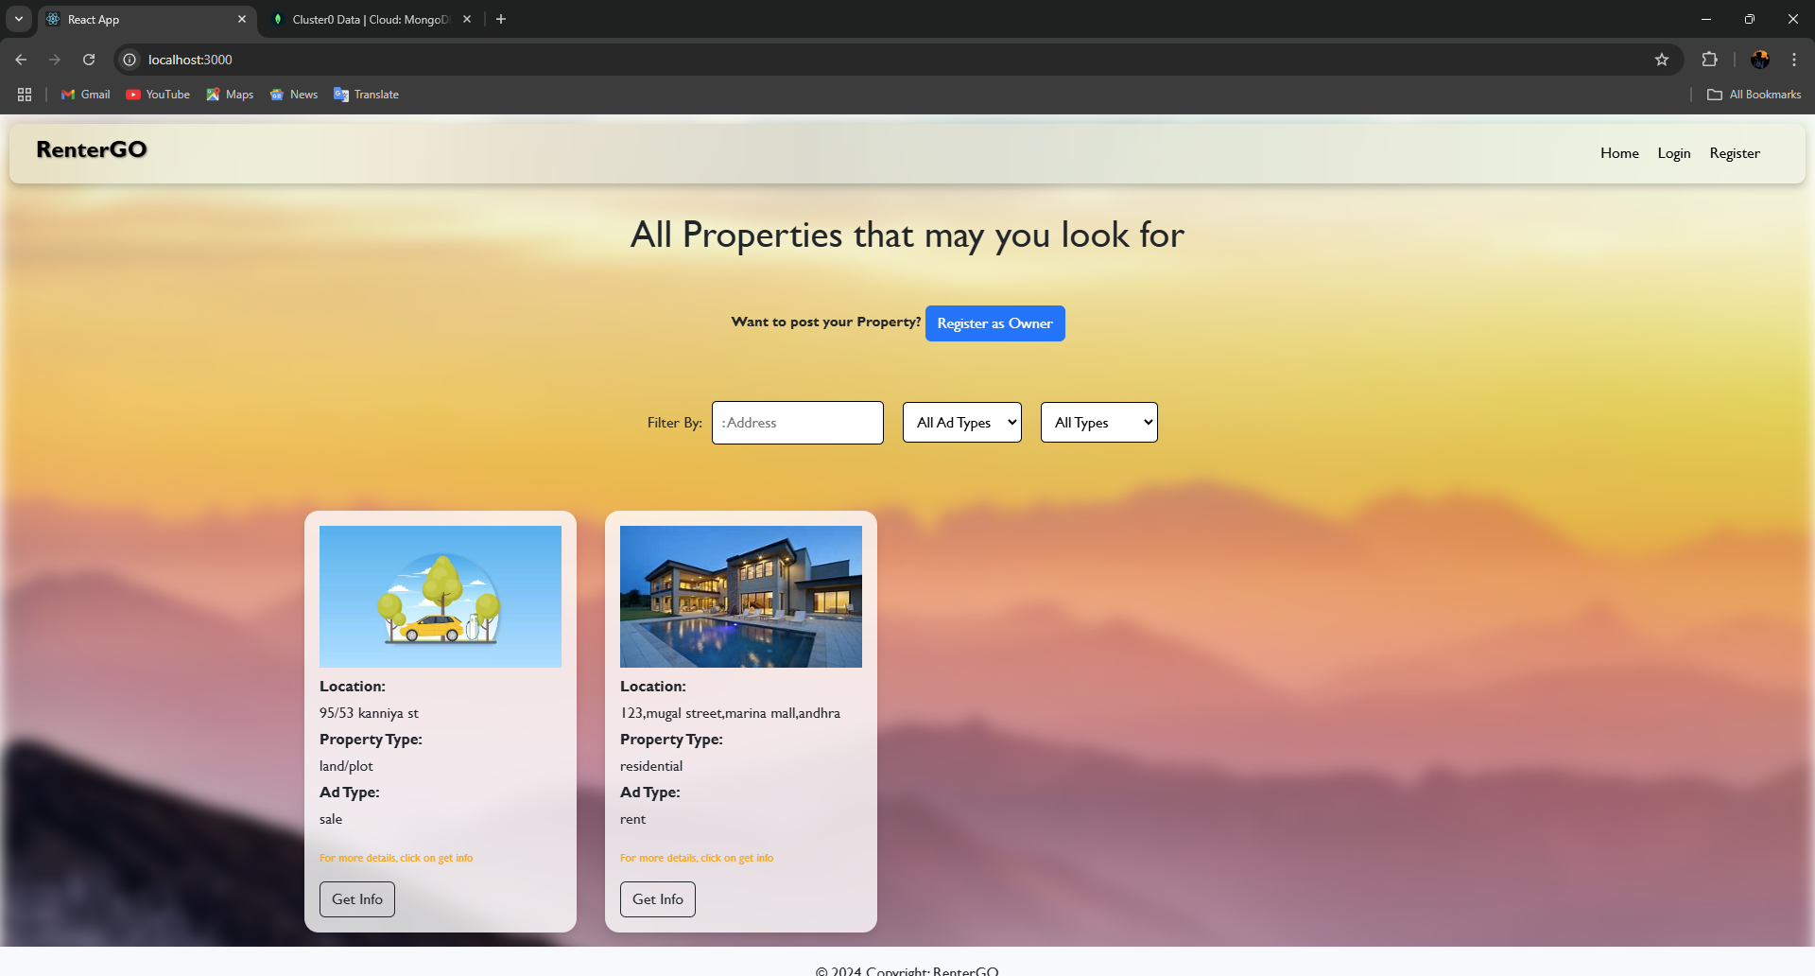

Register page:

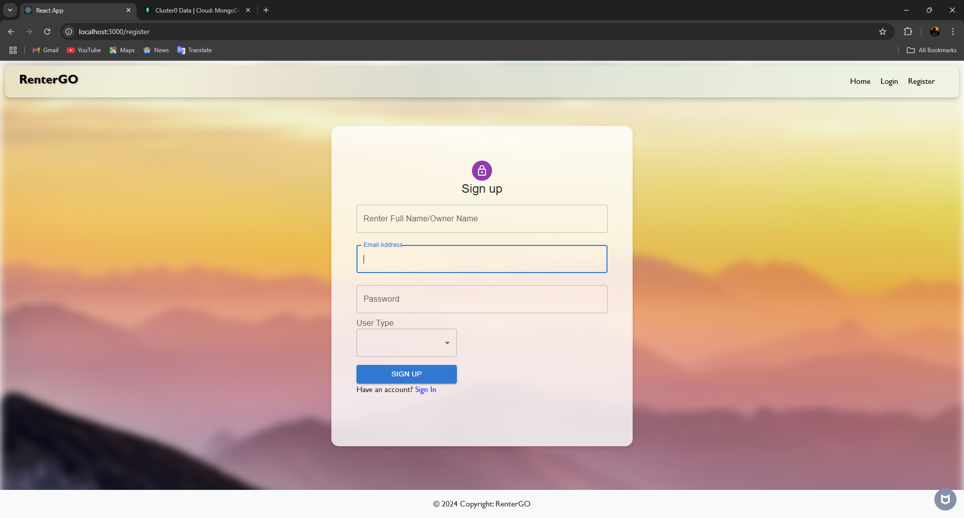

Login page:

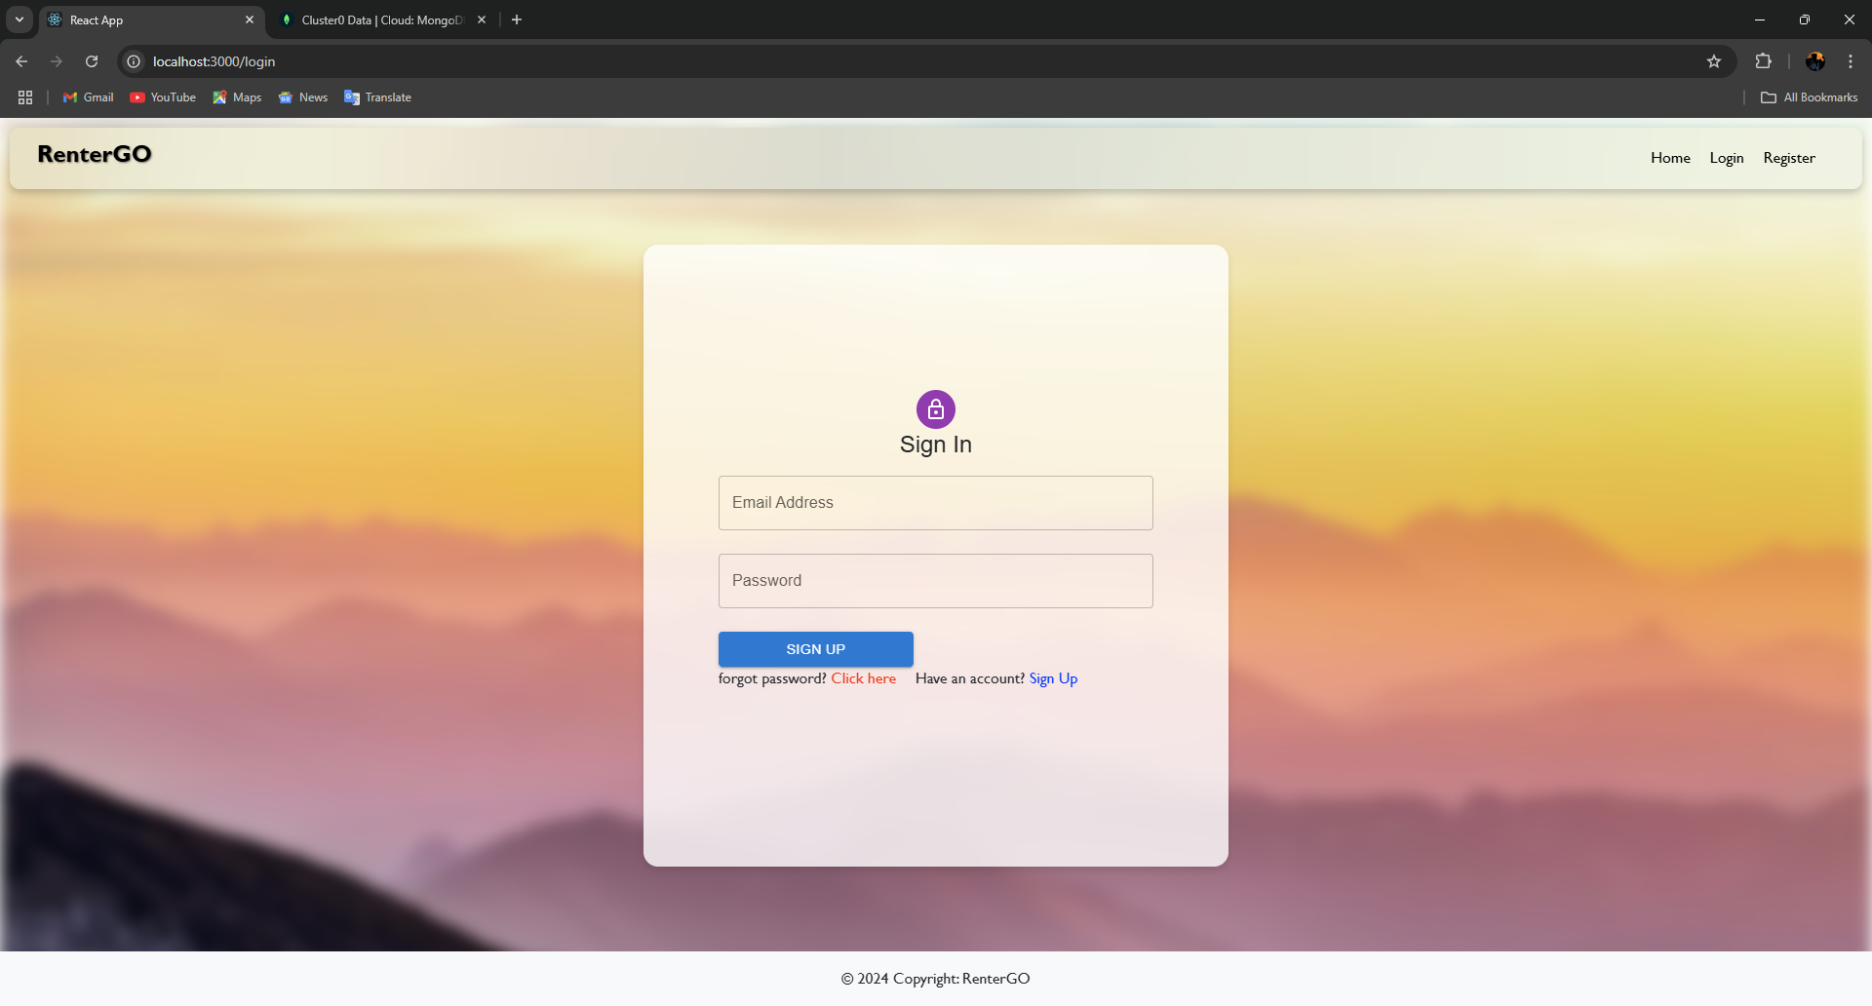

Admin page:

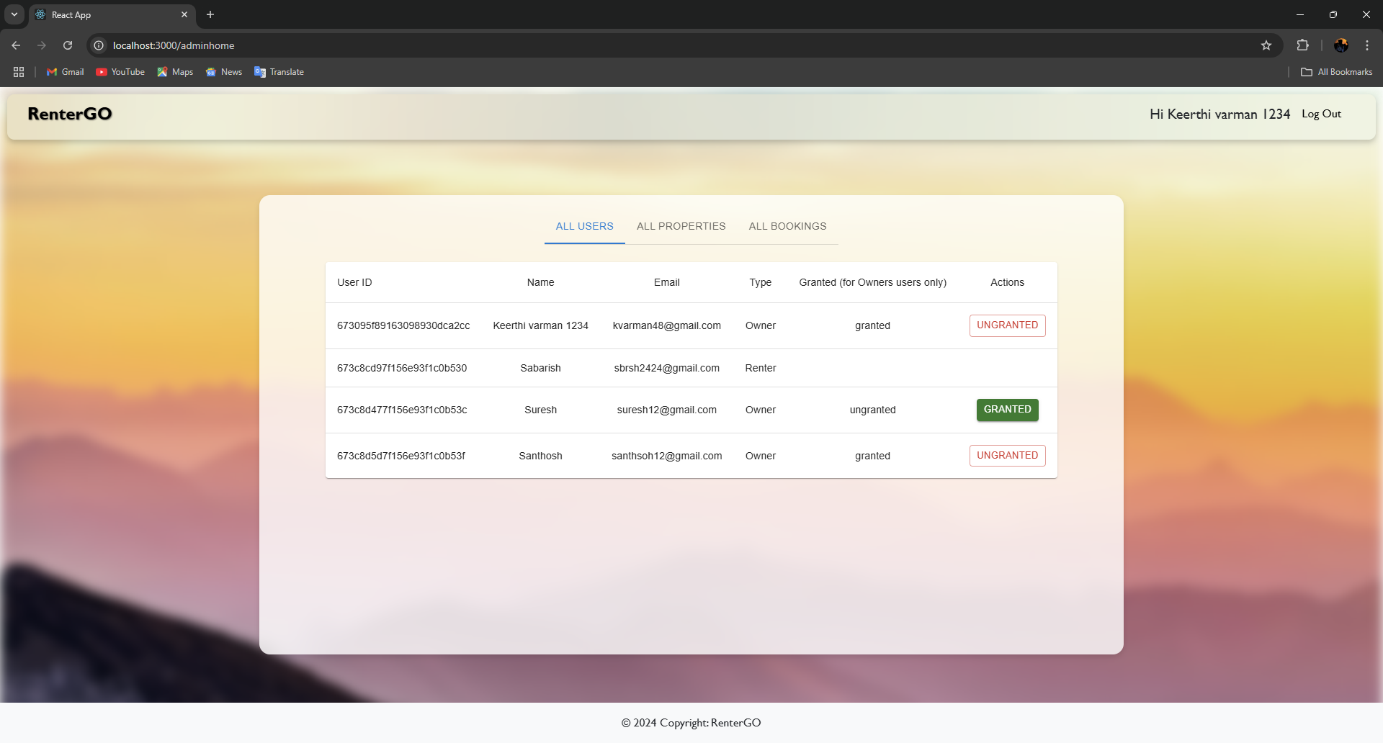

Renter page:

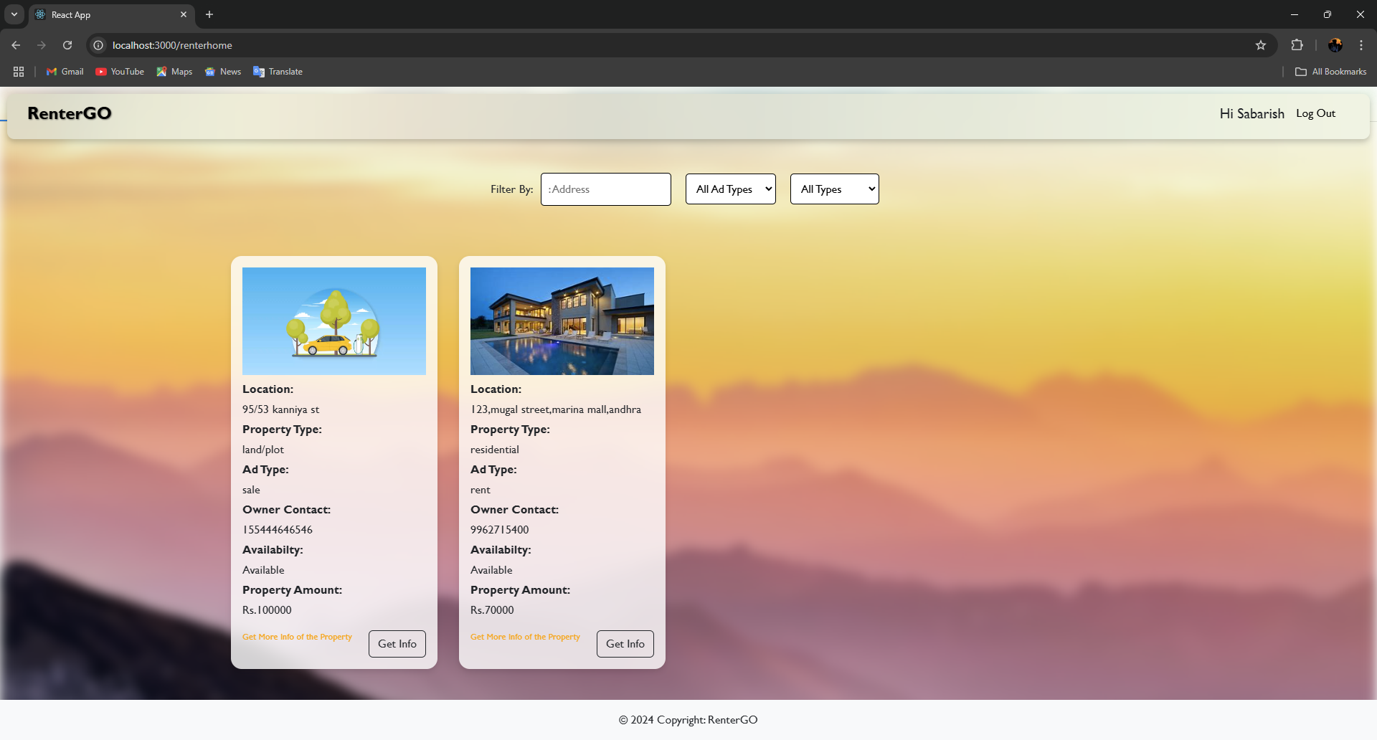

Owner page:

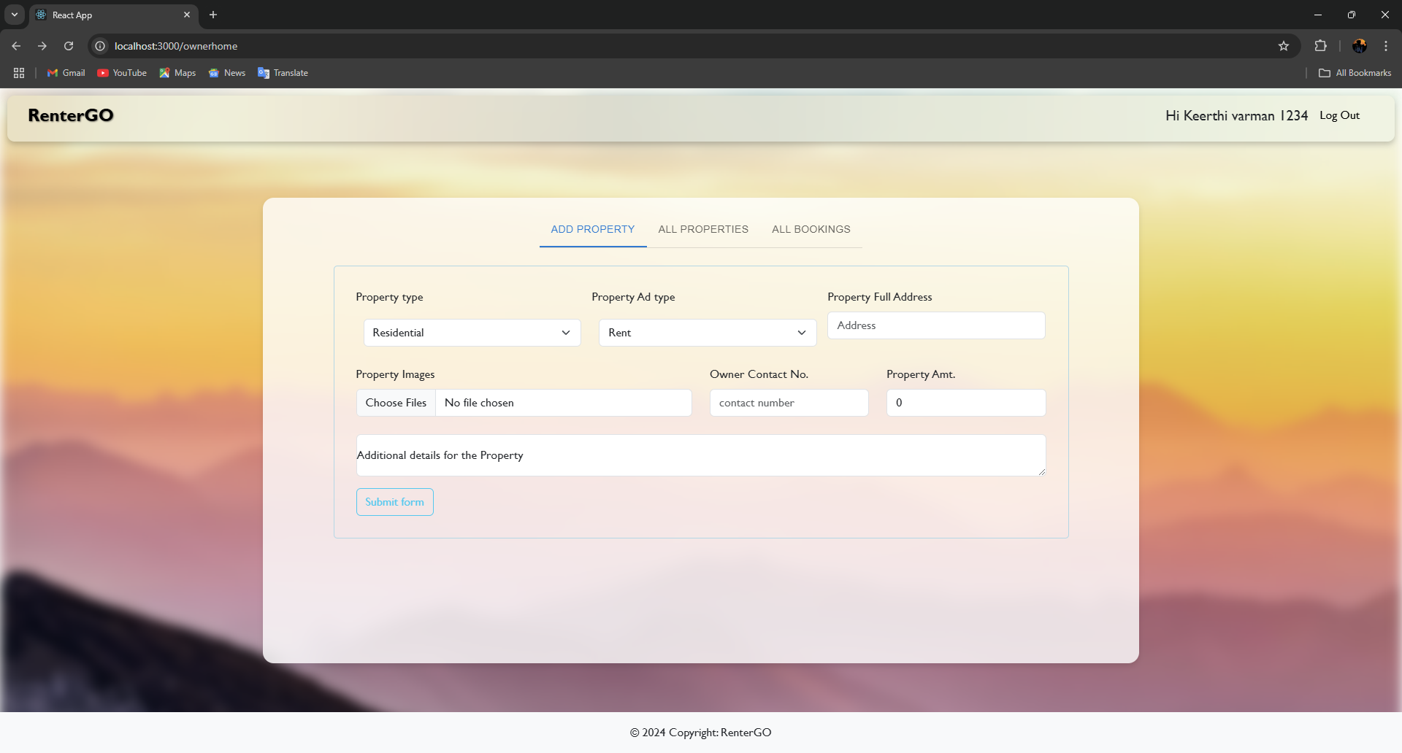

Database:

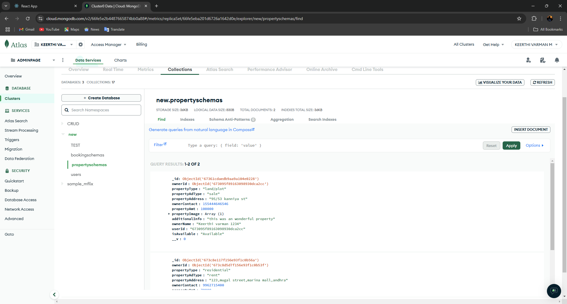

## 12. Known Issues

* **Slow Property Search:** Filtering and search results may take longer with a large number of properties.
* **Image Upload Issues**: Some users experience difficulties when uploading high-resolution images for properties.
* **Mobile View Layout**: Certain UI elements are not fully responsive, especially on smaller mobile screens.

## 13. Future Enhancements

* **Real-Time Chat:** Integrate a messaging feature for direct communication between renters and property owners.
* **Payment Integration:** Add a payment gateway for handling transactions directly within the app.
* **Mobile App:** Develop a mobile application to improve accessibility and user experience.