Consume the web service using WSDL (Web Service Description Language)

Step 1: Create the new web application.

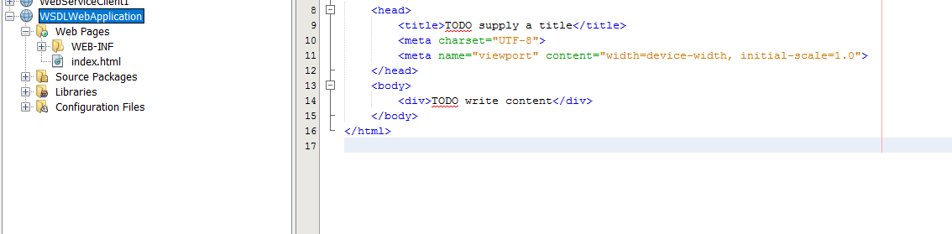

Step 2: Create a new web service client, by right clicking the project folder….select Web Service Client.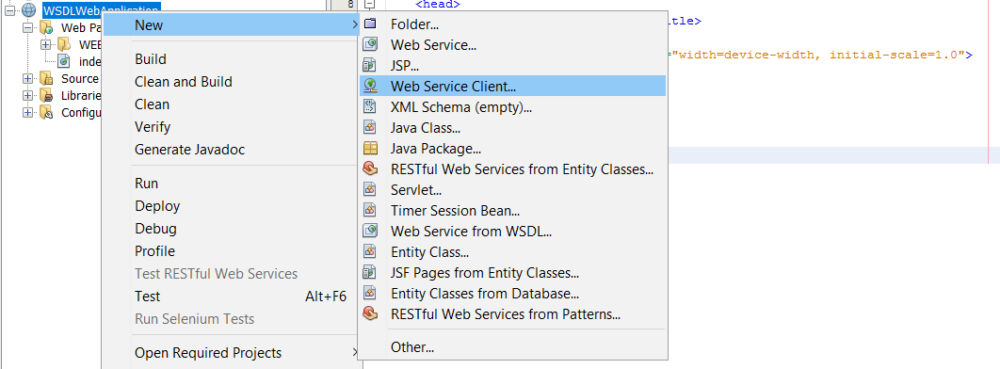

Step 3: Choose WSDL in the WSDL and the client location.

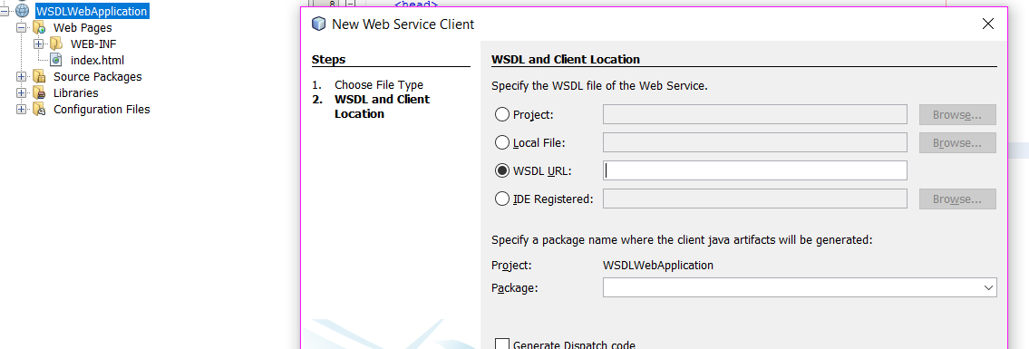

Step 4: Enter the WSDL URL as <http://www.webservicex.com/globalweather.asmx?WSDL> and give some package name then click finish. It generates the java classes and web services references as shown below.

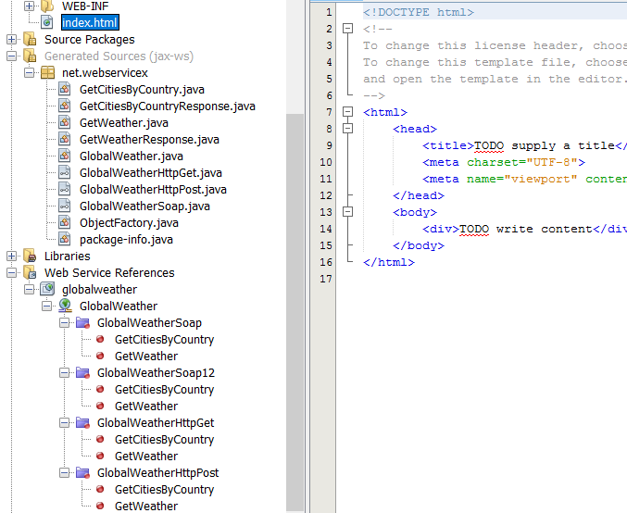

Step 5 : Crete a new JSP to test/consume the web service. After adding new JSP, right click inside

the JSP>>Select Web Services Client resources >> Call Web Service Operation.

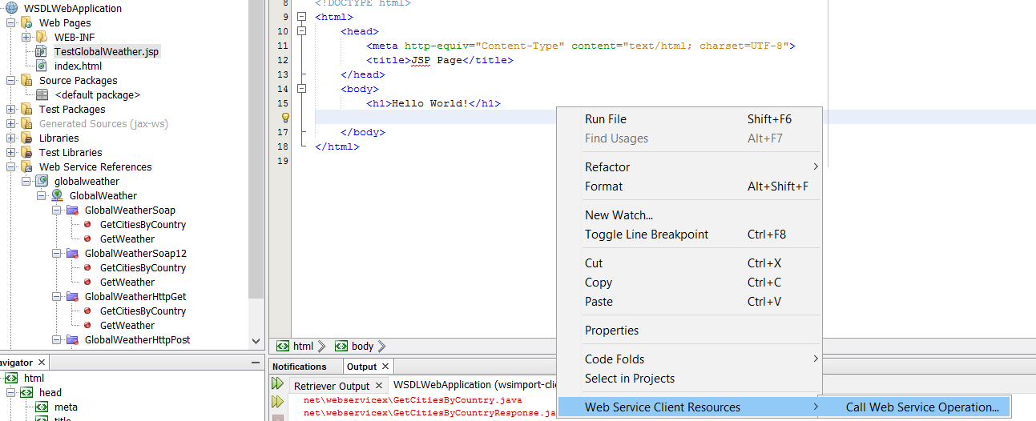

Step 6: Select the “getCitiesByCountry” web service from the Available Web services operation. After that JSP looks as follows,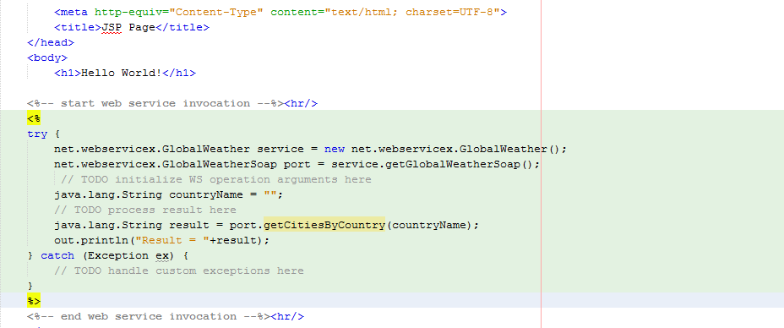

Step 7: Enter countryName as “India” and check the results.

Step 8: Try to check the weather of the particular city. ☺ ☺

Step 9: Crete a web service client for the given WSDL,

<http://www.webservicex.net/length.asmx?WSDL>

Explore and understand the services provided by the WSDL.