Roll No.: _ _ _ _ _ _ _ _ _ _ _ _ _ _ _ _ _ _ _ _ _

Amrita Vishwa Vidyapeetham

B.Tech. Degree Examinations – November 2017

Fifth Semester

Computer Science Engineering

15CSE337 Cloud Computing and Services

Time: Three hours Maximum: 100 marks

Marks: 100 marks

**Answer all questions**

1. List cloud computing service models with examples. (3 Marks)
2. Draw and explain the Type-1 hypervisor. (3 Marks)
3. What is the purpose of the following AWS Components? (3 Marks)
   1. AWS Lambda.
   2. AWS RDS
4. Why single page application is not suitable for search engine optimization? (3 Marks)
5. Write a query to insert multiple documents in a collection called ‘post’. (3 Marks)
6. Consider the following code snippet.

'use strict';

var http = __________________;

var fs = ____________________;

var port = process.env.PORT || 1337;

http.createServer(function (req, res) {

_____________________________

______________________________

______________________________

______________________________

});

}).listen(port);

Complete the above code snippet using node JS to display hello.html file (3 Marks)

1. What is the use of ***get*** methods in the following program? (3 Marks)

var express = require('express');

var app = express();

app.get('/:ssn([0-9]{6})', function (req, res) {

res.send('SSN number is' + req.params.ssn);

});

app.get('*', function (req, res) {

res.send('************');

});

app.listen(1337);

1. Predict the output of the following program. Assume that there are two *pug* files cbe.pug and *chn.pug*. (3 Marks)

'use strict';

var express = require('express');

var app = express();

var router = express.Router();

app.get('/', function (req, res) {

res.render(‘cbe.pug);

});

app.post('/about', function (req, res) {

res.render(‘chn.pug’);

});

module.exports = router;

app.listen(1337);

1. State differences between cloud computing and grid computing. (3 Marks)
2. Why API keys are needed in cloud computing? (3 Marks)
3. Ram needs to send a mail to his friends by wishing them ***good luck for their exams***. Use the given node JS template. (5 Marks)

'use strict';

var nodemailer = ______________________;

var transporter = nodemailer._________________ ({

service:_______________,

auth: {

}

});

var mailOptions = {

};

transporter.sendMail (_________________, function (error, info) {

if (error) {

______________________________________

} else {

____________________________________

}

});

1. Draw the AWS basic components and explain the same. (5 Marks)
2. Design a page shown below using angular JS with necessary validations. (10 Marks)

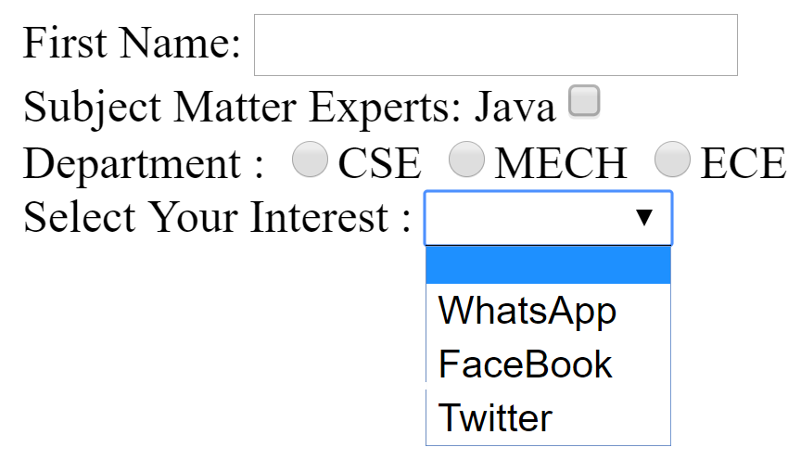

1. Use the following Google API template to change the *default marker* into *beach flag*. If user clicks the marker it should invoke the event to display the text as “*Chennai Marina Beach*”. (6 Marks)

<html>

<body>

  <h1>My Google Flight Map</h1>

  <div id="mapId" style="width:100%;height:400px;"></div>

  <script>

function **initMap**() {

  //Map Options

var options = {

center: {lat: 10.8978, lng: 76.9038},

zoom: 9,

};

var marker = new google.maps.Marker({

______________________________

______________________________

______________________________

});

}

</script>

<script src="https://maps.googleapis.com/maps/api/js?key=**YOUR_KEY**&callback=**initMap**"></script>

</body>

</html>

1. Consider the collection testCol which has the following data.

{ "_id" : ObjectId(5983548781331adf45ec5), "title":"MEAN Stack Overview"}

{ "_id" : ObjectId(5983548781331adf45ec6), "title":"Cloud Computing Overview"}

{ "_id" : ObjectId(5983548781331adf45ec7), "title":"Amrita University"}.

Use MongoDB query to limits and skips the given data. (4 Marks)

1. Design a page shown below which include the map to display all Amrita university campuses. (20 marks)

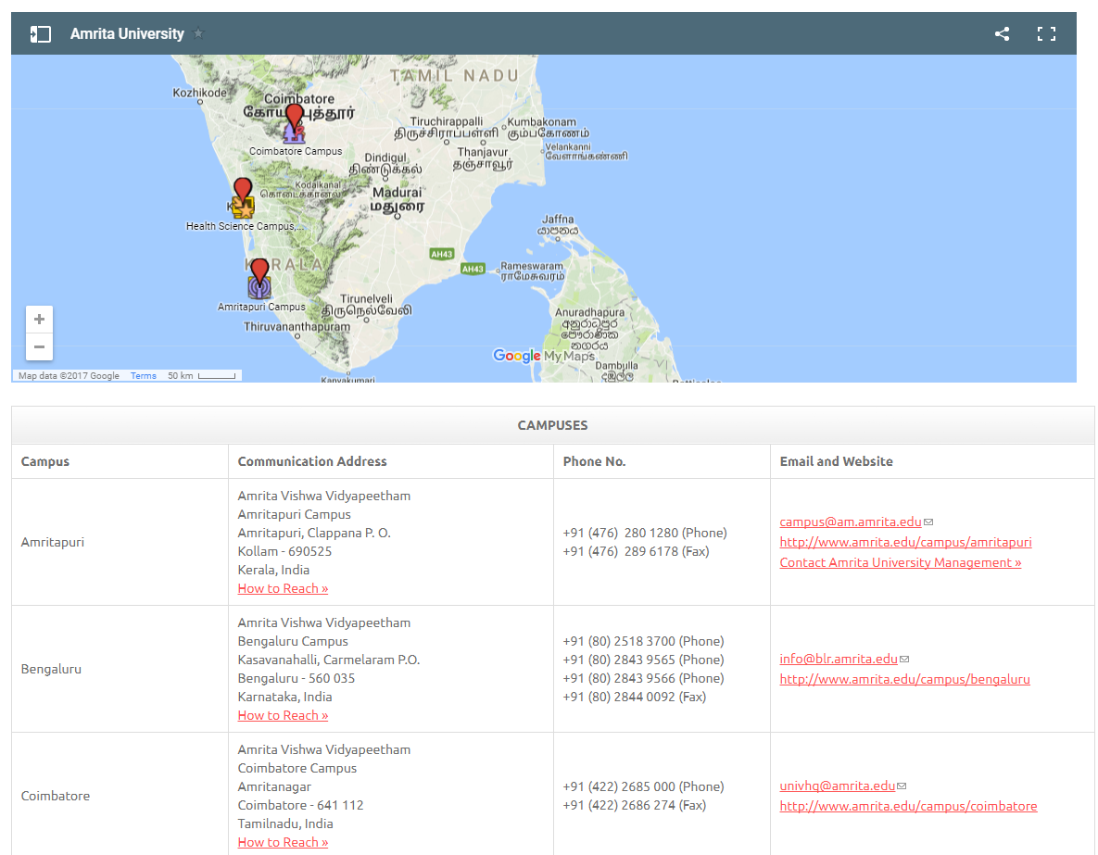

1. Add one button called ***Submit***in the web page given in the question number 16, if user clicks the Submit button, the university communication address to be stored into the cloud. (10 Marks)
2. If user clicks *How to reach link (Refer the question no 16),* the map should show the direction from *Chennai* to the university address. (10 Marks)