# Web Services with NetBeans IDE

Step1: Create a New Java Web Application → Web Application → Click Next

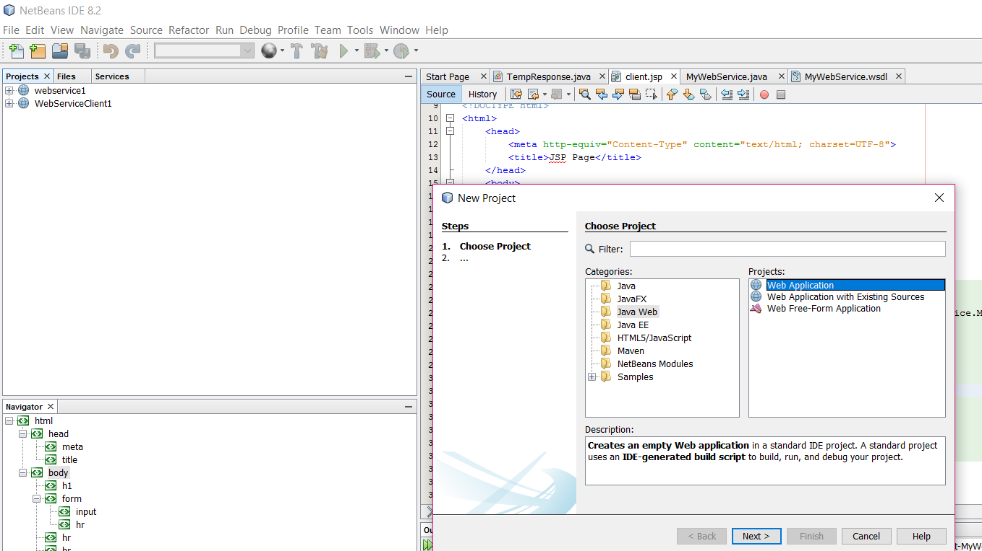

Step2: Enter the project name. I entered as “MyFirstWebService”.

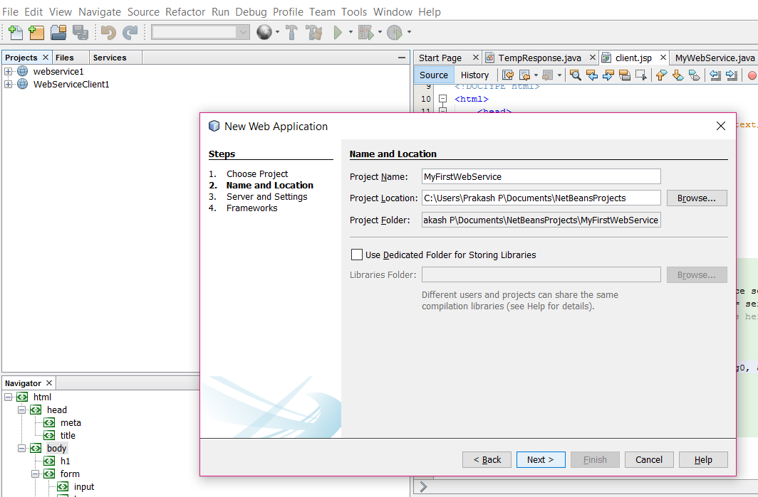

Step 3: Select the server from the server dropdown. I selected GlassFish Sever and Click Finish. It will create a project “MyFirstWebService”. Please check the project explorer .

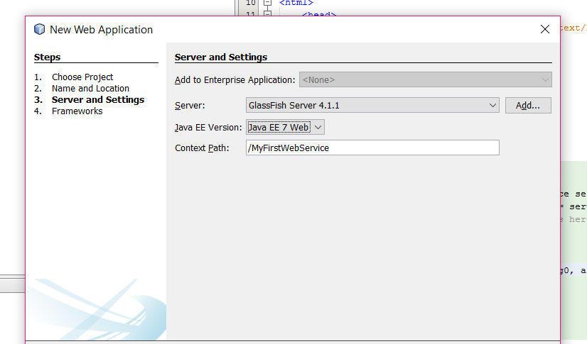

After that try to check whether the server is up or not, by running the project.

Step 4: Create a new Web service class. By right clicking the project → New → Web Service.

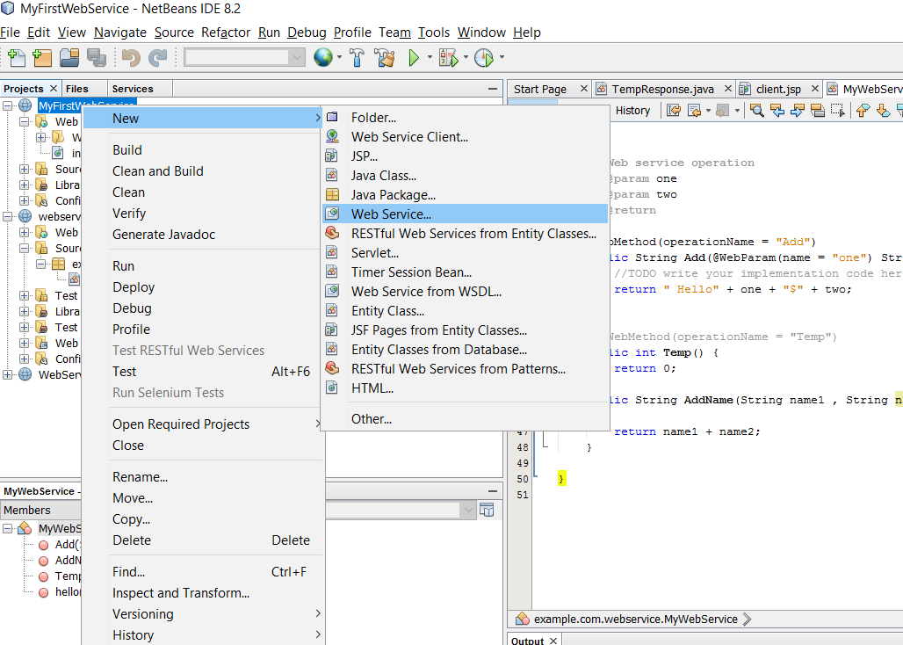

Step 5 : Enter the Web Service Name and the package details and click finish.

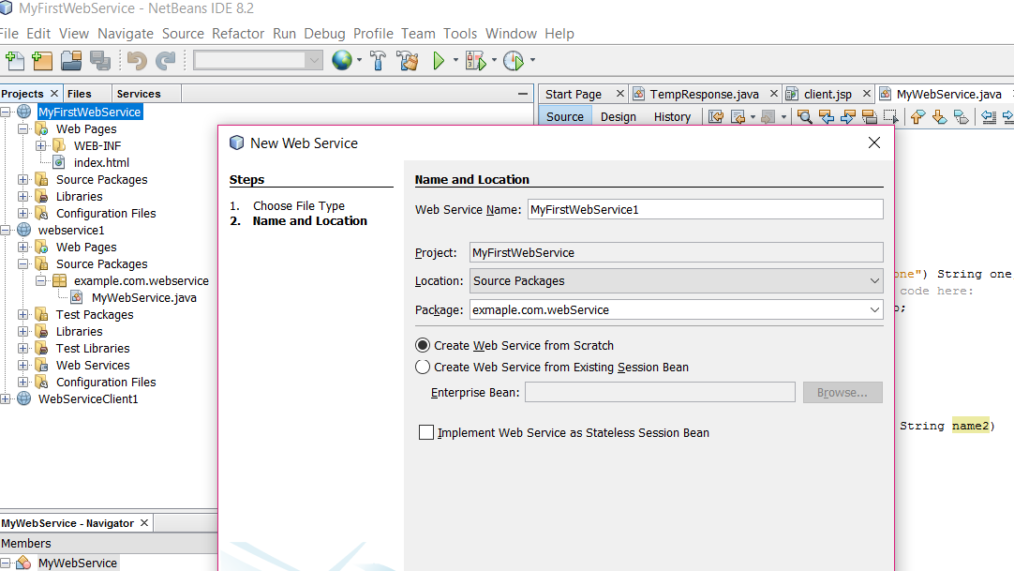

Step 6: The project explorer looks like below. [New Web services folder was added with default method “hello”].

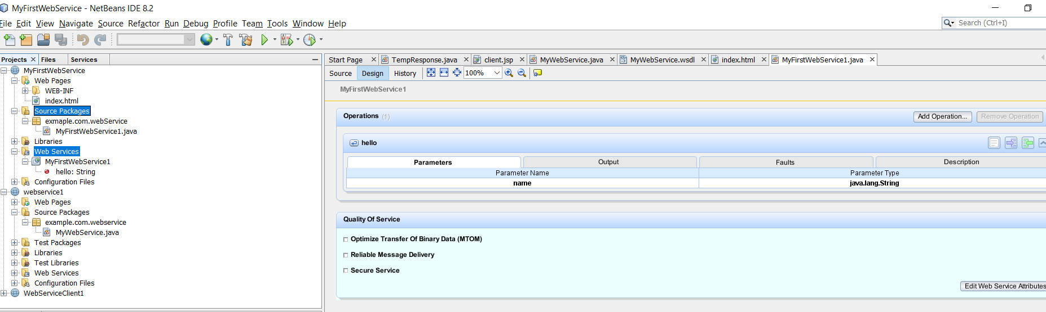

Step 7: MyFirstWebService1.java file looks like,

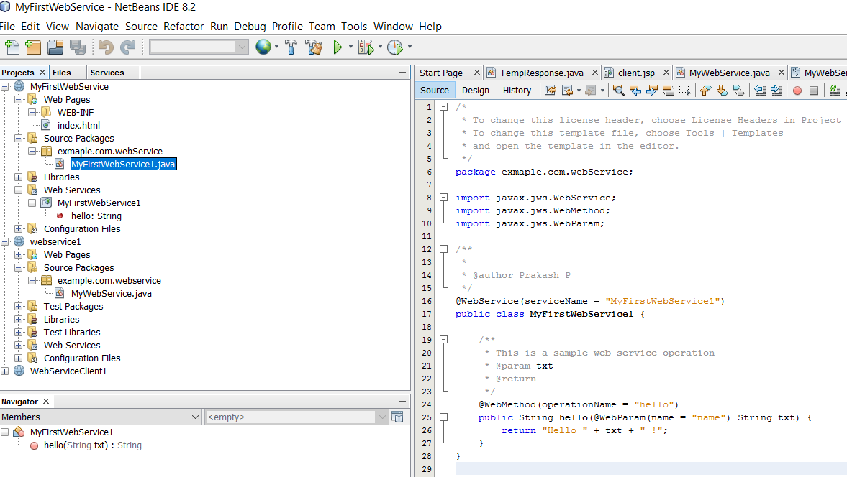

Step 8: Test the Web Service by right clicking, the MyFirstWebService1 in Web Services folder.

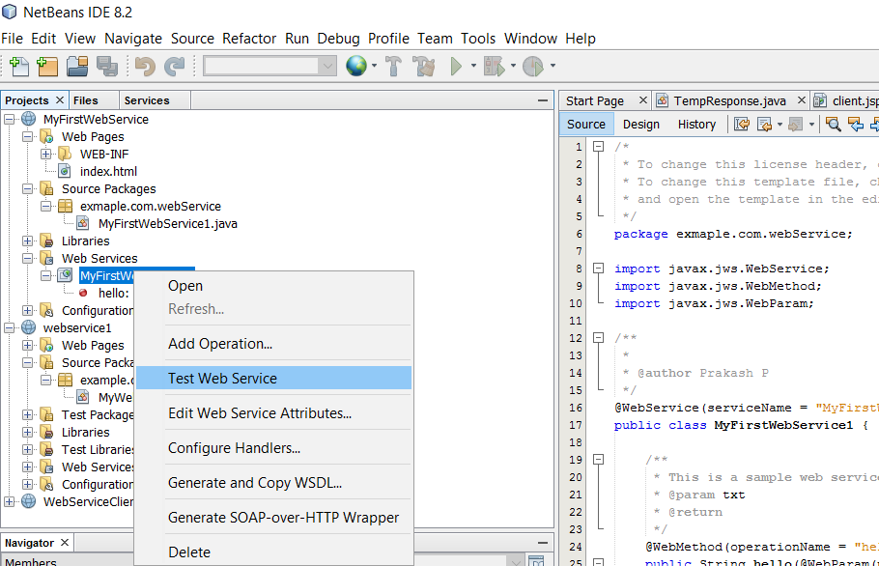

Step 9: It will open a browser with hello method, enter the values in the text box and test it.

Step 10: Add a new operation called Append into that web service, which should add first name and the last name.

Successfully completed the first web service. ☺ ☺ ☺ .

# Create a Client environment to test the Web Services

Step 1: Create a new Java Web Application to test the web service created in the previous module. I created a project called “MyFirstWebServiceClient”.

Step 2: Create a new JSP , to test the Web Service.

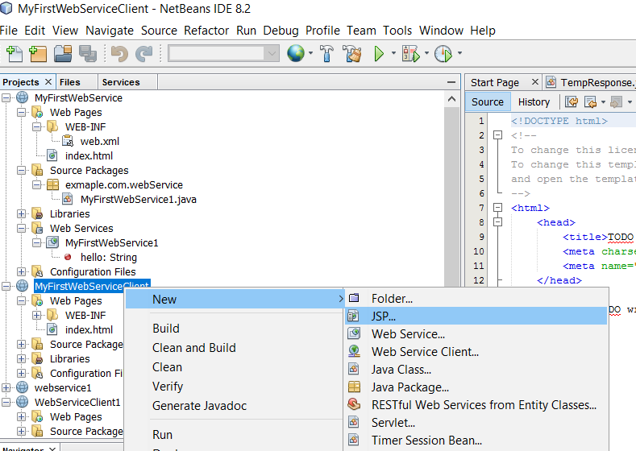

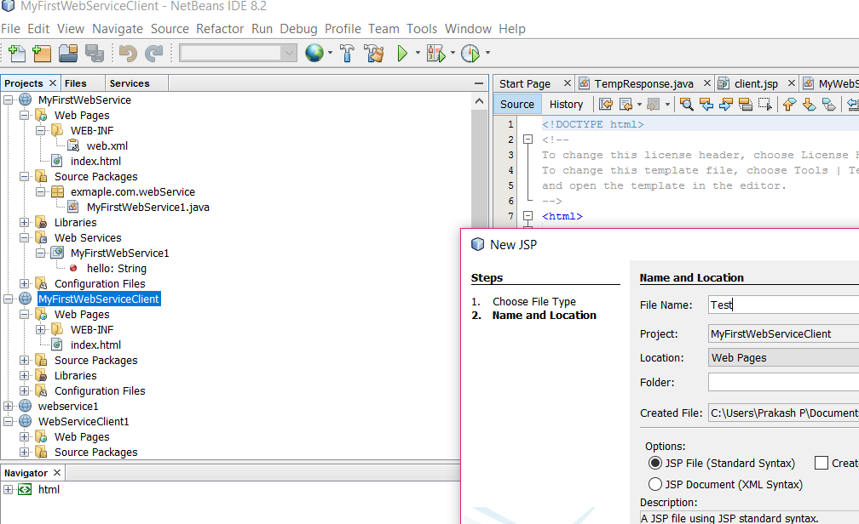

Step 3: Create the new Web Service Client, by right clicking the project.

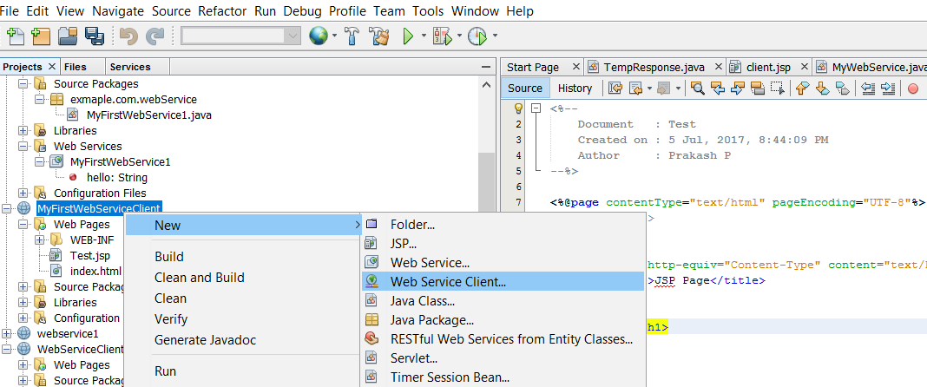

Step 3.1 Select the Web Service (Ex: MyFirstWebService1) from the Project in the New Web Service Client dialog box. It adds Web Services References in your project.

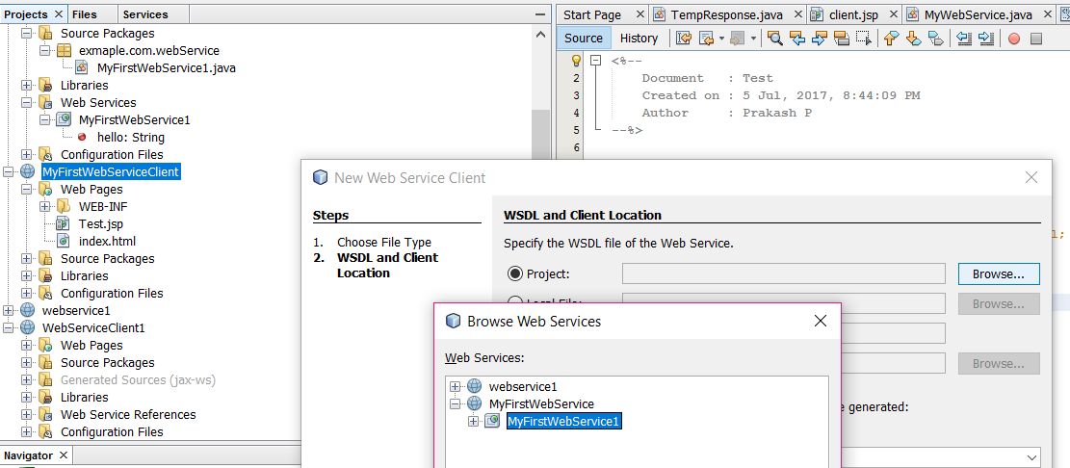

Step 4: Next go to the JSP page, Right click and call the Web Service Operation…

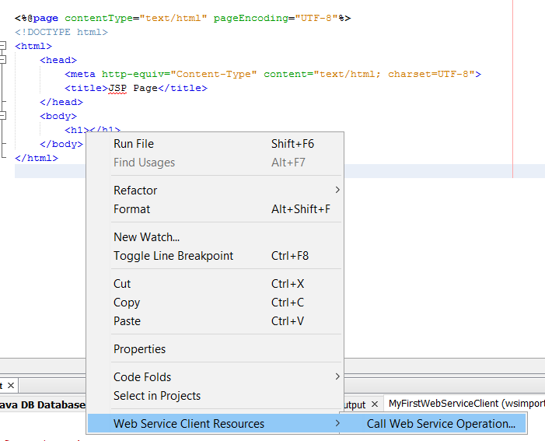

Step 5: Select the appropriate web service method which is to be deployed in this JSP page, Select hello [Default one which is generated by the NetBeans IDE] and click OK.

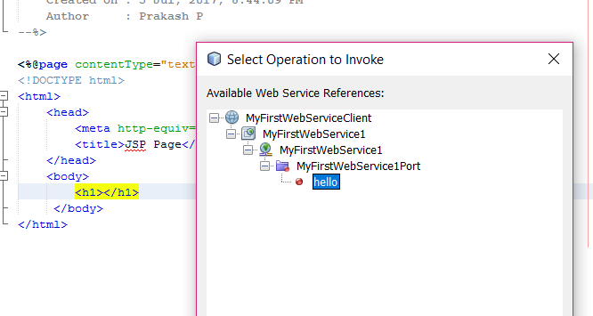

Step 5.1: The JSP file looks like as,

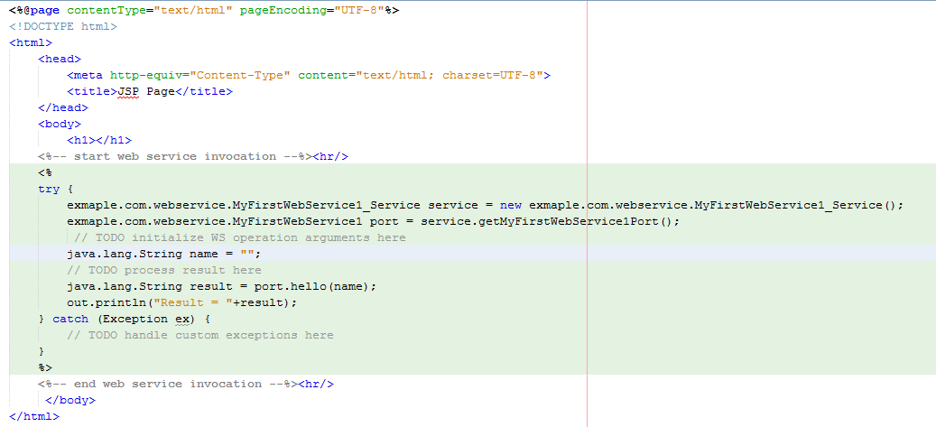

Step 6: Run the project and check the output.

Step 7: Try to do the following things,

1. Add to two text box first name and last name
2. Invoke the AddName Name service and Test it.