**Freshworks – Engineering – Assignment**

**“DataStore”** is a file based key-value datastore that supports the basic CRD (Create, Read, Delete) operations. This datastore is meant to use as a local storage for one single process on one laptop. Key is a string value and value is a JSON object. Each pair has time-to-live after which it cannot be read or deleted and no more than one client is allowed to use the same file as a datastore at any time.

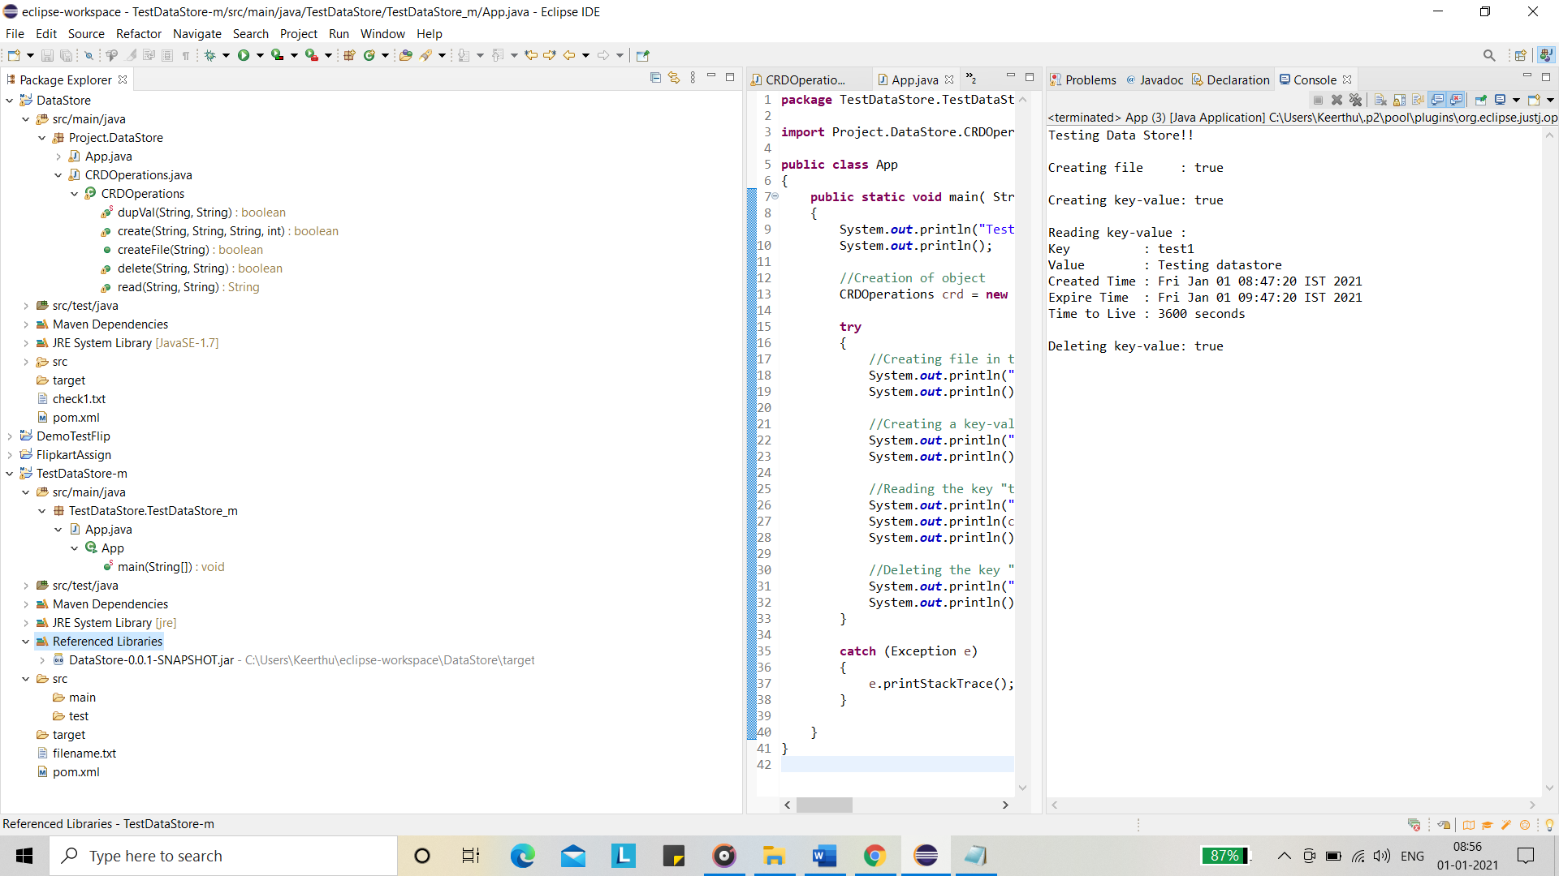

“check1.txt” is a sample file that store key-value pairs.

This is to be used as a library to clients whom can instantiate a class and work with the datastore.

**FUNCTIONS IN DATASTORE:**

**boolean** createFile (String path):

To create a file in the desired location or it will create a file in the same place as the project is created.

* Accepts a string value as argument for the file location

Returns true when the file is created and false when any error has occurred. It throws appropriate responses as exceptions when any error has encountered in its operation.

**boolean** create (String path, String key, String value, **int** ttl):

To create a key-value pair in the file in the desired path. It accepts 4 arguments namely:

* A String value for the desired path with a filename or accepts a filename in the default location.
* A String value for the “key” to be entered.
* A String value for the “value” to be entered.
* An int value for time-to live.

Returns true when the key-value pair is created and false when any error has occurred. It throws appropriate responses as exceptions when any error has encountered in its operation.

**boolean** dupVal (String path, String key):

It is called inside the “create” function to check whether the specified key is already present in the file or not to proceed with the create operation. It takes 2 arguments which is passed inside the “create” function namely:

* A String value for the file location.
* A String value for the “key” to be searched.

Returns true if already the key is present and false when it is not.

**String** read (String path, String key):

To get the value for the specified key entered when its expired time has not yet reached. It accepts 2 arguments namely:

* A String value for the path location of the file.
* A string value for the “key” to be entered.

Returns String value specifying the key-value pair and null if not found.It throws appropriate responses as exceptions when any error has encountered in its operation.

**boolean** delete (String path, String key):

To delete the specified key-value pair from the file when its expired time has not yet reached. It accepts 2 arguments namely:

* A String value for the path location of the file.
* A string value for the “key” to be entered.

Returns true when the key is deleted and false when any error has occurred. It throws appropriate responses as exceptions when any error has encountered in its operation.

**TO USE AS A LIBRARY:**

* Add the jar file (DataStore-0.0.1-SNAPSHOT.jar) which is inside datastore/target to the class path of the project in which the datastore is to be used as library.

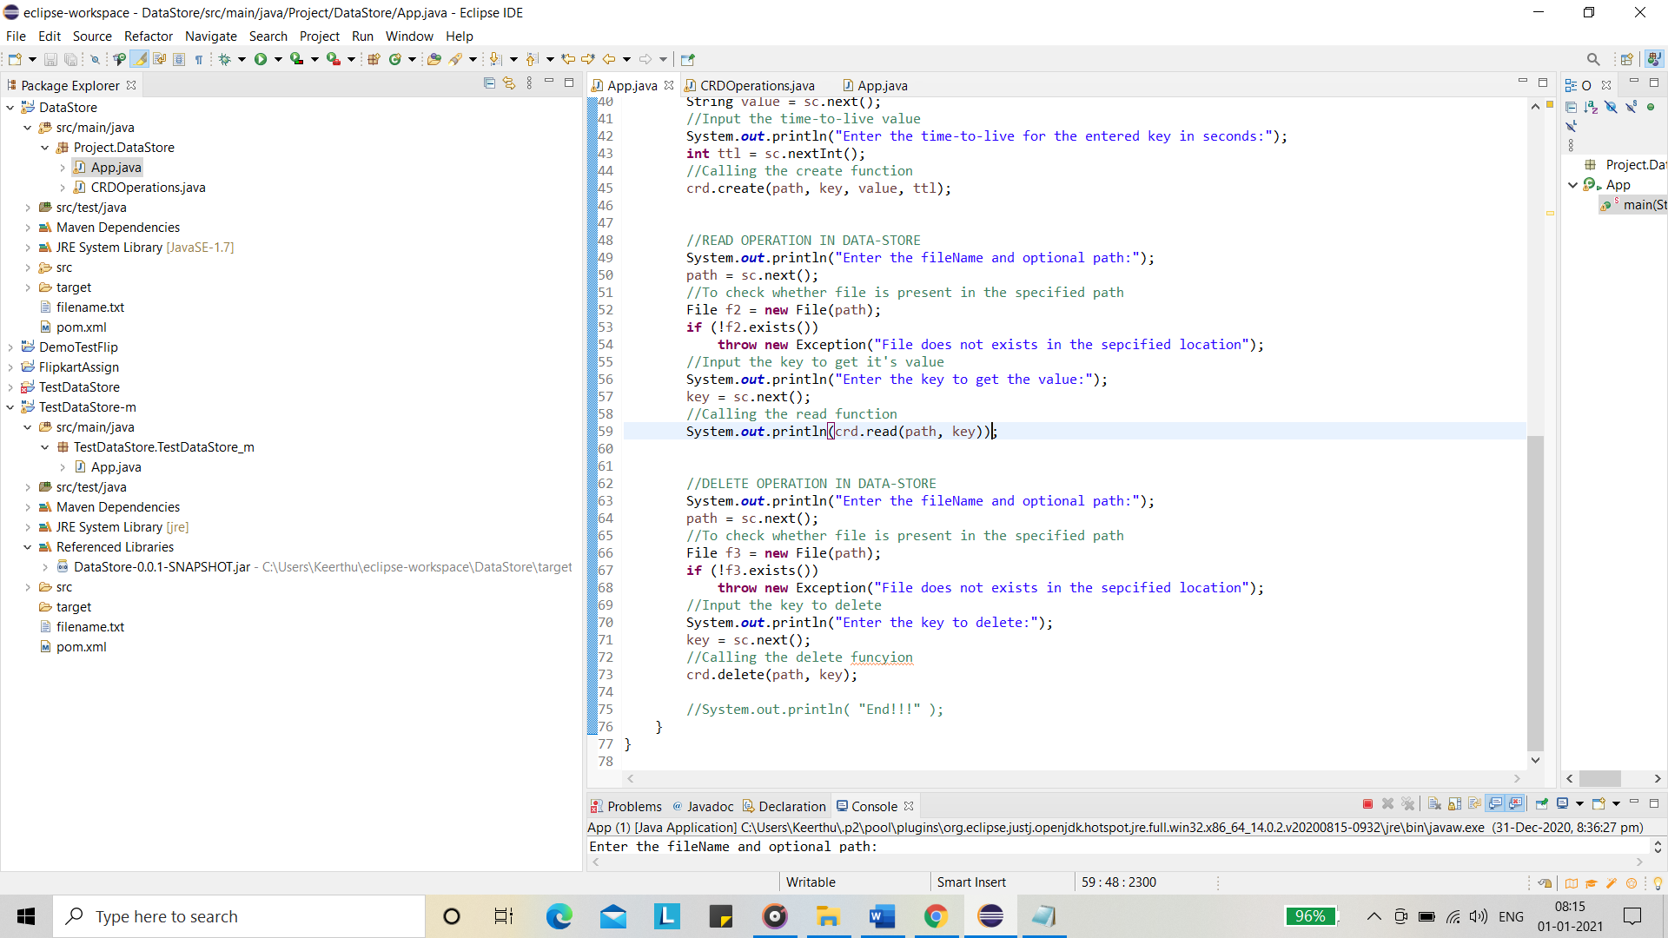

* Import the package “**import** Project.DataStore.CRDOperations;” in you class
* Create object as “CRDOperations crd = **new** CRDOperations();”
* Use “crd” to call the desired functions. Eg: crd.read(“check1.txt”,”key”);

