Redux-movie-app

* npx-create-app redux-movie-app

Deleted files:-

public:

logo192.png

logo512.png

manifest.json

robots.txt

src:

App.test.js

Index.css

Logo.svg

repo(rtWebVitals.js

setupTests.js

App.js

import './App.css';

function App() {

  return (

    <div className="App">

     App

    </div>

  );

}

export default App;

index.html (delete the below code)

 <link rel="manifest" href="%PUBLIC_URL%/manifest.json" />

Index.js

import React from 'react';

import ReactDOM from 'react-dom/client';

import App from './App';

const root = ReactDOM.createRoot(document.getElementById('root'));

root.render(

  <React.StrictMode>

    <App />

  </React.StrictMode>

);

Installed packages

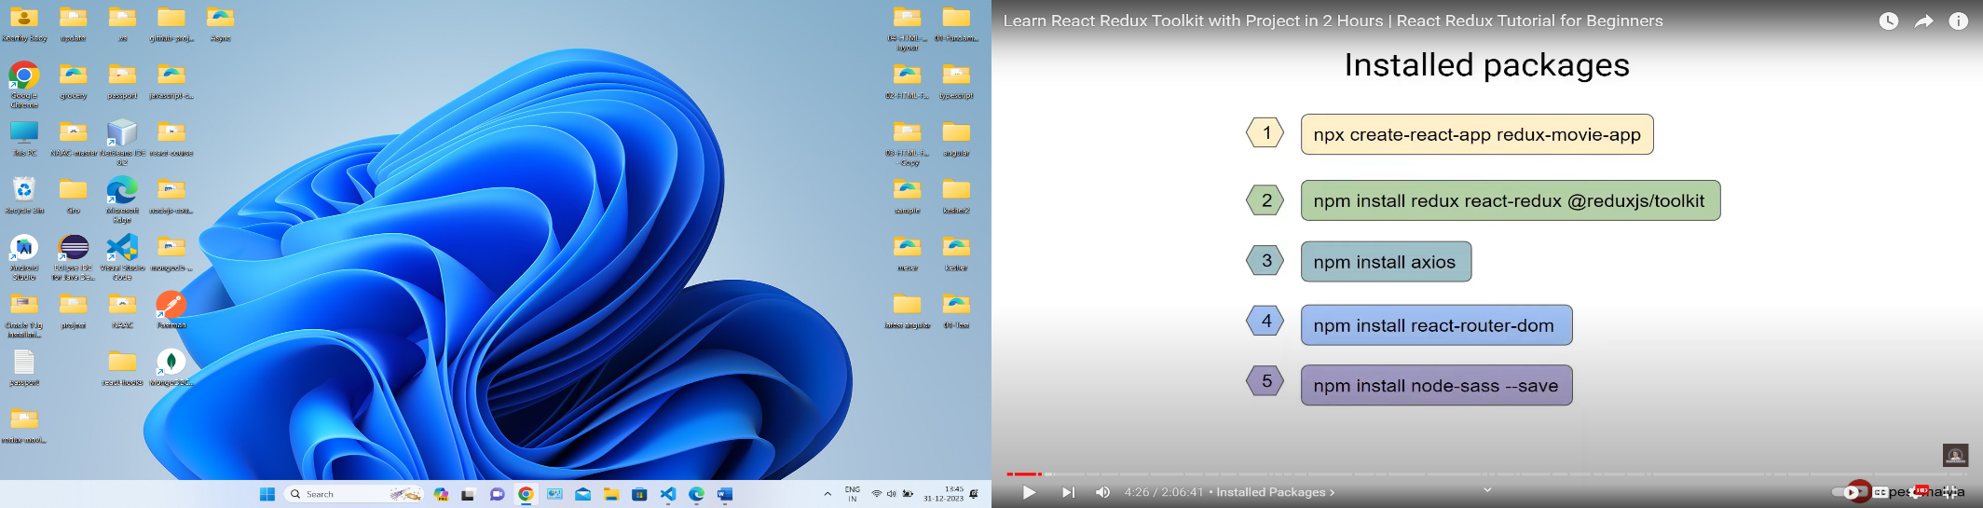

Movie Application Structure

