MOOC on Organic Farming

Project Report:1
ORGANIC MANURE MAKING

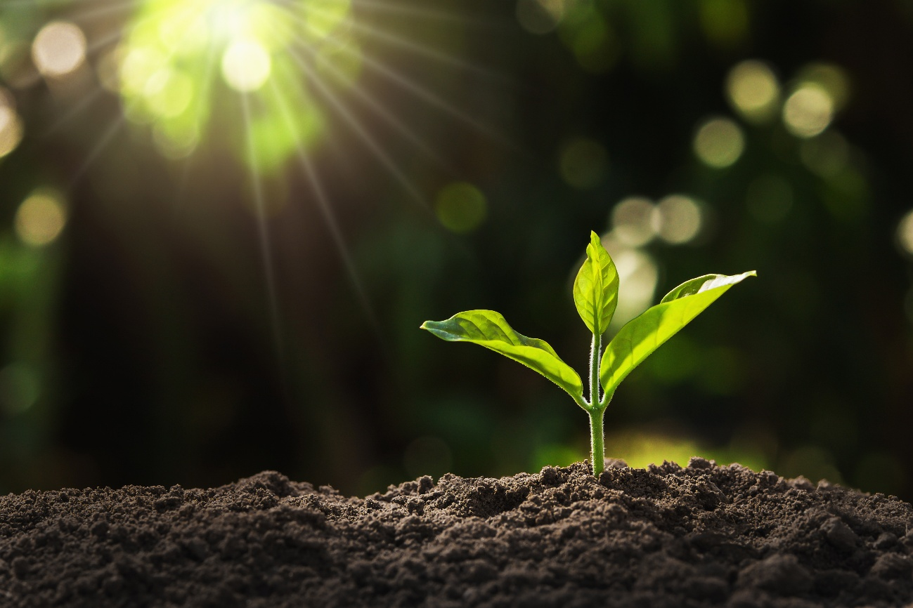

Details of the Students

Name of the Student: Jithin Jose
Register Number: 230021077978
Name of the College: BASELIOS POULOSE SECOND COLLEGE
Name of the Course: Bachelor of Computer Application
Name of the Project: MOOC Course on Organic Manure Making
Submitted To: Mahatma Gandhi University, Kottayam

Aim : Conversion of organic wastes generated at Household level to useful material Like manure
INTRODUCTION
The use of chemical fertilizer is increasing day-by day for the sake of increasing production. By excess use of it, the fertility Of soil and health also deteriorate There for the use of organic manure is one of the alternative ways for enhancing Production and improves the soil health. it is not only cheaper easily available ensures sustainable agriculture too.

ORGANIC MANURE
Manure is the decomposed form of dead plants and animals, Which is applied to the soil to increase production. It is the soil to increase production. It is a natural form of fertilizer and is cost- effective. The animal excretion and kitchen wastes livestock Manure is rich in nitrogen phosphorus, and Potassium. Manure is highly rich in organic matter and humus and thus improves he soil fertility. These are better in the long run and does not cause any pollution. It is valuable and renewable resource.

ADVANTAGES OF ORGANIC MANURE

1.Organic manure provides all the nutrients that are required by plants but in limited quantities.
2. It helps in maintaining C:N ratio in the soil and also Increases the fertility and productivity of soil.
3. It helps the physical, chemical and biological properties of the soil
4. It improves both the structure and texture of soil
5. It increases the water holding capacity of the soil
6. Due to increase in the biological activity, the nutrients that are made available to the plants
7. It acts as much, thereby minimizing the evaporation Losses of moisture from the soil

DISADVANTAGES OF ORGANIC MANURE

1. Not all products are created equally and many organic Products produce inconsistent results
2. Nutrient Levels Are Low. The level of nutrients present In organic fertilizer is often low
3. DIY Compost is a complicated Procedure
4. The excessive use of fertilizers changes the chemical nature of soil and makes the soil less fertile.
5. The excessive use of fertilizers causes water pollution In ponds, lakes and rivers.
6. They harm the microbes present in soil
7. They reduce soil fertility.
8. They change the nature of soil, making it either too acidic or too alkaline

OBJECTIVES OF ORGANIC MANURE

1. Organic manure provides natural way of nutrients in the Soil.
2. Organic manure provides to retain the soil ability to Store water.
3. Organic manure balances soil Ph value
4. Organic Manure provides organic acids to dissolve soil nutrients.
5. Organic manure enhances the growth of essential Micro-organisms.

DIFFERENT SOURCES OF MANURE

1. Cattle shed wastes-dung, urine and slurry from biogas plants
2. Wastes from kitchen, sludge, sewage, domestic Waste.
3. Droppings of goat and sheep.
4. Waste slaughterhouses such as bones, meat, horn and hoof meal, fish waste
5. By-products of agricultural industries.
6. Crop waste

ORGANIC MANURE MAKING FROM KITCHEN WASTES

Composting is the natural process of decomposition and recycling of organic material into a humus-rich soil amendment known as compost. Food waste is composed of organic matter which can be used for composting to make fertilizer. It is an effective and eco-friendly way of disposing of food waste of your kitchen. By using leftovers and other food waste, you can convert these smelly items from the kitchen waste into a highly organic product rich in nutrients that you can use to grow vegetablesor flowers with it. Things like paper, twigs, and leaves are rich in carbon while grass, coffee, and tea grounds, fruit, and vegetables are rich nitrogen. The proper mixture is key to good compost.

WHY USE FOOD WASTE AS FERTILIZER?

Food waste is a major challenge in the present world, tons of food is thrown away in the garbage we could use all the food waste and prepare a compost out of them which can be used as organic fertilizer. This way we save the earth the pollution caused by food waste and also do something productive. Food waste is unique as a composting agent, it is the main source of organic matters. Fruits, vegetables, grains, eggshells can be composted.

STEPS IN COMPOST MAKING

1.Go through Your kitchen waste
Vegetables and fruit peelings are the number one food remnants you should keep aside. Keep over ripened fruits and vegetables, nuts and egg shells. However, do not include grease, oils, fatty meats, and milk products in your compost pile a wet mess and produce an annoying odour. Put these items on a well-drained, level, and open area and sprinkle some wood ash to boost the composting process.
2.Add other organic materials to the compost
Aside from wood ash, you can also add sawdust to the compost to help speed up the composting Process. If you have some livestock, you can add the excess manure to the compost. If you don't have sawdust or manure readily at home, you can buy them from a gardening supplies store.
3.Collect some garden waste
To come up with a nutrient-rich fertilizers, you will also need to add some natural waste to your compost. you can do this by collecting grass clippings and leaves from your lawn.When you mow your lawn, all the organic waste will be sucked and mixed inside the lawnmower bag. Remove all the contents from the lawnmower and place them into your compost bin.
4.Create the compost
Add the prepared kitchen waste to the garden waste already in the compost bin. The compost bin should have a handle you can use to turn as you rotate the compost for through mixing and to incorporate oxygen into the mixture. Also, make sure the bin has some holes on the side to enable excess moisture to escape as you spin the compost. Lawn care experts recommend spinning the compost bin 2 to 3 times a day for best results
5. Apply the manure
Wait for your compost to achieve a soil like mixture that is dark in colour. Once the compost on the garden fields you want to fertilize. Apply The right amount of compost and wait for the fertilizer to seep in and see some effect on the areas applied before you adding more. Composting your kitchen waste offers several benefits which include getting rid of unwanted rubbish and having some fertilizer you can use on your lawn. Before throwing your leftovers and other food remnants, determine if they will work great as compost material first.
STATES OF COMPOST

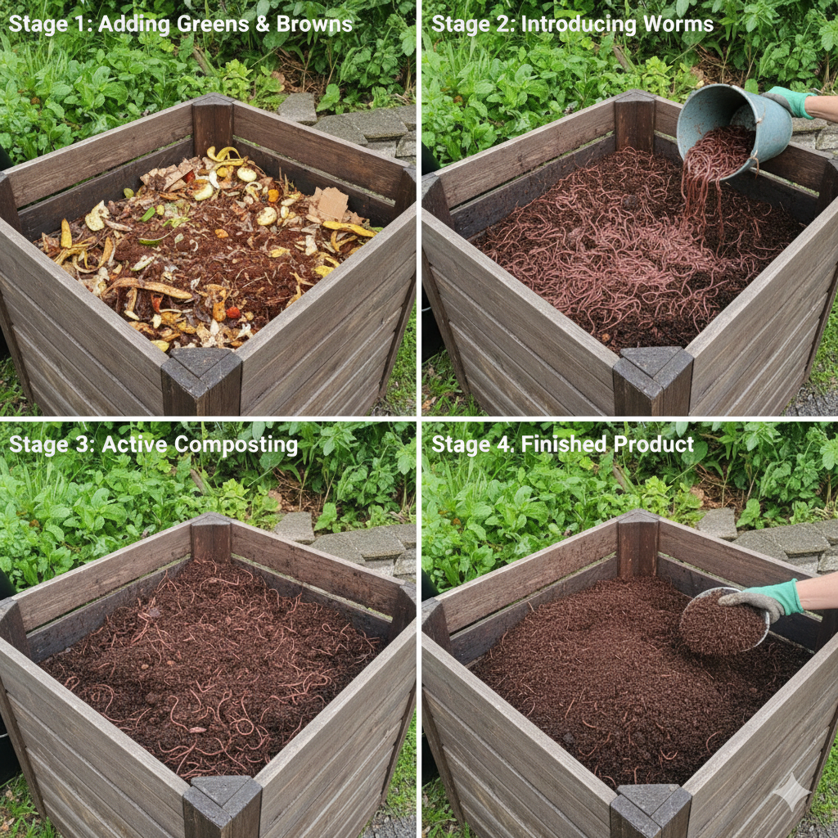

APPLICATION OF MANURE

Cut open a bag of manure and pour the contents onto your garden area. Conversely, if you have bulk manure, pour it from a wheel barrel or shovel it onto the soil. Rake the manure so it forms an even surface over the soil. For new gardens, apply 1 to 2 inches of manure. For established gardens, spread ½ to 1 inches of manure annually, or 40 pounds per 100 square feet of garden soil. Till the manure into the soil to a depth of 6 to 8 inches. Rake the soil again so it level and smooth. Use the rake to break up large pieces of soil or earth to create a fine seedbed. This fine seedbed allows seeds to germinate quickly and reliably.

BENEFITS OF COMPOST

1. Improved airy soil structure.
2. Healthier soil and more fertile
3. Longer period available for crops than chemical fertilizer.
4. Environmental-friendly
5. Easy to use.

CONCLUSION

Organic manure is a natural and sustainable way of fertilizing plants, crops, and provides essential nutrients to the soil, including, nitrogen, phosphorus and potassium, which are necessary for plant growth. Unlike synthetic fertilizers, organic manure is environmentally friendly and does not have any harmful effects on the soil, water, or air. It also improves human health, promotes biodiversity, and help to reduce waste. Overall organic manure is an excellent alternative chemical fertilizers and plays a significant role in sustainable agriculture and gardening practices.

